May 2018.
THIRD TERM TEST №2 (MS4)

…………………………………………………………………………………………………………
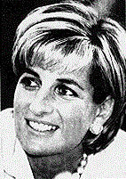
Diana, the Princess of Wales, was killed shortly after midnight on Sunday, August 31st in an automobile accident in a tunnel by the Seine, Paris. She died after being hospitalized in intensive care at the Pitie-Salpetriere Hospital in southeast Paris. The accident also killed Emad Mohammed al-Fayed and their driver. 'The car was chased by photographers on motorcycles, which could have caused the accident,' the police said. French radio stations reported that the British Royal Family in London expressed sadness and anger and said the accident was predictable because photographers relentlessly pursued the Princess wherever she went. The Princess and Mr. al-Fayed had been pursued from the Ritz Hotel where they were staying. The terrible road accident occurred on a high-speed road along the Seine with a divided roadway as it passed under the Place de l'Alma to the Place de la Concorde. The car was totally wrecked and its radiator was hurled onto the knees of the front-seat passenger. The death of Diana in a car crash brought an end to the life of a woman who had gone from being a shy young society girl to one of the world's most glamorous women.

Adapted from: “The New York Times”,

Craig B. Whitney. AUG. 31, 1997

☼Part one:
▪Reading comprehension: Read the text and do the activities below.
-Activity one: Complete the table. (2pts).
WHAT | WHEN | WHERE | WHO
…………………………………………  ………………………………………… | …………………………………………  ………………………………………… | …………………………………………  ………………………………………… | …………………………………………  …………………………………………

-Activity two: Answer the questions below: (3pts)
1-The text is: a)- fairy tale b)- newspaper report c)- fable d)- conversation
2- Give a title to the text. ………………………………...……………..…….……..……………………
3-What do the underlined words in the text refer?
where → …………………………..…… who → ……………………………………
-Activity three: a/Find in the text words that are closest in meaning to the following:
happened = ………………………… , collision = ……………..…….………
b/Find in the text words that are opposite in meaning to the following:
gently≠ ………………………… , happiness ≠ …………………………

▪Mastery of language:
-Activity one: Supply the punctuation and capitalisation where necessary. (2pts)
ways were closed to facilitate the task of rescue the reporters said

………………………………………………………………………………………………………………………………………………………………………………………………….

-Activity two: Turn the sentences below into the negative form. (3pts)
1-The plane crash took place at about 8 am. →……………………………………………………………………………………………………….
2-30 fire trucks were mobilized by the Civil Protection of Algiers. →………………………………………………………………………………….
3-The plane landed near Boufarik-Algiers highway. →……………………………………………………………………………………………………….

-Activity three: Derive nouns from the verbs in the table. Add the correct suffix: -tion or -sion. Make the necessary changes. (2pts)
Verbs | Nouns
To interrupt | ………………………………………….
To examine | ………………………………………….
To classify | ………………………………………….
To discuss | ………………………………………….

☼Part two:
▪Written expression: (6pts)

The military plane crash at Boufarik broke the hearts of all Algerians, leaving the country in depression. Write a newspaper article about this event. Use the following table to help you.

Boufarik, Blida. | April 11th, 2018 (7:55A.M) | 257 people | To crash soon after take-off.
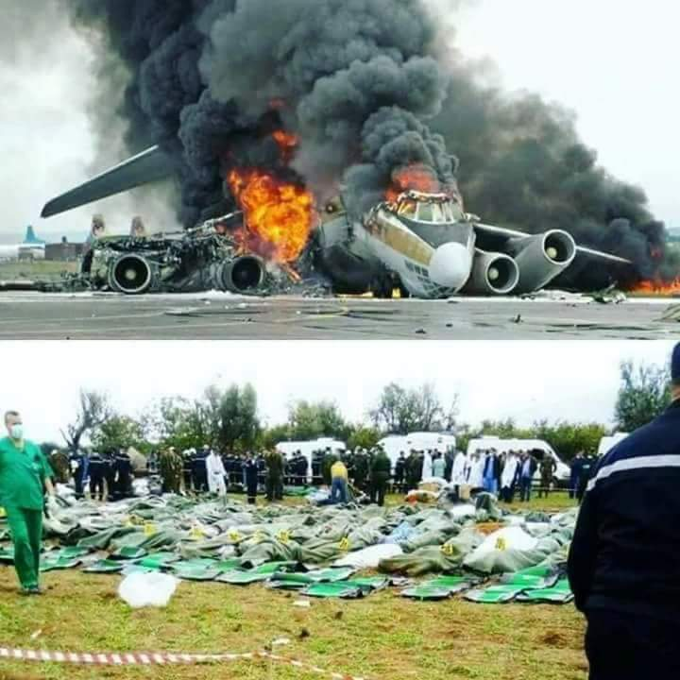
……………………………………………………………………………………………………………………………………………………………………………………………………………………………………………………………………………………………………………………………………………………………………………………………………………………………………………………………………………………………………………………………………………………………………………………………………………………………………………………………………………………………………………………………………………………………………………………………………………………………………………………………………………………………………………………………………………………………………………………………………………………………………………………………………………………………………………………………………………………………………………………………………………………………………………………………………………………………………………………………………………………………………………………………………………………………………………………………………………………………………………………………………………………………………………………………………………………………………………………………………………………………………………………………………………………………………………………………………………………………………………………………………………………………………………………………………………………………………………………………………………………………………………………………………………………………………………………………………………………………………………………………………………………….
GOD HELPS, HE WHO HELPS HIMSELF

May 2018.
THIRD TERM TEST №2 (MS4)
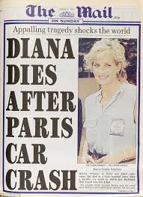
☼Part one:
▪Reading comprehension: Read the text and do the activities below.
-Activity one: Complete the table. (2pts).
WHAT | WHEN | WHERE | WHO
automobile accident | on Sunday, August 31st | in a tunnel by the Seine, Paris | Princess Diana / Mr Emad Mohammed al-Fayed/ the car driver

-Activity two: Answer the questions below: (3pts)
1-The text is: b)- newspaper report
2- Give a title to the text. DIANA DIES IN TRAGIC ACCIDENT/ PAPARATZI KILL DIANA/DIANA DIES IN CAR ACCIDENT IN PARIS/ CAR CRASH KILLS PRINCESS DIANA/ PRINCESS DIANA DEAD…
3-What do the underlined words in the text refer?
where → Ritz Hotel who → a woman (Diana)
-Activity three: a/Find in the text words that are closest in meaning to the following:
happened = occurred , collision = accident
b/Find in the text words that are opposite in meaning to the following:
gently≠ relentlessly , happiness ≠ anger, sadness

▪Mastery of language:
-Activity one: Supply the punctuation and capitalisation where necessary. (2pts)
“Ways were closed to facilitate the task of rescue”, the reporters said.

-Activity two: Turn the sentences below into the negative form. (3pts)
1-The plane crash didn’t take place at about 8 am.
2-30 fire trucks weren’t mobilized by the Civil Protection of Algiers.
3-The plane didn’t land near Boufarik-Algiers highway.

-Activity three: Derive nouns from the verbs in the table. Add the correct suffix: -tion or -sion. Make the necessary changes. (2pts)
●To interrupt →interruption ●To examine→ examination ●To classify→ classification ●To discuss→ discussion
☼Part two:
▪Written expression: (6pts)

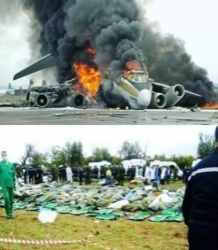
Write a newspaper article about the crash of the military plane crash at Boufarik.

