Game tutorial "Pong"

Begin with some program structure 1
Drawing a square on the screen where we want 3
Bouncing all over the place 5
Organize your Data with structures 8
The structure of the game 10
The paddle 11
Create an IA for right paddle 14
Manage the ball when it goes out of the screen 18
Manage the game arena 23
Show the score 23
Manage end of game 23
Complete properties 24
Resulting code of this tutorial 25

Begin with some program structure

Let's start with the basics. LGE uses a subset of C, which means that any program must have an entry point main(). The entry point is the place from which the program starts to run.
Here is the basic anatomy of an espLGE game:
.

// global variables
void init(){
// the code at this location will be executed only once when the game starts.
}

void step(){
// code in this place will execute each frame
}

void draw(){
// this is where all objects are drawn
delayredraw(); // waiting for frame drawing
}

void main(){ // required function for any program, execution starts with it
init();
while(1){ // infinite loop
step();
draw();
}
}

The code is divided into 4 parts:
- The init function is called once, when the game starts. It’s will setup all needed to be able to launch the game.
Sometimes it’s can be splited in two parts: init and newLevel because newLevel will have to setup some things each time you pass to a new level.

- The step function will be executing each frame you draw. It’s will calculate all the change to do between 2 displayed pictures.

- The draw function is in charge to display all on the screen after that they have been calculated. Doing this avoid having blinking elements for example.

- We already shown the last: main wich s the entry point of your program. The program start here and for a game we place the call of the init function and an infinite loop to let the program running with the 2 other functions: step and draw. So they will be executed until you quit game.

This organization isn’t mandatory but it’s works fine for a game. So additional step can be added but it’s the easiest classic structure for a game.

You can execute this code. It’s only a structure so nothing happens and it’s fine…

Drawing a square on the screen where we want

Our game will be displayed on the screen, the size of 128x128 pixels. The esp8266 microcontroller can work with different LCD screens, and on large screens the image will be scaled. These screens can display up to 65 thousand colors, but the microcontroller has a small memory capacity. Because of this, it was necessary to limit the ability of the game engine to use 16 colors for background and 15 colors for sprites at the same time (+ 1 color for transparent areas). When drawing sprites and images, the position in which the upper left corner will be located.

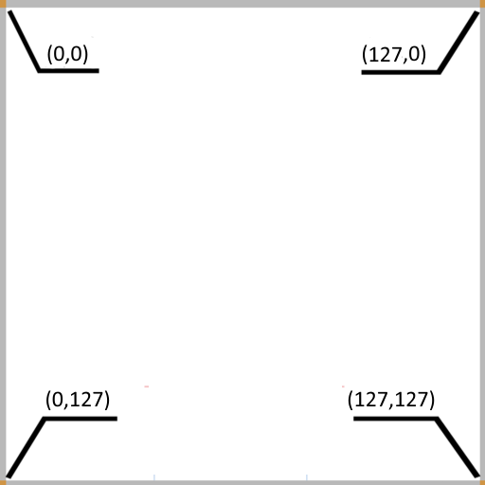
Coordinates on the espLGE screen, just like all other screens, have their origin in the upper left corner, the Y values get bigger when you move downwards, and the X values grow when moving to the right.

All that we want at this point is to draw a square from the middle height of the screen at the left. So half height is 63 (the first line is 0…) and the horizontal left value will be 0
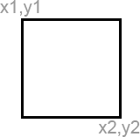
To draw a square, we use the function:

void fillrect(int x1, int y1, int x2, int y2);

fillrect will draw a filled rectangle on the screen between the coordinates
[x1, y1] and [x2, y2].

So try it now. Use the last maked structure and add the instruction in it to draw a square with x1 = 0, y1 = 63, x2 = 2, y2 = 65
The solution is given below but try to do it by yourself.

Solution:

int x1 = 0;
int y1 = 63;
int x2 = 2;
int y2 = 65;

void init(){
// the code at this location will be executed only once when the game starts.
}

void step(){
// code in this place will execute each frame
}

void draw(){
// this is where all objects are drawn
fillrect(x1, y1, x2, y2);
delayredraw(); // waiting for frame drawing
}

void main(){ // required function for any program, execution starts with it
init();
while(1){ // infinite loop
step();
draw();
}
}

This is one solution, many solutions exist, on another fine solution could be to organize code like this:

// Global variables
int x1;
int y1;
int x2;
int y2;

void init(){
x1 = 0;
y1 = 63;
x2 = 2;
y2 = 65;

void draw(){
fillrect(x1, y1, x2, y2);
delayredraw();
}

void main(){
init();
while(1){
draw();
}
}

The function step has been removed as it was not used and the initial values of the variables have been set in init function. It’s some recipes and of course, you can adapt them and use them as you want and as you find it the more logical.

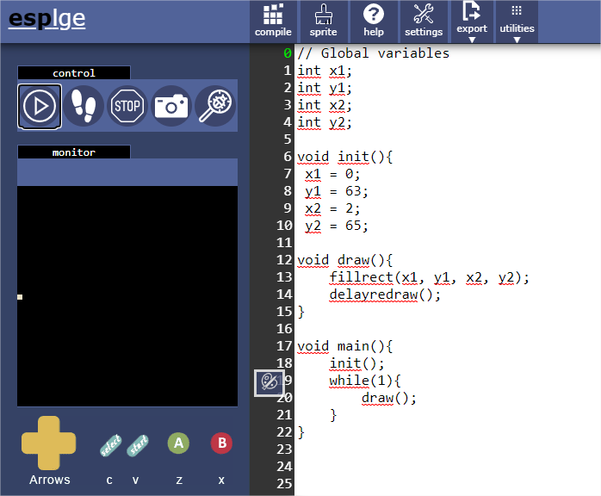

Bouncing all over the place

So I last chapter, we have drawn a square, il was like that that programmer draw the ball before, but now, we can easily use a circle in place of it for that we should just use another instruction:
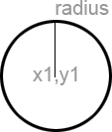
void fillcircle(int x1, int y1, int radius)

So we can change it in the last program. As, x1 and y1 are in the center of the ball, to have a circle looking like a circle, it’s better to have a radius of 2 else…. Circle is something with undefined form. if we want , that the circle touch the left border, we’ll have to use x1=2, y1=64, radius = 2
So program is:
// Global variables
int x1;
int y1;
int radius;

void init(){
x1 = 2;
y1 = 64;
radius = 2;
}

void draw(){
fillcircle(x1, y1, radius);
delayredraw();
}

void main(){
init();
while(1){
draw();
}
}

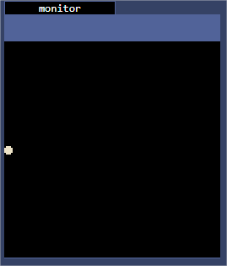

Yes, the ball is here, now we want that it’s moves from left to right.
For that we’ll add a loop to move each frame the ball a few to the left. We’ll fix a step to add between each frame. We can fix how many time the loop is shown in one second with command : setframerate(40); it’s will set the number of screen displayed to 40 each second.
So if we want that the ball go 40 pixels to the left, we’ll add 1 to x1 each time that the step function is called.
A problem: the ball will never stop !!
We’ll stop it when it’s reached the right border. For that we’ll test x1 value and increment it only if it’s less than right border – radius, so 127 – 2 => 125
We can write it in number in the code but if the program gets bigger, if this value is used many times, you will have to change it in all place used.
Same left border is easy to write, it’s 0 + radius but if we want only use in a part of the screen or keep a border, we’ll have to change in all place we wrote it. So, we’ll add another variable to keep it.
A problem: if you draw the ball each time, you’ll not have a ball going to the right but a line drawed step by step from the left border to the right border.To avoid it: add the clearscreen() instruction at the beginning of the draw function => the screen will be drawn from scratch each time and then, your eyes will show some dots looking like a ball going from left to right.
Try to do it by yourself if you successes or not, when ready, continue to read and try the solution below:
// Global variables
int x1;
int y1;
int radius = 2;
int speed;
int leftBorder = radius;
int rightBorder = 127 - radius;

void init(){
x1 = leftBorder;
y1 = 64;
speed = 1;
}

void step(){
if(x1 < rightBorder) x1 = x1 + speed;
}

void draw(){
clearscreen();
fillcircle(x1, y1, radius);
delayredraw();
}

void main(){
init();
while(1){
step();
draw();
}
}
Now try to think to let go first to the right until it reach right border, then that the ball change of direction to return to the left until the ball reach the left border and then loop to the right to have the ball bouncing to infinite (or that you stop the program)
Don’t read solution too quick. Ok, done ? Yes ? Then you can read the solution now. It’s the solution I give but there is not one only solution, there are good solutions, working solutions and don’t working solutions. If you have success, it’s great. Else make some tries, you can do it !
Another thing : time is money for test (and for fun, i’ll fix speed to 3 to wait less that ball reach one of the screen limit => the bal lis quickest and it’s funny (for me) )

Solution :
// Global variables
int x1;
int y1;
int radius = 2;
int speed;
int leftBorder = radius;
int rightBorder = 127 - radius;

void init(){
x1 = leftBorder;
y1 = 64;
speed = 3;
}

void step(){
if (speed > 0) {
if(x1 < rightBorder) {
x1 = x1 + speed;
} else {
speed = 0 - speed;
}
} else {
if(x1 > leftBorder){
x1 = x1 + speed;
} else {
speed = 0 - speed;
}
}
}

void draw(){
clearscreen();
fillcircle(x1, y1, radius);
delayredraw();
}

void main(){
init();
while(1){
step();
draw();
}
}

OK, have you understood the solution?
Really? OK, so try to make the ball moving in diagonal and bouncing each time it’s reach one of the limits of the screen.
I have shown in last solution how to use one if in another.
Another great thing for the tests is to use parentheses, and logical operators…
What is it? it’s let make some logical conditions.
For example, you can test if a condition is true or another one is true to make something
For that you use the logical OR but it’s written ||
If((A==0) || (B==1)) => That means if A value is 0 or B value = 1 then condition is true, and you can do that you have to do …
Another very useful logical operator is AND (Written &&). The condition is true if both values are true.
If((A==0) && (B==1)) => That means if A value is 0 and B value = 1 condition is true so do that you have to do …
If we use that in last solution, we can change the step function like:
void step(){
if (((speed > 0) && (x1 < rightBorder)) || ((speed < 0) && (x1 > leftBorder))) {
x1 = x1 + speed;
} else {
speed = 0 - speed;
}
}

It’s not a better solution it’s another solution and you can use the one you prefer.
If you have problem to make the ball going in diagonal, this could help you.
You have to modify x1 and y1, you can do another speed variable to change value of y1 as we done for x1. You will have to test x1 value to change xSpeed and to test y1 to change ySpeed.
With that you have already all you need to make the ball bouncing on the screen.
Another thing you can add now: a little sound each time that the ball bounce on a limit of the screen. For that use the instruction: tone(300,100);
OK: We have a bouncing ball!!

Organize your Data with structures

Our program is just a little example at this moment, but we already have some variables. You can give significant name to your variables to retrieve the reasons for which you had create them and help other users to read and understand the program you wrote. It’s like the commentary in your code.
You can use many words for Variables, just separate the words with a Caps letter. For an example you could have a variable that we named ballSpeedX but there is another great existing thing: the structures.
Ok, let’s talk a few about them. In the program Pong we have a lot of things but mainly we’ll have a ball and 2 pads. We’ll organize our data to regroup all about each element.
For that we’ll use the word struct. The structure is a type of data like we used int before or we could use char for example, but we declare this type of data to be able to create one or more object using it. As an example, is better than a lot of words, we’ll use our ball to understand.
First we declare the structure like this:
struct ballStruct {
int x;
int y;
char radius;
int x_speed;
int y_speed;
};

So we have the keywords struct to declare that we want create a new structure. Next, we enter the name that will be used when we want to use this new structure then we open a bracket to list all that we want in this structure.
For us, we want 2 int for coordinates x and y of the center of the ball, next we want a radius that we declare as a char. Finally, we’ll use 2 integers for horizontal and vertical speed of the ball.
We close bracket to finish declaration of this new structure.
Now we have to declare a new variable using this new type. For that we will use:
ballStruct ball[1];

Note that we use [1] to set that it’s will be a single element as we could have an array but we’ll not enter in these explanation now.
OK, so now we have the variable ball, but you don’t know yet how to access to the components like x, y, radius, x_speed or y_speed. It’s easy, you type the name of the variable, next you type a dot and the name of the component. So to access to the value x of the variable ball you type: ball.x
Try to use it in your last exercise where the ball moved everywhere, when done or if you have problems, read the solution below:
// Global variables

struct ballStruct {
int x;
int y;
char radius;
int x_speed;
int y_speed;
};

ballStruct ball[1];

ball.radius = 2;

int leftBorder = ball.radius;
int rightBorder = 127 - ball.radius;
int topBorder = ball.radius;
int bottomBorder = 127 - ball.radius;

void init(){
ball.x = leftBorder;
ball.y = 64;
ball.x_speed = 3;
ball.y_speed = -2;
}

void step(){
if (((ball.x_speed > 0) && (ball.x < rightBorder)) || ((ball.x_speed < 0) && (ball.x > leftBorder))) {
ball.x = ball.x + ball.x_speed;
} else {
ball.x_speed = 0 - ball.x_speed;
tone(300,100);
}

if (((ball.y_speed < 0) && (ball.y > topBorder)) || ((ball.y_speed > 0) && (ball.y < bottomBorder))) {
ball.y = ball.y + ball.y_speed;
} else {
ball.y_speed = 0 - ball.y_speed;
tone(300,100);
}
}

void draw(){
clearscreen();
fillcircle(ball.x, ball.y, ball.radius);
delayredraw();
}

void main(){
init();
while(1){
step();
draw();
}
}

OK, we have all the required bases, now we’ll start to think about our Pong game

The structure of the game

First try to split the game into multiple steps. This allows us to focus on a single smaller task at a time.
Trying to figure out the logic behind a game while viewing the game as a bloc is not easy but if you split it, you will see that Pong, like other games, is composed of many simple parts.
- Create the ball and a paddle
- Draw the ball and the paddle
- Update the paddle's position
- Update the ball's position
- Check for collisions between the ball and walls
- Check for collisions between the ball and the paddle
- Check to see if the game is not over
- Add a second paddle
- Count and display the scores

So we have already see how to Create, update ball’s position and draw the ball
We have already seen how to check collisions between the ball and walls
We’ll have now the create paddle, draw it, update the position when user use buttons and next we ‘ll manage the collisions between paddle and ball.

The paddle

We can use a structure like we have do for ball to declare the paddle. The paddle will be a rectangle, we have already use one at the beginning of this tutorial. Rectangles use 2 points,
You can do it like you want but me I have decided to use a point: the top left and to define the width and the height of the paddle.
So the structure we’ll use will be:
struct padStruct {
int x;
int y;
char width;
char height;
int moveSpeed;
}

Having a speed variable is unnecessary because we want to control it with the directional buttons
Now we’ll see another way to initialize a new variable of this new type:
padStruct pad1[1] = {0,0,4,20,3};

So what it’s do. Easy, it’s fill the components in the order we have declare them, so 0 go to component x, next 0 go to y, 4 go to width and last: 20 go to height.
It’s another method to declare items and it’s can be very useful in some cases.
Now, it’s not very important and you can use the method you want.
We’ll draw paddle in the draw function with this line:
fillrect(pad1.x, pad1.y, pad1.x + pad1.width, pad1.y + pad1.height);

You can try it already; you should obtain something like this
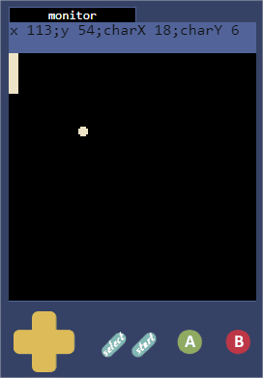

It’s fine we have already the 2 first lines. We can strike them out on the list:
- Create the ball and a paddle
- Draw the ball and the paddle
- Update the paddle's position
- Update the ball's position
- Check for collisions between the ball and walls
- Check for collisions between the ball and the paddle
- Check to see if the game is not over
- Add a second paddle
- Count and display the scores
Now it’s time to manage the keys to control the paddle. With esplge it’s very easy: we want to move the paddle as long as the button top or the bottom buttons are pressed. For that we have the function getkey() which returns the value of the button currently pressed. The value returned will be one of the following: KEY_UP, KEY_DOWN, KEY_LEFT, KEY_RIGHT, KEY_A, KEY_B, KEY_SELECT, KEY_START
For example, to test if the button “UP” is pressed we can type:
char key;
key = getkey();

// Control Pad 1 with "UP" buttons
if((key & KEY_UP) && (pad1.y > 0)) {
pad1.y = pad1.y - pad1.moveSpeed;
}

Easy, no? So try to do same for “Down” button and be able to test (I have make UP buttons as paddle is already as top, you’ll only be able to test control when you’ll have add the test to control that “Down” is pressed and move it down.
OK, another line to strike out on the list.

Now we have to test if ball will have a collision with the paddle to stop it and be able to remove the auto bound (else game will have a lot less interest)
So when ball can be in collision with paddle ?
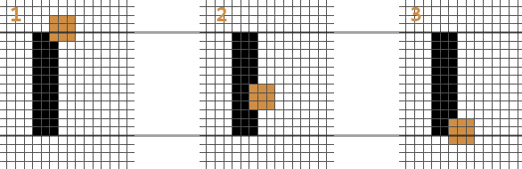
We have to check multiple conditions to be sure the ball hits the paddle. Let's take a look at the diagrams above. The black rectangle is the paddle, and the three squares are three possible positions where the ball enter in collision with the paddle. In each situation, we want the ball to bounce on it..
When looking at it from the X-axis' point of view, this mean that the left side of the ball is overlapping the right side of the paddle.
When ball.x – ball.radius is greater than pad1.x + pad1.width, the ball can’t collided with the pad as it’s too much at left (the green hashed zone on draw below)
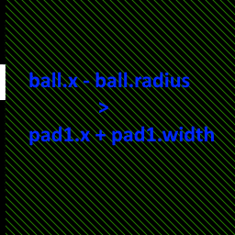
So to have collision, we know first condition: ((ball.x – ball.radius) <= (pad1.x + pad1.width))
Also, we want the ball to bounce even if it is only touching the paddle partially. This corresponds to ball 1 and 3 in the diagrams. In the case of ball 1, we need to check that the bottom of the ball is LOWER than the top of the paddle. In a similar fashion with ball 3, we need the top of the ball to be HIGHER than the bottom of the paddle.
- If the left side of the ball touches the right side of the paddle
- If the bottom of the ball is lower than the top of the paddle
- If the top of the ball is higher than the bottom of the paddle

We write that now:
// Test if the ball touch the left pad

if ((ball.x - ball.radius) <= (pad1.x + pad1.width)) {
// Test if the ball touch the pad
if (((ball.y + ball.radius) > pad1.y) && ((ball.y - ball.radius) < (pad1.y + pad1.height))) {
ball.x_speed = -ball.x_speed;
ball.x = pad1.x + pad1.width;
tone(500,50);
}
}

This is done, now it’s your turn to works: add a second paddle to the right side of the screen and control it with same keys, add collision check and bounds when ball touch padle2. Remove automatic bounds at the right side and at the left side and test that it’s works like you want else try to understand the problem and retry but if you don’t find, continue, the solution will be done later.
The game is near complete. To be able to play alone, we’ll make a little system to let computer stop some of the balls but we have to adjust it to let player been able to win against him.

Create an IA for right paddle

So we have 2 paddles but at the moment, first we control the both and so we’re playing against us: it’s funny but not for a long time… Now, we would play against the computer.
So how we can do it: first idea: move paddle2 to have his center in front of the ball: try it, it’s not very hard to code.
Done? OK, it’s works but you can’t win… it’s not really funny to play a game where you can’t win. You could keep this mode in the option and add a counter for the time. The goal could then be to keep alive as long as you can, but second paddle is not usefull in this case, you can replace it by a wall… it’s not really Pong.
So, we could move the paddle randomly… try it if you want but it’s a stupid IA and it’s will be too easy to win…
There are a lot of solutions: one could be to move slowly the paddle of the computer, then he’ll return some balls but will let pass some. You can code it if you want, it’s very quick as you already have the code, you have just to adjust values.
I have chosen to do a mix of both solution and use something to do it less predictable: I use function random(value) which return a value between 0 and the chosen value.
Atm we haven’t manage when the ball go out of the screen, it’s will be a next step so if we comment the bounds at left or right borders, we’ll stop the move of the ball on the x axis and the ball will keep her vertical speed, touch the paddle or one of the top or the bottom border, bound and touch paddle and then be return in other way.
It’s time to check our programs and give you one to test if you haven’t success to do the last exercises.

Code:

////////////////////////////////////////////////////////////
// Global variables

//////////////////////////////
// Create ball

struct ballStruct {
int x;
int y;
char radius;
int x_speed;
int y_speed;
};

ballStruct ball[1];

ball.radius = 2;

//////////////////////////////
// Create paddles

struct padStruct {
int x;
int y;
char width;
char height;
char moveSpeed;
};

padStruct pad1[1] = {0,53,4,20,3};
padStruct pad2[1] = {123,53,4,20,2};

//////////////////////////////
// Define Game limits

int leftBorder = ball.radius;
int rightBorder = 127 - ball.radius;
int topBorder = ball.radius;
int bottomBorder = 127 - ball.radius;

////////////////////////////////////////////////////////////

void init(){
ball.x = 64;
ball.y = 64;
ball.x_speed = 3;
ball.y_speed = -2;
}

//////////////////////////////

void step(){

char key;
key = getkey();

// Control Pad 1 with "UP" or "DOWN" buttons

if((key & KEY_DOWN) && (pad1.y < 128 - pad1.height)) {
pad1.y = pad1.y + pad1.moveSpeed;
}

if((key & KEY_UP) && (pad1.y > 0)) {
pad1.y = pad1.y - pad1.moveSpeed;
}

// Pad 2 auto move
int center_pad2 = pad2.y + 0.5*pad2.height;

if ((ball.x_speed > 0) && (center_pad2 > ball.y)) {
if (pad2.y > topBorder) pad2.y = pad2.y - random(pad2.moveSpeed);
};

if ((ball.x_speed > 0) && (center_pad2 < ball.y)) {
if((pad2.y + pad2.height) < bottomBorder) pad2.y = pad2.y + random(pad1.moveSpeed);
};

// Test if the ball touch the left pad

if ((ball.x - ball.radius) <= (pad1.x + pad1.width)) {
// Test if the ball touch the pad
if (((ball.y + ball.radius) > pad1.y) && ((ball.y - ball.radius) < (pad1.y + pad1.height))) {
ball.x_speed = -ball.x_speed;
ball.x = pad1.x + pad1.width;
tone(500,50);
}
}

// Test if the ball has reach right pad position
if ((ball.x + ball.radius) >= pad2.x) {
// Test if the ball touch the pad2
if (((ball.y + ball.radius) > pad2.y) && (ball.y < (pad2.y + pad2.height))) {
ball.x_speed = -ball.x_speed;
ball.x = pad2.x - ball.radius;
tone(500,50);
}
}

// Test ball collision with game limits

if (((ball.x_speed > 0) && (ball.x < rightBorder)) || ((ball.x_speed < 0) && (ball.x > leftBorder))) {
ball.x = ball.x + ball.x_speed;
} else {
//
// Section commented as we have add the second paddle but nothing done at this moment
// to manage when ball go out of the screen, it's will be next step...
// atm, the ball will move verticaly until it touch the paddle and will then be returned
//
// ball.x_speed = 0 - ball.x_speed;
// tone(300,100);
}

if (((ball.y_speed < 0) && (ball.y > topBorder)) || ((ball.y_speed > 0) && (ball.y < bottomBorder))) {
ball.y = ball.y + ball.y_speed;
} else {
ball.y_speed = 0 - ball.y_speed;
tone(300,100);
}
}

//////////////////////////////

void draw(){
clearscreen();

// draw ball
fillcircle(ball.x, ball.y, ball.radius);

// draw left paddle
fillrect(pad1.x, pad1.y, pad1.x + pad1.width, pad1.y + pad1.height);

// draw right paddle
fillrect(pad2.x, pad2.y, pad2.x + pad2.width, pad2.y + pad2.height);

delayredraw();
}

//////////////////////////////

void main(){
init();
while(1){
step();
draw();
}
}

/////////////////////////////

Done, it’s not a complex IA, but it’s an IA. As you can see sometimes you don’t try to make it be too good, you just need an IA and have to adjust his level to reach your goal.
You can exercise and prepare different difficulty level, but keep in mind that you have too be able to gain a point and that computer have to return some balls else the game will not be fun
OK, now we’ll have to add 2 things: A score and manage when ball go out of the screen.
The project advance, you’re near end but at the end we’ll add some bonus things for this game and your next ones.

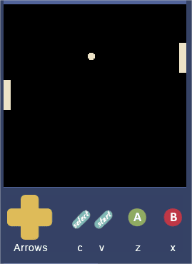

Manage the ball when it goes out of the screen

So what we want do when player or computer will miss the ball?
Soon we’ll add one point to the other player, so we must add 2 score variables to count points for each (one for player points, other for computer points)
When ball goes out, we’ll have to no more see it, we would play a little sound to let know that the event happens, wait a few seconds and then having a new ball launched to continue game.
Nothing in this list of things to do that you don’t know

First the scores: they will be 2 char variables. Why chars? because chars go from 0 to 127, we want a score going from 0 to 10… it’s enough to be in a char… I’ll call them scorePlayer1 and scorePlayer2
Next: manage when ball go out of the screen. When event happen, I have 2 possibility: ball go out of the screen at left, then computer will score or ball go out at right side, then it’s you who score (Player1).
With both cases, you will have to play a sound (same or not), hide ball, wait a few and launch a new ball.
We ‘ll use a function to be able to not type the code 2 times and make it easier to change if we want.
You can give the name you want for this function. I try to keep the names significant, so I have chosen to name it ballLost();
What will have to do ballLost? We have already say it: play a sound, wait a few and launch a new ball
To play a sound we have already use tone to play a note with a frequency and a duration, now we’ll use a new function playrtttl(). What it is? It’s an instruction to play a set of notes defined before.
First, we’ll have to define a string containing a rtttl format melody. I’ll give it to you as creating a rtttl sound or melody could be part of another tutorial. Next, we have to loads this array containing the string of the melody. When done, we can play it.
Example:
// song example
char song[] = "StarWars:d=4,o=5,b=45:32p,32f#,32f#,32f#,8b.,8f#.6,32e6,32d#6,32c#6,8b.6,16f#.6,32e6,32d#6,32c#6,8b.6,16f#.6,32e6,32d#6,32e6,8c#.6,32f#,32f#,32f#,8b.,8f#.6,32e6,32d#6,32c#6,8b.6,16f#.6,32e6,32d#6,32c#6,8b.6,16f#.6,32e6,32d#6,32e6,8c#6";

void main(){
loadrtttl(song, 1);
playrtttl();
}

For us, we ‘ll use this sound when ball go out the screen:
char snd_ballLost[] = "s:d=4,o=4,b=800:8c7,32b,32c#,32a#,32d,32a,32d#,32g#,32e,32g,32f,32f#";

OK, now of to wait a few ?
Many solution exist, me I use a little homemade function: delay().
This function is construct as you want, you can use cyles, time, asw.. For this tutorial it’s just a loop with an given argument
Code:
void delay(int t){
while(t > 0){
t = t - 1;
delayredraw();
}
}

As we use delayredrawin the loop we know how many times we will wait.
If we have 40 pictures / second, if we pass 10 as argument, we’ll wait 40/10 second, so 0.25 second . (It’s very quick), if we pass argument 80, we’ll wait 2 seconds.
OK, and now the last point to do is launching a new ball… How we want to do it?
We want first that the ball return at the center of the screen. It’s could be enough, if we let it like this, the ball will restart with her last speeds (horizontal and vertical) but I don’t want know the direction of the ball at start, so I have to launch it with a random speed… Another problem, random is positive, so if I only use random, balls will always go bottom right when launched, so I have to remove 50% of the max value. Then if the speed returned is less than 50% of the value of the random, it’s will be negative and go left or top. Another problem: random is fine but we could have very slow speed or worst: null speed. Then the game could be blocked as ball will no more advance…
So, we have to check it before launching ball and if speed is too low to add a boost…
So, try it now… and have you seen some bugs in the last codes? I hope you seen them and maybe you have already corrected them else, try to do it now. I’ll not explain how to debug here as the tuto show already a lot of things…
When ready, have a look on the code below and check for changes and try to understand why they have been done.

Code:

////////////////////////////////////////////////////////////
// Global variables

//////////////////////////////
// Create ball

struct ballStruct {
int x;
int y;
char radius;
int x_speed;
int y_speed;
};

ballStruct ball[1];

ball.radius = 2;

//////////////////////////////
// Create paddles

struct padStruct {
int x;
int y;
char width;
char height;
char moveSpeed;
};

padStruct pad1[1] = { 0, 53, 4, 20, 3};
padStruct pad2[1] = {123, 53, 4, 20, 6};

//////////////////////////////
// Define Game limits

int leftBorder = 0;
int rightBorder = 127;
int topBorder = 0;
int bottomBorder = 127;

//////////////////////////////
// Define other game variables

int scorePlayer1 = 0;
int scorePlayer2 = 0;

////////////////////////////////////////////////////////////
// Melodies
char snd_ballLost[] = "s:d=4,o=4,b=800:8c7,32b,32c#,32a#,32d,32a,32d#,32g#,32e,32g,32f,32f#";

////////////////////////////////////////////////////////////

//////////////////////////////

void delay(int t){
while(t > 0){
t = t - 1;
delayredraw();
}
}

//////////////////////////////

void CenterBall() {
ball.x = 63;
ball.y = 63;
ball.x_speed = random(4) - random(4);
ball.y_speed = random(4) - random(4);
while ((ball.x_speed > -2) && (ball.x_speed < 2)) ball.x_speed = random(4) - random(4);
while ((ball.y_speed > -2) && (ball.y_speed < 2)) ball.y_speed = random(4) - random(4);
pad1.y = (127 - pad1.height) / 2;
pad2.y = (127 - pad2.height) / 2;
}

//////////////////////////////

void ballLost() {
loadrtttl(snd_ballLost, 0);
playrtttl();
delay(10);
CenterBall();
}

//////////////////////////////

void init(){
scorePlayer1 = 0;
scorePlayer2 = 0;
CenterBall();
}

//////////////////////////////

void step(){

char key;
key = getkey();

ball.x = ball.x + ball.x_speed;
ball.y = ball.y + ball.y_speed;

// Control Pad 1 with "UP" or "DOWN" buttons

if((key & KEY_DOWN) && (pad1.y <= bottomBorder - pad1.height)) {
pad1.y = pad1.y + pad1.moveSpeed;
}
if (pad1.y > (bottomBorder - pad1.height)) pad1.y = bottomBorder - pad1.height;

if((key & KEY_UP) && (pad1.y >= topBorder)) {
pad1.y = pad1.y - pad1.moveSpeed;
}
if (pad1.y < topBorder) pad1.y = topBorder;

// Pad 2 auto move
int center_pad2 = pad2.y + 0.5*pad2.height;

if ((ball.x_speed > 0) && (center_pad2 > ball.y)) {
if (pad2.y >= topBorder) pad2.y = pad2.y - random(pad2.moveSpeed);
};
if (pad2.y < topBorder) pad2.y = topBorder;

if ((ball.x_speed > 0) && (center_pad2 < ball.y)) {
if((pad2.y + pad2.height) <= bottomBorder) pad2.y = pad2.y + random(pad1.moveSpeed);
};
if (pad2.y > (bottomBorder - pad2.height)) pad2.y = bottomBorder - pad2.height;

// Test if the ball touch the left pad

if ((ball.x - ball.radius) <= (pad1.x + pad1.width)) {
// Test if the ball touch the pad
if (((ball.y + ball.radius) > pad1.y) && ((ball.y - ball.radius) < (pad1.y + pad1.height))) {
ball.x_speed = -ball.x_speed;
ball.x = pad1.x + pad1.width + ball.radius;
tone(500,50);
}
}

// Test if the ball has reach right pad position
if ((ball.x + ball.radius) >= pad2.x) {
// Test if the ball touch the pad2
if (((ball.y + ball.radius) > pad2.y) && (ball.y < (pad2.y + pad2.height))) {
ball.x_speed = -ball.x_speed;
ball.x = pad2.x - ball.radius;
tone(500,50);
}
}

// Test ball collision with game limits

// Test if the ball exit by the left border
if (ball.x - ball.radius < (leftBorder - 5)) {
// Player 2 win one point
scorePlayer2 = scorePlayer2 + 1;
ballLost();
}
// Test if the ball exit by the right border
if ((ball.x + ball.radius) > (rightBorder + 5)) {
// Player 1 win one point
scorePlayer1 = scorePlayer1 + 1;
ballLost();
}

if (((ball.y_speed < 0) && (ball.y > (topBorder + ball.radius))) || ((ball.y_speed > 0) && (ball.y < (bottomBorder - ball.radius)))) {
// we managed it before, so this section is now empty
} else {
ball.y_speed = 0 - ball.y_speed;
tone(300,100);
}
}

//////////////////////////////

void draw(){
clearscreen();

// draw ball
fillcircle(ball.x, ball.y, ball.radius);

// draw left paddle
fillrect(pad1.x, pad1.y, pad1.x + pad1.width, pad1.y + pad1.height);

// draw right paddle
fillrect(pad2.x, pad2.y, pad2.x + pad2.width, pad2.y + pad2.height);

delayredraw();
}

//////////////////////////////

void main(){
init();
while(1){
step();
draw();
}
}

//////////////////////////////

OK, now all important things are in place:
- Create the ball and a paddle
- Draw the ball and the paddle
- Update the paddle's position
- Update the ball's position
- Check for collisions between the ball and walls
- Check for collisions between the ball and the paddle
- Check to see if the game is not over
- Add a second paddle
- Count and display the scores
We have to show the score and draw some lines to simulate the play area, add the management of the end of the game, ask if we want to play again.
Another thing we’ll have to do to complete is to add game information in esplge.

Manage the game arena

First we’ll adjust the borders.
The top limit will be 30. It’s will let us some space to write scores
Bottom limit will be set to 110. We could use the space below but I have no use atm (I’ll let your imagination find some ideas to use it

So we used the limits of the screen before so user could see them. Now we have to draw them with a line to let him see new limit.
For that we can use instruction: line(int x, int y, int x1, int y1);

The instruction draw a line between point 1 (x, y) and point 2 (x1, y1)
We’ll draw a vertical line in the center of the game arena too.

Show the score

We could use many methods to do it, but today we’ll use the easiest: we’ll place where we want print the score with a gotoxy(Column, Line) with maximum for Column = 20 and maximum Line = 15.
Then we will use a print formatted instruction (printf) you can write a chain and place %d in it. After the chain, you enter the variable which will replace the %d in the string. For example, for our game we will use printf("%d : %d ", scorePlayer1, scorePlayer2); It’s will print scorePlayer1 : scorePlayer2

Try to add these 2 functionalities. Your game has now only one line not done on our list: the tests to know if game is ended. So, what you wait, add the 2 functionalities, we are waiting for you before continue.

Manage end of game

If you mark 10 points, you win. If computer gain 10 points, he wins.
If game is ended, we write a little message to announce it, we play a little music (I chosen one for victory and one when you lose), we wait a few to mark the end of the game and the game restart.
The are many way to manage it, we could use game status to manage different state of the game a status when you’re on titlescreen, one when you play, another when you pause the game, another at game end but the tutorial is already long enough, we’ll keep some things for next ones
This one is near complete; we’ll just complete it with the add of the properties and the final listing of the code.

Complete properties

It’s easy again…
First click on Settings
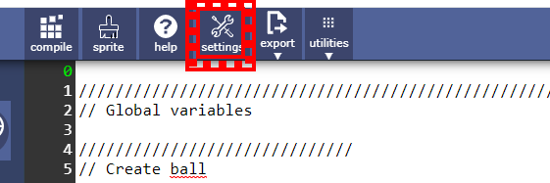
Fill like indicated here
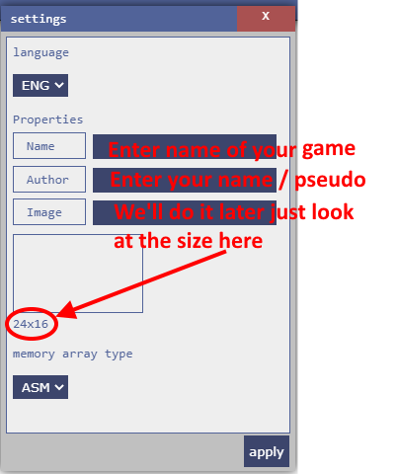
Click on apply
Click on Sprite tools and enter dimensions you shown in properties: 24 and 16
Draw your game picture like you feel it
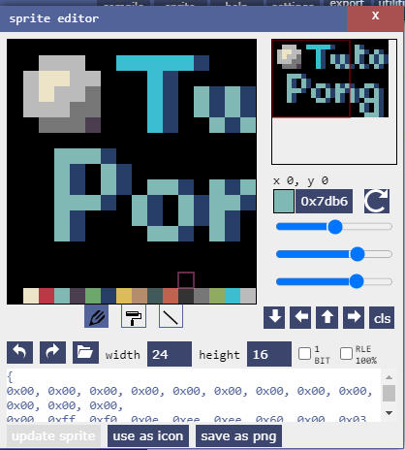
When it’s done, click on Use as icon
Close this tool and now if you look in properties, you have your picture in properties!!
Well done you have completed this tutorial. I have short it a few as it’s made already a lot of things. I hope that you have learn or understand most of the subject in it.
It’s just the beginning, next time we’ll see more elaborated technics.

Resulting code of this tutorial

/*settings*{"name":"Pong for tutorial","author":"Jicehel","image":[0,0,0,0,0,0,0,0,0,0,0,0,0,255,240,14,238,238,96,0,3,96,0,0,15,17,255,0,14,96,0,0,3,54,3,96,15,31,252,0,14,96,54,54,3,96,54,54,15,255,204,0,14,96,54,54,3,96,54,54,0,204,196,0,14,96,3,99,96,54,3,96,0,0,0,0,0,0,0,0,0,0,0,0,0,3,51,96,0,0,0,0,0,0,0,0,0,3,96,54,0,0,0,0,0,0,0,0,0,3,96,54,3,54,3,99,96,3,54,0,0,3,51,96,54,3,99,54,54,54,3,96,0,3,96,0,54,3,99,96,54,54,3,96,0,3,96,0,3,54,3,96,54,3,51,96,0,0,0,0,0,0,0,0,0,54,3,96,0,0,0,0,0,0,0,0,0,54,3,96,0,0,0,0,0,0,0,0,0,3,51,96]}*/

////////////////////////////////////////////////////////////
// Global variables

//////////////////////////////
// Create ball

struct ballStruct {
int x;
int y;
char radius;
int x_speed;
int y_speed;
};

ballStruct ball[1];

ball.radius = 2;

//////////////////////////////
// Create paddles

struct padStruct {
int x;
int y;
char width;
char height;
char moveSpeed;
};

padStruct pad1[1] = { 0, 53, 4, 20, 3};
padStruct pad2[1] = {123, 53, 4, 20, 5};

//////////////////////////////
// Define Game limits

int leftBorder = 0;
int rightBorder = 127;
int topBorder = 30;
int bottomBorder = 110;

//////////////////////////////
// Define other game variables

int scorePlayer1 = 0;
int scorePlayer2 = 0;

////////////////////////////////////////////////////////////
// Melodies
char snd_ballLost[] = "s:d=4,o=4,b=800:8c7,32b,32c#,32a#,32d,32a,32d#,32g#,32e,32g,32f,32f#";
char snd_lost[] = "s:d=4,o=5,b=400:b,4c#,a#,4c#,g#,4c#,f#,4c#,e,4c#,d#,4c#,d,c#,d,c#";
char snd_win[] = "s:d=4,o=5,b=125:8g4,32c,32p,8d,32f,32p,8e,32c,32p,8d,32a,32p,8g,32c,32p,8d,32f,32p,8e,32c,32p,8g,32b,32p,8c6,32a#,32p,8g#,32g,32p,8f,32d#,32p,8d,32a#4,32p,8a#,32c6,32p,8a#,32g,32p,16a,16f,16d,16g,16e,16d,16a,16f,16d,16g,16e,16d,8a4,8f4,8d4,4d4";

////////////////////////////////////////////////////////////

//////////////////////////////

void delay(int t){
while(t > 0){
t = t - 1;
delayredraw();
}
}

//////////////////////////////

void CenterBall() {
ball.x = 63;
ball.y = 63;
ball.x_speed = random(4) - random(4);
ball.y_speed = random(4) - random(4);
while ((ball.x_speed > -2) && (ball.x_speed < 2)) ball.x_speed = random(4) - random(4);
while ((ball.y_speed > -2) && (ball.y_speed < 2)) ball.y_speed = random(4) - random(4);
pad1.y = (127 - pad1.height) / 2;
pad2.y = (127 - pad2.height) / 2;
}

//////////////////////////////

void ballLost() {
loadrtttl(snd_ballLost, 0);
playrtttl();
delay(20);
CenterBall();
}

//////////////////////////////

void traceMsgBox(){
setcolor(0);
fillrect(30, 40, 98, 88);
setcolor(3);
rect(30, 40, 98, 88);
}

//////////////////////////////

void init(){
scorePlayer1 = 0;
scorePlayer2 = 0;
setcolor(1);
CenterBall();
}

//////////////////////////////

void player1Win() {
traceMsgBox();
drawstring("You win !!", 36, 62);
loadrtttl(snd_win, 0);
playrtttl();
delay(120);
init();
}

//////////////////////////////

void player2Win() {
traceMsgBox();
drawstring("You lost !!", 36, 62);
loadrtttl(snd_lost, 0);
playrtttl();
delay(120);
init();
}

//////////////////////////////

void step(){

char key;
key = getkey();

ball.x = ball.x + ball.x_speed;
ball.y = ball.y + ball.y_speed;

// Control Pad 1 with "UP" or "DOWN" buttons

if((key & KEY_DOWN) && (pad1.y <= bottomBorder - pad1.height)) {
pad1.y = pad1.y + pad1.moveSpeed;
}
if (pad1.y > (bottomBorder - pad1.height)) pad1.y = bottomBorder - pad1.height;

if((key & KEY_UP) && (pad1.y >= topBorder)) {
pad1.y = pad1.y - pad1.moveSpeed;
}
if (pad1.y < topBorder) pad1.y = topBorder;

// Pad 2 auto move
int center_pad2 = pad2.y + 0.5*pad2.height;

if ((ball.x_speed > 0) && (center_pad2 > ball.y)) {
if (pad2.y >= topBorder) pad2.y = pad2.y - random(pad2.moveSpeed);
};
if (pad2.y < topBorder) pad2.y = topBorder;

if ((ball.x_speed > 0) && (center_pad2 < ball.y)) {
if((pad2.y + pad2.height) <= bottomBorder) pad2.y = pad2.y + random(pad1.moveSpeed);
};
if (pad2.y > (bottomBorder - pad2.height)) pad2.y = bottomBorder - pad2.height;

// Test if the ball touch the left pad

if ((ball.x - ball.radius) <= (pad1.x + pad1.width)) {
// Test if the ball touch the pad
if (((ball.y + ball.radius) > pad1.y) && ((ball.y - ball.radius) < (pad1.y + pad1.height))) {
ball.x_speed = -ball.x_speed;
ball.x = pad1.x + pad1.width + ball.radius;
tone(500,50);
}
}

// Test if the ball has reach right pad position
if ((ball.x + ball.radius) >= pad2.x) {
// Test if the ball touch the pad2
if (((ball.y + ball.radius) > pad2.y) && (ball.y < (pad2.y + pad2.height))) {
ball.x_speed = -ball.x_speed;
ball.x = pad2.x - ball.radius;
tone(500,50);
}
}

// Test ball collision with game limits

// Test if the ball exit by the left border
if (ball.x - ball.radius < (leftBorder - 5)) {
// Player 2 win one point
scorePlayer2 = scorePlayer2 + 1;
ballLost();
}
// Test if the ball exit by the right border
if ((ball.x + ball.radius) > (rightBorder + 5)) {
// Player 1 win one point
scorePlayer1 = scorePlayer1 + 1;
ballLost();
}

if (((ball.y_speed < 0) && (ball.y > (topBorder + ball.radius))) || ((ball.y_speed > 0) && (ball.y < (bottomBorder - ball.radius)))) {
// we managed it before, so this section is now empty
} else {
ball.y_speed = 0 - ball.y_speed;
tone(300,100);
}
}

//////////////////////////////

void draw(){
clearscreen();

// draw ground
line(leftBorder,bottomBorder,rightBorder,bottomBorder);
line(leftBorder,topBorder,rightBorder,topBorder);
line((rightBorder - leftBorder)/2,topBorder,(rightBorder - leftBorder)/2,bottomBorder);

// draw ball
fillcircle(ball.x, ball.y, ball.radius);

// draw left paddle
fillrect(pad1.x, pad1.y, pad1.x + pad1.width, pad1.y + pad1.height);

// draw right paddle
fillrect(pad2.x, pad2.y, pad2.x + pad2.width, pad2.y + pad2.height);

// Draw score
gotoxy(9,1);
printf("%d : %d ", scorePlayer1, scorePlayer2);

// Check if someone has won
if (scorePlayer1 >= 10) player1Win();
if (scorePlayer2 >= 10) player2Win();

delayredraw();
}

//////////////////////////////

void main(){
init();
while(1){
step();
draw();
}
}

//////////////////////////////

