Game tutorial "Pong"

Begin with some program structure

Let's start with the basics. LGE uses a subset of C, which means that any program must have an entry point main(). The entry point is the place from which the program starts to run.
Here is the basic anatomy of an espLGE game:
.

// global variables
void init(){
// the code at this location will be executed only once when the game starts.
}

void step(){
// code in this place will execute each frame
}

void draw(){
// this is where all objects are drawn
delayredraw(); // waiting for frame drawing
}

void main(){ // required function for any program, execution starts with it
init();
while(1){ // infinite loop
step();
draw();
}
}

The code is divided into 4 parts:
- The init function is called once, when the game starts. It’s will setup all needed to be able to launch the game.
Sometimes it’s can be splited in two parts: init and newLevel because newLevel will have to setup some things each time you pass to a new level.

- The step function will be executing each frame you draw. It’s will calculate all the change to do between 2 displayed pictures.

- The draw function is in charge to display all on the screen after that they have been calculated. Doing this avoid having blinking elements for example.

- We already shown the last: main wich s the entry point of your program. The program start here and for a game we place the call of the init function and an infinite loop to let the program running with the 2 other functions: step and draw. So they will be executed until you quit game.

This organization isn’t mandatory but it’s works fine for a game. So additional step can be added but it’s the easiest classic structure for a game.

You can execute this code. It’s only a structure so nothing happens and it’s fine…

Drawing a square on the screen where we want

Our game will be displayed on the screen, the size of 128x128 pixels. The esp8266 microcontroller can work with different LCD screens, and on large screens the image will be scaled. These screens can display up to 65 thousand colors, but the microcontroller has a small memory capacity. Because of this, it was necessary to limit the ability of the game engine to use 16 colors for background and 15 colors for sprites at the same time (+ 1 color for transparent areas). When drawing sprites and images, the position in which the upper left corner will be located.

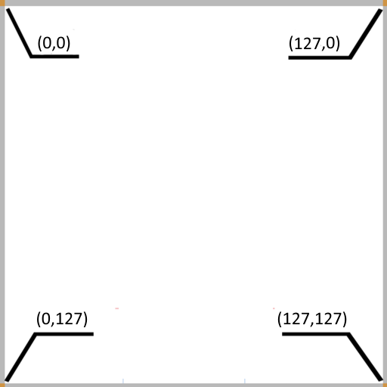
Coordinates on the espLGE screen, just like all other screens, have their origin in the upper left corner, the Y values get bigger when you move downwards, and the X values grow when moving to the right.

All that we want at this point is to draw a square from the middle height of the screen at the left. So half height is 63 (the first line is 0…) and the horizontal left value will be 0
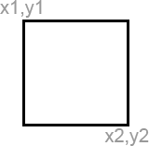
To draw a square, we use the function:

void fillrect(int x1, int y1, int x2, int y2);

fillrect will draw a filled rectangle on the screen between the coordinates
[x1, y1] and [x2, y2].

So try it now. Use the last maked structure and add the instruction in it to draw a square with x1 = 0, y1 = 63, x2 = 2, y2 = 65
The solution is given below but try to do it by yourself.

Solution:

int x1 = 0;
int y1 = 63;
int x2 = 2;
int y2 = 65;

void init(){
// the code at this location will be executed only once when the game starts.
}

void step(){
// code in this place will execute each frame
}

void draw(){
// this is where all objects are drawn
fillrect(x1, y1, x2, y2);
delayredraw(); // waiting for frame drawing
}

void main(){ // required function for any program, execution starts with it
init();
while(1){ // infinite loop
step();
draw();
}
}

This is one solution, many solutions exist, on another fine solution could be to organize code like this:

// Global variables
int x1;
int y1;
int x2;
int y2;

void init(){
x1 = 0;
y1 = 63;
x2 = 2;
y2 = 65;

void draw(){
fillrect(x1, y1, x2, y2);
delayredraw();
}

void main(){
init();
while(1){
draw();
}
}

The function step has been removed as it was not used and the initial values of the variables have been set in init function.

It’s some recipes and of course, you can adapt them and use them as you want and as you find it the more logical.

