
SARA DA SILVA

Bartender/Waitress
FERREIRA

DIPLOMAS AND STUDIES

Holder of a Catering Diploma as Waitress. Holder of the Mention Barman(Like European Bartender School during one year in France) Winner of the "Inventons Lait" bar contest.

Departmental and Regional Gold Medalist at the "Un Des Meilleurs Apprentis de France" competition Barman Section.

CONTACT

telephone: 06.95.23.51.07

Email: SaraCRDaSilvaFerreira@outlook.fr

EXPERIENCES

PROFESSIONAL

INTERNSHIPS

March 2018 to May 13, 2018: Internship as a bartender at the "Mustang Bar" in Montpellier, France. October 2017 to Decembre 31, 2017: Internship as a Bartender at the Bar "Le Parfum" in Montpellier, France.
October 2016 to December 2016: Service internship at the "Solent Hotel & Spa" in Fareham, England.
March 2016 to April 2016: Service internship at the hotel restaurant "Hotel des Thermes Best Western" in Balaruc les Bains, France.
October 2015: Internship in community in a Cafétaria at School Saint Marie in Riom, France.
May 2015 to July 2015: Service internship at the hotel restaurant "Le Grand Hotel de l'Europe" in Saint Flour, France.
June 2015: Internship in service at the restaurant "l'Antre 2" in Riom, France.

Address: 36 Avenue Henri Marès, 34090 Montpellier, France.

LANGUAGES

Languages: English (moderate), Spanish (moderate), Portuguese (beginner).
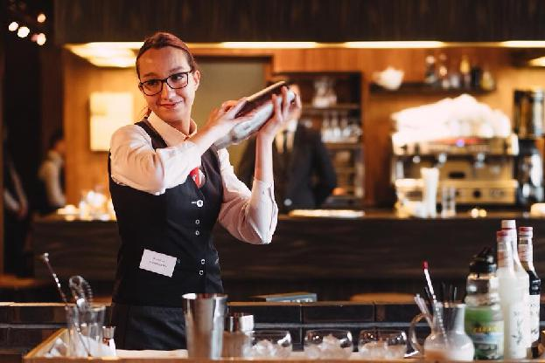

SEASONS AND EXTRAS

July 2020 to October 2020:
Bartender at "Le Kraken Bar" in Montpellier, France. From February 2020 to July 2020: Waitress/saleswoman (to take away during the lockdown), at the Rei Galo Portuguese restaurant, Clermont Ferrand, France. February 2019 to September 2019:
Bartender/Waitress at the "Mustang Bar" in
Montpellier, France.

July 2018 to September 2018: Season as a Bartender at the "Mustang Bar" in Montpellier, France. May 2018 to July 2018: Extra Permanent at the "Mustang Bar" in Montpellier, France.
July 2017 to September 2017: Seasonal Work in company "Astic Cleaning". July 2016 to August 2016: Season as room manager and waitress at the hotel "Hôtel des Messageries et restaurant Le Nautilus" in Saint Flour, France.
June 2016: Extra caterer Wedding as waitress at the hotel restaurant "Hôtel Des Messageries et restaurant le Nautilus" in Saint Flour, France.
2015-2016: Extra permanent as Waitress at the hotel restaurant "Hôtel des Messageries et restaurant Le Nautilus" in Saint Flour, France.
July 2015 to September 2015: Season as a waitress at the hotel restaurant "Le Grand Hotel de l'Europe" in Saint Flour, France.

