
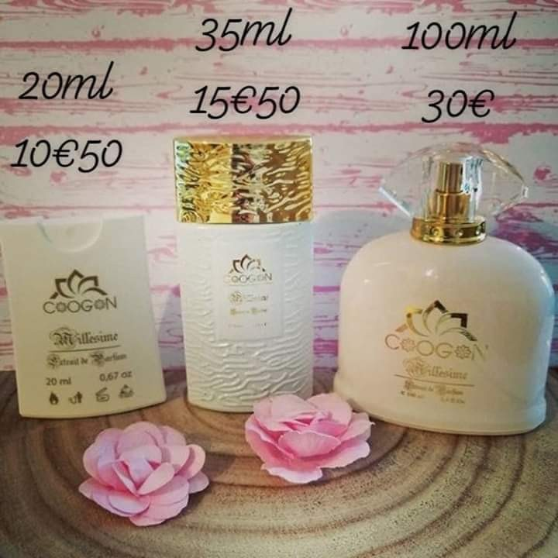

Parfums femmes:
OPIUM – YVES SAINT LAURENT  J’ADORE – DIOR  IRIS NOBILE SUBLIME– ACQUA DI PARMA  ALIEN – THIERRY MUGLER  LIGHT BLUE – D & G  GUILTY – GUCCI  MANIFESTO – YVES SAINT LAURENT  LADY MILLION – PACO RABANNE  HYPNOTIC POISSON – DIOR  CHANEL N°5 – CHANEL  FOR HER – NARCISO RODRIGUEZ  FLOWER – KENZO  TRESOR – LANCOME  ANGEL – THIERRY MUGLER  L’EAU D’ISSEY – ISSEY MIYAKE  MY NAME – TRUSSARDI  MANDORLO DI SICILIA–ACQUA DI PARMA  IDYLE – GUERLAIN  CHERIE MISS DIOR – DIOR  HYPNOSE – LANCÔME  MEMOIRE – AMOUAGE (17€ - 27€ - 52 €) | CHLOE – CHLOE  LA VIE EST BELLE – LANCÔME  LOVE – CHLOE  CRYSTAL NOIR VERSACE  DOLCE – D&G  COCO MADEMOISELLE – CHANNEL  NARCISO – NARCISO RODRIGUEZ  BLACK OPIUM - YVES SAINT LAURENT  ANGE OU DEMON - GIVENCHY  OMNIA AMETHYSTE -BULGARI  THE ONE – D&G  ALLURE - CHANNEL  ACQUA DI GIA – GIORGIO ARMANI  FLORA - GUCCI  SI – GIORGIO ARMANI  CLASSIQUE ESSENCE – J.P GAUTHIER  SIGNORINA – FERRAGAMO  CHANCE – CHANNEL  MON PARIS – YVES SAINT LAURENT  POISON GIRL – DIOR  AVENTUS FOR HER–CREED(17€-27€-52€)  LYRIC – AMOUAGE (14€50 - 23€ - 43€)  LOVE IN WHITE – CREED (17€ - 27€ -52€)

