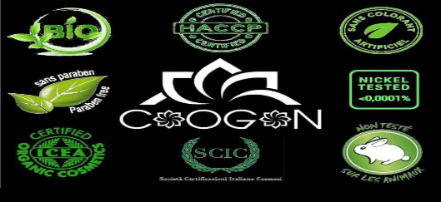

Luxury millesime :
50ML – 52€
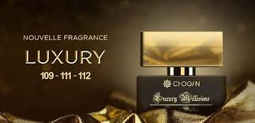
BLACK AFGANO – NASOMATTO
X MEN – CLIVE CHRISTIAN
VELVET AMBER SKIN – D&G
VELVET AMBER SUN - D&G
FUCKING FABULOUS – TOM FORD
J’ADORE L’OR – DIOR
LOST CHERRY TOM FORD
NEROLI PORTOFINO – TOM FORD

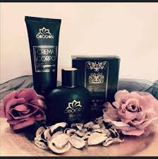

Collection unisexe:
20ML 10€50 – 35ML 15€50 – 100ML 30€
SILVER MOUNTAIN – CREED (14€50 – 23€ - 43€)
BLACK ORCHID – TOM FORD
PATCHOULI – REMINISCENCE
HYMALAYA – CREED (14€50 – 23€- 43€)
MANDARINO DI AMALFI – TOM FORD
WHITE AOUD - MONTALE

