بحث حول الصّلاة

تعريف الصلاة:
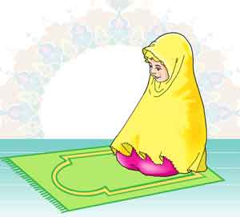
.................................................................................................................................................................................................................................................................................................................................................................................................................................................................................................................................................................................................................................................
شروط الصلاة :

................................................................................................................................................................................................................................................................................................................................................................................................................................................................................................................................................................................................................................................................................................................................................................................................................
.................................................................................................................................................................................
أنواع الصلاة :

...................................................................................................................................................................................................................................................................................................................................................................................................................................................................................................................................................................................................................................................................................................................................................................................
التيسير في الصلاة :
............................................................................................................................................................................................................................................................................................................................................................................................................................................................................................................................................................................................................................................................................................................................................................................................................................................................................................................................................................................................................ 

