
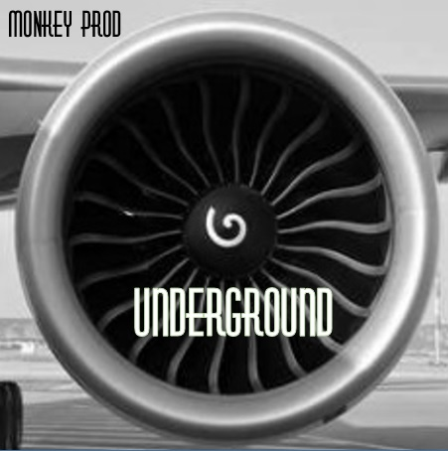

1-DNB 2-TOXIC 3-DANCE TU LE TWIST 4-FUCK OFF 5-KOKAINE 6-LOUANGE
7-NEXT STEP 8-OPPOSSUM SUM 9-PRESSION 10-STAB 11- GOOD STUFF CRACKERS 12-UNDERGROUND

MONKEY pROD

MONKEY pROD

U-n-D-e-R-GROUND

U-n-D-e-R-GROUND

