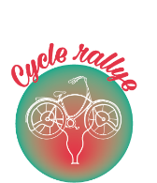Cycle Rallye - Registration form Organized by x-pose Nepal
On the occasion of International Menstrual Hygiene Day
Cycle manage Lalitpur Cycle Group
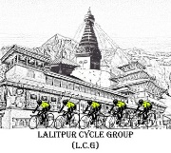
Personal informations :
Full Name : .....................................................................................................................
Address : ........................................................................................................................
Date of Birth : .................................................................................................................
Gender : .........................................................................................................................
Email Address : .............................................................................................................
Contact Details : ............................................................................................................
X-pose Nepal is a nonprofit organization working against sexual violence and menstrual hygiene to the young girls and women in our communities since 2005 A.D.
Every year May 28 is marked as the international Menstrual hygiene day all around the world since 2014. From childhood, a girl is told to remain silence about the difficulties that she faces during her period. With the motive to break the silence of a people regarding menstruation, X-pose Nepal is going to organize a Cycle Rallye programs on the 25th of May 2019 to mark menstrual Hygiene day. Furthermore, this day is also celebrated to make a people understand about the false customs they are practicing during their menstruation and to make them change their behavior and attitude towards the importance of healthy habits during those days.
XPose Nepal does not take any responsibility for any type of accident.
Signature :
Program Details :
Start Kathmandou Durbar Square ; End Patan Durbar Square
Date : 25th of May
Time : 7Am to 9PM
Contact : XPose Nepal : 9410804407, Xposenepal@gmail.com ; Lalitpur Cycle Group : 9823123825 ; 9851095724
Note Free T-Shirt and Free Lunch are Provided.
Rs 100 registration. Free for girls, women and child.
Please crop this coupon and bring it with you on the Cycle Rallye day.

…………………………....................…………………………………………………………………………………………………………………………………………………………………
Full name / address :
COUPON FOR LUNCH BOX
COUPON FOR T-SHIRT

