Recuring Bugs

Hello dauntless devellopers, i’m lexarts moderator on a french speaking community.

I send you this document to help identify the bugs that my community and i encounter

Bug n°1: bug with the repeater that happens when you draw it from holster
https://www.youtube.com/watch?v=rzoXlpTm3h8
Bug n°2: graphic bugs that happens randomly on weapons and transmogs 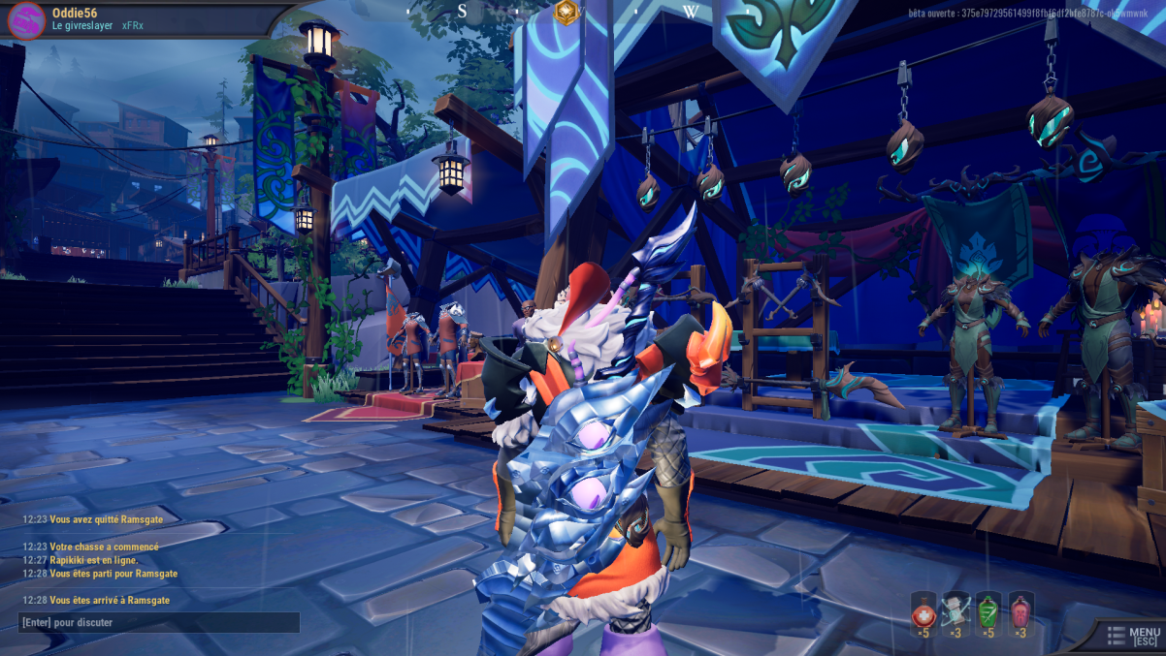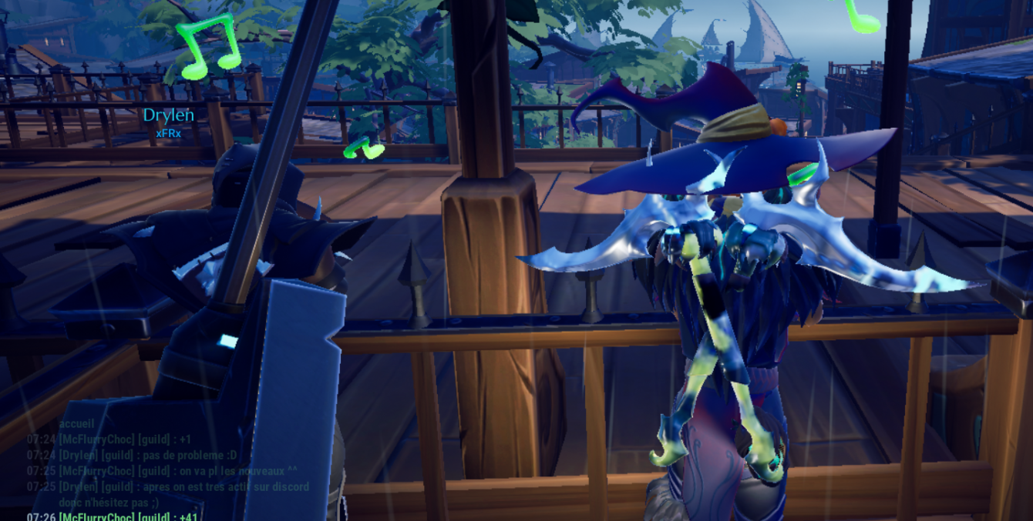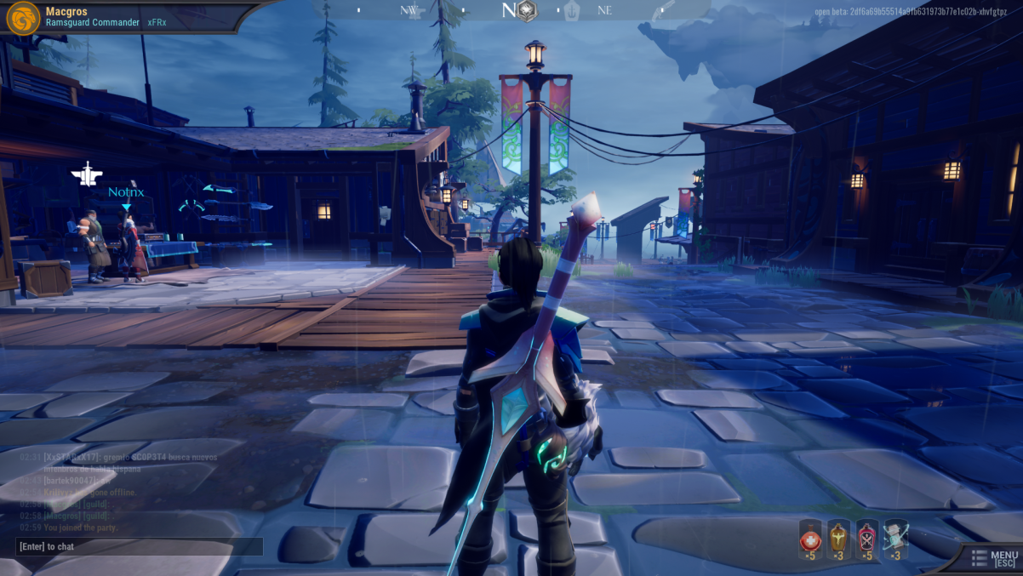
Bug n°3: graphic bugs happens at the start of a hunt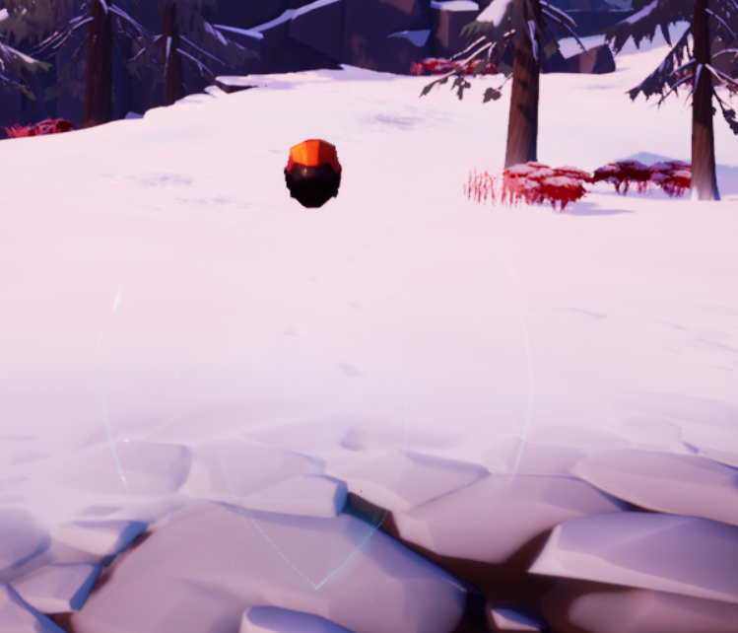
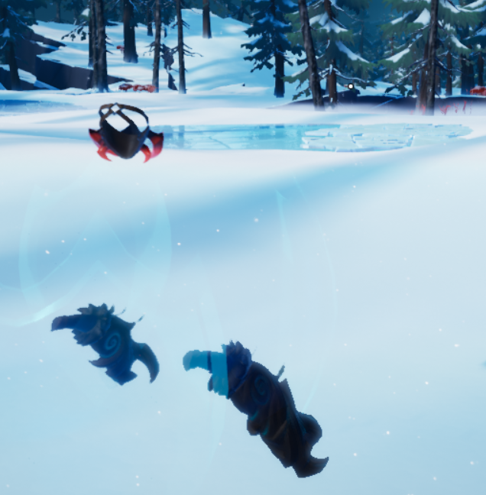
Bug n°4: drask’s bug when he flip on himself .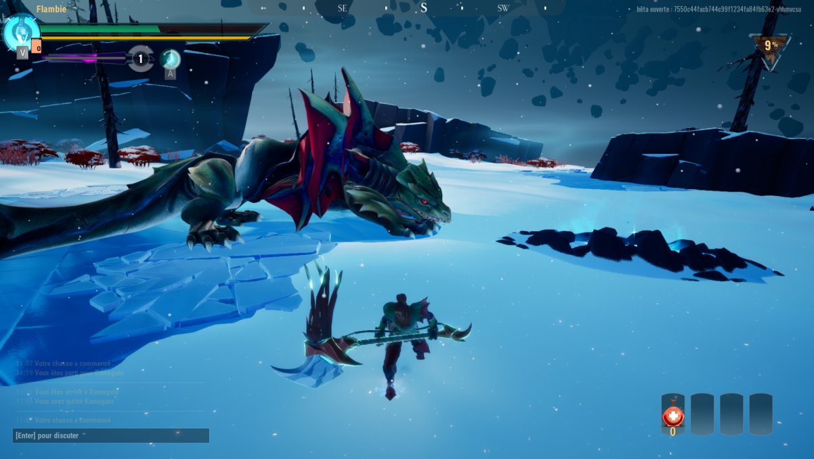

Bug n°5: animation bug on the flag growth from the hunter pass that always goes oblic.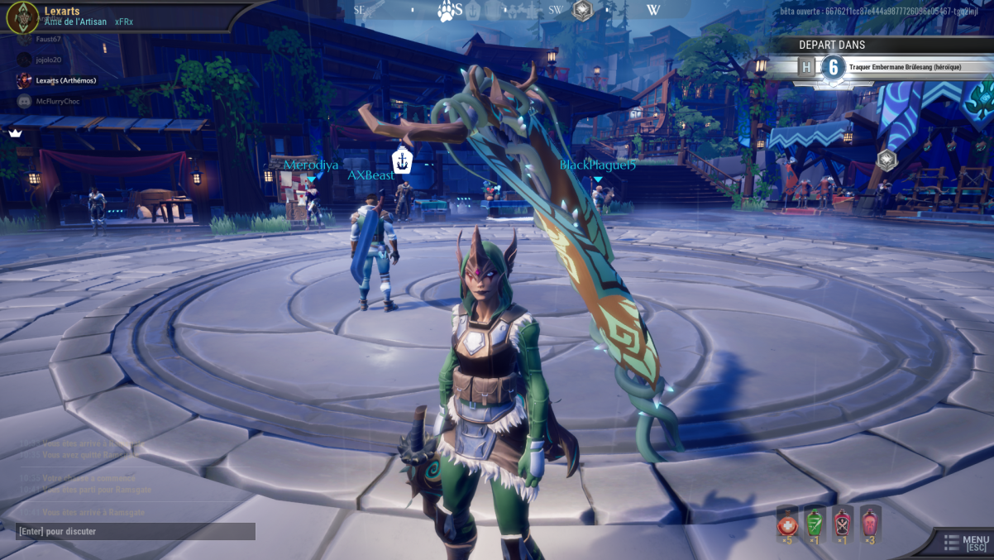

Bug n°6: Bug with the names that appears multiple time in groups.
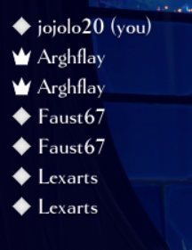
Bug n°7: chat bug (you can’t write in general or guild) .
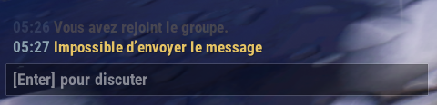

Bug n°8: Shrike Bug where he is stuck in a corner or freezed
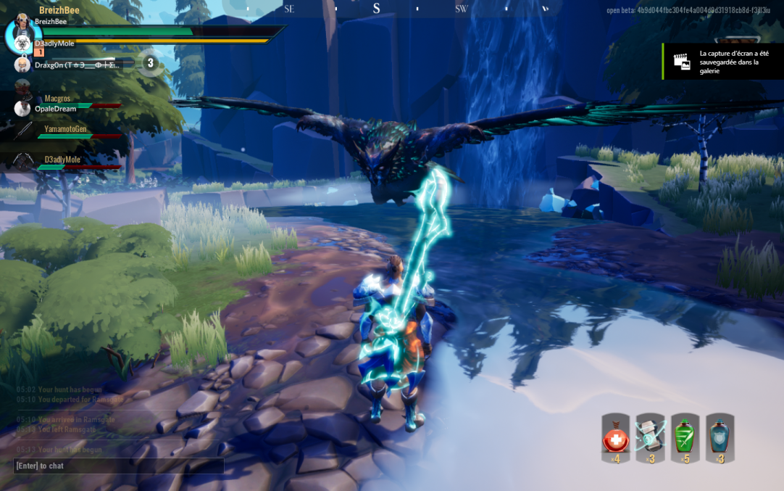
Bug n°9: Bug when you are in the Koshai’s bramble and hit you.
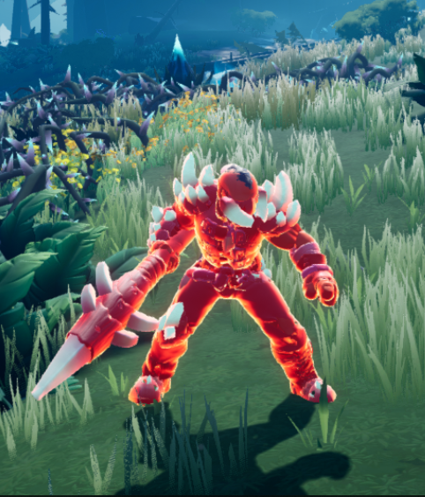
Bug n°10: camera Bug with the hammer that zoom in after a slam sometimes.
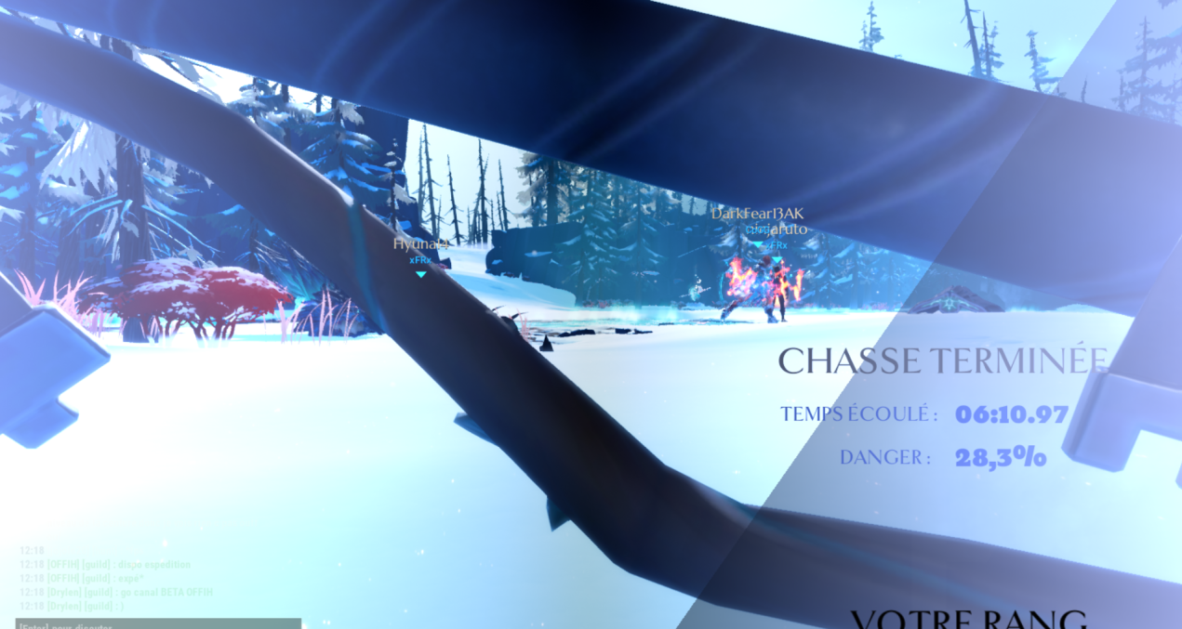
Bug n°11: nayzaga electric pikes that get stucks in tree (less often than before).
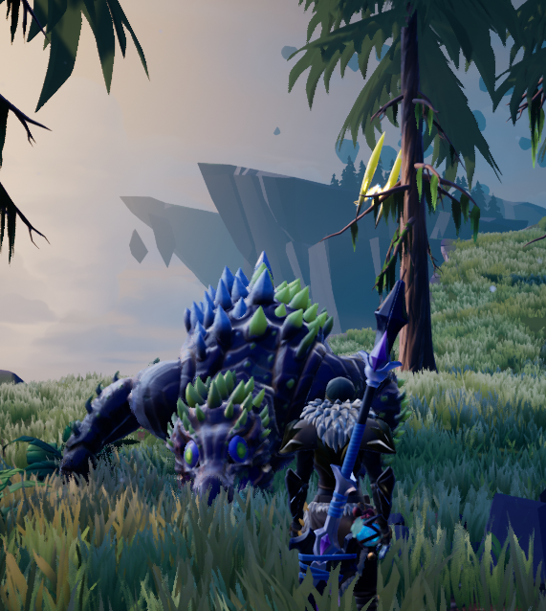
Bug n°12: boreus minions that get stuck in structure or despawn.
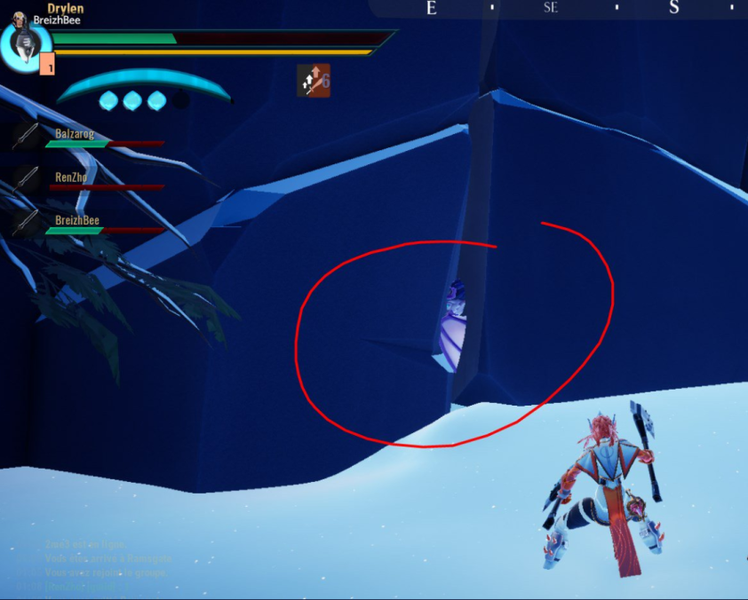
Bug n°13: tragic echo that doesn’t work: clone doesn’t spawn or must use the syringe to be able to move and then must be revive a second time.
(screen/enregistrement en attente)
Bug n°14: prismatic … doesn’t work, no shield, no revive.
(screen/enregistrement en attente)
Bug n°15: Boreus if a minion get the first hit on his icearmor, a graphic bug occur where visualy he has the armor but you can make normal damages on him. (screen/enregistrement en attente)
Bug n°16: Molten Edict doesn’t have a slam, no new gameplay.
https://www.youtube.com/watch?time_continue=12&v=CF5qhZi08HA
Bug n°17: Bug Stormclaw, he spams his electric spikes, if too many they become invisible but are still there.
https://youtu.be/n_WNVeB3gZg
Bug n°18:

