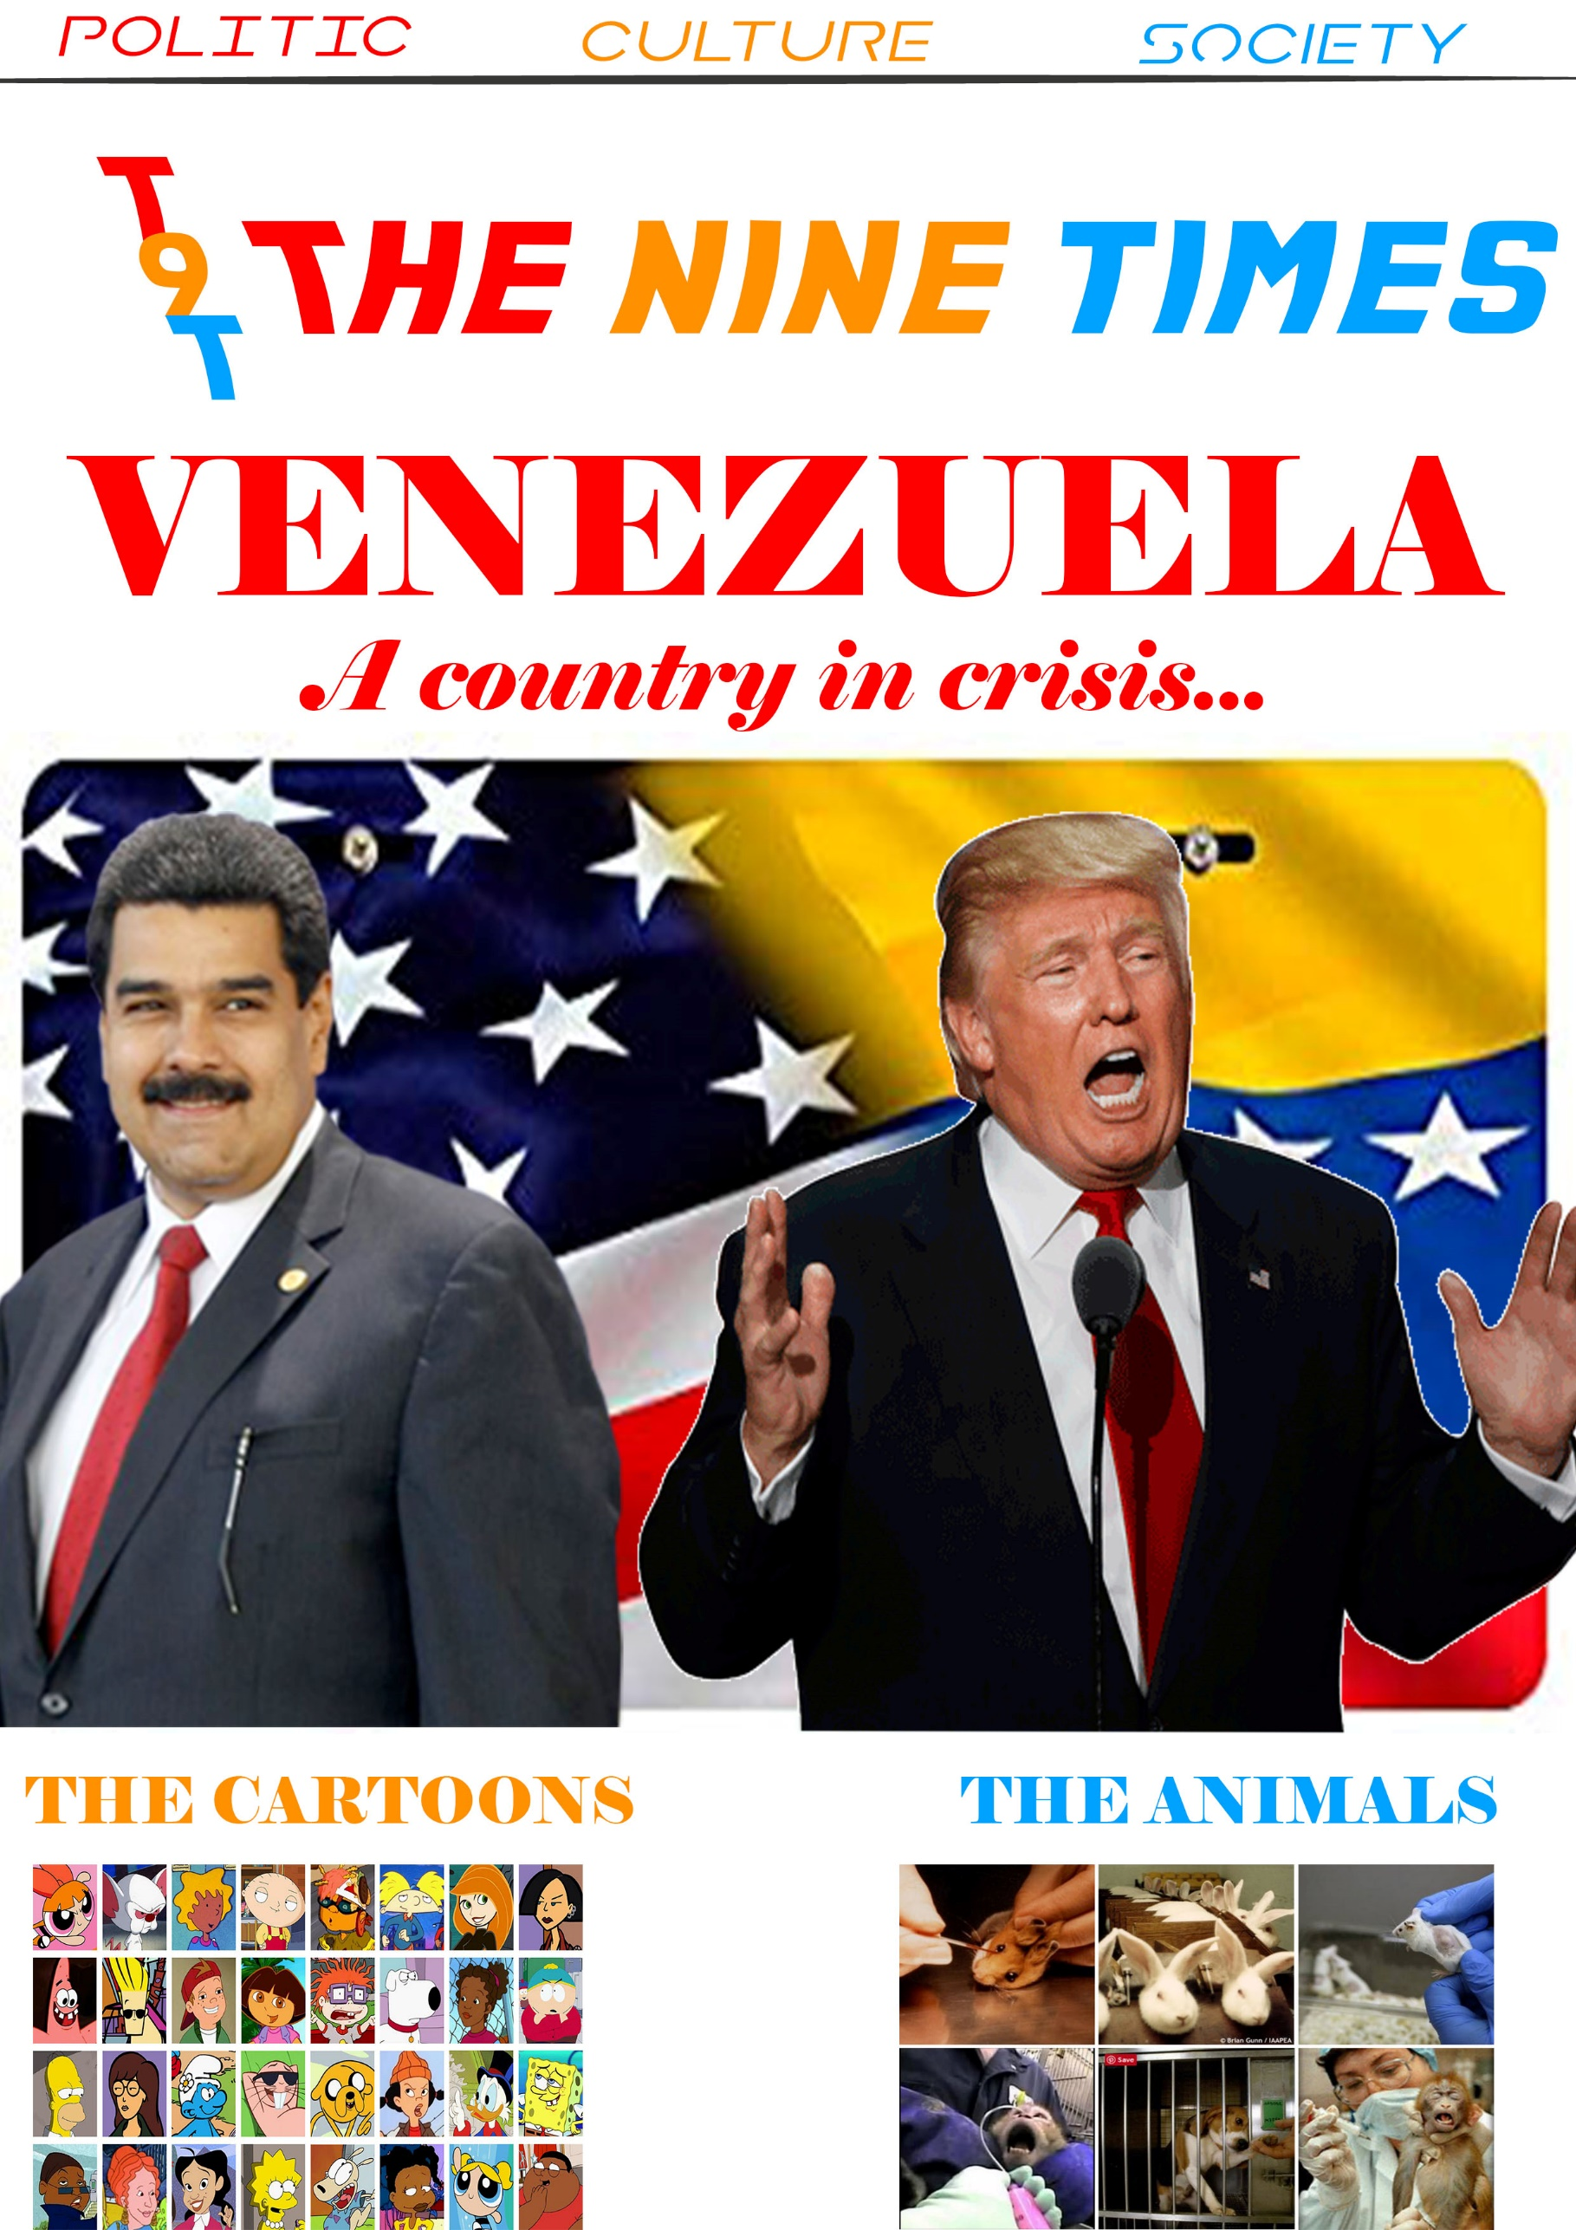

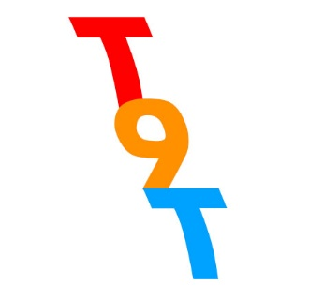
The Editorial

Welcome to THE NINE TIMES, and thanks to your contribution for the new newspaper club. My name is Walid and I am the editorial of this newspaper, my team and myself have worked to give your a newspaper who can interest all people with differents tastes like your favorites comics or how to have a good health going through politic.

The times who is in your hand is the first appeared. In this newspaper you are going to find a lot of articles more or less related. Thanks to our teacher, the students can speak out about subjects they like. I think speak of our passions permit an open mind of people. Our days, the open mind is is one of the keys to success in the life in general.

I want to speak about more precisely of the articles, I want that people read all of the articles, this articles are a source of knowledge, do you know what happened in Europe ? How people create makeup ? What are the consequences of video games on us ? The journalists are going to answer at all the questions. Before, I wasn’t interesting at the comics, but thanks to Achraf I want to watch an episode of Simpsons to see how the articles show the reality. It’s the first number of newspaper, and I am so exciting for the next time, who, I think, will be always better than the time before.

Without the help of my team, their investisment, the newspaper would never have seen the day. And for the respect of them, I beg you to read all the articles. The club is opened to all students but also at the teachers. They can speak about all subjects that they want if it falls into one of the following theme : culture, politic and society.

The Editor, Walid
SUMMARY :

Culture:
The Comics : Achraf
Video Games : Redouane
Street Workout : Ayoub

Politic:
Venezuela : Sofia
Immigration : Rayan
Brexit : Barera

Society:
Makeup : Suheyla
Social Network : Douha
Film Critic : Audrey



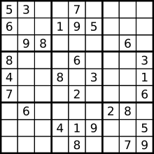

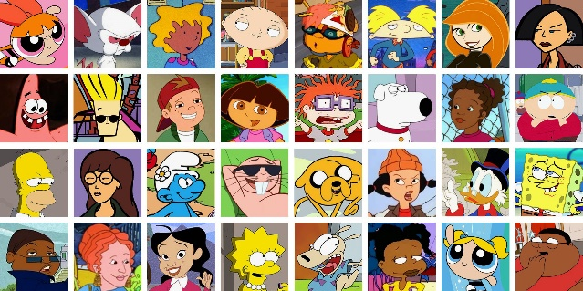
The success of cartoons

The Simpsons, Dragon Ball, Pokémon... cartoons are as entertaining as sports. Indeed, cartoons are made for children, teenagers, adults. The goal of cartoons is to pass a lot of pictures per seconds. This invention allowed to make many famous cartoons.

Morever, all the best TV channel propose cartoons like The Simpson, The Pink Panther, One Piece, etc. Caetoons allow to attain many views and earn money.

The fact that cartoon is excellent is the capacity to be funny or to have a great storyline. Besides, we like cartoons mostly because they are not realistics (a panther who can speak, yellows characters...).

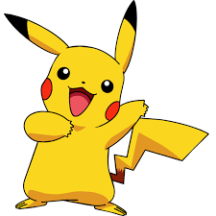
Also, in addition to watch cartoons, we try to find characters that we like or not,

characters who look like people in real life.
One of the principal succes of cartoons is the influence that may have the main characters or others. They are considered like heroes and it's awesome because each people prefer differents characters. Morever, some people refer to a character and they think they are like him. For example, there are people who think they are Sangoku and they do a « Kamehameha ». Other thinks they belong to the Uchiwa family.

To conclude, cartoons are invented to entertain people and to have fun. Morever, their success and influence are exceptional because it's an important part on TV. Besides to be funny, cartoons allow inspire kids (but also adults) through carismatics characters and to identify with them.

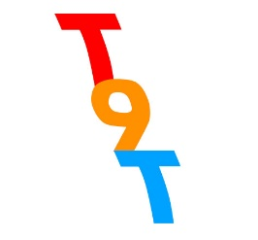
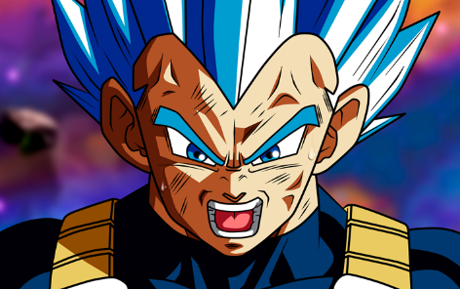
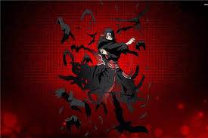
Rédouane
What is the impact of video-games on our society ?

On the occasion of the E3 (the biggest video-games convention of the world in Los Angeles), the game « God Of War » was designed best game of the year 2018.

A video game is an electronic game that involves interaction with an user interface to generate visual feedback on a two- or three- dimensional video dispay device such as a TV screen, virtual reality headset or computer monitor. Since the 1980s, video games have become an increasingly important part of the entertainment industry, and whetever they are also a form of art is a matter of dispute.

So, we can see that today, video-Games got an huge impact in differents fields in our society...

¤Economy :
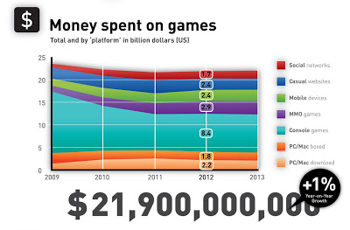
In the 2010s, the commercial importance of the video game industry is increasing. The emerging Asian markets and mobile games on smartphones in particular are driving the growth of the industry .

As of 2015, video-games generated sales of US$74 billion annually worldwide, and were the third-largest segment in the U.S. entermaint market, behind broadcast and cable TV.
http://videogameindustryimpact.blogspot.com/2012/12/industry-revenue.html

¤Politic :

Today, we can se that each country have his own polical laws about video-games.
For exemple, in USA,the State of Illinois voted to introduce legislation to ban the sale of violent or sexually explicit video games to children in Illinois, a move other states and cities have tried but federal courts have repeatedly struck down.

We can add that in 2011, South Korea passed the « Cindrella law » that forbids the children under 16 to play online video-games after midnight (from 12AM to 6AM).
https://cgiclinic.com/south-korea-special-shutdown-law-aka-cinderella-curfew/

¤Social :
With the new viewing plateforms (like Twitch of Youtube), video-games have a big place in the medias.
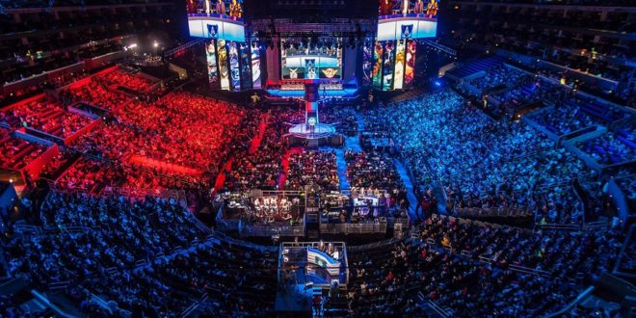
Indeed, in 2014, the amount of people watching the League Of Legends Worlds Finals was higher than the people watching the NBA Final Game.
Twitch sees an average of 15 million daily active users (DAUs). Over 2.2 million Twitch creators broadcast their games live on Twitchmonthly.http://mediakix.com/2017/02/top-twitch-statistics-live-streaming-game-platform/

https://www.realite-virtuelle.com/league-of-legends-realite-augmentee-2905

Street workout

the street workout is a physical activity performed mostly in outdoor parks, public facilities, simply anywhere. It is a combination of gymnatics, athletics and calisthenics. Street workout is a modern name for bodyweight workout in outdoor parks.

A real sport:Not a vulgar activity :
Actualy a lot of persons think that street workout is not a real sport because you train alone on outdoors facilities, evryone, when he want can start the street workout without subscription.
But the street workout is already a real sport. Yes, there is a world federation of street workout and calisthenics and others national federation in different countries, there is also nationals cup and worlds cup of street workout. The actual world champion is a french athlet named Yohan Bounegab aka Sangohan. There are diffrents team of street workout, who have appropriate places to train and practice, they have their own coach and personal trainer with profesionals diplomas to teach.
The origins :
The street workout originated in Ancient Greece, but became a popular movement in the 2000's with Russia and in the United-States. Especialy thanks to Hannibal For King who is the archetype and the precursor of the street workout. He published a video on youtube of if doing street workout in 2008 in a park of new york. He impressed everyone and he shoked the world with his inhuman strenght andwith spectacular moves; muscles-up, front lever, back lever, homan flag, dragon flag, planche, etc...
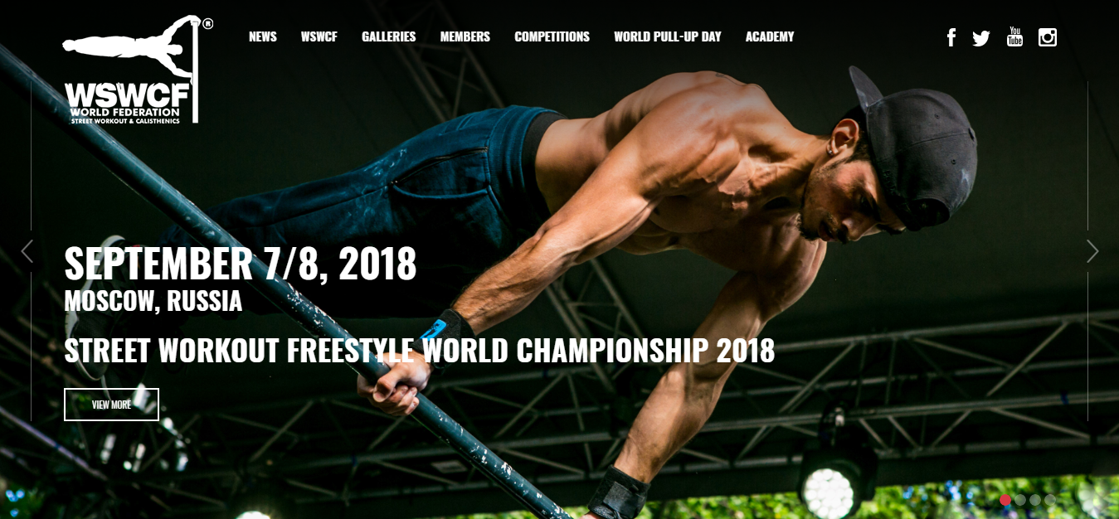
that's how the street workout have been promoted, and since this day the influence of this sport did not stop growing, and there is always new moves who are createad by fans and proffesional

So, the street workout is a new sport with a bigger comunity every day, with new moves very time, with new objectivs every day and with a healthy life style. It give a new vision of the life and a big control of his own whole body, this allows many possible moves like this...

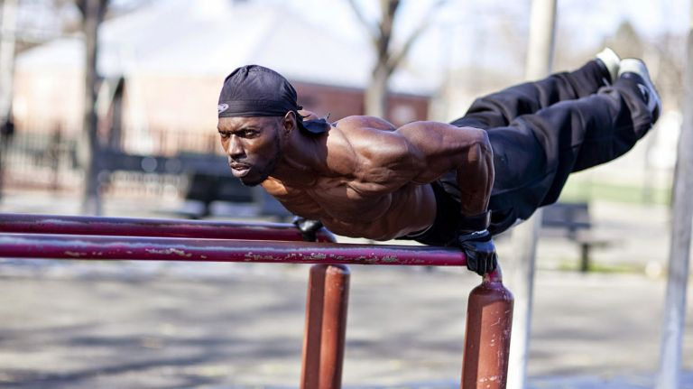

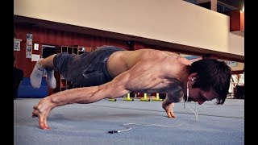

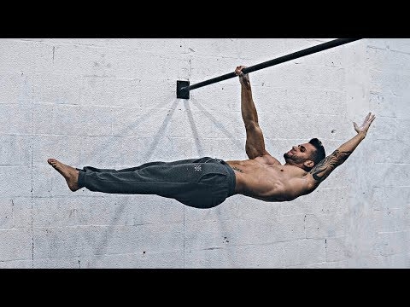

https://wallpapercave.com/w/wp2384367
https://wswcf.org/
https://cdn.newsday.com/polopoly_fs/1.13767823.1498598566!/httpImage/image.jpeg_gen/derivatives/landscape_768/image.jpeg
https://scontent-amt2-1.cdninstagram.com/vp/1c9357c9b2618394cb9551a158b7dd94/5CB210F2/t51.2885-15/sh0.08/e35/c0.135.1080.1080/s640x640/44334682_736901803344721_5108733464737397821_n.jpg?_nc_ht=scontent-amt2-1.cdninstagram.com
https://i.ytimg.com/vi/GPrTqL0DP1w/hqdefault.jpg
https://i.ytimg.com/vi/ZewGON5hJPk/hqdefault.jpg
https://ytimg.googleusercontent.com/vi/1GBfcebqa8o/mqdefault.jpg

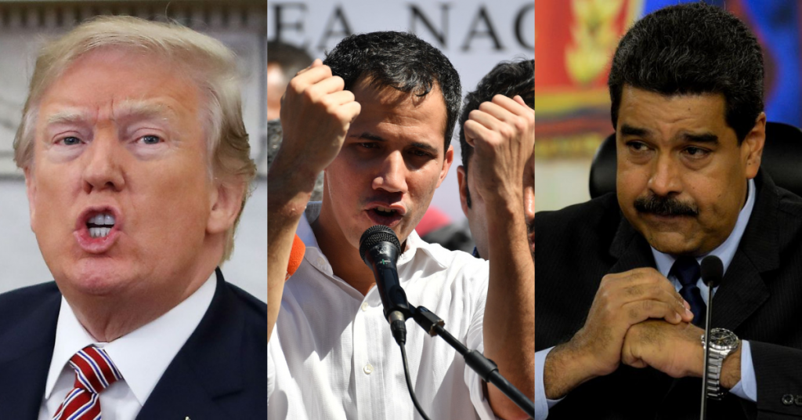
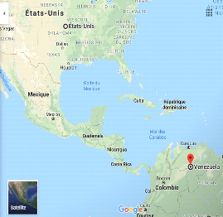
A country in crisis...
After the death of Hugo Chavez, the socialist venezuelian president, Nicolás Maduro was elected even if now he is criticizing for his dictador's attitude.

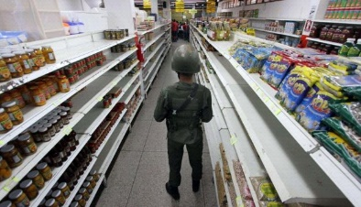
Moreover, today Venezuela is in crisis: people are hungry because of food and pharmaceuticals shortage, the money is devalued and poverty is everywhere (80% of the population), because of the dicreasing of the barrel price.

However, some diplomates denunced the other causes. One said "what is happening in Venezuela, it's not a political crisis, but the consequences of an economic crisis provoked by the USA and the European Union".

This opinion is shared by Maduro who accuses the USA of a coup d'état. And a lot of countries fear that it is happening in Syria.
However recently, Juan Guaido self proclaimed President in interim of Venezuela.
When Maduro denies the crisis, Guaido (ex chief of Parlment) wants to accept the supplies of America for the population who is suffering from hunger. This help of America is not accepted by Maduro because of Donald Trump's attitude. The behavior of Trump was also criticized when he went in Puerto Rico after the hurricane Maria when he threw paper towels. Morever, Guiado is recognized by countries in Europe and in the USA

[Citez votre source ici.]
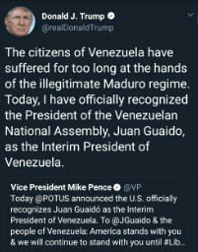

"It's a game very dreary, don't you think? They starve and then howe us beg for breadcrumbs".

That complicated the relations between the president elected and the other countries. In fact he obliged the american diplomates to go back in the USA "They can get home" said Maduro.
Then the food shortage are denied by Maduro, he prefers denunce the hypocrisy of the USA who send humanitarian aid even if they continue to maintain the economic sanctions.
However that is not the opinion of Guaido who wants to accept the supplies of the USA, he warned the venezuelian army : if they prevent the entry of the country to humanitarian aid they will be accuse to be responsible of a crime against humanity; furthermore he threathed Maduro and his army to call the force of the US army.
Finally humanitarian aid could arrive secretly in Venezuela in boat and truck from Colombia with the help of native.
This economic and political crisis show the consequences of the US interference. In the BBC MUNDO Maduro said that this crisis is the responsabilty of the USA because it's an economic war; even if is not the only cause. That proves also that the decisions of the United States have a big impact. For all that the communication of the president Trump is not the best, he use provoction through social network like Twitter. But Maduro can be very violent too when he said that the kkk govern the USA in the White House for example.
But this attitude of the two presidents is understandable: Maduro wants to prove his innocence in this crisis and for that he is accusing the USA to create this crisis to justify a militar intervention to conquer Venezuela. And Trump excels in provocation for the begginig of his mandate.
Sources: El mundo, Sputnik, Le figaro, Le Monde, BBC

The place of immigrants on the British labor market today

In January 2001, the UK Department of the Interior published a report titled Migration: An Economic and Social Analysis of the Linkages between Migration Policy and the Labor Market. This report focuses in particular on the positive impact of immigration on economic growth and employment. In a context of demographic sluggishness, the use of immigration is presented mainly on the lack of good quality labor, provided however a rigorous control of migratory flows supposed to answer almost perfectly to the needs of the labor market. This utilitarian approach is accompanied by a tightening of immigration legislation that seeks to justify one of the key areas of government: ensuring border security to ensure proper integration of immigrant populations. The February 2002 white paper is thus entitled Secure Borders, Safe Havens: Integration with Diversity in Modern Britain (Controlled Borders, Safe Haven: Integration in Diversity).

However, the studies show the extent of the efforts to be made to ensure a fair place for immigrants in the labor market. The tests put in place by the British government are based narrowly on the concept of immigrants (migrants), that is to say all persons born outside the British nation. The concept includes persons of foreign origin who have acquired British nationality, or 47% of them; it excludes persons born in the United Kingdom but remaining foreigners. Immigrants account for 8% of the total population, or 4.8 million people, of which 3.6 million are of working age (10% of all assets). Their composition, which results from the history of migration policy, is summarized in Figure 1. The territorial distribution of immigrants is not random, there is also a particular configuration: more than 40% of them live in London (compared to 10% for the indigenous population); immigrants make up 26% of London's population.

The southern part of the country is the second largest receiving area and, more broadly, the most urbanized areas are added. With a lower participation rate and a lower employment rate than native-born Britons (on average 63.6% compared to 74.6% for indigenous people in 2001) and thus a higher unemployment rate, immigrants occupy a specific place in the labor market. Their level of qualification is on average lower than that of the natives. But this average level in fact covers more important differences than for the native British: 19% of the employed immigrant workers hold an university degree against 15% for the native people; 19% have no qualifications against 16% for Aboriginals. Immigrants in sectors with high self-employment rate: hotels and restaurants, services to persons, retail trade, etc.). Using data from the Labor Force Survey (Eurostat), the Dustmann study.

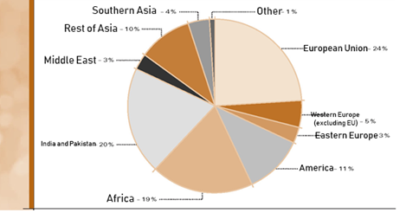

The guide to understand the Brexit
What does Brexit mean ?
Brexit is a word that is used to say that the United Kingdom leaving the European Union. It is the contraction of the words « British » and « exit ».

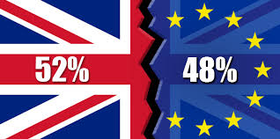
Why is Britain leaving the European Union ?
On 23th June 2016, there had a referedum. So to the question
« should the United Kingdom remain a member of the
European Union or leave the European Union? », 51,9% of
voters answer « leave the European Union ».

Why has there been a referendum ?
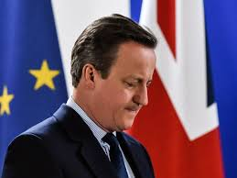
During his compaign, the first minister, David Cameron
promised to organize a referendum on the retention or
not of the United Kingdom in the European Union. So
the government organize the referendum on 23th June
2016. Then David Cameron resigned because the
faction of the « leave » won where as Cameron wanted
that the United Kingdom remain a member of the Euro-
pean Union.

What is the European Union ?
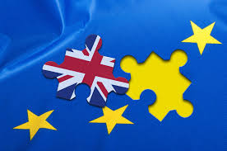
The European Union is an economic and political patnership
involving 28 european country. It was create after the World
War Two for the cooperation between countrys. But now,
it sets rules in many field like the environment, transport and
consumer rights.

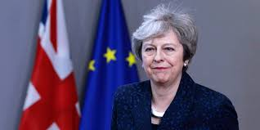
When will the United Kingdom leave the European Union ?
The United Kingdom is due to leave the European Union on 29th
March 2019. Indeed, the article 50 of the Lisbon Treaty gives two
years to agree the terms of the split and Theresa May, who replace
David Cameron, begun this process on 29th March 2017.

What effect will the Brexit have on United Kingdom ?
The gross domestic of United Kingdom will decrease by 7,7%. Moreover, the joblessness will increase from 4,1% to 7,5% even if it will lower and come back under 5% in 2023. Eventually, the pound sterling will drop. So the Brexit will have a negative impact on the daily life of British person.
Source :
The gardian/Le figaro/Le monde/Wikipédia/BBC news/Le parisien/Toute l'Europe
Animals testing in the Cosmetics Industry
Suheyla

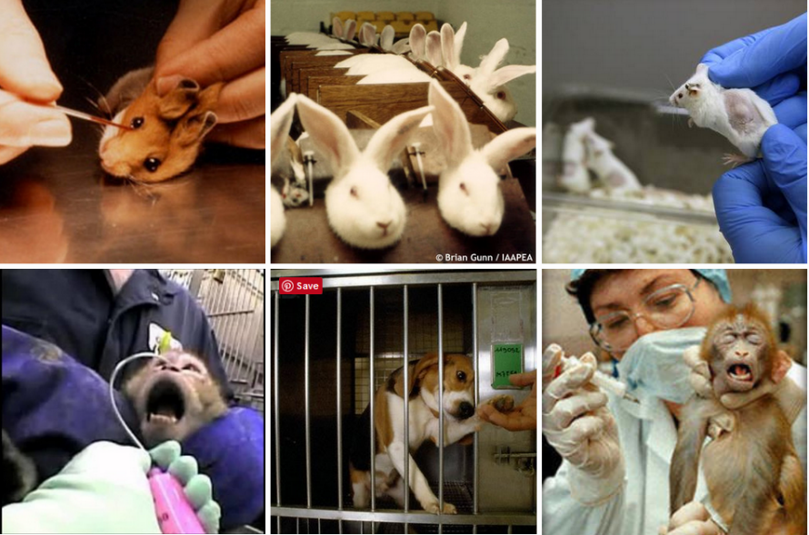
Animal Welfare: The trust about animal cruelty in beauty industry:
Animal welfare means how an animal is coping with the conditions in which lives.
Animals must be provided with water, food, proper handling, health care, and an environment appropriate to their care use, with thoughtful consideration for their species-typical biology and behaviour.
Conservation and management of animal populations should be human, socially responsible, and scientifically prudent.
Animals shall be treated with respect and dignity throughout their lives and when necessary provided a human death.

Did you know that testing just a new ingredient in a beauty care product could result in the deaths of over 1.400 animals?
According to change.org, the US spends approximately $16 billions dollars for the testing of cosmetics on animals a year. The catch is, even though the US government looks down upon brands testing on animals, there are still some governments in the world such as China where animal testing is required in order to sell products in their countries. Brands such as “MAC” cosmetics who claim to be cruelty free also sell their products in China. The pieces of that puzzle just do not seem to fit.
Examples of typically animals’ tests for cosmetics include: skin and eye irritation tests where chemicals are rubbed on to the shaved skin or dripped into the eyes of rabbits.
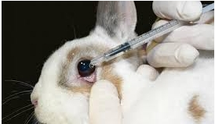

What can you do to help protect animals?
Until animal testing is banned everywhere in the world, the best thing to do is to boycott companies that continue to support animal cruelty and choose brands that are Leaping Bunny certified.


These tests can cause considerable pain and distress including blindness, swollen eyes, sore bleeding skin, internal bleeding and organ damage, birth defects, convulsions and death.
The Social Network
A social network refers to a group of people who are brought together by a social link. At the end of the years 1990, social networks appeared on the Internet, bringing together people via personalized Servicesd'échange who could decide to read the messages of a particular user.
Nowadays, social networks on the Internet appear as a new means of communication capital. Social networks on the web were discovered in the United States in 1995, but were only known by all continents in 2004.
First of all, a social network is a grouping of users on the Internet, which exchange information. According to a recent survey, 80% of Americans aged 12-17 years use social networks daily.Thus, social networks are taking more and more place in the lives of the younger generations. What we know less is the hidden face of these sites which, according to an American study, would have a bad influence on teenagers. However, most of the debates that agitate the web concern social networks: security parameters, content limitations, censorship, surveillance... Despite the constant criticism, social networks still have the coast, especially among teenagers, most accumulating profiles on several social networks: Facebook, Twitter, Instagram... at the risk of spreading their life online.
Thus, nowadays social networks on the Internet appear as a new means of communication capital
-Social networks have an impact on the behavior
Today's young people prefer to go on social networks rather than study. 60% of school children and teenagers are very often connected to Facebook above their results. These hours of scrolling on Facebook include mostly concentration.
-Mental health ?
Even if social networks are rather civilized spaces, the risks exist:
25% of 8-17 year olds have been victims of insults, lies or rumors.
36% of 8-17 year olds have already been shocked by certain content, especially
sexual, violent, racist
or homophobic.
And they are only 10% to have talked to their parents!

Social networks in good and bad:
In good:
Today's youth are the ones called "The Children of the Net-generation". They grew up with the Internet at their fingertips. But will it have an impact on the adults of tomorrow? Will they know more sociable than the generation without the Internet? According to Sylvie Octobre, sociologist, then declares that the real work of teenagers and make encounters all over the world, they then realize the place they have among millions else. But also to pass on knowledge to his peers, so to learn in their turn some things to their parents.
In bad:
The use of social networks also entrains bad meetings on the web. 3 out of 10 youth are being solicited by paedophiles on the web. In addition their behavior changes also, the nicks used by the young people can lead to personality splitting by changing the correspondent they change their attitude in Fonctio

To conclude, we can say that through our intellectual reflection on social networks and their impact on society, that if they are misused, they can become a danger to society at all levels. Indeed, it can have serious consequences on human behavior but also on the professional level. The question now is whether we should continue to use these social networks in large quantities, or whether they should be reduced in their use to protect the privacy and professional life of regular users

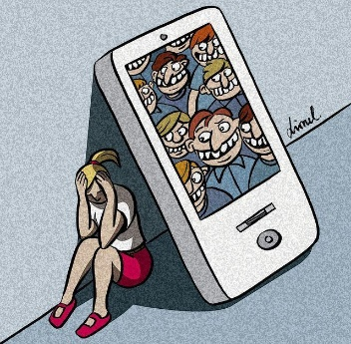

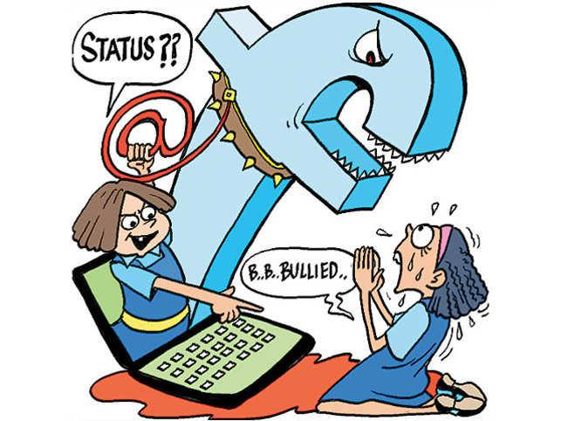

AQUAMAN
Audrey

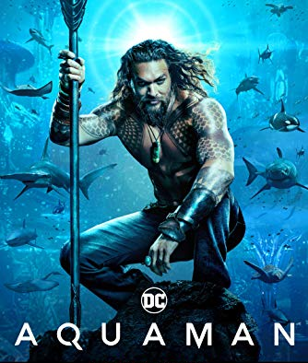
The Cast
- Jason Momoa: Arthur Curry/Aquaman.

- Amber Heard: Mera, princess de Xebel.

- Patrick Wilson: Orm Ocean Master/ Aquaman’s stepbrother.

- Nicole Kidman: Atlana, Queen of Atlantis, Mother of Aquaman.

- Temuera Morrison: Dad of Aquaman.

Synopsis
Aquaman is the 6th film from Universe D.C Comics, Warner Bros, achieved by James Wan came out December 2018. Aquaman stages Arthur Curry son of a lighthouse keeper and son of a mother, queen of Atlantis (lost city under the sea). 30 years after the disappearance of his mother, Arthur becomes Aquaman (half-human, half-fish) he is able to speak with the ocean’s species such as fish, dolphin, sharks, manta reys… But the terrestrial world and the marine world are fighting, Aquaman is the only one able to establish peace by becoming Atlantis’ king by finding the tridents of Poseidon (legend of Atlantis) which only the chosen one will have access to. So, he starts lo look for it with help of Mera. Their quest will be eventful by the apparition of anti-heroes (Orm and Black Manta).
Journalist Critic
Main Company Information: the initials D.C come from the abbreviation of Detective Comics. The
Company was created in the years 1930 and more specially in 1934 by Malcom Wheeler-Nicholson. The firm counts almost 50 superheroes and almost as many supervillains. It first film came out in 1951 and was Superman and the Dwarves of Hell and the last, Aquaman in 2018. A new film Shazam! Should appear on the screen during this year. Here are two of logos of D.C Comics (left from 2005 to 2012 and right from 2016.



The first apparition of Aquaman is in Justice League, film of Zack Snyder in 2017. Aquaman’s movie collects more than 1 milliards of dollars (world box-office) and more than 329.153.766 dollars just in United States and Canada. Aquaman completely change the D.C Universe major under aqua. The fight scenes submarine are immersive. The spectator has an impression of to live under the seas. The actor Jason Momoa signed for at least four films. So, it would not be impossible to see Aquaman on the screen again.

Source: http://www.allocine.fr/film/fichefilm-208692/casting/
https://www.dccomics.fr/

