Written by L0rdman01

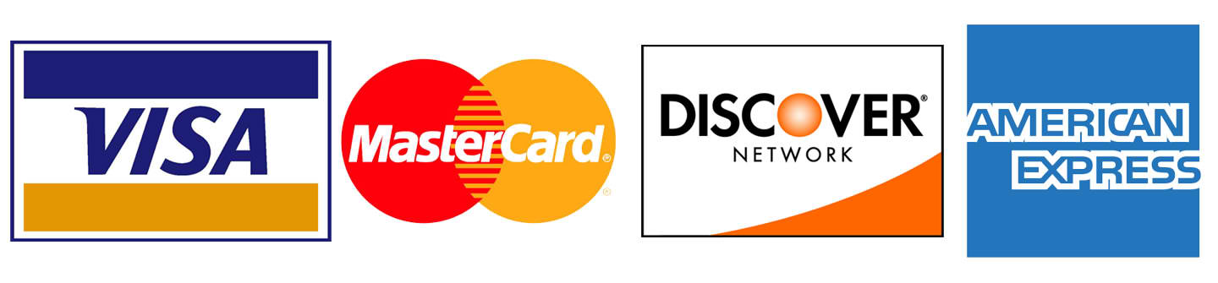
Credit card Canada version 2

Hi friends, if you’re here, then its mean you know already how to order credit cards, but things change,
and banks adapt against fraudsters.

In this chapter we gonna talk about.
-New way to put your drop address to credit report.
-Which bank works better.
-Mail forward.
-New requirements bank ask.

Like I said early banks adapt againts fraud.
-Mail Forward-
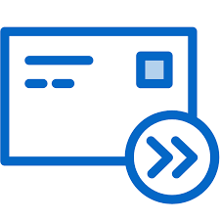
Here I gonna listed banks still work whit m

ail forward, because some bank advice Canada post to not mail forward certain type of mailing.
-Bmo still work for card having 5-10k limit max
-Canadian tire still work.
-President choice still work.
-Rbc still work.
-American express Canada still work.
- Cibc-Td-Tangerine-Hsbc- doesn’t work whit mail forward no more.

-New way to put your drop address to credit report-
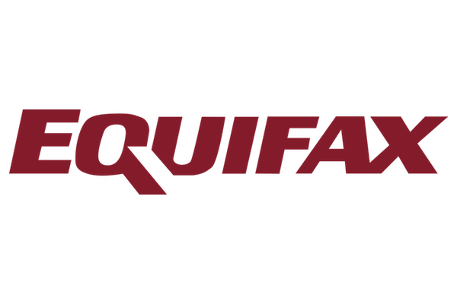
Here I gonna teach you 2 new way.
1 regular way!
1 way no one ever heard about !
The first way is to register online for a bank account
-Go to the bank you want to open an account, navigate a bit and go back 24 hours later and fulfill all dob, name , ssn , drop address = put you live there since the last 2 months and put the legit address of your profile.
-When its done wait 1 week.
-Go to bell-rogers-fido-telus-chatr whit a fake id and ask
to have a monthly plan whit them and give them your drop address the same you have enter for the bank account.
-Wait 48 hours , and apply for credit cards online.
-Never forget 3 max credit card application.
-Do the application whit an ip close to your drop, max 10km.

The second way its something I did couple time and its my secret it will work forever, he can be scary but IT WORK !
You have to find a crappy job, no id need, and apply online or in person. You have to work there whit the name of your profil, ssn, dob, and your drop address.
You have to work 2-3 hours and leave and say the job is not for you but you want to be pay for the 3 hours you did. 1 week later when they give to you the paycheck its mean your Equifax profil as been updated = new address , new job name, even new phone number.
I know it look complicated but it work, and its more complicated everyday to put your new dropp address in Equifax you need to be smart and get involved if you want to make serious money in 2018-2019.
Fraud it’s a full time job like a normal one but more $$$.

-New requirements-
I not gonna lie ordering credit card in 2018-2019 its hard business and some bank ask to go to the branch.
Here I gonna list bank ask to go to the branch and who don’t.

Even if you receive the card to your drop those banks ask you to go to the branch to activate it , and I will give you a tip for bypass it but its gonna be hard.

Banks who ask to go at the branch
-BMO
-RBC
- TD
-CIBC
Bank who don’t
President choice, but they ask to send a cheque of 1$
Canadian tire
Tangerine
Hsbc
American Express

Whit an excellent fake id you can go to the branch, I really suggest a health care more than a driver license, and SIN card whit it.

If you want to bypass the branch thing, there only one way, and its ordering the credit card to the legit address of your profil, you can choose one whit a house and not a old person so you know he or she work and you can go and pick up the mail everyday until you pick up the cards.

Like I say early ordering credit card it become an hard business, In my next tutorial I will talk about a new way to use credit whitout credit card, and couple stores to rape for big profit $$$
The new way in 2019 its gonna be this way, be fast because like the other type of fraud its not gonna last forever, cheers and thanks again for you to buy my tutorial.

l0rdman01@xmpp-hosting.de

