I have a new idea for the game.

On the map, they are a different region, it would be nice to have a different type of territory with a different characteristic to got resources.
Personally, I see the outpost as resource wells. As in the series "Anno ...". You can place the wells or quarry only on the corresponding areas.

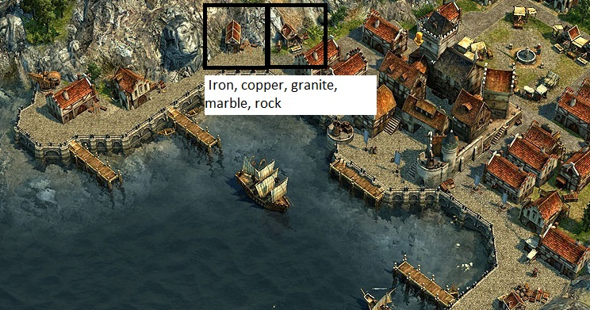

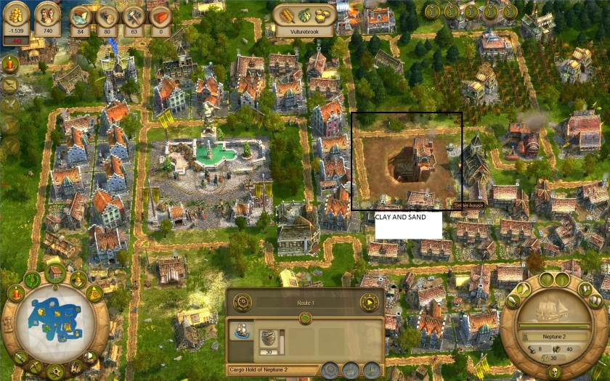

Woods resources.
Agrictulture resources.
Ore resources.

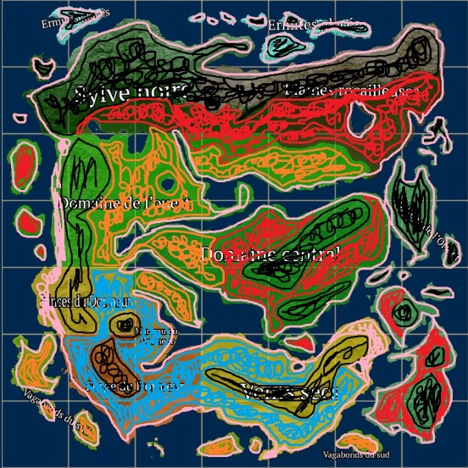

Type 1: The mountain.
Type 2: The forest.
Type 3: The steppes.
Type 4: The desert.
Type 5: The river, the sea.

I explain…

Type 1: The mountain.

This is the resources that I got in this type of territory.

Woods resources:
Oak tree (chêne) : Efficient 0%
Elm tree (orme) : Efficient 0%
Maple tree (érable) : Efficient 0%
Birch tree (bouleau) : Efficient 0%
Pine tree (pins) : Efficient 0%
Aspen tree (peuplier) : Efficient 0%
Spruce tree (épicéa) : Efficient 0%
Mulberry tree (murier) : Efficient 0%
Juniper tree (génévirer) : Efficient 0%
-------------------------------
Apple tree (pommier) : Efficient 0%
Hazel (noisette) : Efficient 0%

Efficient 0% = If I plant a tree in this type of territory on the forest soil, trees die every time.

Agrictulture resources.
Wheat (blé) : Efficient 0%
Peas (Pois) : Efficient 0%
Onions (oignons) : Efficient 0%
Carrots (carrote) : Efficient 0%
Flax (lins) : Efficient 0%
Cabbage (choux) : Efficient 0%
Grappes (raisins) : Efficient 0%
Potatoes (pomme de terre) : Efficient 0%

Efficient 0% = If I sow on this type of territory on the fertile soil, plantations die every time.

Metallic matérials.
Copper ore (cuivre) : Moderate (50%)
Iron ore (fer) : Abundante (100%)
Gold ore (or) : Nothing (0%)
Silver or (argent) : Nothing (0%)

100% = easy to find this resource.
50% = difficulty moderate to find this resource.
0% = no resource.

Terrains materials.
Clay (argile) : Nothing (0%)
Sand (sable) : Nothing (0%)
Granite (granite) : Abundante (100%)
Marble (marbre) : Abundante (100%)
Rock (pierre) : Abundante (100%)
Slate (ardoise) : Nothing (0%)

100% = easy to find this resource.
50% = difficulty moderate to find this resource.
0% = no resource.

Outpost:
Outpost mill (windmill): Agricultural crops Efficient 0%

Outpost mine shaft: Copper ore (cuivre) : Efficient 75%
Iron ore (fer) : Efficient 100%
Coal (charbon) : Efficient 100%

Outpost herbalist : All plants : Efficient 0%

Outpost quarry : Sand (sable) : Efficient 0%
Clay (argile) : Efficient 0%

Oupost sawnmill : Soft wood (bois tendre) : Efficient 0%
Hard wood (bois dur) : Efficient 0%

Outpost slaughterhouse : Thick leather : Efficient 0%
Fine leather : Efficient 0%
Foods (nourriture) : Efficient 0%

Outpost hut of the bowler : Plant fiber : Efficient 25%
Edible berries : Efficient 25%
Mushrooms : Efficient 25%

Outpost slaves camps : Delete this outpost

Outpost of geognose : Delete this outpost

100% = outpost make maximum use of these capabilities.
75% = outpost use ¾ of these capabilities.
50% = outpost used to half of these capabilities.
25% = outpost outpost used at quarter of these capabilities.
0% = no resource.

Type 2: The forest.

This is the resources that I got in this type of territory.

Woods resources:
Oak tree (chêne) : Efficient 100%
Elm tree (orme) : Efficient 100%
Maple tree (érable) : Efficient 100%
Birch tree (bouleau) : Efficient 100%
Pine tree (pins) : Efficient 100%
Aspen tree (peuplier) : Efficient 100%
Spruce tree (épicéa) : Efficient 100%
Mulberry tree (murier) : Efficient 100%
Juniper tree (génévirer) : Efficient 100%
-------------------------------
Apple tree (pommier) : Efficient 75%
Hazel (noisette) : Efficient 75%

Efficient 100% = Durability got after i finished to cut trees to maximum.
For example: Oak quality 100 = 1200 durability. If I plant tree in this type of territory, I got 1200/1200 maximum per tree..
Efficient 75% = An apple tree, I get 15 apples maximum. So in this type of territory, I get 11/15 apples.
Agrictulture resources.
Wheat (blé) : Efficient 50%
Peas (Pois) : Efficient 50%
Onions (oignons) : Efficient 50%
Carrots (carrote) : Efficient 50%
Flax (lins) : Efficient 50%
Cabbage (choux) : Efficient 50%
Grappes (raisins) : Efficient 50%
Potatoes (pomme de terre) : Efficient 50%

Efficient 50% = There are 3 stages for get resources by boxe (1-3 or 4-7 or 8-12). Efficient 50% = stage 2.
For example, I get 4-6 wheat maximum by boxe, not more.

Metallic matérials.
Copper ore (cuivre) : Abundante (100%)
Iron ore (fer) : Moderate (50%)
Gold ore (or) : Nothing (0%)
Silver or (argent) : Nothing (0%)

100% = easy to find this resource.
50% = difficulty moderate to find this resource.
0% = no resource.

Terrains materials.
Clay (argile) : Nothing (0%)
Sand (sable) : Nothing (0%)
Granite (granite) : Nothing (0%)
Marble (marbre) : Nothing (0%)
Rock (pierre) : Moderate (50%)
Slate (ardoise) : Nothing (0%)

100% = easy to find this resource.
50% = difficulty moderate to find this resource.
0% = no resource.

Outpost:
Outpost mill (windmill): Agricultural crops : Efficient 75%

Outpost mine shaft: Copper ore (cuivre) : Efficient 100%
Iron ore (fer) : Efficient 75%
Coal (charbon) : Efficient 25%

Outpost herbalist : All plants : Efficient 75%

Outpost quarry : Sand (sable) : Efficient 0%
Clay (argile) : Efficient 0%

Oupost sawnmill : Soft wood (bois tendre) : Efficient 100%
Hard wood (bois dur) : Efficient 100%

Outpost slaughterhouse : Thick leather : Efficient 50%
Fine leather : Efficient 50%
Foods (nourriture) : Efficient 75%

Outpost hut of the bowler : Plant fiber : Efficient 100%
Edible berries : Efficient 100%
Mushrooms : Efficient 100%

Outpost slaves camps : Delete this outpost

Outpost of geognose : Delete this outpost

100% = outpost make maximum use of these capabilities.
75% = outpost use ¾ of these capabilities.
50% = outpost used to half of these capabilities.
25% = outpost outpost used at quarter of these capabilities.
0% = no resource.

Type 3: The steppes.

This is the resources that I got in this type of territory.

Woods resources:
Oak tree (chêne) : Efficient 75%
Elm tree (orme) : Efficient 75%
Maple tree (érable) : Efficient 75%
Birch tree (bouleau) : Efficient 75%
Pine tree (pins) : Efficient 75%
Aspen tree (peuplier) : Efficient 75%
Spruce tree (épicéa) : Efficient 75%
Mulberry tree (murier) : Efficient 75%
Juniper tree (génévirer) : Efficient 75%
-------------------------------
Apple tree (pommier) : Efficient 100%
Hazel (noisette) : Efficient 100%

Efficient 75% = Durability got after i finished to cut trees to ¾.
For example: Oak quality 100 = 1200 durability. If I plant tree in this type of territory, I got 900/1200 maximum per tree.
Efficient 100% = An apple tree, I get 15 apples maximum. So in this type of territory, I get 15/15 apples.

Agrictulture resources.
Wheat (blé) : Efficient 100%
Peas (Pois) : Efficient 100%
Onions (oignons) : Efficient 100%
Carrots (carrote) : Efficient 100%
Flax (lins) : Efficient 100%
Cabbage (choux) : Efficient 100%
Grappes (raisins) : Efficient 100%
Potatoes (pomme de terre) : Efficient 100%

Efficient 100% = There are 3 stages for get resources by boxe (1-3 or 4-7 or 8-12). Efficient 100% = stage 3.
For example, I get 8-12 wheat maximum by boxe, not more.

Metallic matérials.
Copper ore (cuivre) : Nothing (0%)
Iron ore (fer) : Nothing (0%)
Gold ore (or) : Moderate (50%)
Silver or (argent) : Moderate (50%)

100% = easy to find this resource.
50% = difficulty moderate to find this resource.
0% = no resource.

Terrains materials.
Clay (argile) : Nothing (0%)
Sand (sable) : Nothing (0%)
Granite (granite) : Nothing (0%)
Marble (marbre) : Nothing (0%)
Rock (pierre) : Moderate (50%)
Slate (ardoise) : Abundante (100%)

100% = easy to find this resource.
50% = difficulty moderate to find this resource.
0% = no resource.

Outpost:
Outpost mill (windmill): Agricultural crops : Efficient 100%

Outpost mine shaft: Copper ore (cuivre) : Efficient 0%
Iron ore (fer) : Efficient 25%
Coal (charbon) : Efficient 0%

Outpost herbalist : All plants : Efficient 100%

Outpost quarry : Sand (sable) : Efficient 0%
Clay (argile) : Efficient 0%

Oupost sawnmill : Soft wood (bois tendre) : Efficient 100%
Hard wood (bois dur) : Efficient 100%

Outpost slaughterhouse : Thick leather : Efficient 100%
Fine leather : Efficient 100%
Foods (nourriture) : Efficient 100%

Outpost hut of the bowler : Plant fiber : Efficient 75%
Edible berries : Efficient 75%
Mushrooms : Efficient 75%

Outpost slaves camps : Delete this outpost

Outpost of geognose : Delete this outpost

100% = outpost make maximum use of these capabilities.
75% = outpost use ¾ of these capabilities.
50% = outpost used to half of these capabilities.
25% = outpost outpost used at quarter of these capabilities.
0% = no resource.

Type 4: The desert.

This is the resources that I got in this type of territory.

Woods resources:
Oak tree (chêne) : Efficient 0%
Elm tree (orme) : Efficient 0%
Maple tree (érable) : Efficient 0%
Birch tree (bouleau) : Efficient 0%
Pine tree (pins) : Efficient 0%
Aspen tree (peuplier) : Efficient 0%
Spruce tree (épicéa) : Efficient 0%
Mulberry tree (murier) : Efficient 0%
Juniper tree (génévirer) : Efficient 0%
-------------------------------
Apple tree (pommier) : Nothing (0%)
Hazel (noisette) : Nothing (0%)

If I plant a tree in this type of territory on the forest soil, trees die every time.

Agrictulture resources.
Wheat (blé) : Efficient 0%
Peas (Pois) : Efficient 0%
Onions (oignons) : Efficient 0%
Carrots (carrote) : Efficient 0%
Flax (lins) : Efficient 0%
Cabbage (choux) : Efficient 0%
Grappes (raisins) : Efficient 0%
Potatoes (pomme de terre) : Efficient 0%

If I sow on this type of territory on the fertile soil, plantations die every time.

Metallic matérials.
Copper ore (cuivre) : Nothing (0%)
Iron ore (fer) : Nothing (0%)
Gold ore (or) : Abundante (100%)
Silver or (argent) : Abundante (100%)

100% = easy to find this resource.
50% = difficulty moderate to find this resource.
0% = no resource.

Terrains materials.
Clay (argile) : Nothing (0%)
Sand (sable) : Nothing (0%)
Granite (granite) : Nothing (0%)
Marble (marbre) : Nothing (0%)
Rock (pierre) : Nothing (0%)
Slate (ardoise) : Nothing (0%)

100% = easy to find this resource.
50% = difficulty moderate to find this resource.
0% = no resource.

Outpost:
Outpost mill (windmill): Agricultural crops : Efficient 25%

Outpost mine shaft: Copper ore (cuivre) : Efficient 0%
Iron ore (fer) : Efficient 25%
Coal (charbon) : Efficient 100%

Outpost herbalist : All plants : Efficient 25%

Outpost quarry : Sand (sable) : Efficient 100%
Clay (argile) : Efficient 25%

Oupost sawnmill : Soft wood (bois tendre) : Efficient 25%
Hard wood (bois dur) : Efficient 25%

Outpost slaughterhouse : Thick leather : Efficient 0%
Fine leather : Efficient 0%
Foods (nourriture) : Efficient 0%

Outpost hut of the bowler : Plant fiber : Efficient 25%
Edible berries : Efficient 0%
Mushrooms : Efficient 0%

Outpost slaves camps : Delete this outpost

Outpost of geognose : Delete this outpost

100% = outpost make maximum use of these capabilities.
75% = outpost use ¾ of these capabilities.
50% = outpost used to half of these capabilities.
25% = outpost outpost used at quarter of these capabilities.
0% = no resource.

Type 5: The river, the sea.

This is the resources that I got in this type of territory.

Woods resources:
Oak tree (chêne) : Efficient 100%
Elm tree (orme) : Efficient 100%
Maple tree (érable) : Efficient 100%
Birch tree (bouleau) : Efficient 100%
Pine tree (pins) : Efficient 100%
Aspen tree (peuplier) : Efficient 100%
Spruce tree (épicéa) : Efficient 100%
Mulberry tree (murier) : Efficient 100%
Juniper tree (génévirer) : Efficient 100%
-------------------------------
Apple tree (pommier) : Efficient 100%
Hazel (noisette) : Efficient 100%

Efficient 100% = Durability got after i finished to cut trees to maximum.
For example: Oak quality 100 = 1200 durability. If I plant tree in this type of territory, I got 1200/1200 maximum per tree.
Efficient 100% = An apple tree, I get 15 apples maximum. So in this type of territory, I get 15/15 apples.

Agrictulture resources.
Wheat (blé) : Efficient 100%
Peas (Pois) : Efficient 100%
Onions (oignons) : Efficient 100%
Carrots (carrote) : Efficient 100%
Flax (lins) : Efficient 100%
Cabbage (choux) : Efficient 100%
Grappes (raisins) : Efficient 100%
Potatoes (pomme de terre) : Efficient 100%

Efficient 100% = There are 3 stages for get resources by boxe (1-3 or 4-7 or 8-12). Efficient 100% = stage 3.
For example, I get 8-12 wheat maximum by boxe, not more.

Metallic matérials.
Copper ore (cuivre) : Nothing (0%)
Iron ore (fer) : Nothing (0%)
Gold ore (or) : Nothing (0%)
Silver or (argent) : Nothing (0%)
100% = easy to find this resource.
50% = difficulty moderate to find this resource.
0% = no resource.

Terrains materials.
Clay (argile) : Abundante (100%)
Sand (sable) : Abundante (100%)
Granite (granite) : Nothing (0%)
Marble (marbre) : Nothing (0%)
Rock (pierre) : Nothing (0%)
Slate (ardoise) : Nothing (0%)

100% = easy to find this resource.
50% = difficulty moderate to find this resource.
0% = no resource.

Outpost:
Outpost mill (windmill): Agricultural crops : Efficient 100%

Outpost mine shaft: Copper ore (cuivre) : Efficient 0%
Iron ore (fer) : Efficient 0%
Coal (charbon) : Efficient 0%

Outpost herbalist : All plants : Efficient 100%

Outpost quarry : Sand (sable) : Efficient 100%
Clay (argile) : Efficient 100%

Oupost sawnmill : Soft wood (bois tendre) : Efficient 75%
Hard wood (bois dur) : Efficient 75%

Outpost slaughterhouse : Thick leather : Efficient 25%
Fine leather : Efficient 25%
Foods (nourriture) : Efficient 50%

Outpost hut of the bowler : Plant fiber : Efficient 100%
Edible berries : Efficient 25%
Mushrooms : Efficient 50%

Outpost slaves camps : Delete this outpost

Outpost of geognose : Delete this outpost

100% = outpost make maximum use of these capabilities.
75% = outpost use ¾ of these capabilities.
50% = outpost used to half of these capabilities.
25% = outpost outpost used at quarter of these capabilities.
0% = no resource.

