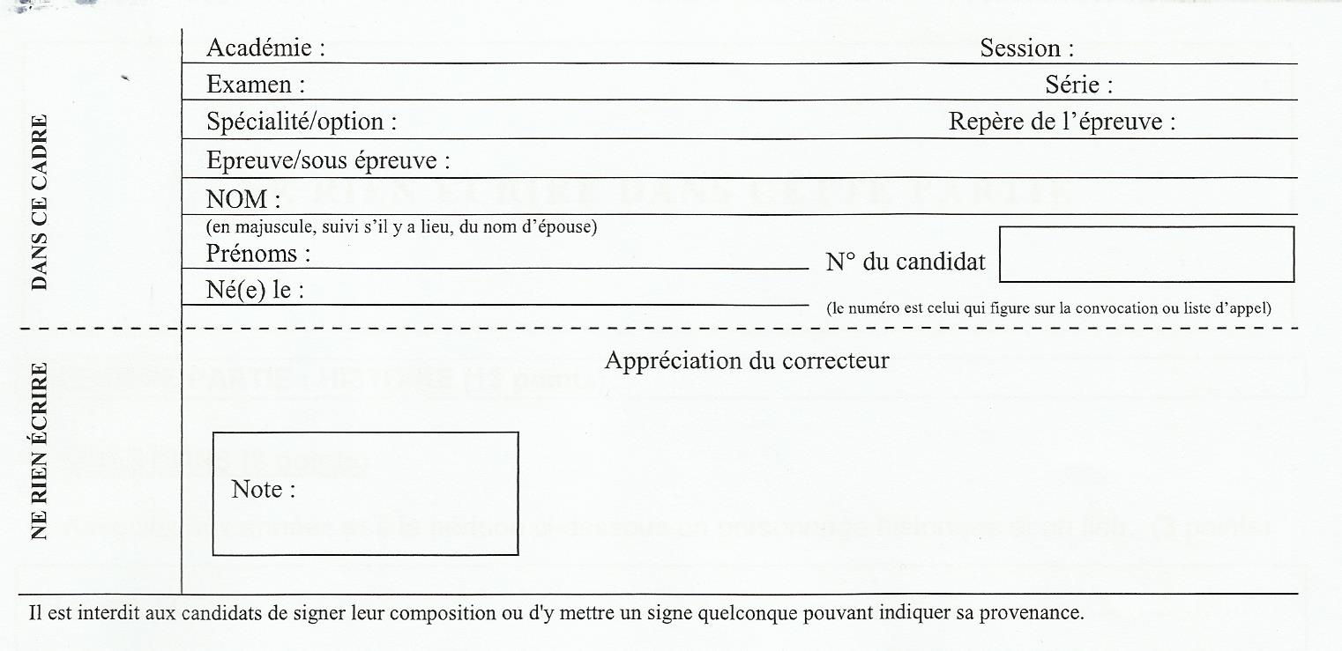

Collège …………….

Mardi 13 mai 2014

BREVET BLANC

EPREUVE D’HISTOIRE, DE GEOGRAPHIE, D’EDUCATION CIVIQUE

L’épreuve se compose de trois parties qui doivent être obligatoirement traitées par le candidat ;

1ère partie : histoire (13 points)

2e partie : géographie (13 points)

3e partie : éducation civique (10 points)

Maîtrise de la langue (4 points)

Total : 40 points

NE RIEN ECRIRE DANS CETTE PARTIE

PREMIERE PARTIE : HISTOIRE

QUESTIONS (9 points) :
1) Associez aux années et à la période ci-dessous un personnage historique et un lieu (2 points)
52 avant JC : _______________________________________________________________
1492 : ____________________________________________________________________

2) Qu’est-ce que le Front Populaire ? Quelles sont les 2 grandes lois sociales qu’il met en place ? (2 pts)
____________________________________________________________________________________________________________________________________________________________________________________________________________________________________________________________________________________________________
__________________________________________________________________________________________________________________________________________________
_____________________________________________________________________________________________________________________________________________________________________________________________________________________________________________________________________________________________________________________________________________________________________________

3) Dans un développement construit, vous montrerez que la Seconde Guerre mondiale est une « guerre d’anéantissement » (5 pts)
____________________________________________________________________________________________________________________________________________________________________________________________________________________________________________________________________________________________________
__________________________________________________________________________________________________________________________________________________
_________________________________________________________________________________________________________________________________________________________________________________________________________________________________________________________________________________________________________________________________________________________________________________________________________________________________________________________________________________________________________________________________________________________________________________________________________________________________________________________________________________

NE RIEN ECRIRE DANS CETTE PARTIE

____________________________________________________________________________________________________________________________________________________________________________________________________________________________________________________________________________________________________
___________________________________________________________________________________________________________________________________________________________________________________________________________________________
___________________________________________________________________________________________________________________________________________________________________________________________________________________________
______________________________________________________________________________________________________________________________________________________________________________________________________________________________________________________________________________________________________________________________________________________________________________________________________________________________________________________________________________________________________________________________________________________________________________________________________________________________________________________________________________________________________________________________________________________________________________________________________________________________________________________________________________________________________________________________________________________________________________________________________________________________________________________________________________________________________________________________________________________________________________________________________________________________________________________________________________________________________________________________________________________________________________________________________________________________________________________________________________________________________________________________________________________________________________________________________________________________________________________________________________________________________________________________________________________________________________________________________________________________________________________________________________________________________________________________________________________________________________________________________________________________________________________________________________________________________________________________________________________________________________________________________________________________________________________________________________

NE RIEN ECRIRE DANS CETTE PARTIE

TRAVAIL SUR DOCUMENT (4 points) :

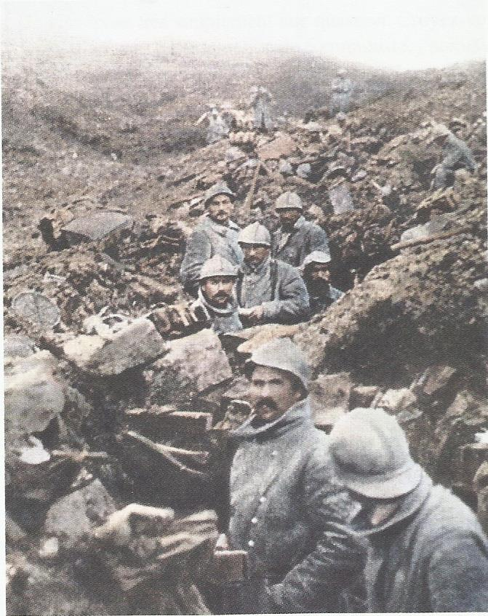
Soldats français du 87e régiment de Verdun (Cote 304) en 1916

1) Comment appelle-t-on cette phase de la guerre ? Quelles armées se sont affrontées durant cette bataille ? (1 pt)
________________________________________________________________________________________________________________________________________
________________________________________________________________________________________________________________________________________________________________________________________________________________________________________________________________________________

2) Pourquoi le paysage est-il dévasté ? (1 pt)
___________________________________________________________________________________________________________________________________________________________________________________________________________________________
___________________________________________________________________________________________________________________________________________________________________________________________________________________________

3) En quoi ce document justifie-t-il l’expression « enfer de Verdun » ? (2 pts)
___________________________________________________________________________________________________________________________________________________________________________________________________________________________
_______________________________________________________________________________________________________________________________________________________________________________________________________________________________________________________________________________________________________________________________________________________________________________________________________________________________________________________________________________________________________________________________

NE RIEN ECRIRE DANS CETTE PARTIE

DEUXIEME PARTIE : GEOGRAPHIE

QUESTIONS (9 points) :
1)
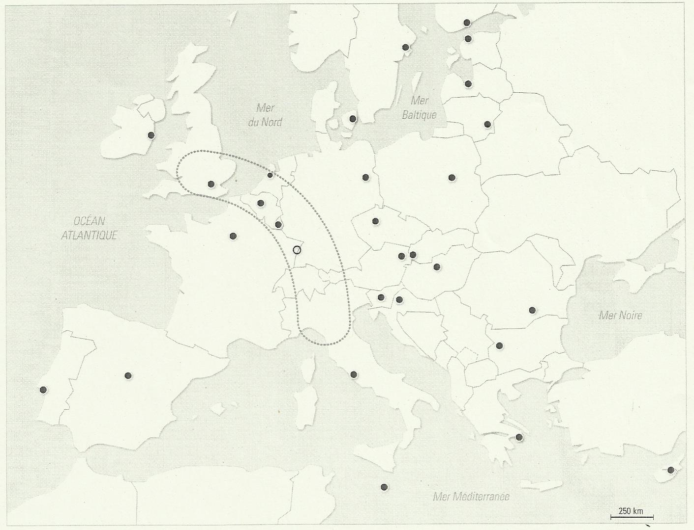

- Quel espace est délimité par les pointillés ? Pourquoi est-ce un espace important ? (2 pts)
_______________________________________________________________________________________________________________________________________________________________________________________________________________________________________________________________________________________________________________________________________________________________________________________________________________________________________________________________________________________________________________________________

- Quels sont les pays (lettres) et capitales (numéros) suivants : (2 pts)
A : 1 :
B : 2 :
C : 3 :
D : 4 :

NE RIEN ECRIRE DANS CETTE PARTIE

2) De quand date le traité de Maastricht ? Quels changements apporte-t-il ? (2 pts)
_______________________________________________________________________________________________________________________________________________________________________________________________________________________________________________________________________________________________________________________________________________________________________________________________________________________________________________________________________________________________________________________________
_________________________________________________________________________

3) Quels sont les 4 types d’espaces les moins dynamiques du territoire français ? (2 pts)
____________________________________________________________________________________________________________________________________________________________________________________________________________________________________________________________________________________________________________________________________________________________________________________________________________________________________________________________________________________________________________________________________________________________________________________________________________________________________________________________________________________________________________________________________________________________________________________________________________________________________________________________________________________________________________________________________________________________________________________

4) Citez une caractéristique démographique et une caractéristique économique de votre région ? (1 pt)
___________________________________________________________________________________________________________________________________________________________________________________________________________________________
__________________________________________________________________________________________________________________________________________________
____________________________________________________________________________________________________________________________________________________________________________________________________________________________________________________________________________________________________

NE RIEN ECRIRE DANS CETTE PARTIE

TRAVAIL SUR DOCUMENT (4 points) :
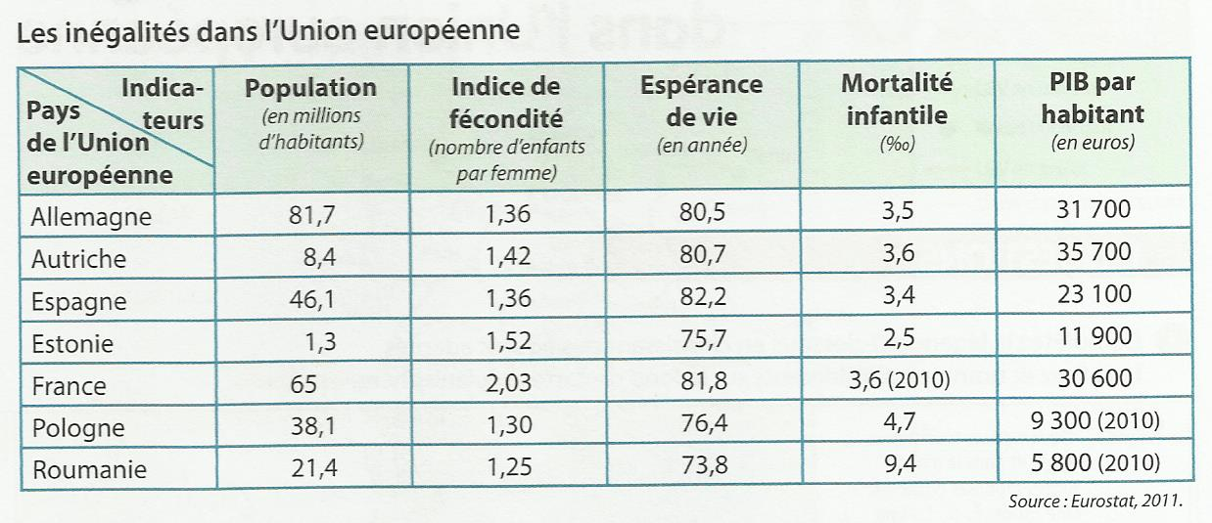

1) Quels indicateurs montrent le niveau de santé des populations ? (1 pt)
__________________________________________________________________________________________________________________________________________________
_________________________________________________________________________

2) A l’aide d’un indicateur que vous citerez, identifiez deux pays possédant un niveau de vie élevé. Dans quelle partie de l’Europe sont-ils situés ? (1 pt)
___________________________________________________________________________________________________________________________________________________________________________________________________________________________
___________________________________________________________________________________________________________________________________________________________________________________________________________________________

3) Que révèle l’espérance de vie sur la situation économique des pays de l’Union Européenne ? (1 pt)
___________________________________________________________________________________________________________________________________________________________________________________________________________________________
___________________________________________________________________________________________________________________________________________________________________________________________________________________________

NE RIEN ECRIRE DANS CETTE PARTIE

4) Quelle particularité démographique de la France apparaît dans ce tableau ? (1 pt)
______________________________________________________________________________________________________________________________________________________________________________________________________________________________________________________________________________________________________________________________________________________________________________________________________________________________________________________

TROISIEME PARTIE : EDUCATION CIVIQUE

QUESTIONS (6 points) :
1) Quelle est la composition du Conseil de Sécurité de l’ONU ? (2 pts)
___________________________________________________________________________________________________________________________________________________________________________________________________________________________
__________________________________________________________________________________________________________________________________________________

2) Quels sont les engagements militaires de la France au niveau mondial ? (2 pts)
___________________________________________________________________________________________________________________________________________________________________________________________________________________________
______________________________________________________________________________________________________________________________________________________________________________________________________________________________________________________________________________________________________________________________________________________________________________________________________________________________________________________

NE RIEN ECRIRE DANS CETTE PARTIE

3) Expliquez pourquoi le droit de vote est une conquête, en donnant des dates précises (2 pts)
___________________________________________________________________________________________________________________________________________________________________________________________________________________________
____________________________________________________________________________________________________________________________________________________________________________________________________________________________________________________________________________________________________

TRAVAIL SUR DOCUMENT ( 4 points) :
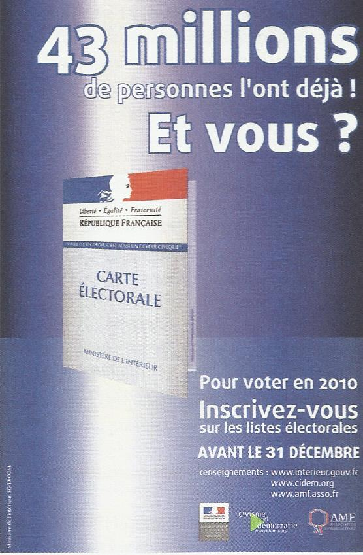

1) A qui s’adresse cette affiche et quel est son message ? (1 pt)
__________________________________________________________________________________________________________________________________________________
___________________________________________________________________________________________________________________________________________________________________________________________________________________________

NE RIEN ECRIRE DANS CETTE PARTIE

2) Quels sont les 3 symboles représentés sur cette affiche ? (1.5 pt)
___________________________________________________________________________________________________________________________________________________________________________________________________________________________
__________________________________________________________________________________________________________________________________________________

3) En vous appuyant sur vos connaissances, vous montrerez pourquoi les citoyens doivent voter dans une démocratie. (1.5 pt)
_______________________________________________________________________________________________________________________________________________________________________________________________________________________________________________________________________________________________________________________________________________________________________________________________________________________________________________________________________________________________________________________________________________________________________________________________________________________________________________________________________________________________________________________________________________________________________________________________________________________________________________________________________________________________________________________________________________________________________________________________________________________________________________________________________________________________________________________________________

