TECHNICAL PASSPORT OF THE GOODS
CONSTRUCTION MACHINES SPECIALES
POUR RECHERCHE AGRONOMIQUE
ET PRODUCTION DE SEMENCES

1 – Holder
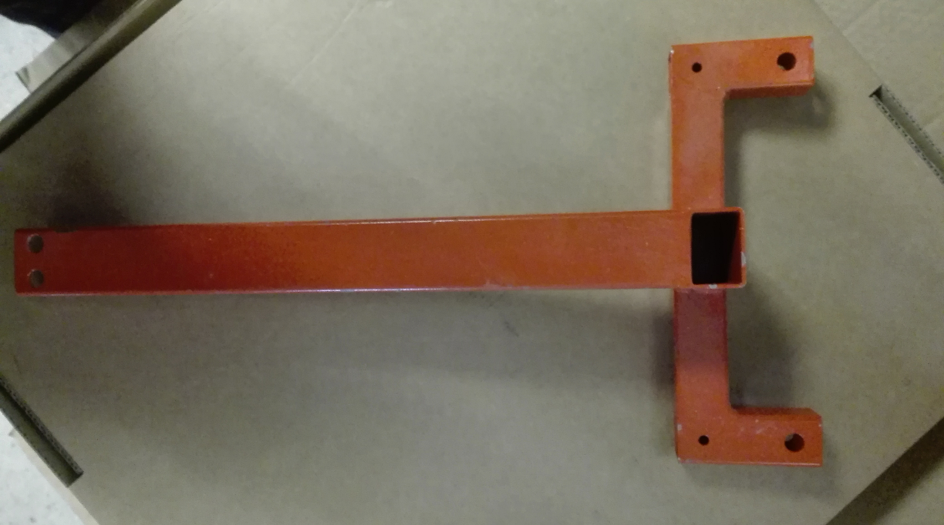
2- Rod Holder
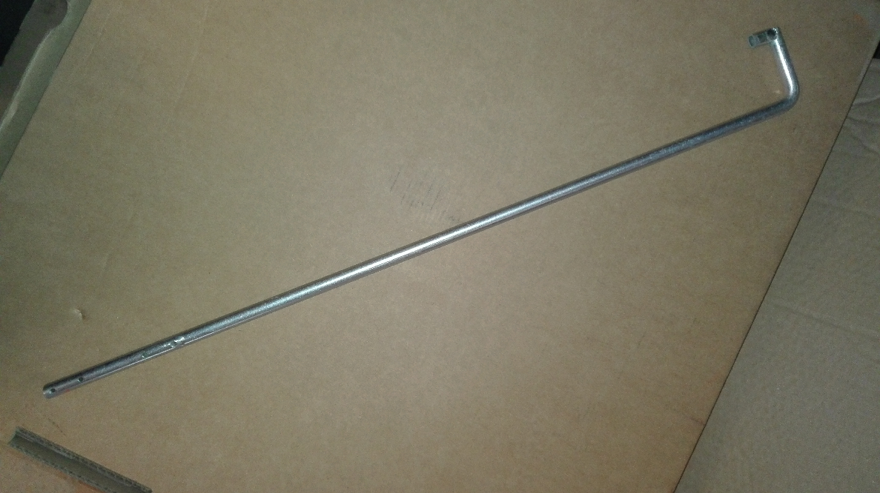
3 – Chronometer
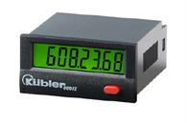
4- Spring
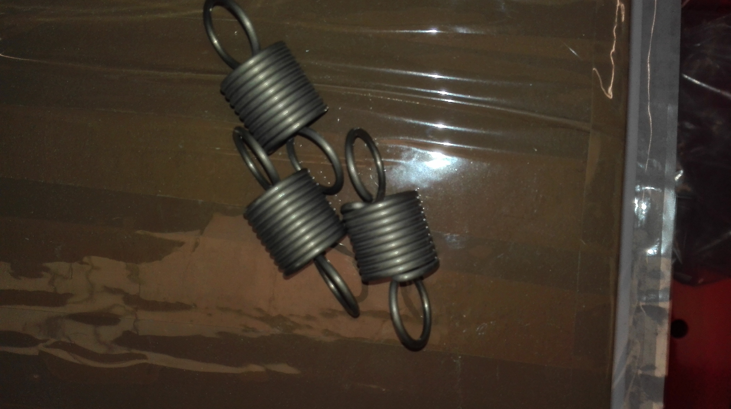
5- Turbine
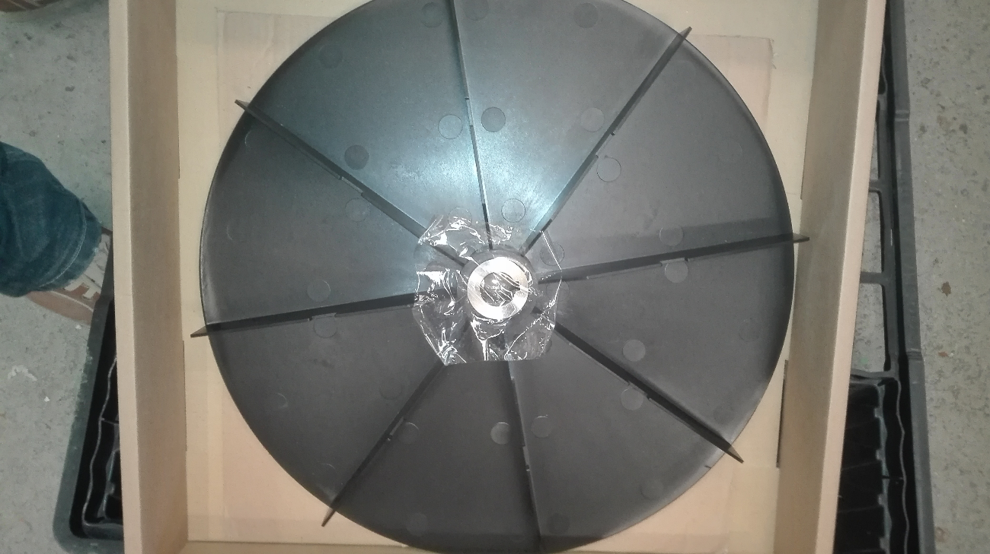
6 – Electrical wire
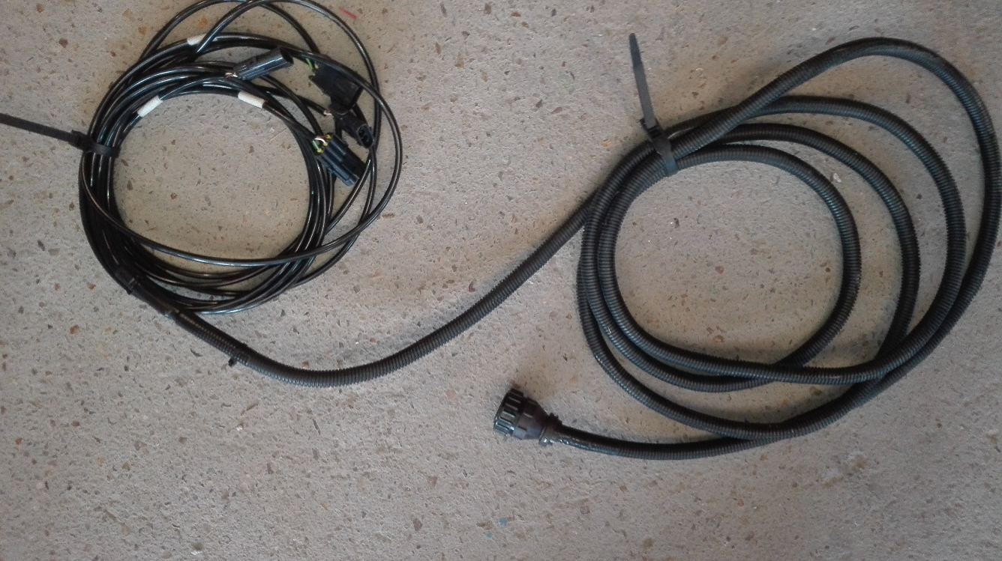
7- Rod for sorting
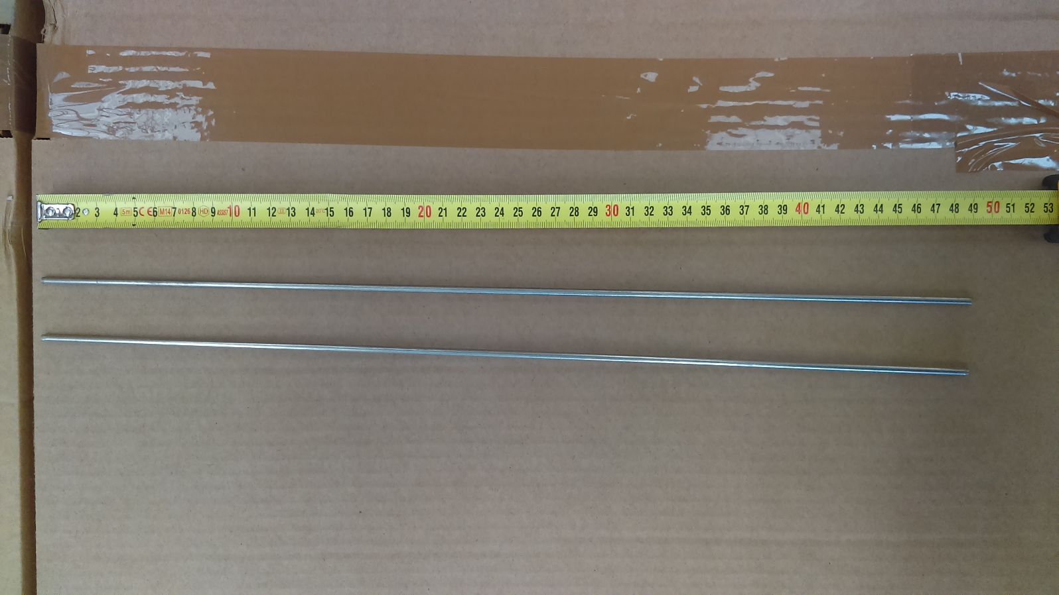

8- Washers
