How to detoxify your body in 3 days + secret advice.
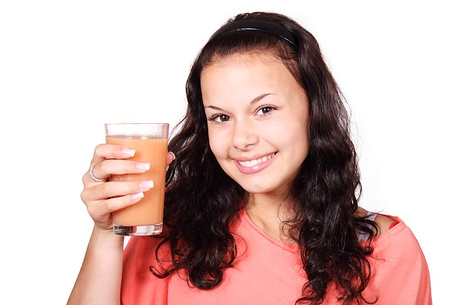

We always seek a solution to detoxicate ourbody !!

We always seek to have a healthy body!!

We always seek to avoid the toxins which are harmful with health to

have a total good health and a good digestion!!
In this article we share with you a secret to detoxicate ourselves during 3 days!

1- Procedure of Detoxification
During 3 days –
Food to be taken is in the shape of Liquid do not take Meat, Milk, Products dairy, Wheat, and Butterfat
Nutrition Therapy
Fresh vegetable juice (by centrifuge): Carrots, Beetroot, Cucumber, Cabbage, which can be diluted with boiled water or mineral water, or fruit juices, and then add one tablespoon of honey + A teaspoon of fresh bee pollen beans for each glass.
- Fruit juice: Green apple, Pomegranate, Cherry, Cactus fruit, Orange, Lemon, Grapefruit, Pineapple, Papaya, Watermelons.
- Infusion of plants : Thyme, Oregano, Fenugreek, Fennel, Anise, Armoise, Camomile, Curcumin, Saffron, Olive leaf, Carum Caraway, Ginger, Cacti Racket, Salvia, Marjoram, Licorice, Cinnamon, Rosemary, Thuja
- Barley green.
- Germinated seeds (germinated wheat, germinated watercress, germinated fenugreek
etc.)
Phytotherapy
We can also prepare the following combination:
- Thyme + Oregano + Ginger
- Camomile + Salvia + Marjoram
- Cinnamon + Liquorice + Anisates +Safran
- Anisate + Fennel + Caraway + Cumin
- Fenugreek + Carob
- Olive leaf + Salvia + Marjoram + Anise
- Curcumin + Licorice + Ginger + Anise
- Wormwood + Fennel
- Juice of the racket of cactus + Honey + Freshpollen
- Rosemary + Thuja + Fennel + Little ginger + Saffron
- Fenugreek + Carrobe + Jujube tree
- Barley + Artichoke sheet + Anise
Apitherapy
The second day to delay your breakfast up to10 a.m.: do not take anything except two honey soup spoons in
large tepid water glass (Water must be previously boiled)
If vomiting drink too much warm water until vomiting stops then take an infusion of thyme + tea. Take three to five dates and then still drink lukewarm water and rest yourself

To all the preparations indicated above we add for each glass 1 Tablespoon honey + 1 teaspoon apple vinegar.
During this 3-day period, at least one hour of brisk walking or a medium activity sport + sauna bath (if the person is not hypertensive and does not have a steam allergy).
For the next 5 Days
During these 5 days continue to take the liquids cited above to which are added cooked vegetables in the form of soup + whole rice + barley or germinated wheat or maize.
But still no milk, no cheese, no meat !
After these 5 days gradually add fish, vegetable oils (Olive, Argan), chicken, Wholemeal bread.
Dietetic:
- Reducing the consumption of red meat to a minimum. Avoid beef, veal and lamb, as well as meats and cold meats, dairy products yoghurt, cheese, ice cream, remove white sugar, pastries and sweets, white flour and derivatives (pasta, spaghetti, white rice ),
- Eliminate all types of fried foods, dyes and additives and all industrialized food products (table olive oil, soybean oil), chocolates, sweets, mortadella, condiments, preserves, mayonnaise, ketchup, lemonades, juices, coffee, tea, soft drinks ... )
- Increase the omega-3 fatty acid intake from fatty fish and fish oil and linseed oil (2 teaspoon oil or 5 tablespoon of seed)
- Increase intake of olive oil and argan oil. Olive oil contains many antioxidants. It must however be chosen natural.
Two tablespoons (30 ml) per day are sufficient. Preferably use unheated olive oil: in salads or with bread, instead of butter.
Each day, consume nuts not roasted and unsalted + Almonds (a dozen a day), nuts contain fatty acids of the same family as those found in olive oil, in addition they are very rich in Mg , Zn, folic acid.
- To increase the contribution out of fruit and vegetables. Objective: 7 to 12 portions
by day.
The fruits and the vegetables are rich in antioxydants. Consume regularly at least a vegetable or fruit portion of each of the six colors in order to obtain the largest spectrum antioxydants.

-Eliminate the consumption of margarines forever.
Avoid exposure to all types of chemicals: cigarettes, detergents, bleach, shoe polish, paint, smoke, gas, toilet water, cosmetics, perfumes, deodorants, toothpaste, insecticides, plastic packaging.
- Avoid the stressing situations, which cause agitation, and to learn how to manage its stress.
- Rest sufficiently: To have good nights of sleep and to make besides the naps at the beginning of afternoon, if necessary.
- Consume almost each day a vegetable soup + with chicken stock + parsley + coriandre +cinnamon sheet + bay-tree + sage sheet.
Algae: 2 soup spoons/day divided into two catches, between meal.
Sheets of olive-tree out of infusion (in the form of herb tea), two large glasses by day.

It remains you to apply the natural combinations and to follow the advices, the result depends on you now. We wish you to have a good health.

