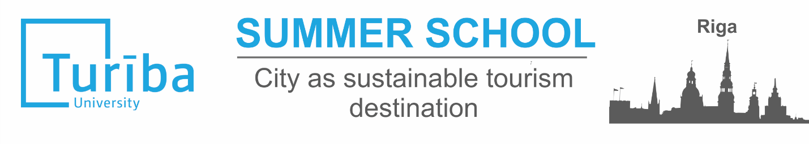
31.07.2017.-11.08.2017.
APPLICATION FORM
Name
Surname
Gender
Citizenship
Date of birth
Passport number, date of expiration
Home University
Study programme, study year
E-mail and contact phone
English knowledge (please evaluate your level of English, please mention if you have any Internationally recognised certificate)
Please explain your motivation to participate in Summer school (personal and academic motivation).
(from 150-200 words)
Detailed explanation should be added in Letter of motivation
Please describe your skills and knowledge which can bring added value to the group works and workshops. Describe your strong sides
(max.150 words)

Would you be interested to participate in case if you do not get scholarship (fee is 395 EUR) | YES / NO

Additionally to the application form please submit: 1) Letter of motivation 2) your CV.

All documents should be send to: kristine.tihanova@turiba.lv until 26.04.2017.

