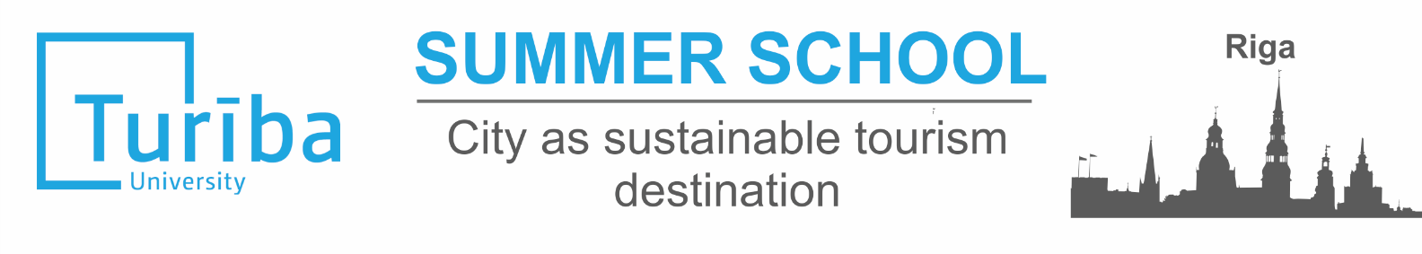
31.07.2017. - 11.08.2017.

Turiba University, one of the leading private higher business and tourism educational institutions in Latvia, invites you to participate in Summer school in Riga this summer.

Main topics: 1) City from perspective of architecture, infrastructure, culture and planning on the example of Riga; 2) Urban environment and City as sustainable Tourism destination; 3) Latvian culture, language and traditions.

Summer school will take place in Riga – capital of Latvia. Riga is biggest city of the Baltic States, it is cultural and economic centre of Baltics. At the same time Riga is good example of sustainable Tourism destination, which is main topic of the summer school. During the summer school you will explore different topics related to sustainability of the city, planning and development of tourism, will get to know Riga and with the help of our local students’ government will spend wonderful time in our beautiful city!

Summer school students will participate in lectures, workshops, discussions, will meet professionals and experts from Riga and Jūrmala city council, will participate in study visits and excursions. Students will have possibility to develop their own project work and will gain 3 ECTS for this Course.

Participants: bachelor or master level students interested in topic of Sustainable development, Tourism, Strategic planning, Architecture and Culture. Students must be at least 18 years old.

Place: Turiba University is located in Riga. University has modern campus where students will have everyday lectures as well as will be accommodated in our Students Hostel. Center is 8 minutes by train from the University.

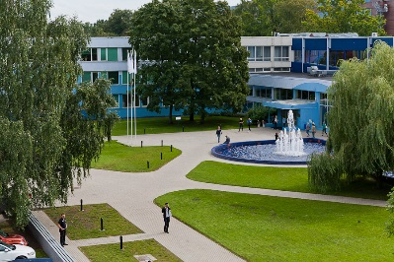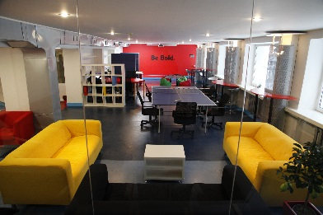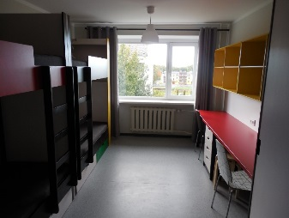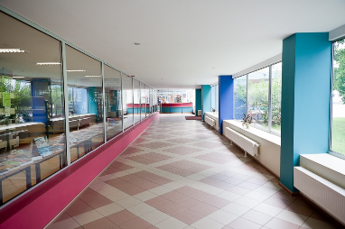

Costs:
Tuition fee is 395 Euro.
Participation fee includes accommodation (in campus, 3 or 4 bedded rooms in newly renovated students hostel, www.hostelturiba.lv), catering (3 times per day) and full programme of the School – lectures and workshops, excursions and study visits, public transport in the city, several cultural and free time activities.
Additional costs: traveling to Riga, visa costs, insurance.

PROVISIONAL PROGRAMME AND MAIN TOPICS OF THE SUMMER SCHOOL:
Day 1 | Introduction  Getting to know Latvia and Riga, Latvian language
Day 2 | Sustainable city and Tourism – what does it means?  Example of Riga city  Excursion in Riga centre
Day 3 | City as Tourism destination  Urban environment, examples of the world  Sustainable Tourism examples
Day 4 | Nature and environment issues in city  Study visit and examples
Day 5 | Architecture  Art Nouveau in Riga  Visit to Art Nouveau museum
Day 6 | Visit to Jurmala city, national part of Ķemeri  Free time and activities in Jurmala beach
Day 7 | Free time and optional activities organised by students’ government
Day 8 | Infrastructure and transport in the City  Group work
Day 9 | Culture and events as element of City tourism  Events, Cultural life and active Tourism possibilities in the City
Day 10 | Marketing of the city  Development of sustainable brad of the city  LiveRiga example
Day 11 | Development of new and specific tourism offers- business, conference, medical, gastronomy tourism products  Group works, preparing for final presentation
Day 12 | Final evaluation and feedback

For applications please contact Turiba University:
Kristine Tihanova, Kristine.tihanova@turiba.lv, phone: +371 67625371.
Please find more information and application documents on www.turiba.lv/en/
Turiba University will support you in visa application procedure, if needed.
YOUR BEST SUMMER SCHOOL EXPERIENCE IN RIGA, TURIBA UNIVERISTY!
