MYONGJI UNIVERSITY 2017 CSAM CULTURAL EXCURSIONS
Please check the programs you wish to participate. It is not possible to cancel the participation status
during the program since the programs will be reserved 2 months prior to the actual program date.
Program | Details | Picture | Price | Check
Play a  Korean  traditional  percussion  quartet  (Samul nori) | You will learn to play Korean traditional instruments and Korean traditional music. Samul nori is a Korean folk genre comprising music, acrobatics, folk dance, and rituals, which was traditionally performed in rice farming villages in order to ensure and to celebrate good harvests. | 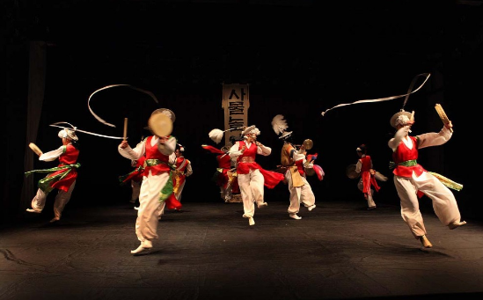 | 25,000  KRW
Watch a  Performance  Show  (the show may change  without  prior notice) | Bibap is a nonverbal performance based on the Korean representative dish, bibimbap (rice mixed with vegetables and beef). As a nonverbal performance, the actors mimic the sound of making bibimbap with beat-boxing and a cappella, demonstration of motions through b-boying, and acrobatics and martial arts. | 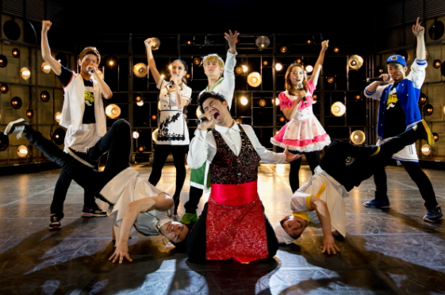 | 30,000  KRW
Designing a  Korean  Fan with  Traditional  Korean Art  Paper (Hanji) | You will use Korean traditional flour glue to paste a unique type of Korean traditional paper in a traditional Korean fan. You will gain your own version of Korean traditional fan, one of a kind. | 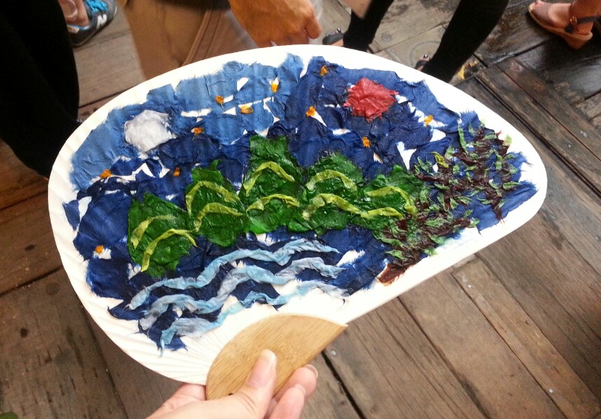 | 25,000  KRW
1 night &  2 days trip  out of Seoul  to a Korean  traditional  Village | Sleeping in a Korean traditional style house within a Korean traditional village town with Korean students.  You will also be making a traditional Korean item, try-on Korean traditional costume and enjoy traditional Korean games.  The village is around two hours away from Seoul. This will be a great chance to experience Korean traditional culture by reliving the past in Hanok, a traditional Korean housing.  Students also get to enjoy a cool water splash in the water stream. | 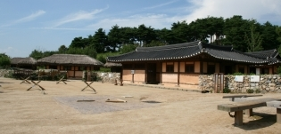  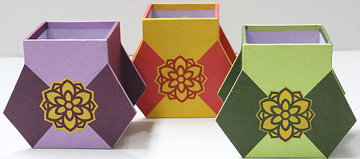  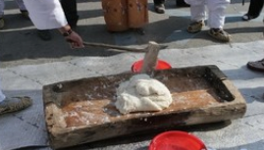  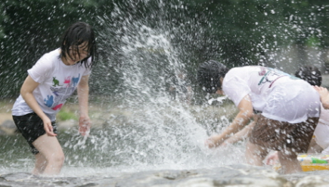 | 250,000  KRW
Painting  two mini  traditional  Korean Mask | You will be experiencing Korean traditional calligraphy with Korean traditional brush and ink.  You get to make your own hanging scroll with your Korean name and paintings. | 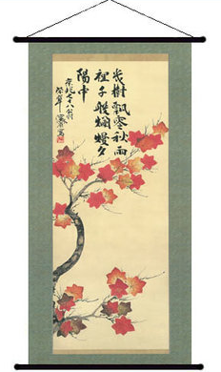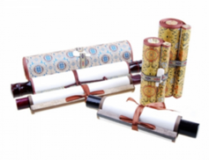 | 25,000  KRW
Cooking Korean Food  & Visiting  Korean  Cultural  Street | You will be cooking two different Korean dishes. Jjimddak (steam soy sauced chicken) and Hemul Pajeon (green garlic pan cakes with seafood). These menu are popular Korean dishes that is eaten widely even today. | 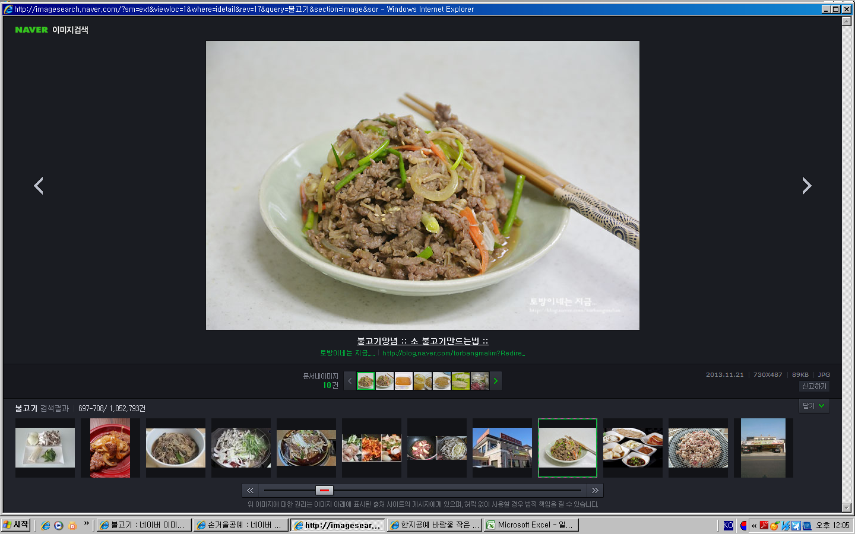 | 30,000  KRW
Visit  Gyeongbok gung &  Traditional  Museums | Gyeongbokgung is the palace where  Kings used to live in Joseon Dynasty. Built during the reign of King Taejo, beginning of the  Joseon Dynasty, Gyeongbok means  “a palace greatly blessed by Heaven.” One can admire the glamorous & classic architectural details and see how old time Koreans lived. | 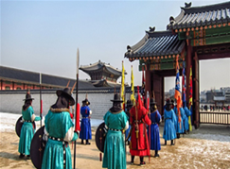 | 10,000  KRW
※ Vising Insadong and the Han River is free of charge, but to protect the rights of students who pay for the cultural excursions, only those who participated in the Korean Cooking class (with charge) and MBC visit (with charge) can accompany the participant group.
※ The details of the excursions may vary or change without prior notice and price won’t change since other details will be customized.

