SPONSORING FILE
Zoé DARNANVILLE

Thank you for taking the attention to read the document.
Presentation
My name is Zoé Darnanville, I am 21 years old in 2017 (02/07/1996). I am a professional rider and a young hopeful of CDE 76 (Equestrian Departmental Committee).
Formerly a member of the French team in the "Pony" category, I get a reserve place at the European championships in Fontainebleau and a Bronze medal at the French championships in 2012.
I get a second Bronze medal in the junior category on horseback in 2014 and several rankings in the year.
In 2015, I get several national and international rankings, I am then spotted by the coach of the France team in the Young Rider category (19 to 21 years), this category is the last step before the high level (Senior).
In 2016, I am ranked quite regularly with my horse and my other horses especially in the CSI * Le Mans or I am 8/10/ 8th of the 1.40m. I currently run on 1.45m and I made my first GP 1.50m at the CSIO-YR in Macon or I got a small fault on the river.
This year (2017) I am aiming for my entry in Team France Young Cavaliers with a regular season on the national and international courses as well as to obtain rankings at the Championships of France of the As (Young Riders) and the Championships of France Professionals in Fontainebleau .

I still have 1 year in the Young Cavaliers category and before reaching the senior category. This year's event with my horse "Amelon" is the Pro 1 (1.45) and the Pro Elite (1.50), I will follow the “Grand National circuit” (national circuit) and do international (CSI ** / CSI ***).
I have other horses, like my second horse of head "Royal" that will turn on 1.40 then 1.45m, an 8 year “selle français” "Vridi Beach" which will make the 1m30 / 1m35, "Regal" for the speed events 1.25, then two horses (5 years) to the valorization on the circuit young horses with the championship young horses.
I work with a 5* French rider in order to continue my learning.
I am looking for sponsors for several reasons, on the one hand the project of a possible sponsorship / partnership can be a real help for the season to come. Indeed to arrive at high level, in addition to training, the budget becomes really important.
I am a really motivated and dynamic person to represent the brand. I talk a lot around me during contests of the products I try. I am someone who regularly sails on social networks, I have a good notoriety in France.
Some sponsors already follow me, why do not you leave? (CWD, Le Sabotier, Tutti Quanti)
So, if the project comes to fruition, I have a lot of advertising material to offer.
In addition you can find the link of my Youtube channel to view my horseback riding: https://www.youtube.com/user/ZoeDarn
A website is being created. My Facebook page and Instagram: Zoé Darnanville
I am open to all proposals.
Contact: zoedarnanville@icloud.com / + 33 6 43 39 66 28
Some pictures below ...
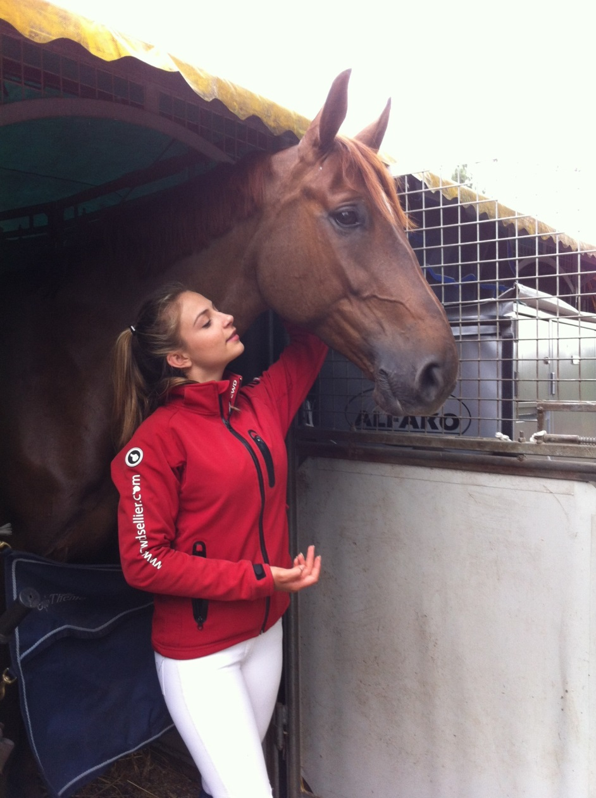
Amelon & me

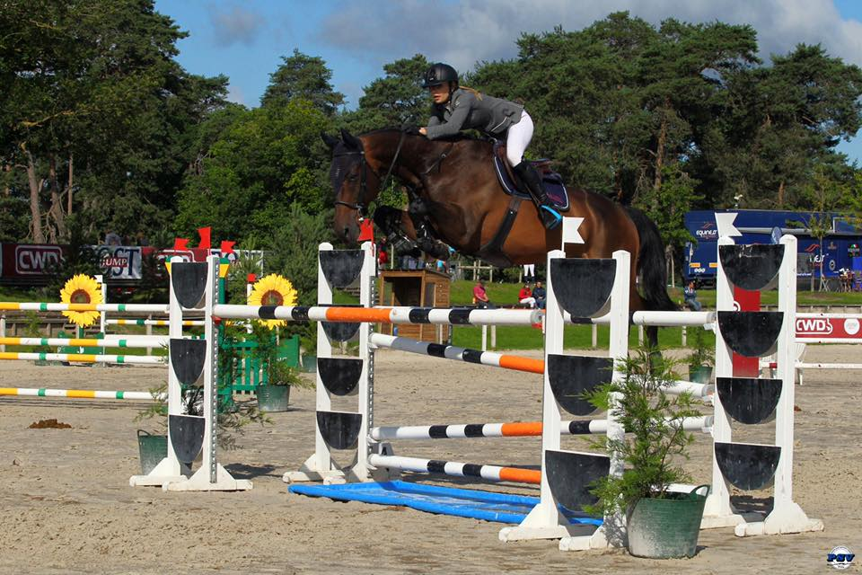
Royal & me (1,35)
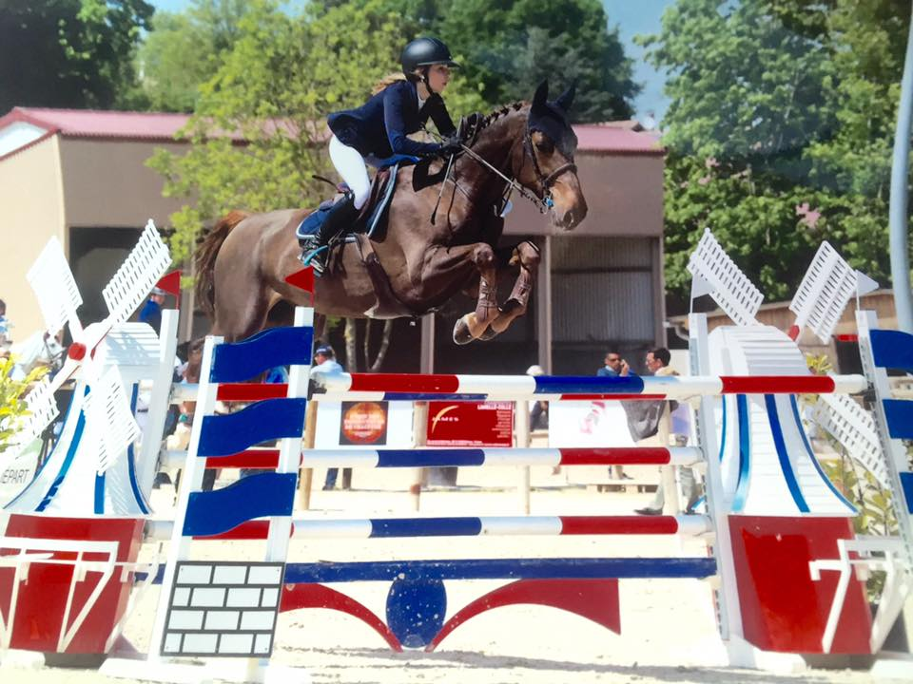
Amelon & me (1,50)
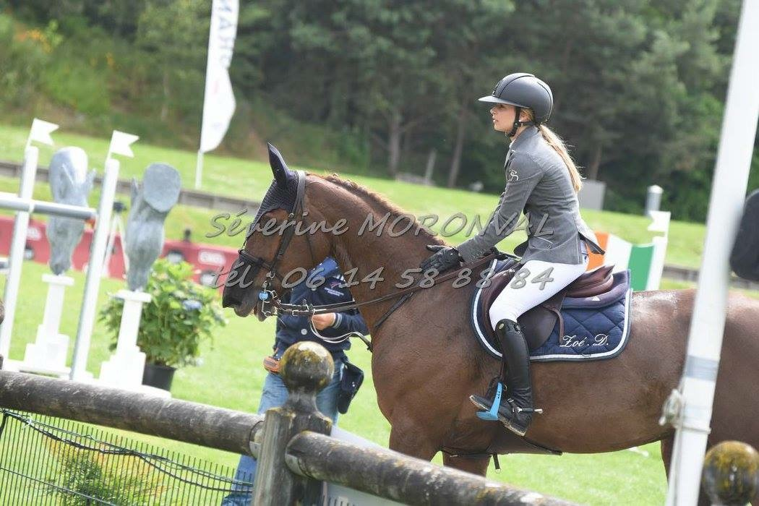
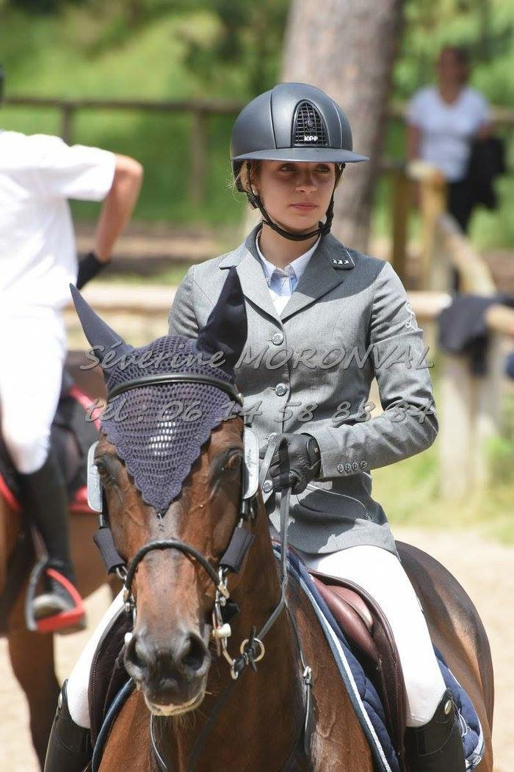
Royal & me

