Khairedine becha. Prep school Teacher :Miss Kouki
October,2016 Level :7th form

MID- FIRST- TERM TEST

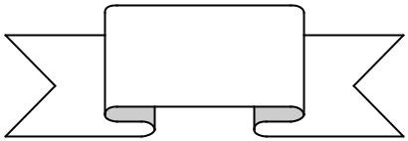Name :………………………….………………………….. Class : …………………………..……………… number:………….

…... / 20

SPELLING (6marks)

Task1 : Listen and complete the paragraph. (3marks )

Hello ! My name is Sarah. I’m a………………………………… .  I’ve got two
………………………………………. : a son and a……………………………

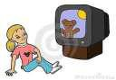They are pupils in a prep……………………………………….. . They usually …………………………cartoons. It’s

.

their only……………………………

Task2 : Complete the words and write the numbers in letters. (3marks)


Hi ! My name is Kate. I’m (11)…………………………years old. My father is a f-
f- - - - - My mother is a housewife. I’ve got two brothers . They are (9)……………………………… and (13)……………………………..years old.

They like d - - - - - g pictures very much. I love d - - - - - -

LANGUAGE (1 4marks)

Task1 : Fill in the blanks with words from the list below. (5marks)

enjoys - wife - They - love - mechanic - boys - sister - have got - pastime - isn’t - is - girls
- doesn’t - composed

My name is Jack . I’m a …………………………………. . My family is …………………… of four persons. Mary is my………………………………… . She ………………………………….

a secretary. We ………………………. two sons :Bob and Ted. ……………… are nice

…………………. Bob is 12 years old . He is very intelligent. He …………………….. chess
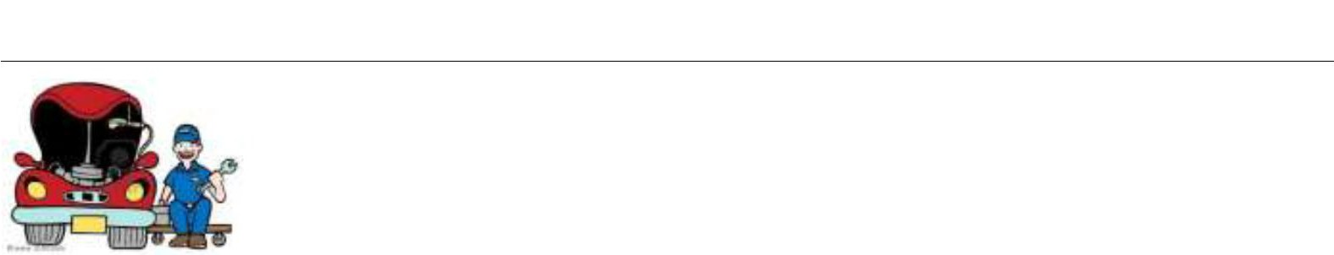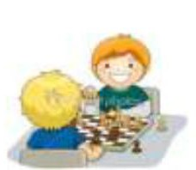Ted is only five. His favourite ……………………………… is playing with his dog.  But he …………………………. like cartoons ! 

Task2 : Circle the right alternative(4marks )

Linda is my best friend. She is (England - English - england ). Her father is a doctor.
But her mother doesn’t ( work - works - working). She ( gets up usually -

usually gets up - gets usually up ) early. She ( wash - cleans – cooks )

the house and prepares lunch.
Linda ( isn’t – hasn’t – haven’t) got brothers and sisters.I sometimes visit her and we do our ( homework – class - bed ) together.

(At – On – In) Sunday, Linda goes out with her parents. They like ( eating in a restaurant.
- eat – eats)

Task3 : Match the questions with the right answers. (3marks)

QUESTIONS | ANSWERS
- What’s your name ?  - How old are you ?  - Are you in my class ?  - What’s your hobby ?  - Have you got brothers ?  - How many brothers have you got ?  - Does he like football ? | a- Yes, I have. b- Yes, he is. c- I’m Jim.  d- I love football. e- No, he doesn’t. f- Yes, I am.  - Only one.  - He is sixteen.  i- I’m 14.

1 | + | C | 2 | + | …….. | 3 | + | …….. | 4 | + | ……… | 5 | + | …… | 6 | + | …….. | 7 | + | ……

Task4 : What time is it ? Draw the hands or write the time. (2marks)

1/ It’s………………………………….

2/ It’s……………………………………

3/It’s four o’clock

4/It’s a quarter to six

