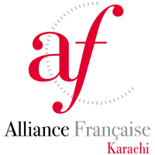
Call for Art Students
Alliance Française is providing an astonishing and a huge platform for undergraduate students to demonstrate their best “Art Work” in The Mahvash and Jahangir Siddiqui Art Gallery at Alliance Française de Karachi. Students, who have created treasures of art and have the spark to what it takes to stand out, then wait no further as we are providing the opportunity to exhibit your work and to get yourself enrolled with the art world with an ultimate exposure. The exhibition aims to communicate the unique and varied ways that students see the world, and to provide them a reputed platform.
Submission Criteria:
- Submit up to five (5) works, in any medium.
- Artist will photograph their work and attach the photographs along with this form and email it on af.artgallery@gmail.com
- Number your photographs according to the table on pg2.
- If necessary for an art piece such as a sculpture which needs to be photographed from all three dimensions.
- Work must be dry, clean, framed (if required) and ready to hang.

Deadlines:
- Last date of submission of this form is 20th June 2016
- Art works will be selected and selected candidates will be informed via call or email onwards 21st June 2016.

Application Form
Artist Name:
Address:
Contact number: Email id:
Name of Institute/University:
Diploma/Degree: Semester/Year:

No. | Type of Work | Medium | Title | Size | Description/ Statement | Price
1.
2.
3.
4.
5.

