Reciprocating saw Ryobi RJ165V Variable speed/ Double insulated + extension cord – $20
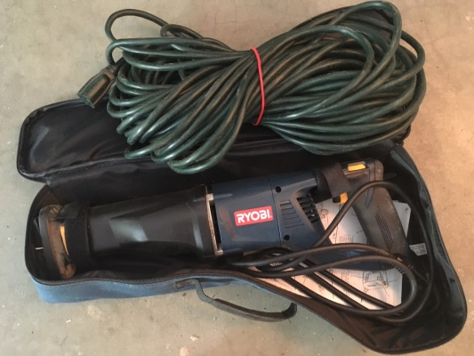

Belt Sander Black&Decker 7 Amp 3 in. x 21 in. – $20

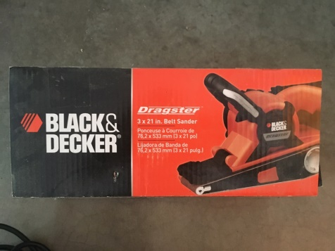
Humidifier Air Innovation MH602 - $40
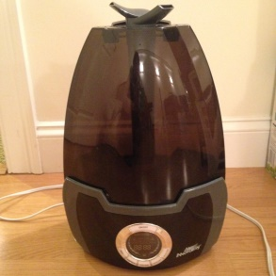
Outdoor Christmas lights - $10
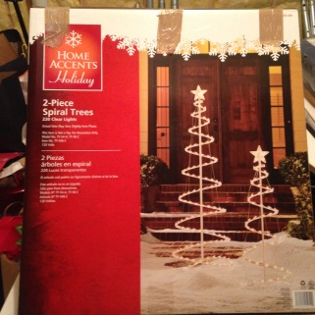
Raclette - $40
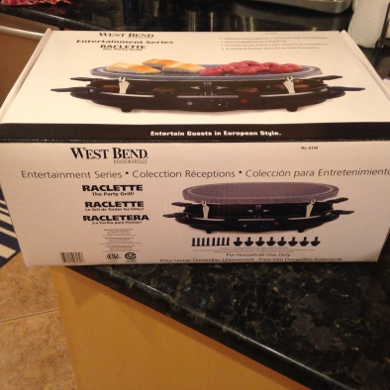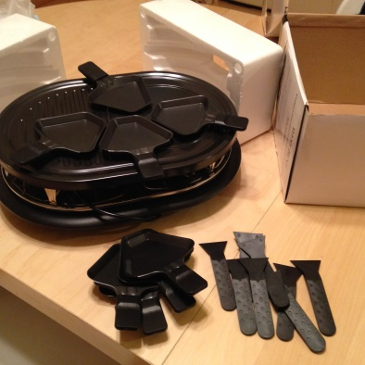
Stroller Graco (compatible with Graco baby carseats) - $15
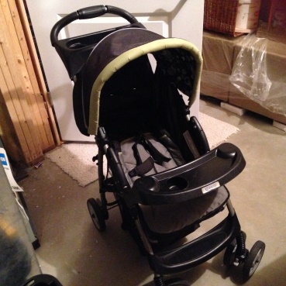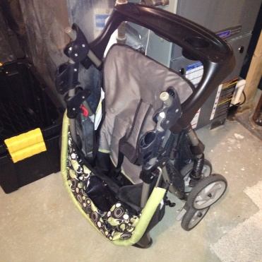
Funsport Play Yard (Cosco) - $20
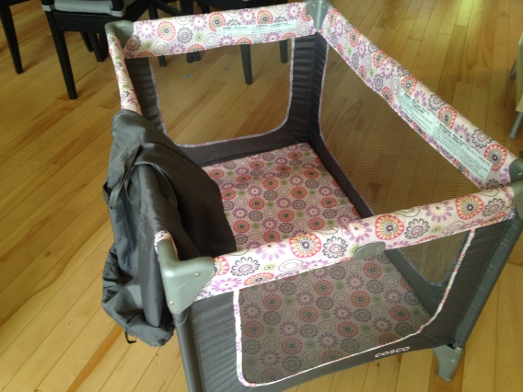
Home phone - $25
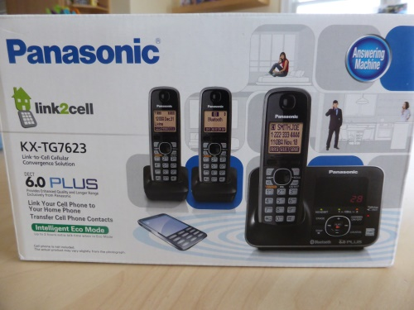

Coffee Maker MR COFFEE, 5 cups - $7
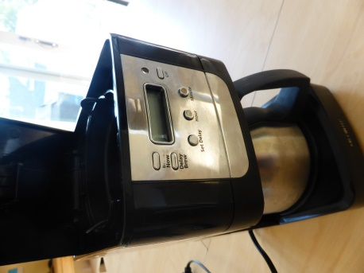

Electric Kettle Hamilton Beach, 1.7L - $7
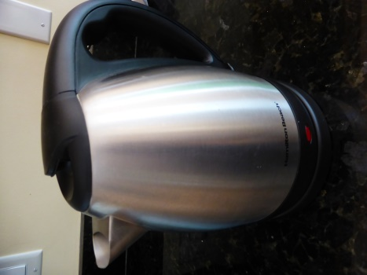
Toaster Oster - $20
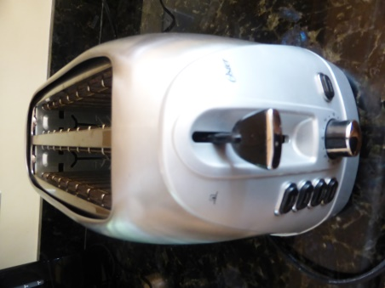
Food chopper Kitchen Aid - $20
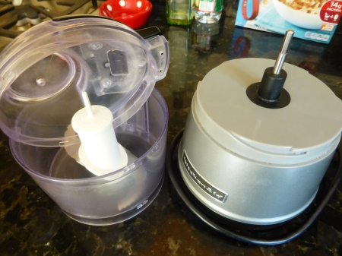
Hand blender Kitchen Aid - $15
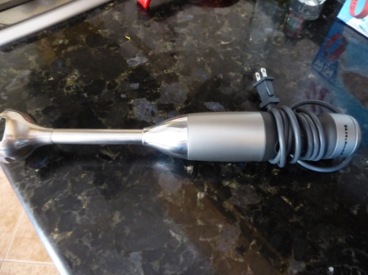

Electric hand mixer Kitchen Aid - $20
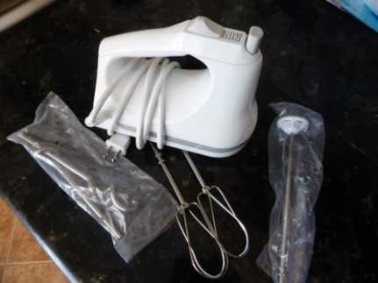
Rice cooker Aroma - $10
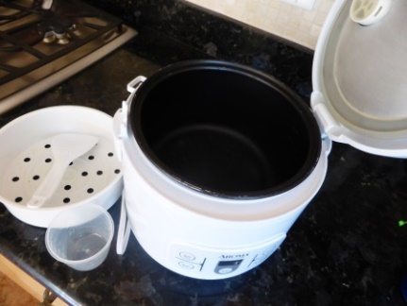
Blender Oster - $25
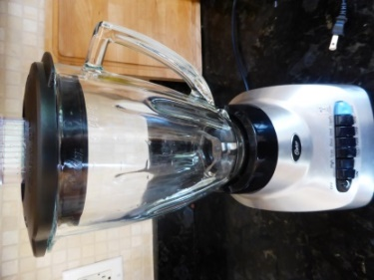
Television LG (LGLM 62-42’’) - $500
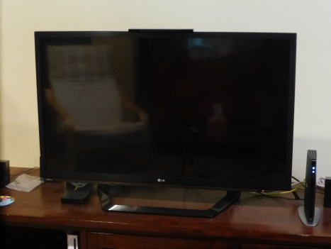
Home cinema Sony DAV TZ 135 (can read French DVDs) - $50
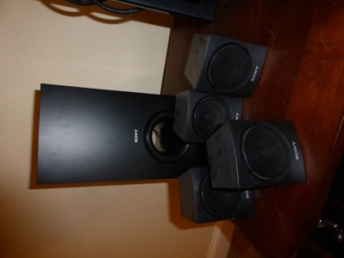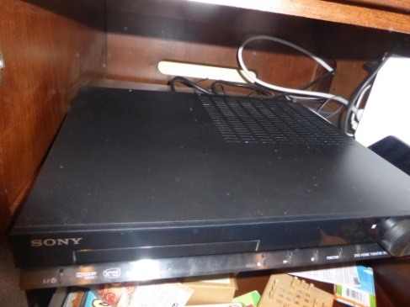
Iron Rowenta (available June 12th) - $30
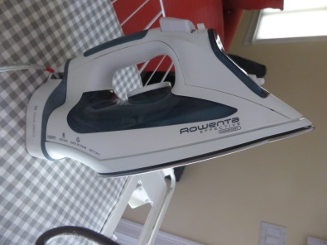
Vacuum Electrolux Access T8, bought in 2015 (available June12th) - $90
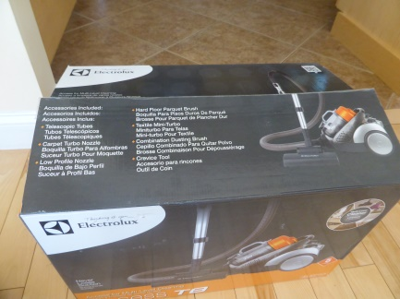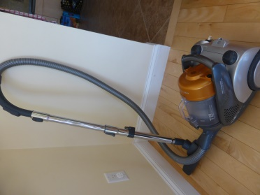
GPS Tomtom #4CT50, with jacket, bought in 2012 (battery out of service, need to be connected to 12V power) - $20
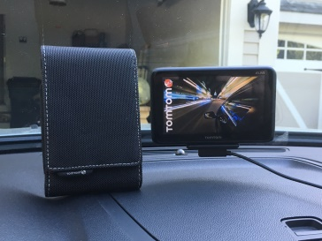
GPS Garmin, Nüvi 2555 LM, with jacket, bought in 2012 - $100
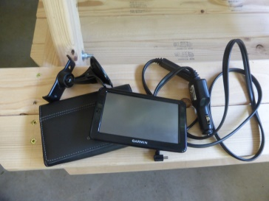

6.9 cu. ft. Chest Freezer in White, bought in 2015 - $150

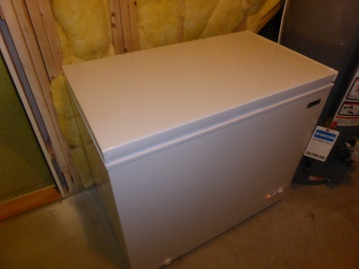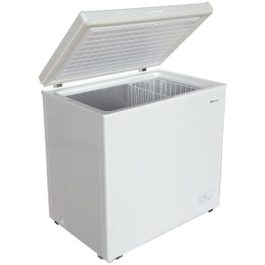

HELLO KITTY KT2024A Stereo AM/FM/CD Boom Box - $20

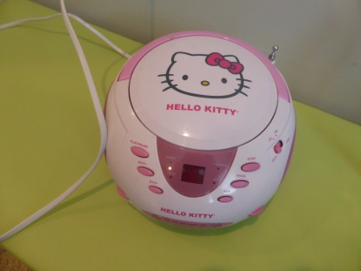
2 table lamps, Ikea, Knubbig - $5 each
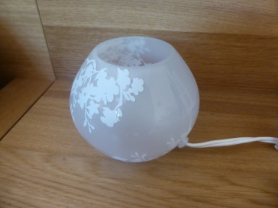
2 floor uplight/reading lamps, Ikea, Not - $5 each
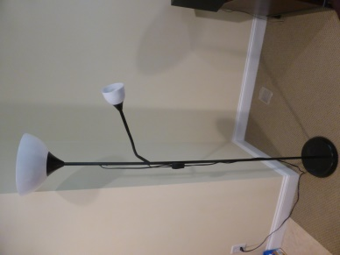
1 table lamp, Ikea, Grönö - $5
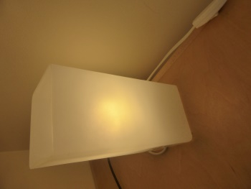
3 work lamps, Ikea, Jansjö - $5 each
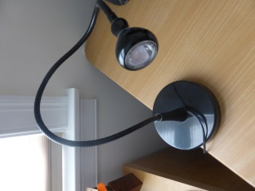
1 table lamp - $5
