Madani Boualem middle school March 2016 Level : MS2 Duration : 1h:30
Examination of English ( 2nd Term)

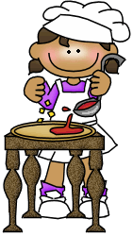
My name is Liza .My favourite food is pizza. I can make pizza. My dad says my pizzas are very good. I don´t like cheese. So there´s no cheese on my pizzas. When we go to a restaurant I always order chicken with chips and an ice cream. My favourite flavour is strawberry. We like drinking coke. When we have a party we have lots of coke.

My name is James . I don´t like vegetables. Mum always tell me to eat carrots. She says they are good for me. But I hate them. I only eat potatoes. Potatoes are my favourites. I like them as chips or as crisps. I often eat crisps at school. I drink a lot of milk, but I don´t like juice or coke. But you can´t drink milk with hamburgers or chicken. So I drink water too.

My name is Bob . I like tomatoes and peas. My mum says they are good for me. I always have tomatoes on my pizza. We have peas in our garden. Mum and I like the fresh peas from the garden. I don´t eat chicken or fish, I think it´s not right to eat animals. My favourite sweets are doughnuts.

Part One : (14 points)
Reading Comprehension :(7 pts)
Activity one: (3pts)

True /False ( correct if it is false)

- Liza favourite food is hamburger.
- James loves vegetables.
- Bob likes tomatoes and peas.

Answer the following questions : ( 2pts)

- Can Liza make pizza?
- Is vanilla Liza’s favorite flavour?
3- Does james eat Chicken?
4- Does Bob drink a lot of milk?

Lexis : (2pts)

Read the short texts again and complete the following chart:

Vegetables | Fruit | Meat | Dairy products
1-……………..  2-…………….. | 1-………….. | 1-………….. | 1-………………  2-………………

B - / Mastery of Language : ( 7 pts)
Activity one : Add ( ‚ ) or ( s) : (1.5 pt)
- Karim ……car is broken.
- Anes …….mobile is new.
- The pupils……books are on the tables.
Activity two : Circle the adverb of manner in the following sentences:( (1.5)
- Amina writes ( careful – carefully).
- She sings ( well – good).
- My cousin drives ( fast – fastly).
Activity three: Turn to he passive voice: ( 2 pts)
- My mother prepares dinner .
- I wash the vegetables .
Activity four : Find in the text :( 2 pts )
/ ʃ / Sheep | / tʃ / Chips
1-………….  2-…………. | 1-…………….  2-………..

Part two : Written Expression: ( 6pts)
Imagine you are alone at home and you feel hungry , what is the easiest sandwich you can make alone:
This table will help you to prepare your sandwich :
Ingredients | Verbs | Sequencers
Bread  Olives  Tomatoes  Cheese / Mayonnaise  Lettuce | Cut  Add  Spread  Wash | First ,  Then ,  After that ,  Finally,

Good Luck .

Madani Boualem middle school March 2016 Level : MS2 Duration : 1h:30
Examination of English ( 2nd Term)

Watermelon
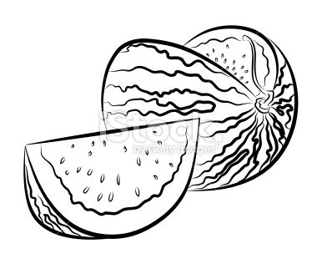
Watermelon is a delicious fruit. It is called watermelon because it is mostly water. In fact it is 92% water.
It’s usually round and green on the outside. When you cut open a watermelon it’s red or yellow inside. Sometimes there are black seeds inside and sometimes the watermelon is seedless.
Watermelons are grown all over the world. The largest producer of this fruit is China. More watermelons are grown in China than anywhere else in the world. Many people like to eat watermelon, especially on a hot summer day!
Part One : (14 points)
Reading Comprehension :(7 pts)
Activity one: (3pts)
True /False ( correct if it is false)
- Watermelon is a vegetable.
- Watermelon is very rich in water.
- Water melon are grown only in Africa.
Choose the correct answer : ( 2pts)
- Watermelon contains : 90 – 92- 95 $\%$ water .
- Watermelon is : round and red – round and red yellow – round and green .
Lexis : (1pt)

Words | Synonyms
- Tasty  - Many | - lot of  - Delicious
Color this watermelon : ( 1 pt)
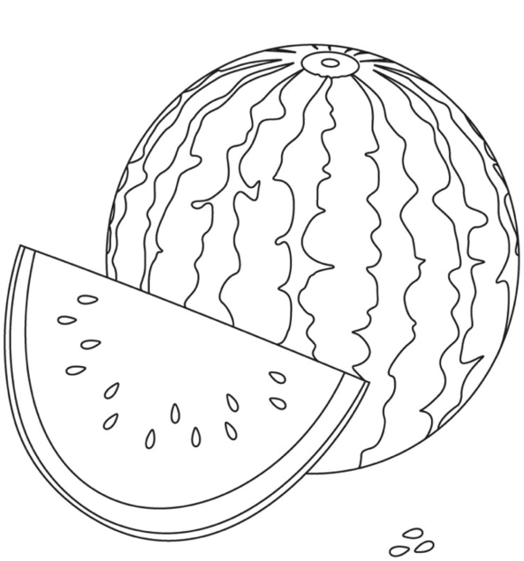

B - / Mastery of Language : ( 7 pts)
Activity one : Add ( ‚ ) or ( s) : (1.5 pt)
- Karim ……car is broken.
- Anes …….mobile is new.
- The pupils……books are on the tables.
Activity two : Circle the adverb of manner in the following sentences:( (1.5)
- Amina writes ( careful – carefully).
- She sings ( well – good).
- My cousin drives ( fast – fastly).
Activity three: Turn to he passive voice: ( 2 pts)
- My mother prepares dinner .
- I wash the vegetables .
Activity four : Classify the following words:( 2 pts )
(China – ship – match – wash )
/ ʃ / Sheep | / tʃ / Chips
1-………….  2-…………. | 1-…………….  2-………..
Part two : Written Expression: ( 6pts)
Why is healthy food good for you?
In a short paragraph , explain what is healthy food and why is good for you by giving examples about it .
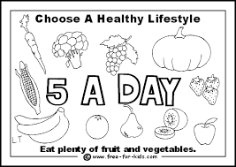

Good Luck .

