Madani Boualem middle school March 2016 Level: MS4 Duration:1h:30
Examination of English 2nd Term
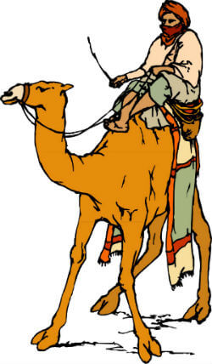
Tassili n'Ajjer is a place located in the southeastern part of Algeria. Is it is a very large place that is 72,000 square kilometers in area. It is in the desert so is very dry.It is a UNESCO World Heritage Site.
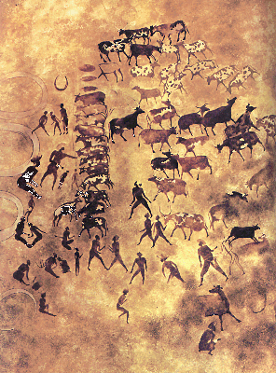
1933, archeologists found cave paintings and drawings. People who used to live at Tassili n'Ajjer many years ago painted them. They tell the history of the area and the people who lived there.
Today, can look at the paintings and understand what Tassili n'Ajjer looked like 8000 years ago. These pictures show lots of cows and people’s everyday life. Other pictures show camels and lots of desert. What these pictures tell us is that there must have been a lot of water there. Cows need water to drink and grass to eat.
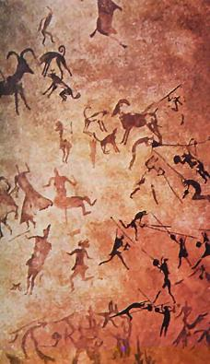
Because these paintings are so important to history, they are being very well protected. The Algerian government as well as the United Nations takes care of them. Scientists are also doing research to learn how they can protect the paintings from the weather and the heat. It is important to preserve the beautiful images so that we can all learn about our history from them.

Part one : (14 pts)Reading comprehension : ( 7 pts)
Read the text carefully , then answer do the following activities:
Activity one : True / False / Not mentioned: ( 3pts)
- The text is about Tassili N’Ajjer which is situated in the north of Algeria.
- Tassili N’Ajjer is one of the most beautiful places in the world.
- Tassili N’Ajjer is protected by the U.N.E.S.C.O.
Activity two: Answer the following questions: ( 2 pts)
- Where is Tassili N’Ajjer ?
- When did the archeologist discover the paintings?
Activity three: Match
Word | Synonyms
Protected | Sahara
Frescoes | Climate
Desert | Paintings, drawings
Weather | Preserved

Mastery of language : ( 7 pts)
Activity one : Supply punctuation and capital letters when necessary and correct the underlined mistakes : ( 2pts)
is algeria is one of the more beautiful countries on africa
Activity two : Turn into the negative form : (3pts)
- Caves people used to live in wooden house.
- Life in the Sahara was safe in the past .
- In the past people lived complicated life.

Activity three : Pick out ( ) the word with a different vowel sound : ( 2pts)
/ɔ:/ | boy soy saw toy
/ɪ:/ | sit seat sea seem
/u:/ | school dot choose goose
/ei/ | may my name make

Part two : ( 6 pts)
Your English friend wants to visit Algeria as a tourist. He asked you about the most famous places he should visit when he comes .Reply to his letter, suggesting to him the best places he should visit.
Respect the letter’s body.
- Talk about Algeria’ location ,area, climate
- Talk about the famous places in the north and in the south
- Don’t forget to show that you are proud of your country
- Use simple tenses, linking words , sequencers
- Don’t fear words, words must fear you?

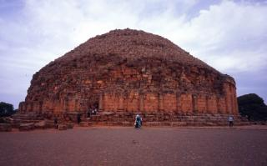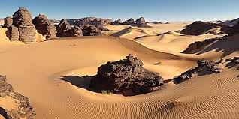

Good Luck

