HARBOUR PASS $50 (available at EF)
7pm- 8pm include Fireworks at Circular Quay
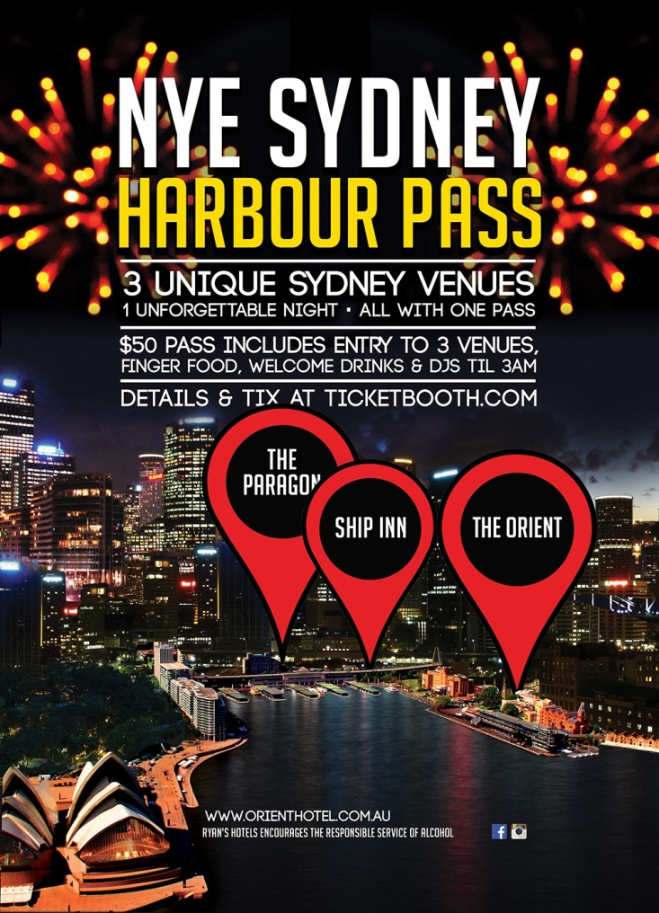
With entertainment across 3 venues from the best DJs and Artists gathered from across Australia, food stations and bars located all around 3 Iconic locations, unlimited access for all ticket holders and all the amenities to make your evening as comfortable and enjoyable as possible – Sydney Harbour Pass is the only ticket you need when in Sydney for New Year’s Eve! | Orient Hotel: 89 George St, THE ROCKS  Entry into the Orient and Toto nightclub from 6pm (pass outs included)  Food stalls & NYE food specials  DJ’s & entertainment from 8pm ( Dollar Bear, Jackson Hunter, Aftertouch, Steph Luxe )  Views of the harbour  Complimentary canapes from 7pm – 8pm
Paragon Hotel: 1 Loftus St, Circular Quay  General Entry into the Paragon hotel from 6pm onwards (pass outs included)  DJ’s and entertainment from 8pm (Joe Barrs, Caviar, House Bear, Whiskey Mixed)  NYE Special food menu and NYE happy hour from 7-8pm  Access to the Harbour foreshore precinct for the fireworks | Ship Inn: CNR Pitt St & Alfred St, Circular Quay  Entry into Ship Inn bar from 6pm (pass outs included)  Complimentary pizza from 7pm – 8pm  DJ’s from 8pm (DLE, Sarkozy, Liminal, Coopa)  Prizes & Giveaways
Online tickets
Marquee : Dash Berlin $182.20
10pm without fireworks
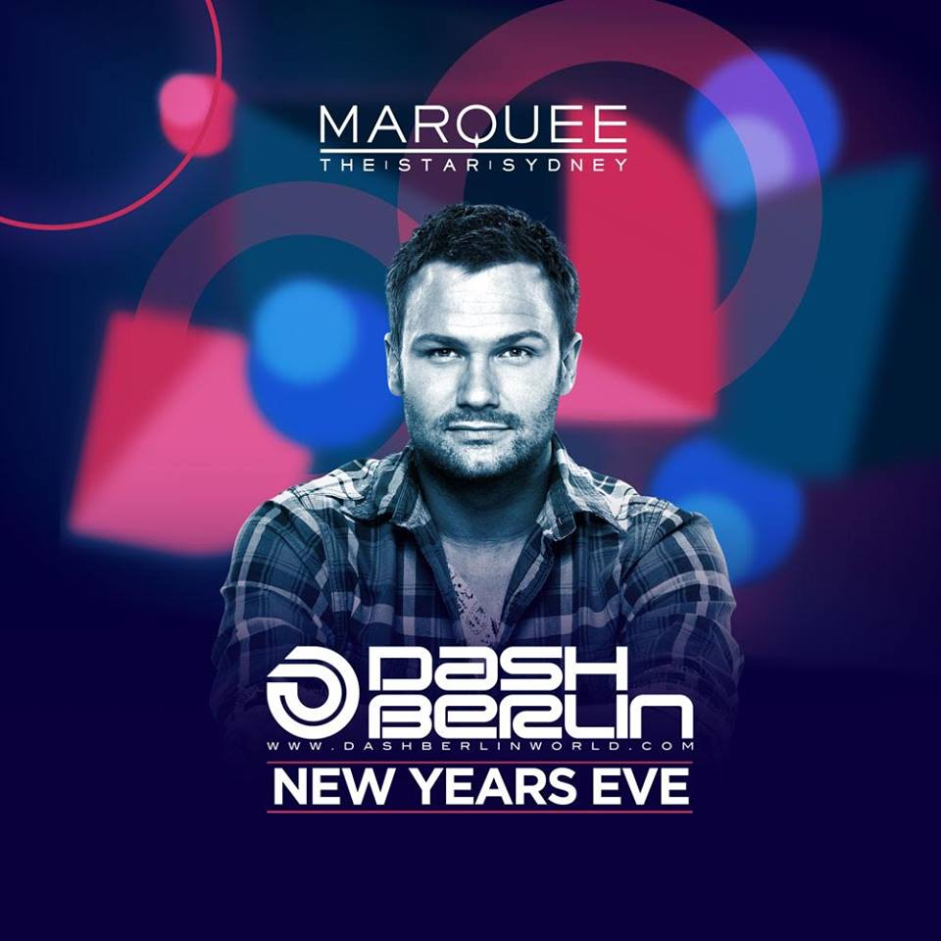
Lights! Camera! Action! Marquee Sydney is pleased to announce Dutch superstar Dash Berlin will be headlining NYE at Sydney’s most prestigious
nightclub. Amongst the elite of the world’s top DJs, Dash Berlin is the man behind one of the biggest anthems of the noughties ‘Till The Sky Falls Down’.
Celebrate with exceptional views of the midnight fireworks and Sydney’s most fashionably minded crowd til the sun rises on 2016.
Your ticket includes:
Express entry to Marquee all night, personalized photograph on arrival and sparkling midnight toast.

IVY: New Years Party $134.10
8pm without fireworks
Moet Gold Nye Party $80
7 Pm Moet gold Nye without fireworks

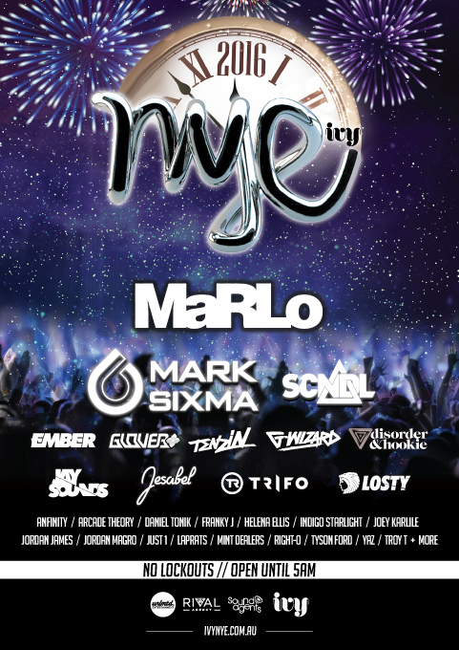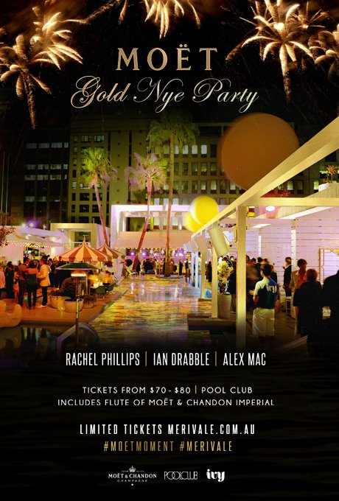

NYE : This New Year's Eve, ivy will house some of Australia’s biggest dance music artists including an exclusive New Year's Eve set from trance heavyweight MaRLo as well as an all star line up SCNDL, Tenzin, Ember, Jesabel, Disorder & Hookie, Glover, G-Wizard, Jay Sounds, Trifo and many more.

MOET : Free flute of Moet Chandon Imperial

Shelbourne Hotel : NYE carnaval $25
Doors Open 8pm and 1.30am Lockouts enforced
Fireworks from Darling Harbour
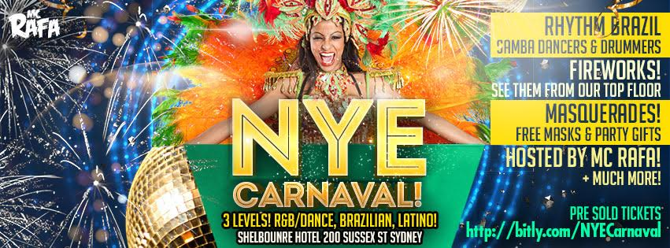
NYE Carnaval at Shelbourne Hotel200 Sussex st Sydney

3 Levels of Music
Level 1: Old School, R&B, Trap & Dance Music Mash Ups
Level 2: Brazilian Party Anthems, Baile Funk & MPB
Level 3: Latin Rooftop Party! Reggaeton, Salsa & Latin Mix!
Rhythm Brazil
Australia's Finest Brazilian Performance Company and Samba Dancers in Full Feather Costume & Batucada Drummers!

Free Masquerades Masks & Party Gifts, Pick them up at the door on your way in.

Luna Park Fireworks $150 GE
6.30pm other kind of tickets available
Fireworks from circular Quay
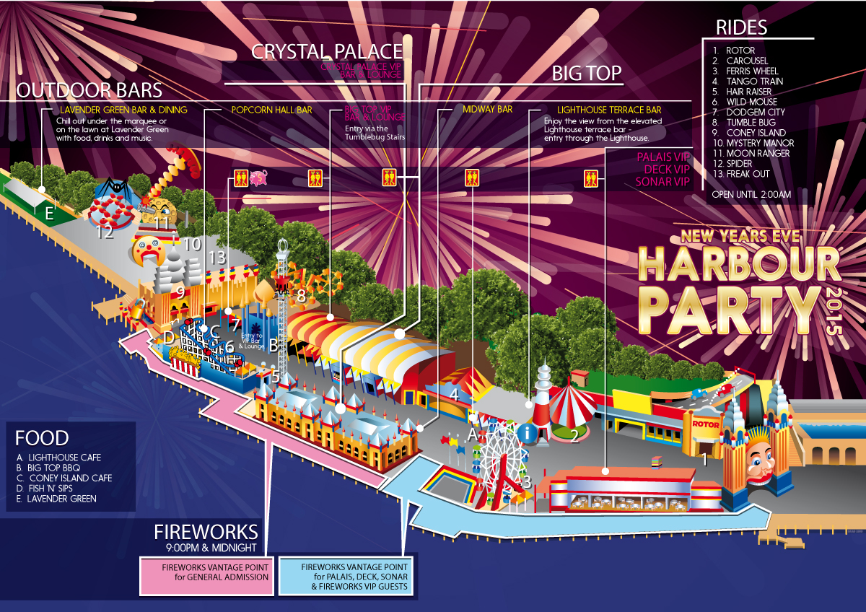
After a fun new years with all the excitement of the Luna Park rides, easy access to amenities, food and beverages, entertainment and an amazing location to catch the Sydney Harbour fireworks?

General Admission grants you:
– entry to Luna Park with free rides all night
– access to numerous bars and eateries including Lavender Green
– entry to Big Top Sydney and Crystal Palace for live entertainment from DJs and performer
Boat Party VKR $120
1.30 am Departing from Casino Wharf
After fireworks
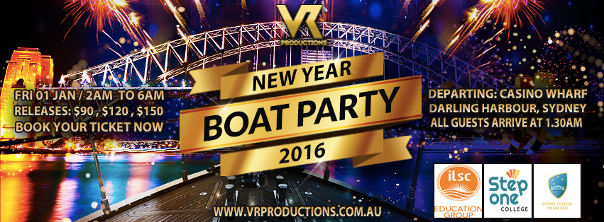

Sydney Harbour, Opera House and Harbour Bridge cast a espetacular setting for New Year's Eve fireworks! The show is watched by people all over the world and it is one of the most expected events of the year! Meeting friends and family to watch the fireworks performance is definitely a very special moment but jumping in a New Year Boat Party through Sydney Harbour for the first sunrise of the year is also a magical experience you want to be part of! A beautiful gathering of Sydney's Biggest Colleges bringing students and education groups together proudly supported by ILSC Education Group, Step One College and Sydney College of English!
Delicious snacks and finger food available on the boat!

MUSIC
● House ● Deep House ● Techno ● Psy ● Trance ● Latin ● Brazilian●

Sydney Hard Rock café News Eve
Fireworks From Darling harbour
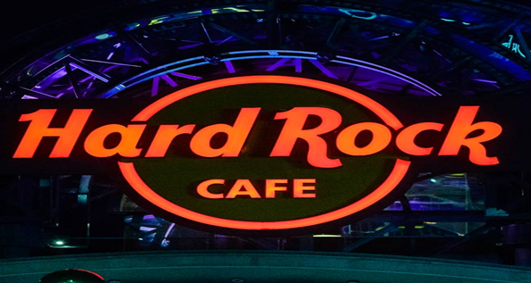

Package 1: Dinner (6:30pm-10pm) $150  - 3 Course Set Menu  - Unlimited Beer, Wine & Soft Drink  - Darling Harbour 9pm Fireworks Display  - Wrap around balcony  - NYE Party Décor  * Strict 10pm vacating policy applies (unless purchasing dinner & dance package) | Package 2: Dance (10pm - 2am) $100pp  - Bar Snacks  - Unlimited Beer, Wine & Spirits  - DJ's  - Darling Harbour Midnight Fireworks Display  - Wrap around balcony  - NYE Party Décor
Package 3: Dinner & Dance (7pm - 2am) $250pp

- 3 Course Set Menu

- Bar Snacks after 10pm

- Unlimited Beer, Wine, Spirits & Soft Drink

- Darling Harbour 9pm & Midnight Fireworks

- Wrap around balcony
What’s happen the 31st December

6.50pm flying ace Matt Hall masterminds
a tug boat takes centre stage at Sydney Harbour with a stunning water display, before Matt Hall’s return at 8pm. Prepare to be thrilled as an aerial display just for NYE.

8.40pm Welcome to Country
This ceremony reflects our respect for Aboriginal and Torres Strait Islander peoples, their heritage and living culture. Eucalyptus smoke is released over the water, cleansing Sydney Harbour of any bad spirits. Spectacular images on the bridge pylons celebrate Eora country.

9.00pm Family fireworks display
The first fireworks allow our littlest spectators, who may nod off a little earlier, the chance to see a fantastic display. Look out for rockets firing from 4 barges and the Sydney Harbour Bridge. Fireworks director Fortunato Foti will pay tribute to the 200th year of the Royal Botanic Garden and 100 years of Taronga Zoo.

9.15pm Harbour of Light Parade
Sydney Harbour will be illuminated with up to 60 ships gliding across the water, enchanting spectators of all ages. Each vessel will be decorated with cool white ropelight, dazzling the crowds and adding to the unique choreography as they dance in the harbour.

Midnight Fireworks display
At the stroke of midnight, we celebrate the start of the new year in spectacular fashion. The 12 minute display features a huge range of pyrotechnic effects from 7 barges in the harbour, 4 sails of the Sydney Opera House, and firing points from across the Sydney Harbour Bridge. Tune in to the synchronised simulcast on 104.1 2Day FM.

Fireworks free Spot

1. Koshigaya Park
Campbelltown City is renowned for offering a quality New Year’s Eve alternative to the crowded CBD of Sydney - with a huge night of entertainment from 7pm, along with two spectacular fireworks displays at 9pm and midnight. A giant screen on the western side of the park will display all of the onstage action, so everyone has a front-row seat.. The event is drug and alcohol free, so there is no better place to celebrate the end of the year with family and friends.
2. North Sydney
Welcome in the New Year from the north shore. Just across the harbour from the city lie the leafy northern suburbs, known for their easy bushwalks, bustling markets and family entertainment.North Sydney has plenty of great vantage points to bring in the New Year. Ball’s Head in Waverton is a local family-friendly favourite and offers majestic views of Sydney Harbour. Blue’s Point Reserve is even closer to the epicentre of the fireworks display and offers one of the best views in Sydney. Milson Point’s Bradfield Park is also a great location close to the centre of the fireworks action.
3. North Head
Situated away from the city crowds in Manly on the northernmost edge of Sydney Harbour National Park, North Head is a fantastic place to spend New Year’s Eve. Offering a spectacular panorama of Sydney Harbour and the CBD skyline, bring along a picnic hamper, roll out your blanket and watch the sun set before the NYE fireworks begin. Please note alcohol is not permitted and entry into the park will be managed. This glass-free, alcohol-free zone will ensure everyone can relax in a safe and fun environment.
4. Balmain
Celebrate Sydney New Year’s Eve in this elegant bohemian hub. Balmain is one of Sydney’s oldest working-class suburbs, a mere 10-minute ferry ride from Circular Quay. Illoura Reserve in Balmain East is an excellent vantage point to see the Sydney Harbour Bridge — the centrepiece of the fireworks display. Access is easy and cost-free, and the alcohol-free environment is great for families and couples.

5. Newport Arms
Northern Beaches’ most famous NYE institution, The Newport Arms Hotel, will be hosting another huge NYE beer garden party for over 18s with fireworks over the Pittwater waterway, Sydney’s second largest waterway. The Arms annual fireworks display that is shot over Pittwater for the benefit of their patrons at 9pm and midnight.
6. Bondi
Celebrate Sydney New Year’s Eve on the golden sands of this iconic beach. While golden sands, turquoise waters and perfect waves make Bondi Beach an iconic Sydney attraction, there’s plenty to do beyond the surf.
7. Peppercorn Reserve
Located on the Drummoyne foreshore, this small park offers great views of the water and city. It looks out to several islands, including Snapper and Spectacle Island. The Reserve is located in Drummoyne off St Georges Road and looks out to several islands including Snapper and Spectacle Island.
8. Tumbalong Park Precinct
Celebrating as only Sydneysiders can, Darling Harbour’s New Year’s Eve party is all about breathtaking fireworks and free entertainment. Darling Harbour will be a little different this New Year’s Eve. From 7.30pm you’ll enjoy free entertainment throughout Darling Harbour to create the party atmosphere before fireworks ignite the sky at 9pm and midnight from both Tumbalong Park and Cockle Bay.
9. Pyrmont Bay Park
Located between the Australian National Maritime Museum at Darling Harbour and The Star casino, this park has limited views of fireworks on the Sydney Harbour Bridge. Views of the bridge can predominantly be seen from the western side of the park only.
10. Dee Why Beach
The New Year’s Eve fireworks are set off from a barge right off Dee Why Beach and can be seen up and down the northern beaches coast. The display starts at 9pm and families are invited to come down for a meal in one of the Dee Why restaurants or to have a picnic in the reserve.

