The Ship
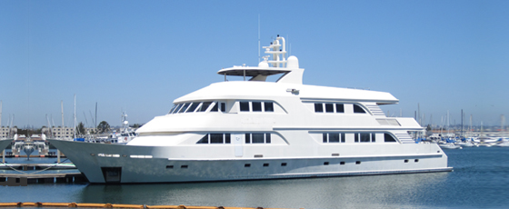

About Nautilus Belle Amie
- 140' x 33' ocean-going dive boat
- Built in 2005 by Bollinger Shipyards, USA
- Steel hull and superstructure, Stabilized, 11 knot maximum service speed
- ISM audited by Bureau Veritas
- Water capacity: Unlimited with high capacity watermakers
- Compressors: 3 x Bauer with banks + nitrox membrane system
- Rebreather friendly
- Dive skiffs: 3 x high speed twin engine 28' rigid hull inflatables
- Passengers: 28-30 guests open boat / up to 36 guests on private charters
- Crew: 11 - 12
- Spacious, comfortable and stable
- Satphone, email & internet access
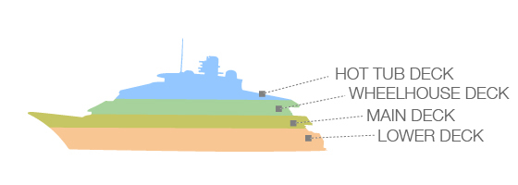

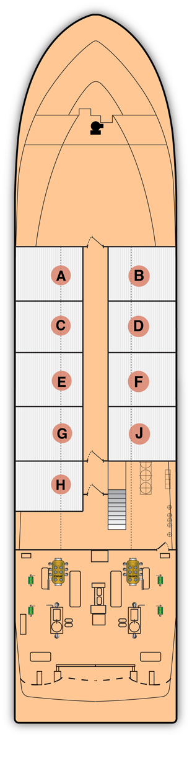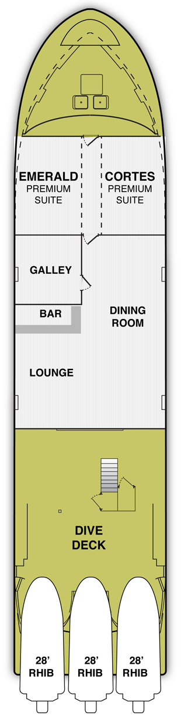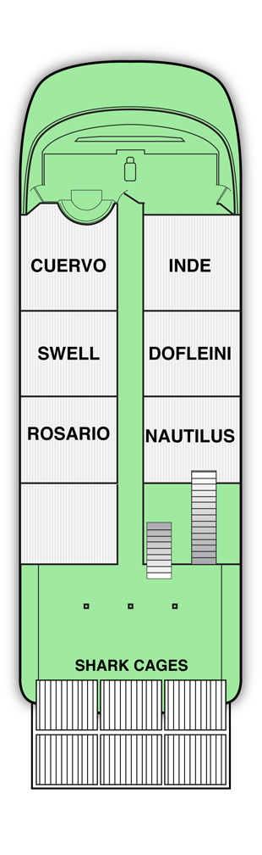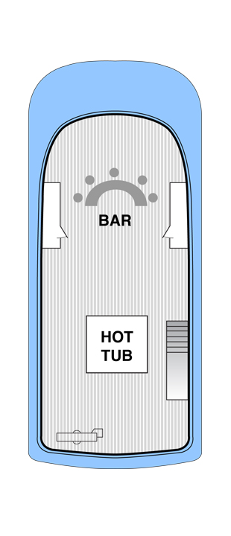

LOWER DECK |  | MAIN DECK | WHEELHOUSE DECK | SUN DECK
Guest Cabins  - Stateroom A  - Stateroom B  - Stateroom C  - Stateroom D  - Stateroom E  - Stateroom F  - Stateroom G  - Stateroom J  - Stateroom H (Quad)  Only five staterooms available for guests! The rest reserved for dive leaders |  | Guest Cabins / Public Area  Premium Suite  - Emerald Premium Suite  - Cortes Premium Suite  - Platinum Suite (combines both Premium Suites)  Dining Room  Lounge  Dive Deck | Guest Cabins / View Deck  Superior Suites  - Cuervo Superior Suite  - Inde Superior Suite  - Dofleini Superior Suite  - Rosario Superior Suite  - Nautilus Superior Suite | Hot Tub & Relaxing  Hot Tub  Shade Area + Sun Lounge
8N/9J | $3,495.00  $3,354.75 | $ 4,595.00  $ 4,509.75 | $ 3,995.00  $ 3,889.75 | Published rates  Charter rates
9N/10J | On request | On request | On request
15N/16J | On request | On request | On request

* Prices do not include 5% of Mexican VAT
* IVA tax has been harmonized at 16% across Mexico. The original 11% tax is included in your trip fee. The 5% increase in tax is shown separately
** For same gender roommate please book shared stateroom or suite

YOUR TRIP
Trips board at the main API dock in Cabo San Lucas harbour at either 8:00 a.m. or 8:00 p.m. and depart shortly afterward. After a one-day ocean crossing we arrive at our first dive site. There are 6 dive days on an 8-night trip and we will be visiting 3 different islands of this beautiful remote and deserted archipelago. We will pack up after the last full dive day and enjoy a relaxing dinner anchored in a protected cove before the one day voyage home, arriving in Cabo San Lucas the next evening. You spend one more night on the boat before you disembark the next morning at 8:30 a.m. Average trip length is 8 nights, 9 days. We also offer 10 and 12 night combo trips that combine diving at Socorro with the best of the Sea of Cortez, 15-night combo trips combining Socorro with Clipperton Island, and 15-night combo trips with the great white sharks of Guadalupe Island. During the regular trip you can expect 22 dives plus a thrilling night snorkel with silky sharks hunting under the ship's deck lights (unless it is a full moon - the silkies don't like to cooperate when it is a full moon).

