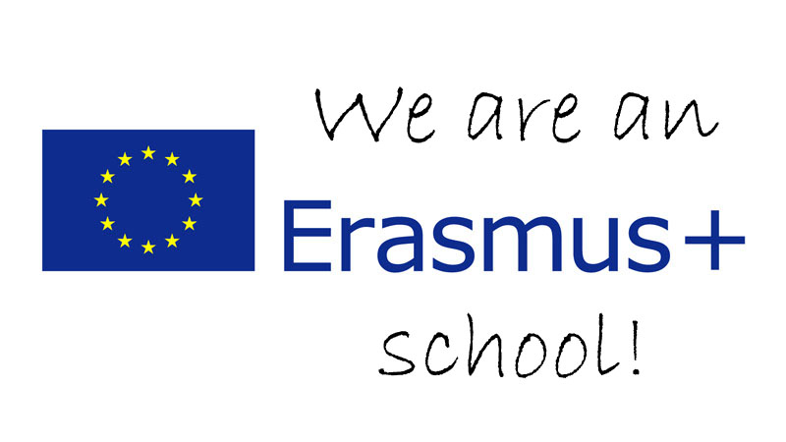

The Languages Department at Tile Hill Wood School and Language College has a long and proud tradition of native speakers from all around the world working with our students and enriching their cultural and linguistic experience! We would love to hear from you if you are eligible for the Erasmus Plus programme and interested in taking an active role in a vibrant and exciting working environment. We offer French, German, Spanish and Japanese placements and are very flexible in accommodating shorter and longer placements. You will gain experience of working with a wide range of students, teachers and other professionals and play a crucial role in promoting your native culture and language.
Please don’t hesitate to get in touch if you have any queries at info@thw.coventry.sch.uk and we very much look forward to hearing from you!
Bertram Richter
Curriculum Leader – Modern Foreign Languages
-------------------------------------------------------------------------
Find out more about the Erasmus + scheme here:
http://ec.europa.eu/programmes/erasmus-plus/index_en.htm
You will find the relevant contact details for your country here: http://ec.europa.eu/education/tools/national_agencies_en.htm
To get a flavour of what we do have a look at our blog:
http://thwlanguages.blogspot.co.uk/

