RULES AND GUIDELINES FOR

OBEDIENCE TRAILS for CLASSES 1 & 2 & 3

The rules and guidelines have been dealt with at the FCI Obedience Commission meetings in Helsinki 2013 and Brussels 2014.
The rules and guidelines of classes 1&2 have been combined with those of class 3. The changes are summed up in this document.
The exercises of class 3 are those of an international obedience trial as well, and will be effective from 1.1.2016. These will be applied in SW and WW obedience competitions from year 2016. The other specifics of an international competition will be dealt with by the Commission in May 2015.
The classes 1 & 2 can be applied by the nations that choose to do so according to their own timetables, that suite them.
The guidelines for arranging a SW and WW competition in obedience will be dealt with in The Obedience Commission meeting of May 2015. The WW competition is already separated from the World Dog Show and it will be so also in the future.
The FCI Obedience Commission suggests that
- the first choice is to arrange the annual World Championship Competition in Obedience in the same country where the World Dog Show is held, but not necessarily at the same time and in the same place.

- if the WDS is held on another continent than Europe, the World Championship in Obedience will be arranged by the country responsible for arranging the European Dog Show

- if neither of the above alternatives can be executed, the FCI Obedience Commission will suggest another place and date

- the date and place of the World Championship in Obedience should preferably be released three years before the event; the precise date of the competition should never be released later that two years before the event.

Summing up of the changes in the obedience rules and guidelines

The rules and guidelines of classes 1 & 2 and class 3 have been come combined as one document and the following changes have been made.

Class 1 | Exercises | Coeff
1 | Old: Lying in a group for 2 minutes, handlers out of sight  New: Sitting in a group for 1 minute, handlers in sight | 3
2 | Heelwork: no changes | 3
3 | Stand under march  If the dog takes the wrong position, 5 points can be awarded if the exercise is perfect in all other aspects. | 3
4 | Recall: no changes | 3
5 | Old: Sit under march  New: Sit or down under march  The handler has to inform the judge before the exercise starts if he will command the dog to sit or lie down. If the dog takes the wrong position, 5 points can be awarded if the exercise is perfect in all other aspects. | 2
6 | Send away into a square.  The handler has to tell the judge before the exercise starts if the dog will first stand and then lie down or lie down directly. If the dog takes the wrong position in the square 3 points are reduced and if the standing position is not clear 2 points are reduced. | 3
7 | Retrieve: no changes | 4
8 | Distance control. If the dog sits up before the handler returns, not more than 8 points should be given. Extensive use of voice and exaggerated or continuous / long-lasting hand signals drop points. (General rules)  A third command on a position may be given, but this position fails. The first time a second command has to be given on a position 2 points are reduced. The next time a second command on a position is given, 1 point is reduced. | 3
9 | Jumping over a hurdle: no changes | 3
10 | A new exercise was composed: Send away around a cone and return  Command: “Around” and hand signal  Performance: The handler stands with the dog in heel position at the starting point facing a cone, approximately 15-20 cm high, at a distance of approximately 10 m. The handler is told to send his dog from the starting point towards a cone. The dog should run around the cone and return to the handler and take the heel position.  Directions: Emphasis should be on the dog’s willingness to follow the commands, the dog’s tempo and its taking the shortest way. If the dog turns before the cone, not more than 5 points can be awarded. The breed should be taken into consideration in judging the speed. If a recall command is given, the highest score is 8. A second recall fails the exercise. | 2
11 | General impression: No changes | 32

Class  2 | Exercises | Coeff.
1 | Old: Sitting in a group for 1 minute, handlers in sight  New: Lying in a group for 2 minutes, handlers out of in sight | 2
2 | Heelwork: walking backward 2-5 meters (6 - 15 steps) is included | 3
3 | Old: Stand and sit under march  New: Stand, sit or down under march (2 positions)  Change: Walking schema as in class 3 (10m – 10m)  Before the competition the judge decides which positions should be performed and in which order. The turning points (left/right) should be marked with small cones. Turning left or right should be the same for all dogs of a competition. | 3
4 | Recall with stand: no changes | 4
5 | Send away with down and recall. The handler has to tell the judge before the exercise starts if the dog will first stand and then lie down or lie down directly. If the dog takes the wrong position in the square 3 points are reduced and if the standing position is not clear 2 points are reduced. | 4
6 | Directed retrieve  The stopping point is not indicated by a cone. | 3
7 | Scent and retrieve  Change: No longer 5 neutral articles, they will be laid out by the steward by hand. | 4
8 | Distance control: If the dog misses one position of the six, not more than 7 points should be given and if it misses two positions not more than 5 points should be given. Thus if the dog jumps over one position and takes the next position instead, not more than 5 points can be awarded. | 4
9 | Old: Jumping over a hurdle and retrieving a metal or wooden object  New: Jumping over a hurdle and retrieving a metal object | 3
10 | General impression | 2
 | Total | 32

Class  3 | Exercises | Coeff
1 | Old: Sitting in a group for 2 minutes handlers out of sight  New: Sitting in a group for 2 minutes handlers out of sight | 2
2 | Old: Lying in a group for 4 minutes handler out of sight  New: Lying in a group for 1 minute and recall  Commands: “Sit”, “Stay”, ”Down” and/or Hand signal , ”Come”  Performance: The exercises 1 and 2 are combined.  Part 1: Sitting in a group for 2 minutes  Part 2: Lying on a group for 1 minute and recall  The points are given for both parts separately after the end of the second part of the exercise. The exercise starts when all handlers of the group stand in the row at approximately 4 meters distance from each other with their dogs in heel position and the steward announces “exercise starts”. The exercise ends (Part 1) when the handlers have returned inside the ring, facing their dogs at a distance of not less than approximately 10 meters and the steward announces ”exercise over”.  The dogs are sitting in heel position in a row at approx. 4 meters distance from each other. When told, the handlers leave the dogs and walk out of sight of the dogs and stay hidden for 2 minutes. When 2 minutes have elapsed, the handlers are instructed to walk back into the ring and take a standing position inside the ring. The handlers are then told to walk and take a standing position approximately 10 meters from the dogs facing the dogs. Part 1 has ended and part 2 begins.  The steward starts the second part of the exercise. The handlers are told to command the dogs down one by one from left to right. They will be lying for 1 minute and then they will be recalled one by one from right to left. A loud command may disturb the others and will severely reduce points.  There should be four dogs in a group, not less than three. In case of only five entries in class 3, all five can do the exercise together.  Directions: A dog that stands up or lies down during part 1 gets 0 points for part 1. A dog that leaves its position (more than 2 body lengths) fails the whole exercise  (parts 1 and 2). Dogs, that are standing or lying after part 1 has ended, can be commanded one by one to sitting position. No points will be lost for the first command to a sitting position. If a second command is needed, 2 points will be reduced. Part 2 is failed if the dog does not sit.  If a dog lies down before command (f. ex. on a neighbours command) not more than 8 points can be awarded for part 2. If a dog comes on another dog’s recall command, not more than 5 points can be awarded for part 2. A dog coming without any command will fail part 2. If the dog barks 1-2 times, 1-2 points are withdrawn; if it barks most of the time, the exercise is failed (0 points). The dog is allowed to turn its head and look around, and it is allowed to show interest if there is distraction or noise inside or outside the ring. This, however, should not give an appearance of restlessness or anxiety. If a dog stands up and goes close to another dog, so that there is fear for severe disturbance or a fight, the exercise must be stopped and then resumed for all the dogs except for the dog that caused the disturbance.  It is recommended that the area outside the ring in front of the dogs is a closed area (no outsiders besides personnel are allowed) during this exercise. In the SW and WW competitions this arrangement is obligatory. | 2
3 | Heelwork  Change: Walking backwards 5-10 meters (15-30 steps). Walking backwards can include one turn. | 3
4 | Stand, sit and down under march: No changes | 3
5 | Recall with stand and down: No changes | 3
6 | Send away with directions, down and recall  Change: The handler has to tell the judge before the exercise starts if the dog will first stand and then lie down or lie down directly. If the dog takes the wrong position in the square 3 points are reduced and if the standing position is not clear 2 points are reduced.  No cone will be used in the center of the circle. A marker may be used. The circumference of the circle should be tagged, f. ex 6-8 pieces of tape or a line in the sand, chalk lines, etc. If the dog sits or lies down outside the circle or square the exercise is failed. No redirecting command is allowed. | 3
7 | Directed retrieve: No changes | 3
8 | Old: Jumping a hurdle and retrieving a metal object  New: Directing to circle a cone, retrieve a wooden dumbbell and jump a hurdle  Commands: “Around“ , “Stand/Sit/down“ and/or hand signal – “right/left" "retrieve“ and/or hand signal – “Jump“ – “Release“, (“Heel“)  "Description: Before the competition starts, the judge will determine, which position (stand/sit/down) the dog should to take on its way back to the handler. The same position for all competitors. The handler should draw the direction (right/left) from which the dog has to retrieve the dumbbell and jump the hurdle. The handler will not be told the direction at this stage.  An approximately 40 cm high, well visible cone is at a distance of approximately 20 metres from the starting point. Two hurdles are situated approximately 5 meters from the starting point and 5 metres from each other. See figures.  There should to be three different sizes of wooden dumbbells available, suitable for different breeds. The weight of the largest should be max 450 g. The size of the dumbbells should be in proportion of the size of the dog but the handler is free to choose the size.  Performance: The handler stands with the dog in heel position at the starting point. The steward announces the start of the exercise and walks to place the dumbbells approximately 5 meters behind the hurdles. On instruction, the handler sends the dog forward around the cone. When the dog has passed around the cone at a distance of at least approximately 2 metres back towards the handler, but not passed the imaginary line connecting the dumbbells, the handler commands the dog into the position that was determined by the judge. Voice and hand signals may be given for taking the required position. After about 3 seconds, the handler is informed by the steward which the direction was that was drawn and instructed to command his dog to retrieve the correct dumbbell and jump the correct corresponding hurdle and return to heel position.  "Directions: Emphasis should be on the dog’s willingness to follow the commands, the dog’s tempo and its taking the shortest ways. Showing the dog directions or touching the dog at the starting point will lead to failing of the exercise (0).  It is important that the dog is happy and willing to obey the commands. The dog has to show a good and consistent speed, at least a fast trot. Slow working is a failure. The breed has to be taken into consideration when judging the speed.  The dog should immediately obey the commands. There is a tolerance for fast dogs, but not for slow dogs.  To obtain points for this exercise, the dog must remain in its position (stand/sit/down) untill it gets the command to go on with the exercise. A dog that takes the wrong position cannot get more than 8 points.  If the dog turns back before the cone, it has to be redirected to the cone. This drops points. The exercise is failed if the dog does not go around the cone. The handler has two directing commands (-1 point for each additional command if the dog obeys). After the dog has gone around the cone the dog should take the correct position on command.  The handler gets the information which dumbbell (right or left) when the dog has taken its position (stand/sit/down). The handler is allowed to give a jump command after the dog has picked up the dumbbell. If the dog passes the connecting lines of the dumbbells the exercise is failed (0) without having picked up the correct dumbbell, the exercise is failed.  If the dog goes to the wrong dumbbell, but is redirected to the correct one and the dog brings the correct one, 6 points can be awarded.  The reduction of points for extra directing commands depends on their strength and the dog’s willingness to obey the commands. It can be 1-2 points/command.  The reduction of points for other extra commands should be congruent with the general directions.  If the dog jumps the hurdle on the way to the cone, the exercise is failed (0).  If the dog picks up the wrong dumbbell or jumps the wrong hurdle, the exercise is failed (0).  Dropping the dumbbell: general rules  Chewing or biting on the dumbbell: general rules  Figure for the recommended construction of the hurdles is in the appendix. One of the hurdles should be open and the other should be an ordinary closed hurdle See figures. | 4
9 | Scent and retrieve  Change: The number of articles may vary from 6 to 8. The organizer should mark the handler’s articles before the competition starts. The pattern for the articles is free. The handler’s article, however, should not be placed at the edges. . | 3
10 | Distance control: No changes | 4

APPENDIX: Figures on
performing the exercise

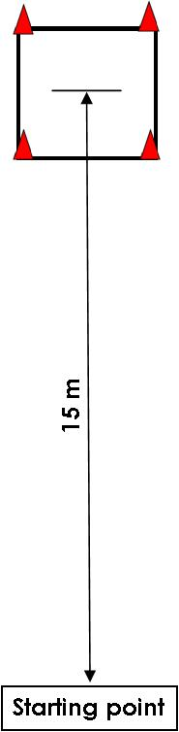
Class 1 Exercise 6. Send away into a square
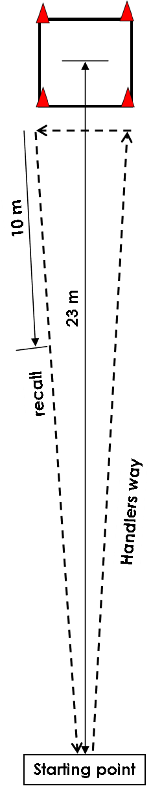

Class 2. Exercise 6. Send away into a square with down and recall.

APPENDIX: Figures on

performing the exercise
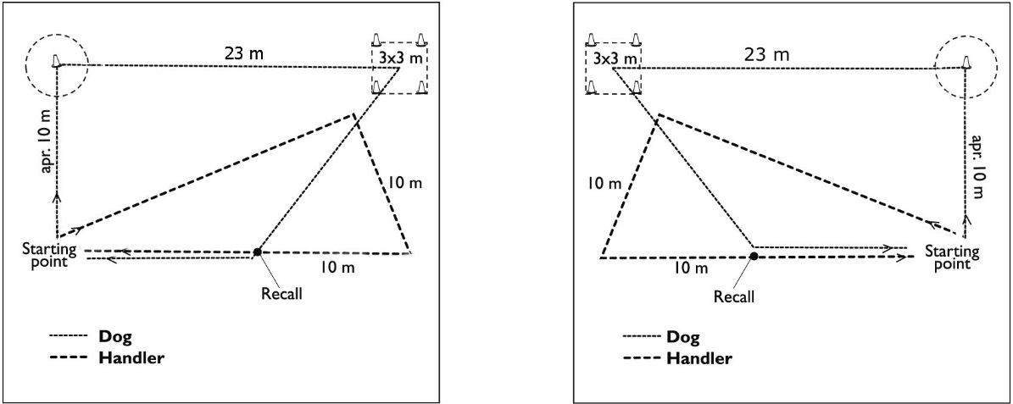
Class 3. Exercise 6. Send away with directions, lie down and recall. The cone in the circle will be replaced by a small marker. It is an option to leave the marker out. Segments of the circumference of the circle or the whole circumference should be marked.

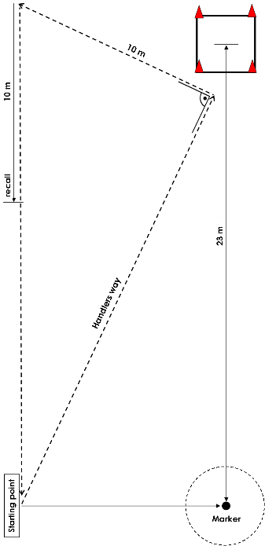

APPENDIX: Figures on
performing the exercise

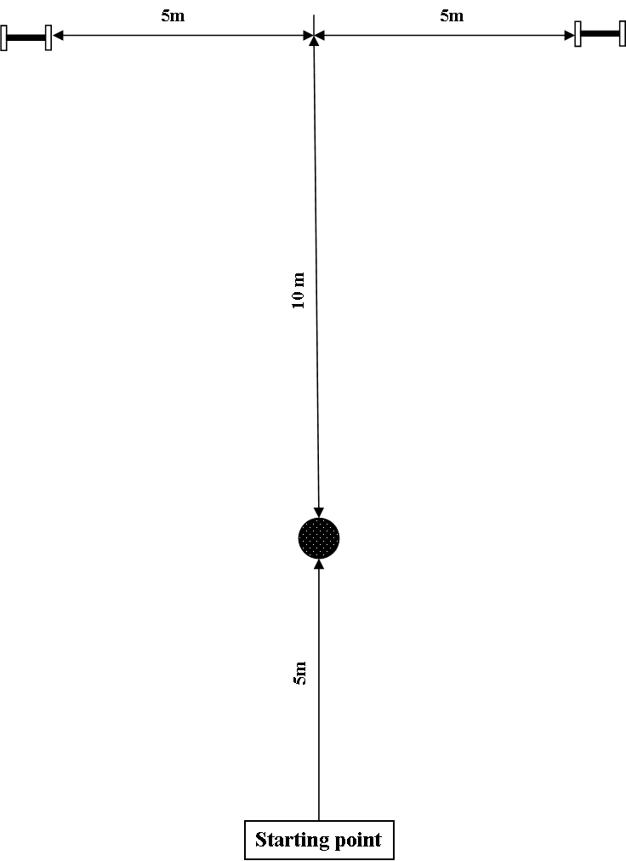
Class 2. Exercise 7. Directed retrieve

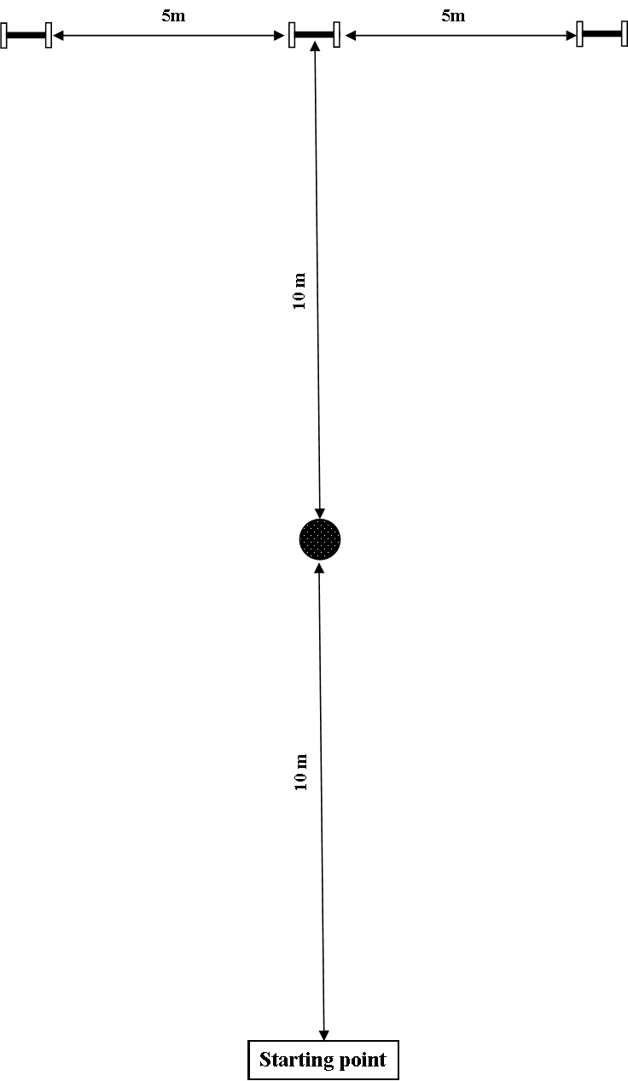

Class 3. Exercise 7. Directed retrieve
APPENDIX: Figures on
performing the exercise
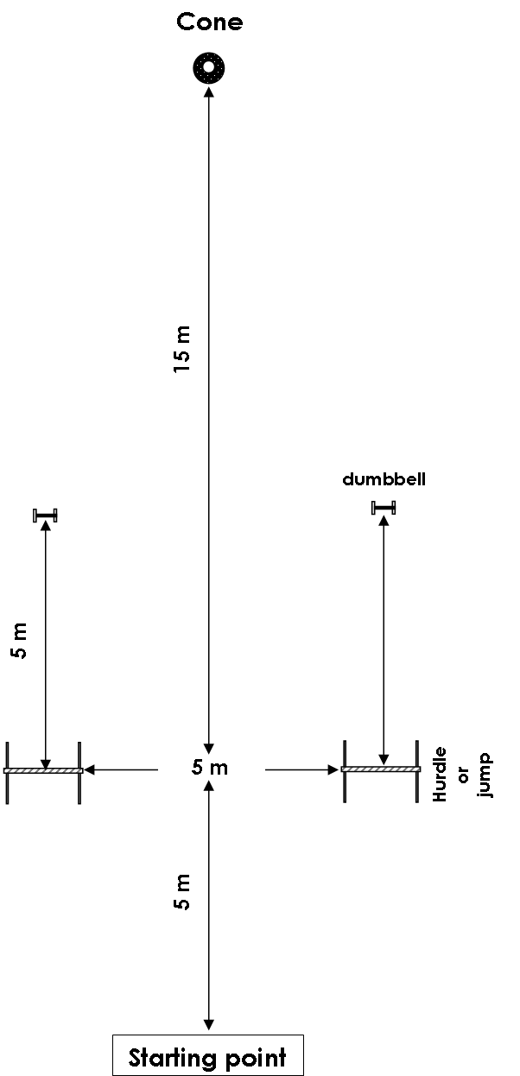
Class 3. Exercise 8. Directing to circle a cone, retrieve a wooden dumbbell and jump a hurdle.

APPENDIX: Figures on
equipment

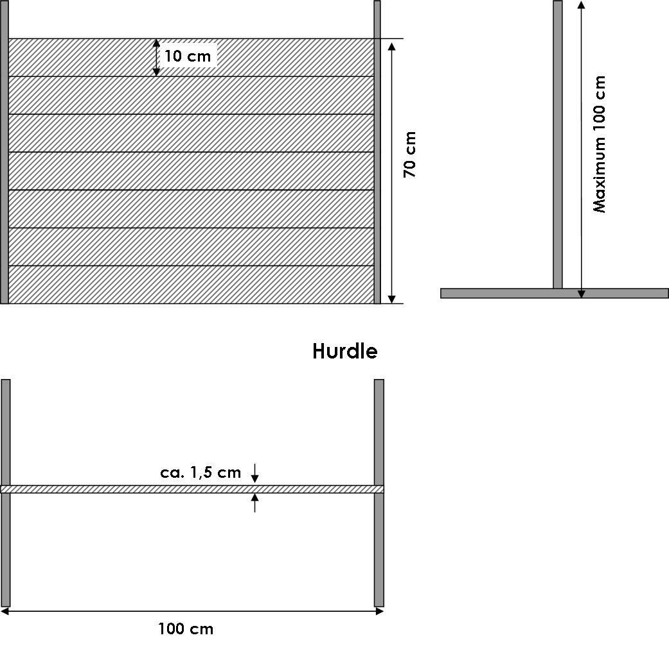
Classes 1 & 2 & 3. The hurdle

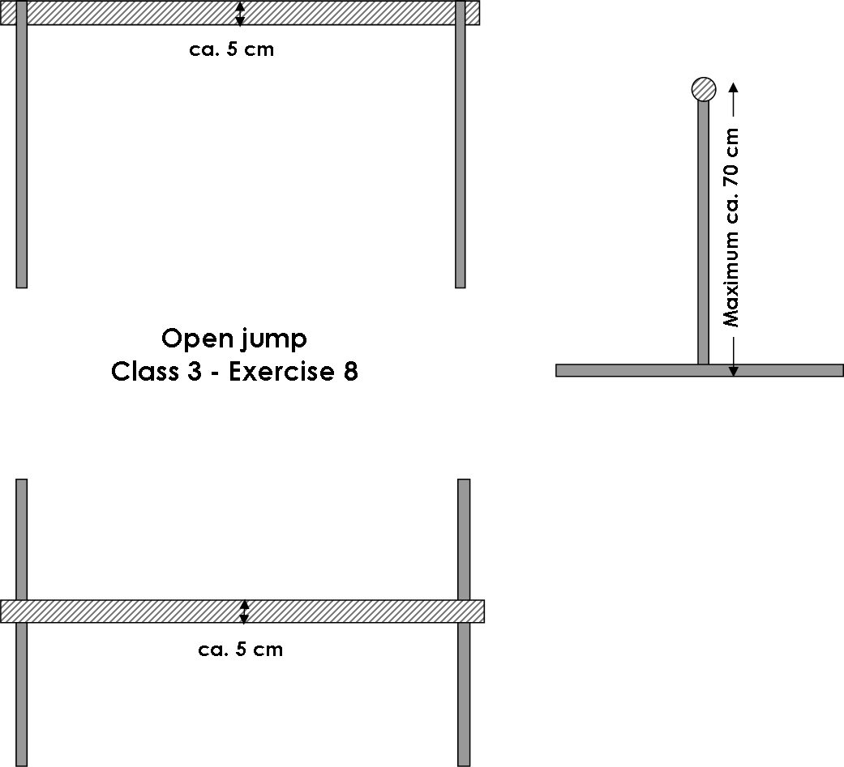

Class 3. Exercise 8. The open hurdle.

