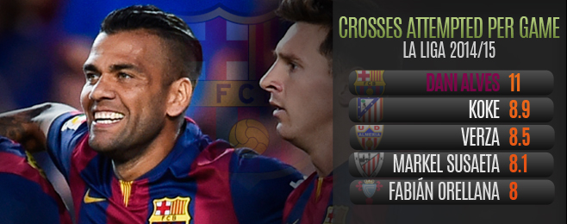

A common sight during Barcelona games so far this season has been Dani Alves getting into a good position up the right wing, and then putting in a cross that causes little or no danger to the opposition defence.
Alves actually tops the entire Liga in the ‘inaccurate cross’ standings with a whopping 53 so far this season, despite having played just six of Barcelona’s eight games so far.
The statistics [8.8 inaccurate crosses per match] back up an impression shared by many frustrated blaugrana fans and pundits, who have seen apparently promising attacking positions wasted time and time again. It would be easier to explain had Barca a traditional number nine to aim at, not the relatively diminutive Lionel Messi, Neymar, Pedro and Munir.
The story was the same during Saturday's 3-0 home win over Eibar at the Camp Nou, during which Alves attempted a pretty unbelievable 20 crosses in all – the most of any player in a single Liga game this season. Luis Enrique was asked at his post-match press conference if he was growing frustrated watching so many pointless balls being hoisted towards the penalty spot.
“[Alves] does not exasperate me, he is a useful player, the best in his position,” the blaugrana coach countered. “He crossed many times, he helps us, and he never stops. I am more than happy with him. He is a vital player for us.”
These comments backed up a feeling that Luis Enrique still sees Alves as a key player for Barca, even as the now 31-year-old enters what looks likely to be his last year at the Camp Nou. The new coach is keen to play a narrow front three - with Luis Suarez soon to join Neymar up top, and Messi just a bit deeper. The team then gets width from its full-backs, through Alves or Jordi Alba on the other side. Barca’s skewing of play towards the right is also shown by long-time back-up right-back Martin Montoya hitting five crosses, and summer signing Douglas knocking over four during their one game apiece so far.
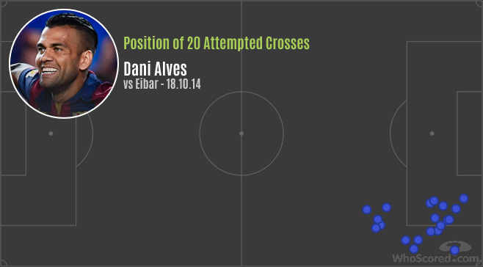
Luis Enrique could also have pointed out that one of those 20 right-wing crosses against Eibar was volleyed to the net by Neymar for Barca’s second goal. This was the 10th ‘key pass’ to create a goalscoring opportunity made by Alves in his six La Liga games. His other assist came against Granada, in a move that recalled Barca’s best years under Josep Guardiola. Xavi Hernandez’s diagonal ball found Alves overlapping down the right behind a napping defence, and the volleyed first time cross was headed in by the fast arriving Messi in the centre. Many of his crosses may have missed their target, but his completed cross average of 2.2 per game is the third best in the division.
The connection between the Brazilian provider and Argentine finisher has been working since Alves joined from Sevilla in summer 2008. In total Alves has been responsible for a pretty phenomenal 47 league assists since the start of the 2009/10 season at the Camp Nou. The former Sevilla player is well aware of his value to his side, and can get understandably frustrated when his contribution is not widely recognised.
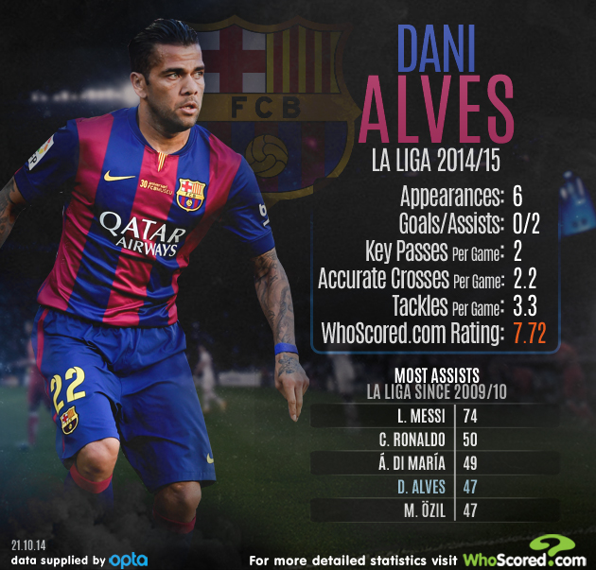
“I am the best ‘assister’ for Messi at Barcelona,” Alves said last week. “That is history. Messi’s 400th goal came from my cross. In Barca’s first World Club Cup, the decisive goal from Leo came from another of my crosses. That will annoy a few people, but there we are.”
Those critics might also like to know that Alves’ start to the season has not just been about crosses, or assists. His average passes completed per game so far this season [78.3] is actually the highest of all Primera Division players [joint top with Rayo’s Roberto Trashorras - interviewed earlier this month by WhoScored.com]. He’s also been busy off the ball, and is 13th overall in La Liga for tackles made, at 3.3 per game.
Such displays mean that Alves is also the joint fourth highest ranked player overall in La Liga so far this season, with a 7.72 ranking. The only players rated more highly are Real Madrid’s Cristiano Ronaldo, and Camp Nou teammates Messi and Neymar. This is not bad going for someone who was assumed in some quarters to be well past his best.
It can - and likely will - be argued that the above statistics do not show that opposing teams have long been exploiting the gaps left down Alves' wing when he bombs forward. There is of course something to this argument, but Barca can counter that other players are supposed to cover when he pushes forward, and that they have yet to concede a goal in La Liga all season. Plus they could point out the only game in which the current La Liga leaders didn’t score was when Alves was rested - for Douglas - at Malaga.
So to Saturday's ‘clasico’ at the Estadio Santiago Bernabeu, when Alves will likely be in direct opposition to Ronaldo. Even Madrid's 15-goal top scorer might think it worth making an effort to track back when Alves races forward to join the attack. Because if Messi does become La Liga's highest ever goalscorer this weekend, it's quite likely the goal will come from yet another Dani Alves cross.

