
SET LUNCH AND DINNER
1 savoury galette +
1 sweet crepe (above 1$)
=
1 DRINK FREE

SAVOURY GALETTES

Sin Sisamuth 2 $
Ham & Cheese
Pan Ron 2 $
Chicken Lime Pepper
& Cheese

Big Hunger? Hummm!!!
Double cheese +0,50 $
Double Ham +0,50 $
Double Chicken +0,50 $

It’s hot! Need a cold Drink?
By Glass 0,40 $
By Can 0,60 $

Samourai
 Bottle 0,60 $

SWEET CREPES

Sugar

White Sugar 0,50 $
Organic Palm Sugar 1 $
Caramel Beurre Sale 1,25 $

Chocolate

Chocolate  0,75 $
Chocolate Banana 1 $ 1,50 $
Banana 1,75 $
Jam 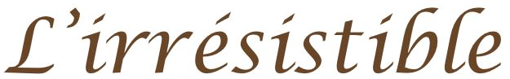
1$ only!
Pineapple Mango
Pineapple Passion Fruit
Green Tomato

Sweet Milk

Sweet Milk MyBoy 0,65 $
Sweet Milk Banana 0,90 $

