Thanksgiving :

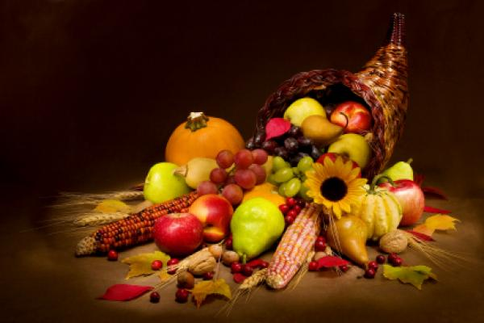
Thanksgiving Day is traditionally a day for families and friends to get together for a special meal. The meal often includes a turkey, stuffing, potatoes, cranberry sauce, gravy, pumpkin pie, and vegetables. Thanksgiving Day is a time for many people to give thanks for what they have.
It’s celebrate the fourth Thursday of November and it’s last four days and most government offices, businesses, schools and other organizations are closed on Thanksgiving Day. Many offices and businesses allow staff to have a four-day weekend so these offices and businesses are also closed on the Friday after Thanksgiving Day. Public transit systems do not usually operate on their regular timetables

