

WINE BAR SNACKS

½ BAGUETTE $4.75
With olive oil and balsamic vinegar.

NUTS & OLIVES $5
Walnuts, hazelnuts and almonds with Sicilian cracked green olives.

ESCARGOTS $7.50
French treat served in provençal butter with baguette toasts.

MÉLANGE À TROIS $12.50
Three pleasurable dips: hummus, tapenade and dill tzatziki with tortilla chips.

TAPENADE MAISON $7.75
Traditional Mediterranean aperitif made with kalamata olive, garlic, lemon and anchovies.
Comes with baguette.

GARLIC & HERB HUMMUS $7
Middle Eastern dip with Tahini, seasoned with garlic, lemon, and herbs de provençe.
Comes with tortilla chips and carrot sticks.

MAPLE BAKED GOAT CHEESE $12.50
Great sweet and salty combination to share with friends. Comes with baguette.

BRUSCHETTAS
Original: $5.75 3 Cheeses: $6.75 Meat: $7.75

GOAT BALLS $6.50
3 Fresh goat cheese balls seasoned with Pistachios, herbs and cracked pepper.

MEDITERRANEAN TABOULEH $6
A delicious couscous salad filled with tomatoes, onions, bell pepper and cucumber. Seasoned with fresh mint, olive oil and lemon juice.

TAX INCLUDED IN PRICE
SIGNATURE ITEMS

CHEESE PLATE $22.50
Assorted fine cheeses with nuts mix, fresh fruits & green olives. Comes with baguette.

CHARCUTERIE PLATE $17.50
Assorted meats with gherkins, olives & game pâté. Comes with baguette.

MÉLANGE PLATE $21.50
3 cheeses, 2 meats, game pâté, nuts & olives. Comes with baguette.

CHEESE FONDUE $39.50
Emmental, smoked cheddar, garlic, white wine. Served with baguette, fruits, gherkins & olives.

BENOIT’S QUICHE $12
Homemade quiche served with a side house salad

HOUSE SALAD $6.75
Fresh specialty salad.

DESSERTS
BUBBLE FRUIT SALAD $7.50
Our Chef’s selection of fresh fruits, served with homemade coulis in a bed of bubbly

TRUFFLES $6
Decadence in a ball shape! 3 delicious handmade chocolate truffles: espresso, pistachio and almond

CHOCOLATE FONDUE $13.75
The romance starts here! Fresh cut fruits served with melted dark Belgian chocolate.

COLONEL $10.50 Perfect summer treat! 2 scoops of handmade Lemon or sangria sorbet served in 2oz of vodka.

TAX INCLUDED IN PRICE

TAX INCLUDED IN PRICE


BUCKWHEAT CRÊPES

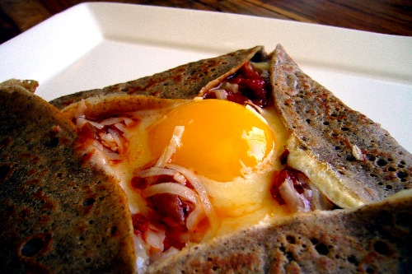

Base of a crêpe with swiss cheese for $4
add any topping for $.75

Toppings: blue cheese, goat cheese, swiss cheese, black forest ham, prosciutto, sopressata salami, mushroom, tomato, spinach, artichoke hearts, smoked salmon, capers, walnuts, maple syrup
Add an egg for $1.75

SWEET CRÊPES
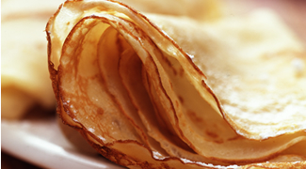

Base of crêpe with butter for $3
add any topping for $.75
Toppings: brown sugar, butter, lemon juice, honey, maple syrup, nutella, banana, apple, pear
Add 1 scoop of gelato or whipping cream for $1.75

