ENGLISH EXAMINATION – MAY 2013 – ANSWER KEY
THE BELOW MENTIONED ARTICLES ARE AIMED AT OPTIMIZING YOUR KNOWLEDGE ON SOME FIELDS AND DO NOT SUBSTITUTE A MORE STRICT STUDY.

The BAT lasts 120 minutes and consists of eight sections: chart and graphics (12%), global markets (14%), investment banking (12%), financial statement analysis (12%), analytical reasoning (12%), math (14%), economics (12%) and news analysis (12%). The whole examination contains 100 questions.

SUMMARY – CHART AND GRAPH ANALYSIS

Charts and Graphs

Choosing the Right Format


© iStockphoto
"A picture is worth a thousand words." This is certainly true when you're presenting and explaining data. You can provide tables setting out the figures, and you can talk about numbers, percentages, and relationships forever. However, the chances are that your point will be lost if you rely on these alone. Put up a graph or a chart, and suddenly everything you're saying makes sense!

Graphs or charts help people understand data quickly. Whether you want to make a comparison, show a relationship, or highlight a trend, they help your audience "see" what you are talking about.
The trouble is there are so many different types of charts and graphs that it's difficult to know which one to choose. Click on the chart option in your spreadsheet program and you're presented with many styles. They all look smart, but which one is appropriate for the data you've collected?

Can you use a bar graph to show a trend? Is a line graph appropriate for sales data? When do you use a pie chart? The spreadsheet will chart anything you tell it to, whether the end result makes sense or not. It just takes its orders and executes them!
To figure out what orders to give, you need to have a good understanding of the mechanics of charts, graphs and diagrams. We'll show you the basics using four very common graph types:
- Line graph
- Bar graph
- Pie chart
- Venn diagram

First we'll start with some basics.

X and Y Axes – Which is Which?
To create most charts or graphs, excluding pie charts, you typically use data that is plotted in two dimensions, as shown in Figure 1.
- The horizontal dimension is the x-axis.
- The vertical dimension is the y-axis.
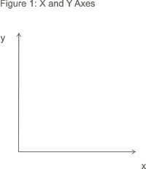
To remember which axis is which, think of the x-axis as going along the corridor and the y-axis as going up the stairs. The letter "a" comes before "u" in the alphabet just as "x" comes before "y".

When you come to plot data, the known value goes on the x-axis and the measured (or "unknown") value on the y-axis. For example, if you were to plot the measured average temperature for a number of months, you'd set up axes as shown in Figure 2:
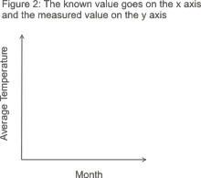
The next issue you face is deciding what type of graph to use.

Line Graphs
One of the most common graphs you will encounter is a line graph. Line graphs simply use a line to connect the data points that you plot. They are most useful for showing trends, and for identifying whether two variables relate to (or "correlate with") one another.
Trend data:
- How do sales vary from month to month?
- How does engine performance change as its temperature increases?
Correlation:
- On average, how much sleep do people get, based on their age?
- Does the distance a child lives from school affect how frequently he or she is late?
You can only use line graphs when the variable plotted along the x-axis is continuous – for example, time, temperature or distance.
Note:
When the y-axis indicates a quantity or percent and the x-axis represents units of time, the line graph is often referred to as a time series graph.
Example:
ABC Enterprises' sales vary throughout the year. By plotting sales figures on a line graph, as shown in Figure 3 , it's easy to see the main fluctuations during the course of a year. Here, sales drop off during the summer months, and around New Year.
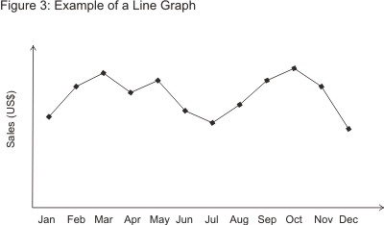
While some seasonal variation may be unavoidable in the line of business ABC Enterprises is in, it may be possible to boost cash flows during the low periods through marketing activity and special offers.
Line graphs can also depict multiple series. In this example you might have different trend lines for different product categories or store locations, as shown in Figure 4 below. It's easy to compare trends when they're represented on the same graph.
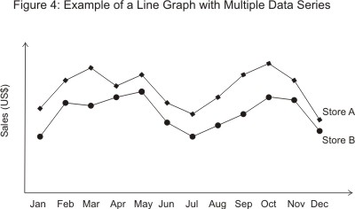

Bar Graphs
Another type of graph that shows relationships between different data series is the bar graph. Here the height of the bar represents the measured value or frequency: The higher or longer the bar, the greater the value.
Example:
ABC Enterprises sells three different models of its main product, the Alpha, the Platinum, and the Deluxe. By plotting the sales each model over a three year period, it becomes easy to see trends that might be masked by a simple analysis of the figures themselves. In Figure 5, you can see that, although the Deluxe is the highest-selling of the three, its sales have dropped off over the three year period, while sales of the other two have continued to grow. Perhaps the Deluxe is becoming outdated and needs to be replaced with a new model? Or perhaps it's suffering from stiffer competition than the other two?
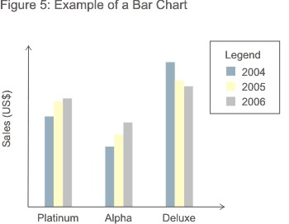
Of course, you could also represent this data on a multiple series line graph as shown in Figure 6.
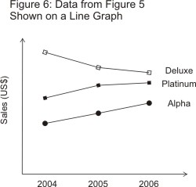
Often the choice comes down to how easy the trend is to spot. In this example the line graph actually works better than the bar graph, but this might not be the case if the chart had to show data for 20 models rather than just three. It's worth noting, though, that if you can use a line graph for your data you can often use a bar graph just as well.

The opposite is not always true. When your x-axis variables represent discontinuous data (such as different products or sales territories), you can only use a bar graph.
In general, line graphs are used to demonstrate data that is related on a continuous scale, whereas bar graphs are used to demonstrate discontinuous data.

Data can also be represented on a horizontal bar graph as shown in Figure 7. This is often the preferred method when you need more room to describe the measured variable. It can be written on the side of the graph rather than squashed underneath the x-axis.
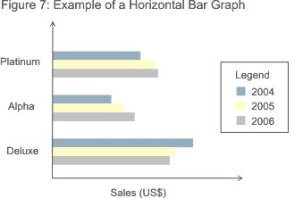
Note:
A bar graph is not the same as a histogram. On a histogram, the width of the bar varies according to the range of the x-axis variable (for example, 0-2, 3-10, 11-20, 20-40 and so on) and the area of the column indicates the frequency of the data. With a bar graph, it is only the height of the bar that matters.

Pie Charts

A pie chart compares parts to a whole. As such it shows a percentage distribution. The entire pie represents the total data set and each segment of the pie is a particular category within the whole.

So, to use a pie chart, the data you are measuring must depict a ratio or percentage relationship. You must always use the same unit of measure within a pie chart. Otherwise your numbers will mean nothing. The pie chart in Figure 8 shows where ABC Enterprise's sales come from.
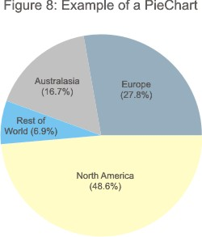
Tip 1:
Be careful not to use too many segments in your pie chart. More than about six and it gets far too crowded. Here it is better to use a bar chart instead.
Tip 2:
If you want to emphasize one of the segments, you can detach it a bit from the main pie. This visual separation makes it stand out.
Tip 3:
For all their obvious usefulness, pie charts do have limitations, and can be misleading.

Venn Diagram
The last graph we will cover here is the Venn diagram. Devised by the mathematician John Venn in 1881, this is a diagram used to show overlaps between sets of data.
Each set is represented by a circle. The degree of overlap between the sets is depicted by the overlap between circles.
Figure 9 shows sales at Perfect Printing. There are three product lines: stationery printing, newsletter printing, and customized promotional items such as mugs.
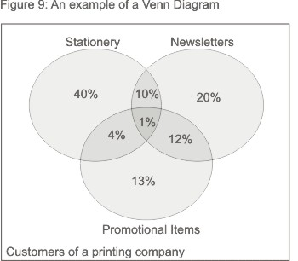
By separating out the proportions of the business' customers that buy each type of product, it becomes clear that the majority of the biggest group of customers (55% of the total) – those who have their company stationery printed – are only using Perfect Printing for stationery. It's possible that they don't realise that Perfect Printing could also print their company newsletters and promotional items. As a result, Perfect Printing should consider designing some marketing activity to promote these product lines to its stationery customers.

Customers who get their newsletters printed by Perfect Printing, on the other hand, seem to be well aware that the company also offers stationery printing and promotional items.
A Venn diagram is a great choice to use when you are trying to convey the amount of commonality or difference between distinct groups.

Key Points:
There are many chart and diagram formats you can choose from when representing information graphically. Selecting the right type starts with a good understanding of how each is created.

When you are clear about the specific sort of data the main types can be used to represent, you will be much more comfortable using the different types of chart in your analysis. This will add great value and improve the clarity and effectiveness of your communication.

Reference: http://www.mindtools.com/pages/article/Charts_and_Diagrams.htm Access on: May 15th 2013

SUMMARY – GLOBAL MARKETS

Euro breaks below $1.29 on weak euro zone data
* European GDP data fuels rate cut hopes
* Dollar rises through 102.50 yen briefly
* European shares climb, U.S. stocks seen mixed

By Richard Hubbard
LONDON, May 15 (Reuters) - The euro hit a six-week low against the dollar and European shares rose on Wednesday after euro zone economic data undershot already weak expectations, strengthening the case for another interest rate cut.

Europe's broad FTSEurofirst 300 index of top company shares was up 0.5 percent at 1,242.54 points by midday, a level not seen since mid-2008. However, U.S. stock index futures pointed to a more mixed open on Wall Street.

"If we look at the figures from this morning, Europe is still in the doldrums but liquidity is still dominating the market and investors are hoping at least that the second half of this year will improve," said Rabobank euro zone market strategist Emile Cardon.

The euro, down roughly 2.3 percent against the dollar in May, fell 0.3 percent to a low of $1.2883 after data showed Germany's economy crept back into growth at the start of the year but not by enough to take the euro zone out of recession.
European Central Bank president Mario Draghi has said he will cut rates again if the growth outlook for the region worsens, making markets highly sensitive to each data release.

Draghi is "trying to be transparent and tell the market that any sort of weak data would give (the ECB) scope to cut again, and certainly that's the way the market is trading," said Greg Matwejev, director of FX Hedge Fund Sales and Trading at Newedge.

The euro zone has now been stuck in recession since the end of 2011, with the latest data showing the region's economy shrank 0.2 percent in the January-March quarter.

Growth should return to the 17-member currency bloc in the second half of this year, but economists see no chance it will recover strongly until at least 2015, the latest Reuters poll showed.

By contrast, a run of solid U.S. economic data has raised expectations the Federal Reserve may wind down its asset-buying
effort by the end of the year, driving the dollar to a 4-1/2 year high against the yen on Wednesday of 102.63.

Against a basket of major currencies, the dollar rose 0.5 percent to 84, a peak not seen since last summer, before Draghi pledged to do "whatever it takes" to save the euro.

LIQUIDITY RULES

The Fed's easy monetary policy, a big injection of cash from the Bank of Japan into its economy and hopes for easier policies from the ECB have combined to depress yields on government bonds.

Britain's central bank chief Mervyn King suggested Britain may not need to keep adding to the flood of liquidity, offering a slightly improved outlook for the economy for the first time since the financial crisis.

But King is bowing out soon and much depends on how his successor, Canadian Mark Carney, interprets the data. "The market is driven by one thing: the massive liquidity injected by central banks. With bond yields at such levels, equities seem to be the only interesting asset class," said Thierry Jabes, strategist at 360 Asset Managers, which has 180 million euros ($232 million) under management.

Liquidity in the system has driven MSCI's world equity index back to levels last seen in mid-2008. It was flat at 376.18 points and about 13 percent away from its all-time high set in October 2007.

In Asia, the yen weakness induced by the BOJ's action lifted Japan's Nikkei share average above the psychologically key 15,000 threshold for the first time since January 2008 as investors sought Japanese exporters.

DEBT SUPPLY SURGE

As returns shrink on safe haven government bonds, 10-year Greek bond prices surged on Wednesday after Fitch Ratings upgraded the country's sovereign credit ratings, saying reforms have reduced its risk of a euro zone exit.

However, most attention was focused on Italy getting ready to launch a new 30-year bond to follow the successful 10-year debt sale by Spain on Tuesday. It received over 10 billion euros ($13 billion) of orders for the new bond.

Market players had expected solid appetite for the Italian bond after investors also snapped up Slovenian and Portuguese debt this month in their hunt for higher-yielding securities.

In the corporate credit market, fast food giant McDonald's was preparing a 10-year euro-denominated bond in what is likely to be the busiest week for new corporate supply in over two months.

Gold was trading around three-week lows at $1,414.50 an ounce and stretching its losses into a fifth straight day.

Brent crude slipped 39 cents to $102.21 a barrel. U.S. oil fell $1.22 to $92.99, declining for a fifth straight day and matching a similar losing streak in December.

Reference: http://www.reuters.com/article/2013/05/15/markets-global-idUSL6N0DV4M220130515 Access on May 15th 2013

SUMMARY – INVESTMENT BANKING

An Introduction to Investment Banking: The financial crisis of 2008 brought the world of investment banking to the notice of the general public, but unfortunately, not in a good light. Names like Lehman Brothers and Goldman Sachs were in news almost daily for more than a year. Most of the news about them was bad – for example, that Lehman Brothers declared bankruptcy and closed. Others survived, but not as investment banks. However, even when all these multi-Billion dollar investment banks were in news, and it seemed as if civilization itself was in jeopardy, not many knew or completely understood what was it that they did.

What is Investment Banking? Investment banking refers to services rendered by financial institutions, called investment banks, whereby these banks help other entities, including private companies and governments, raise money from the equity and bond market. For example, Facebook Inc was in news recently because the company wants to raise money from the equity market. To make an offer of its shares in the market, Facebook needs the services of an investment bank to take care of all the legal and technical paperwork required to make an Initial Public Offer (IPO). For its services rendered in the launch of the IPO, the bank will take a fee, which will likely run into tens of millions of dollars.

Apart from assisting companies, and governments, raise money from the equity and bond market, investment banks are also involved in a number of other financial and banking businesses. For example, one of the most profitable businesses for investment banks is the buying and selling of financial products, including shares and bonds, with the goal of making a profit on each trade. This business is called brokerage, and investment banks are very good at it. Indeed, before the 2008 financial crisis, the world’s largest brokerage company was an investment bank – Merrill Lynch. Merrill Lynch ceased to exist as a separate entity after it was bought by Bank of America.

Other businesses investment banks are involved in include asset management, prime brokerage, underwriting services, and giving mergers and acquisitions advice to companies. Though investment banks do not offer their services to the general public, they usually have many High Net Worth Individuals (HNI) as clients.

Top Investment Banks: The following are the top three investment banks in the world, when ranked based on the fees earned by them in the year 2010:
J.P. Morgan Founded in 1871 by one of the financial giants of his time, the eponymous J P Morgan, it is a commercial as well as an investment bank. As an investment bank, it earned fees in excess of $5.5 Billion in 2010.

Bank of America Merrill Lynch is the investment banking arm of Bank of America, and the direct descendent of the company known as Merrill Lynch. The latter was bought by the Bank of America during the financial crisis of 2008.

Goldman Sachs was originally founded in 1869 by Marcus Goldman, who was joined by his son-in-law Samuel Sachs in 1882. Goldman Sachs was one of the key companies that helped create the IPO market in the early 20th century United States.

Investment banking refers to the business of helping companies raise money for their growth and functioning. Its importance in the proper functioning of the economy, and its growth, cannot be overstated. Every company needs money to grow, or to just survive, and investment banks help them do that by raising capital from equity and bond markets, as well as from private individuals and entities.

Reference: http://www.money.si/investment-banking.php Access on: May 15th 2013

SUMMARY – FINANCIAL STATEMENT ANALYSIS

Financial statements paint a picture of the transactions that flow through a business. Each transaction or exchange - for example, the sale of a product or the use of a rented a building block - contributes to the whole picture.
Let's approach the financial statements by following a flow of cash-based transactions. In the illustration below, we have numbered four major steps:
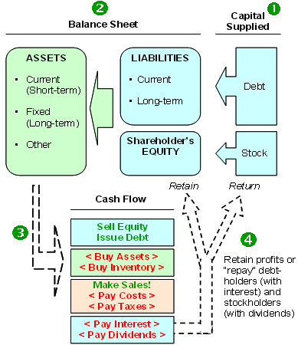
- Shareholders and lenders supply capital (cash) to the company.
- The capital suppliers have claims on the company. The balance sheet is an updated record of the capital invested in the business. On the right-hand side of the balance sheet, lenders hold liabilities and shareholders hold equity. The equity claim is "residual", which means shareholders own whatever assets remain after deducting liabilities.
The capital is used to buy assets, which are itemized on the left-hand side of the balance sheet. The assets are current, such as inventory, or long-term, such as a manufacturing plant.
- The assets are deployed to create cash flow in the current year (cash inflows are shown in green, outflows shown in red). Selling equity and issuing debt start the process by raising cash. The company then "puts the cash to use" by purchasing assets in order to create (build or buy) inventory. The inventory helps the company make sales (generate revenue), and most of the revenue is used to pay operating costs, which include salaries.
- After paying costs (and taxes), the company can do three things with its cash profits. One, it can (or probably must) pay interest on its debt. Two, it can pay dividends to shareholders at its discretion. And three, it can retain or re-invest the remaining profits. The retained profits increase the shareholders' equity account (retained earnings). In theory, these reinvested funds are held for the shareholders' benefit and reflected in a higher share price.
This basic flow of cash through the business introduces two financial statements: the balance sheet and the statement of cash flows. It is often said that the balance sheet is a static financial snapshot taken at the end of the year (To read more, see What is a Cash Flow Statement? and Reading The Balance Sheet.)
Statement of Cash Flows
The statement of cash flows may be the most intuitive of all statements. We have already shown that, in basic terms, a company raises capital in order to buy assets that generate a profit. The statement of cash flows "follows the cash" according to these three core activities: (1) cash is raised from the capital suppliers - cash flow from financing, (CFF), (2) cash is used to buy assets - cash flow from investing (CFI), and (3) cash is used to create a profit - cash flow from operations (CFO).
However, for better or worse, the technical classifications of some cash flows are not intuitive. Below we recast the "natural" order of cash flows into their technical classifications:
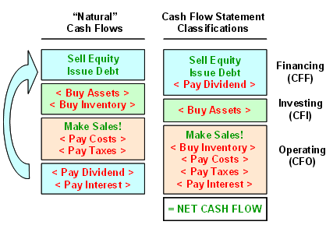
You can see the statement of cash flows breaks into three sections:
- Cash flow from financing (CFF) includes cash received (inflow) for the issuance of debt and equity. As expected, CFF is reduced by dividends paid (outflow).
- Cash flow from investing (CFI) is usually negative because the biggest portion is the expenditure (outflow) for the purchase of long-term assets such as plants or machinery. But it can include cash received from separate (that is, not consolidated) investments or joint ventures. Finally, it can include the one-time cash inflows/outflows due to acquisitions and divestitures.
- Cash flow from operations (CFO) naturally includes cash collected for sales and cash spent to generate sales. This includes operating expenses such as salaries, rent and taxes. But notice two additional items that reduce CFO: cash paid for inventory and interest paid on debt.
The total of the three sections of the cash flow statement equals net cash flow: CFF + CFI + CFO = net cash flow. We might be tempted to use net cash flow as a performance measure, but the main problem is that it includes financing flows. Specifically, it could be abnormally high simply because the company issued debt to raise cash, or abnormally low because it spent cash in order to retire debt.
CFO by itself is a good but imperfect performance measure. Consider just one of the problems with CFO caused by the unnatural re-classification illustrated above. Notice that interest paid on debt (interest expense) is separated from dividends paid: interest paid reduces CFO but dividends paid reduce CFF. Both repay suppliers of capital, but the cash flow statement separates them. As such, because dividends are not reflected in CFO, a company can boost CFO simply by issuing new stock in order to retire old debt. If all other things are equal, this equity-for-debt swap would boost CFO.
Reference: http://www.investopedia.com/university/financialstatements/financialstatements2.asp Access on May 15th 2013

Cash Flow: First, cash is raised from investors and/or borrowed from lenders. Second, cash is used to buy assets and build inventory. Third, the assets and inventory enable company operations to generate cash, which pays for expenses and taxes before eventually arriving at the fourth stage. At this final stage, cash is returned to the lenders and investors. Accounting rules require companies to classify their natural cash flows into one of three buckets (as required by SFAS 95); together these buckets constitute the statement of cash flows. The diagram below shows how the natural cash flows fit into the classifications of the statement of cash flows. Inflows are displayed in green and outflows displayed in red:
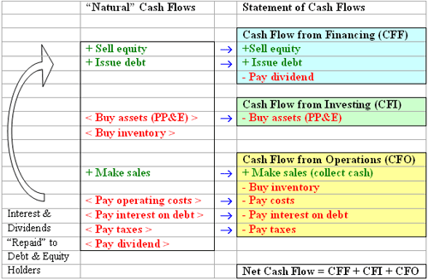
The sum of CFF, CFI and CFO is net cash flow. Although net cash flow is almost impervious to manipulation by management, it is an inferior performance measure because it includes financing cash flows (CFF), which, depending on a company's financing activities, can affect net cash flow in a way that is contradictory to actual operating performance. For example, a profitable company may decide to use its extra cash to retire long-term debt. In this case, a negative CFF for the cash outlay to retire debt could plunge net cash flow to zero even though operating performance is strong. Conversely, a money-losing company can artificially boost net cash flow by issuing a corporate bond or by selling stock. In this case, a positive CFF could offset a negative operating cash flow (CFO), even though the company's operations are not performing well.
Now that we have a firm grasp of the structure of natural cash flows and how they are represented/classified, this section will examine which cash flow measures are best used for a particular analysis. We will also focus on how you can make adjustments to figures so that your analysis isn't distorted by reporting manipulations.
Which Cash Flow Measure Is Best?
You have at least three valid cash flow measures to choose from. Which one is suitable for you depends on your purpose and whether you are trying to value the stock or the whole company.
The easiest choice is to pull cash flow from operations (CFO) directly from the statement of cash flows. This is a popular measure, but it has weaknesses when used in isolation: it excludes capital expenditures, which are typically required to maintain the firm's productive capability. It can also be manipulated, as we show below.
If we are trying to do a valuation or replace an accrual-based earnings measure, the basic question is "which group/entity does cash flow to?" If we want cash flow to shareholders, then we should use free cash flow to equity (FCFE), which is analogous to net earnings and would be best for a price-to-cash flow ratio (P/CF).
If we want cash flows to all capital investors, we should use free cash flow to the firm (FCFF). FCFF is similar to the cash generating base used in economic value added (EVA). In EVA, it's called net operating profit after taxes (NOPAT) or sometimes net operating profit less adjusted taxes (NOPLAT), but both are essentially FCFF where adjustments are made to the CFO component.
Cash Flow To: | Measure: | Calculation:
Operations | CFO | CFO or Adjusted CFO
Shareholders | Free Cash Flow to Equity | CFO - CFI *
Firm (Shareholders and Lenders) | Free Cash Flow to Firm (FCFF) | CFO + After-tax interest - CFI*
(*) Cash flow from investment (CFI) is used as an estimate of the level of net capital expenditures required to maintain and grow the company. The goal is to deduct expenditures needed to fund "ongoing" growth, and if a better estimate than CFI is available, then it should be used.
Free cash flow to equity (FCFE) equals CFO minus cash flows from investments (CFI). Why subtract CFI from CFO? Because shareholders care about the cash available to them after all cash outflows, including long-term investments. CFO can be boosted merely because the company purchased assets or even another company. FCFE improves on CFO by counting the cash flows available to shareholders net of all spending, including investments.
Free cash flow to the firm (FCFF) uses the same formula as FCFE but adds after-tax interest, which equals interest paid multiplied by [1 – tax rate]. After-tax interest paid is added because, in the case of FCFF, we are capturing the total net cash flows available to both shareholders and lenders. Interest paid (net of the company's tax deduction) is a cash outflow that we add back to FCFE in order to get a cash flow that is available to all suppliers of capital.
A Note Regarding Taxes
We do not need to subtract taxes separately from any of the three measures above. CFO already includes (or, more precisely, is reduced by) taxes paid. We usually do want after-tax cash flows since taxes are a real, ongoing outflow. Of course, taxes paid in a year could be abnormal. So for valuation purposes, adjusted CFO or EVA-type calculations adjust actual taxes paid to produce a more "normal" level of taxes. For example, a firm might sell a subsidiary for a taxable profit and thereby incur capital gains, increasing taxes paid for the year. Because this portion of taxes paid is non-recurring, it could be removed to calculate a normalized tax expense. But this kind of precision is not always necessary. It is often acceptable to use taxes paid as they appear in CFO.
Adjusting Cash Flow from Operations (CFO)
Each of the three cash flow measures includes CFO, but we want to capture sustainable or recurring CFO, that is, the CFO generated by the ongoing business. For this reason, we often cannot accept CFO as reported in the statement of cash flows, and generally need to calculate an adjusted CFO by removing one-time cash flows or other cash flows that are not generated by regular business operations. Below, we review four kinds of adjustments you should make to reported CFO in order to capture sustainable cash flows. First, consider a "clean" CFO statement from Amgen, a company with a reputation for generating robust cash flows:
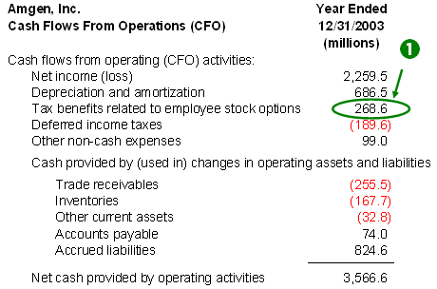
Amgen shows CFO in the indirect format. Under the indirect format, CFO is derived from net income with two sets of 'add backs'. First, non-cash expenses, such as depreciation, are added back because they reduce net income but do not consume cash. Second, changes to operating (current) balance sheet accounts are added or subtracted. In Amgen's case, there are five such additions/subtractions that fall under the label "cash provided by (used in) changes in operating assets and liabilities": three of these balance-sheet changes subtract from CFO and two of them add to CFO.
For example, notice that trade receivables (also known as accounts receivable) reduces CFO by about $255 million: trade receivables is a 'use of cash'. This is because, as a current asset account, it increased by $255 million during the year. This $255 million is included as revenue and therefore net income, but the company hadn't received the cash as of the year's end, so the uncollected revenues needed to be excluded from a cash calculation. Conversely, accounts payable is a 'source of cash' in Amgen's case. This current-liability account increased by $74 million during the year; Amgen owes the money and net income reflects the expense, but the company temporarily held onto the cash, so its CFO for the period is increased by $74 million.
We will refer to Amgen's statement to explain the first adjustment you should make to CFO:
1. Tax Benefits Related to Employee Stock Options (See #1 on Amgen CFO statement)
Amgen\'s CFO was boosted by almost $269 million because a company gets a tax deduction when employees exercise non-qualified stock options. As such, almost 8% of Amgen\'s CFO is not due to operations and is not necessarily recurring, so the amount of the 8% should be removed from CFO. Although Amgen\'s cash flow statement is exceptionally legible, some companies bury this tax benefit in a footnote.
To review the next two adjustments that must be made to reported CFO, we will consider Verizon\'s statement of cash flows below.
2. Unusual Changes to Working Capital Accounts (receivables, inventories and payables) (Refer to #2 on Verizon\'s CFO statement.)
Although Verizon\'s statement has many lines, notice that reported CFO is derived from net income with the same two sets of add backs we explained above: non-cash expenses are added back to net income and changes to operating accounts are added to or subtracted from it:
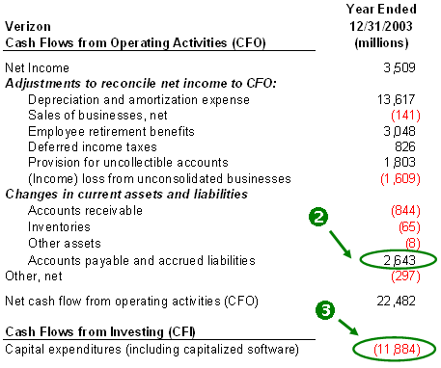
Notice that a change in accounts payable contributed more than $2.6 billion to reported CFO. In other words, Verizon created more than $2.6 billion in additional operating cash in 2003 by holding onto vendor bills rather than paying them. It is not unusual for payables to increase as revenue increases, but if payables increase at a faster rate than expenses, then the company effectively creates cash flow by "stretching out" payables to vendors. If these cash inflows are abnormally high, removing them from CFO is recommended because they are probably temporary. Specifically, the company could pay the vendor bills in January, immediately after the end of the fiscal year. If it does this, it artificially boosts the current-period CFO by deferring ordinary cash outflows to a future period.
Judgment should be applied when evaluating changes to working capital accounts because there can be good or bad intentions behind cash flow created by lower levels of working capital. Companies with good intentions can work to minimize their working capital - they can try to collect receivables quickly, stretch out payables and minimize their inventory. These good intentions show up as incremental and therefore sustainable improvements to working capital.
Companies with bad intentions attempt to temporarily dress-up cash flow right before the end of the reporting period. Such changes to working capital accounts are temporary because they will be reversed in the subsequent fiscal year. These include temporarily withholding vendor bills (which causes a temporary increase in accounts payable and CFO), cutting deals to collect receivables before the year's end (causing a temporary decrease in receivables and increase in CFO), or drawing down inventory before the year's end (which causes a temporary decrease in inventory and increase in CFO). In the case of receivables, some companies sell their receivables to a third party in a factoring transaction, which has the effect of temporarily boosting CFO.
3. Capitalized Expenditures That Should Be Expensed (outflows in CFI that should be manually re-classified to CFO) (Refer to #3 on the Verizon CFO statement.)
Under cash flow from investing (CFI), you can see that Verizon invested almost $11.9 billion in cash. This cash outflow was classified under CFI rather than CFO because the money was spent to acquire long-term assets rather than pay for inventory or current operating expenses. However, on occasion this is a judgment call. WorldCom notoriously exploited this discretion by reclassifying current expenses into investments and, in a single stroke, artificially boosting both CFO and earnings.
Verizon chose to include 'capitalized software' in capital expenditures. This refers to roughly $1 billion in cash spent (based on footnotes) to develop internal software systems. Companies can choose to classify software developed for internal use as an expense (reducing CFO) or an investment (reducing CFI). Microsoft, for example, responsibly classifies all such development costs as expenses rather than capitalizing them into CFI, which improves the quality of its reported CFO. In Verizon's case, it's advisable to reclassify the cash outflow into CFO, reducing it by $1 billion.
The main idea here is that if you are going to rely solely on CFO, you should check CFI for cash outflows that ought to be reclassified to CFO.
4. One-Time (Nonrecurring) Gains Due to Dividends Received or Trading Gains
CFO technically includes two cash flow items that analysts often re-classify into cash flow from financing (CFF): (1) dividends received from investments and (2) gains/losses from trading securities (investments that are bought and sold for short-term profits). If you find that CFO is boosted significantly by one or both of these items, they are worth examination. Perhaps the inflows are sustainable. On the other hand, dividends received are often not due to the company's core operating business and may not be predictable. Gains from trading securities are even less sustainable: they are notoriously volatile and should generally be removed from CFO unless, of course, they are core to operations, as with an investment firm. Further, trading gains can be manipulated: management can easily sell tradable securities for a gain prior to the year's end, boosting CFO.

Summary
Cash flow from operations (CFO) should be examined for distortions in the following ways:
- Remove gains from tax benefits due to stock option exercises.
- Check for temporary CFO blips due to working capital actions. For example, withholding payables, or "stuffing the channel", to temporarily reduce inventory.
- Check for cash outflows classified under CFI that should be reclassified to CFO.
- Check for other one-time CFO blips due to nonrecurring dividends or trading gains.
Aside from being vulnerable to distortions, the major weakness of CFO is that it excludes capital investment dollars. We can generally overcome this problem by using free cash flow to equity (FCFE), which includes (or, more precisely, is reduced by) capital expenditures (CFI). Finally, the weakness of FCFE is that it will change if the capital structure changes. That is, FCFE will go up if the company replaces debt with equity (an action that reduces interest paid and therefore increases CFO) and vice versa. This problem can be overcome by using free cash flow to firm (FCFF), which is not distorted by the ratio of debt to equity.

Reference: http://www.investopedia.com/university/financialstatements/financialstatements3.asp Access: May 15th 2013

Earnings: In this section, we try to answer the question, "what earnings number should be used to evaluate company performance?" We start by considering the relationship between the cash flow statement and the income statement. In the preceding section, we explained that companies must classify cash flows into one of three categories: operations, investing, or financing. The diagram below traces selected cash flows from operations and investing to their counterparts on the income statement (cash flow from financing (CFF) does not generally map to the income statement):
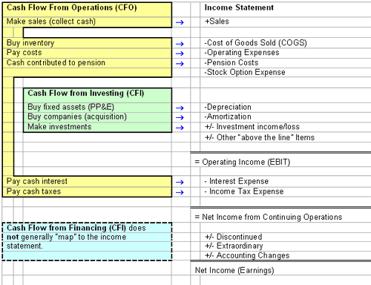
Many cash flow items have a direct counterpart, that is, an accrual item on the income statement. During a reporting period like a fiscal year or a fiscal quarter, the cash flow typically will not match its accrual counterpart. For example, cash spent during the year to acquire new inventory will not match cost of goods sold (COGS). This is because accrual accounting gives rise to timing differences in the short run: on the income statement, revenues count when they are earned and they're matched against expenses as the expenses are incurred.
Expenses on the income statement are meant to represent costs incurred during the period that can be tracked either (1) to cash already spent in a prior period or (2) to cash that probably will be spent in a future period. Similarly, revenues are meant to recognize cash that is earned in the current period but either (1) has already been received or (2) probably will be received in the future. Although cash flows and accruals will disagree in the short run, they should converge in the long run, at least in theory.
Consider two examples:
Depreciation - Say a company invests $10 million to buy a manufacturing plant, triggering a $10 million cash outflow in the year of purchase. If the life of the plant is 10 years, the $10 million is divided over each of the subsequent 10 years, producing a non-cash depreciation expense each year in order to recognize the cost of the asset over its useful life. But cumulatively, the sum of the depreciation expense ($1 million per year x 10 years) equals the initial cash outlay.
- Interest Expense - Say a company issues a zero-coupon corporate bond, raising $7 million with the obligation to repay $10 million in five years. During each of the five interim years, there will be an annual interest expense but no corresponding cash outlay. However, by the end of the fifth year, the cumulative interest expense will equal $3 million ($10 million - $7 million), and the cumulative net financing cash outflow will also be $3 million.
In theory, accrual accounting ought to be superior to cash flows in gauging operating performance over a reporting period. However, accruals must make estimations and assumptions, which introduce the possibility of flaws.
The primary goal when analyzing an income statement is to capture normalized earnings, that is, earnings that are both recurring and operational in nature. Trying to capture normalized earnings presents two major kinds of challenges: timing issues and classification choices. Timing issues cause temporary distortions in reported profits. Classification choices require us to remove one-time items or earnings not generated by ongoing operations, such as gains from pension plan investments.
Timing Issues
Most timing issues fall into four major categories:
Major Category: | For Example: | Specific Implications:
1. Recognizing Revenue Too Early | - Selling with extended financing terms. For example, the customer doesn\'t pay for 18 months. | - Revenue recognized in current period but could be "reversed" in the next year.
2. Delaying, or "front loading" expenses to save them in future years | - Capitalizing expenditures that could be expensed  - Slowing down depreciation rate of long-term assets  - Taking big write-offs (also know as "big baths") | - Only part of the expenditure is expensed in the current year - the rest is added to future depreciation expense  - Depreciation expense is reduced in current year because total depreciation expense allocated over a greater number of years  - Saves expenses in future years
3. Overvaluing Assets | - Underestimating obsolete inventory  - Failing to write down or write off impaired assets | - As obsolete (low-cost) inventory is liquidated, COGS is lowered and gross profit margins are increased  - Keeping overvalued assets on the balance sheet overstates profits until losses are finally recognized.
4. Undervaluing Liabilities | - Lowering net pension obligation by increasing the assumed return on pension assets  - Excluding stock option expense | - A lower net pension obligation reduces the current pension cost.  - Avoids recognizing a future transfer of wealth from shareholders to employees
Premature revenue recognition and delayed expenses are more intuitive than the distortions caused by the balance sheet, such as overvalued assets. Overvalued assets are considered a timing issue here because, in most (but not all) cases, "the bill eventually comes due." For example, in the case of overvalued assets, a company might keep depreciation expense low by carrying a long-term asset at an inflated net book value (where net book value equals gross asset minus accumulated depreciation), but eventually the company will be required to "impair" or write-down the asset, which creates an earnings charge. In this case, the company has managed to keep early period expenses low by effectively pushing them into future periods.
It is important to be alert to earnings that are temporarily too high or even too low due to timing issues.
Classification Choices
Once the income statement is adjusted or corrected for timing differences, the other major issue is classification. In other words, which profit number do we care about? The question is further complicated because GAAP does not currently dictate a specific format for the income statement. As of May 2004, FASB has already spent over two years on a project that will impact the presentation of the income statement, and they are not expected to issue a public discussion document until the second quarter of 2005.
We will use Sprint's latest income statement to answer the question concerning the issue of classification.
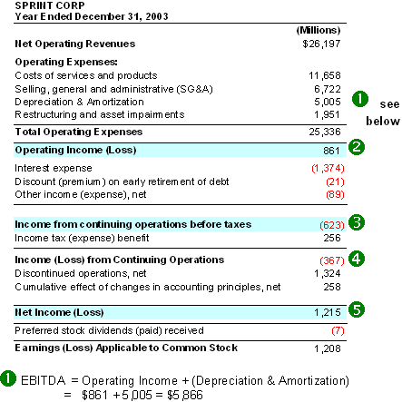
We identified five key lines from Sprint's income statement. (The generic label for the same line is in parentheses):
1. Operating Income Before Depreciation and Amortization (EBITDA)
Sprint does not show EBITDA directly, so we must add depreciation and amortization to operating income (EBIT). Some people use EBITDA as a proxy for cash flow because depreciation and amortization are non-cash charges, but EBITDA does not equal cash flow because it does not include changes to working capital accounts. For example, EBITDA would not capture the increase in cash if accounts receivable were to be collected.
The virtue of EBITDA is that it tries to capture operating performance, that is, profits after cost of goods sold (COGS) and operating expenses, but before non operating items and financing items such as interest expense. However, there are two potential problems. First, not necessarily everything in EBITDA is operating and recurring. Notice that Sprint\'s EBITDA includes an expense of $1.951 billion for "restructuring and asset impairments." Sprint surely includes the expense item here to be conservative, but if we look at the footnote, we can see that much of this expense is related to employee terminations. Since we do not expect massive terminations to recur on a regular basis, we could safely exclude this expense.
Second, EBITDA has the same flaw as operating cash flow (OCF), which we discussed in this tutorial\'s section on cash flow: there is no subtraction for long-term investments, including the purchase of companies (because goodwill is a charge for capital employed to make an acquisition). Put another way, OCF totally omits the company\'s use of investment capital. A company, for example, can boost EBITDA merely by purchasing another company.
2. Operating Income After Depreciation and Amortization (EBIT)
In theory, this is a good measure of operating profit. By including depreciation and amortization, EBIT counts the cost of making long-term investments. However, we should trust EBIT only if depreciation expense (also called accounting or book depreciation) approximates the company\'s actual cost to maintain and replace its long-term assets. (Economic depreciation is the term used to describe the actual cost of maintaining long-term assets). For example, in the case of a REIT, where real estate actually appreciates rather than depreciates - where accounting depreciation is far greater than economic depreciation - EBIT is useless.
Furthermore, EBIT does not include interest expense and, therefore, is not distorted by capital structure changes. In other words, it will not be affected merely because a company substitutes debt for equity or vice versa. By the same token, however, EBIT does not reflect the earnings that accrue to shareholders since it must first fund the lenders and the government.
As with EBITDA, the key task is to check that recurring, operating items are included and that items that are either non-operating or non-recurring are excluded.
3. Income From Continuing Operations Before Taxes (Pre-Tax Earnings)
Pre-tax earnings subtracts (includes) interest expense. Further, it includes other items that technically fall within "income from continuing operations," which is an important technical concept.
Sprint\'s presentation conforms to accounting rules: items that fall within income from continuing operations are presented on a pre-tax basis (above the income tax line), whereas items not deemed part of continuing operations are shown below the tax expense and on a net tax basis.
The thing to keep in mind is that you want to double-check these classifications. We really want to capture recurring, operating income, so income from continuing operations is a good start. In Sprint\'s case, the company sold an entire publishing division for an after-tax gain of $1.324 billion (see line "discontinued operations, net"). Amazingly, this sale turned a $623 million loss under income from continuing operations before taxes into a $1.2+ billion gain under net income. Since this gain will not recur, it is correctly classified.
On the other hand, notice that income from continuing operations includes a line for the "discount (premium) on the early retirement of debt." This is a common item, and it occurs here because Sprint refinanced some debt and recorded a loss. But in substance, it is not expected to recur and therefore it should be excluded.
4. Income From Continuing Operations (Net Income From Continuing Operations)
This is the same as above, but taxes are subtracted. From a shareholder perspective, this is a key line, and it\'s also a good place to start since it is net of both interest and taxes. Furthermore, it excludes the non-recurring items discussed above, which instead fall into net income but can make net income an inferior gauge of operating performance.
5. Net Income
Compared to income from continuing operations, net income has three additional items that contribute to it: extraordinary items, discontinued operations, and accounting changes. They are all presented net of tax. You can see two of these on Sprint\'s income statement: "discontinued operations" and the "cumulative effect of accounting changes" are both shown net of taxes - after the income tax expense (benefit) line.
You should check to see if you disagree with the company\'s classification, particularly concerning extraordinary items. Extraordinary items are deemed to be both "unusual and infrequent" in nature. However, if the item is deemed to be either "unusual" or "infrequent," it will instead be classified under income from continuing operations.
Summary
In theory, the idea behind accrual accounting should make reported profits superior to cash flow as a gauge of operating performance. But in practice, timing issues and classification choices can paint a profit picture that is not sustainable. Our goal is to capture normalized earnings generated by ongoing operations.
To do that, we must be alert to timing issues that temporarily inflate (or deflate) reported profits. Furthermore, we should exclude items that are not recurring, resulting from either one-time events or some activity other than business operations. Income from continuing operations - either pre-tax or after-tax - is a good place to start. For gauging operating performance, it is a better starting place than net income, because net income often includes several non-recurring items such as discontinued operations, accounting changes and extraordinary items (which are both unusual and infrequent).
We should be alert to items that are technically classified under income from continuing operations but perhaps should be manually excluded. This may include investment gains and losses, items deemed either "unusual" or "infrequent" and other one-time transactions such as the early retirement of debt.

Reference: http://www.investopedia.com/university/financialstatements/financialstatements4.asp Access on: May 15th 2013

Revenue: Revenue recognition refers to a set of accounting rules that governs how a company accounts for its sales. Many corporate accounting scandals have started with companies admitting they have reported "irregular" revenues. This kind of dishonesty is a critical accounting issue. In several high-profile cases, management misled investors - and its own auditors - by deliberately reporting inflated revenues in order to buoy its company's stock price. As of June 2004, the Financial Accounting Standards Board (FASB) has begun working to consolidate and streamline the various accounting rules into a single authoritative pronouncement.
But this series is not concerned with detecting fraud: there are several books that catalog fraudulent accounting practices and the high-profile corporate meltdowns that have resulted from them. The problem is that most of these scams went undetected, even by professional investors, until it was too late. In practice, individual investors can rarely detect bogus revenue schemes; to a large extent, we must trust the financial statements as they are reported. However, when it comes to revenue recognition, there are a few things we can do.
1. Identify Risky Revenues
If only cash counted, revenue reporting would not pose any risk of misleading investors. But the accrual concept allows companies to book revenue before receiving cash. Basically, two conditions must be met: (1) the critical earnings event must be completed (for example, service must be provided or product delivered) and (2) the payment must be measurable in its amount, agreed upon with the buyer, and its ultimate receipt must be reasonably assured (SFAC 5, SEC Bulletin 101).
For some companies, recording revenue is simple; but for others, the application of the above standards allows for, and even requires, the discretion of management. The first thing an investor can do is identify whether the company poses a high degree of accounting risk due to this discretion. Certain companies are less likely to suffer revenue restatements simply because they operate with more basic, transparent business models. (We could call these "simple revenue" companies.) Below, we list four aspects of a company and outline the degree of accounting risk associated with each aspect:
Aspects of Companies | Type Associated with Simple Revenue | Type Associated with Difficult Revenue | Examples of "Difficult" Revenue
1. Revenue Type | Product | Service | Extended service warranty contract is sold with consumer electronics
Ownership Type | Company is the owner/seller | Company is an agent, distributor or franchisor (or products are sold on consignment) | Auction site sells airline tickets (should it report "gross" revenue or "net" fee received?) Or a restaurant boosts revenue by collecting franchise fees
Type of Sales Cycle | Sales are made at delivery or "point of sale" | Sales are made via long-term service, subscription or membership contracts | Fitness facility operator sells long-term gym memberships
Degree of Product Complexity | Stand-alone products | Bundled products and services (that is, multiple deliverable arrangements (MDAs)) | Software publisher bundles installation and technical support with product
Many of the companies that have restated their revenues sold products or services in some combination of the modes listed above under "difficult revenues." In other words, the sales of these companies tended to involve long-term service contracts, making it difficult to determine how much revenue should be counted in the current period when the service is not yet fully performed. These companies also engaged in complex franchise arrangements, pre-sold memberships or subscriptions and/or the bundling of multiple products and/or services.
We're not suggesting that you should avoid these companies - to do so would be almost impossible! Rather, the idea is to identify the business model; if you determine that any risky factors are present, then you should scrutinize the revenue recognition policies carefully.
For example, Robert Mondavi (ticker: MOND) sells most of its wines in the U.S. to distributors under terms called FOB Shipping Point. This means that, once the wines are shipped, the buyers assume most of the risk, which means they generally cannot return the product. Mondavi collects simple revenue: it owns its product, gets paid fairly quickly after delivery and the product is not subject to overly complex bundling arrangements. Therefore, when it comes to trusting the reported revenues "as reported," a company such as Robert Mondavi poses low risk. If you were analyzing Mondavi, you could spend your time focusing on other aspects of its financial statements.
On the other hand, enterprise software companies such as Oracle or PeopleSoft naturally pose above-average accounting risk. Their products are often bundled with intangible services that are tied to long-term contracts and sold through third-party resellers. Even the most honest companies in this business cannot avoid making revenue-reporting judgments and must therefore be scrutinized.
2. Check Against Cash Collected
The second thing you can do is to check reported revenues against the actual cash received from customers. In the section on cash flow, we see that companies can show cash from operations (CFO) in either the direct or indirect format; unfortunately, almost all companies use the indirect method. A rare exception is Collins Industries:
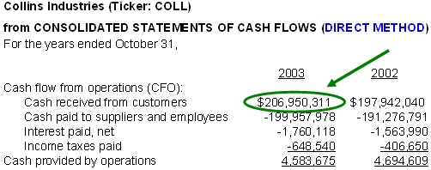
The virtue of the direct method is that it displays a separate line for "cash received from customers." Such a line is not shown under the indirect method, but we only need three items to calculate the cash received from customers:
(1) Net sales
(2) Plus the decrease in accounts receivable (or minus the increase)
(3) Plus the increase in cash advances from customers
(or minus the decrease)
______________________________________________________
= Cash received from customers
We add the decrease in accounts receivable because it signifies cash received to pay down receivables. 'Cash advances from customers' represents cash received for services not yet rendered; this is also known as unearned or deferred revenue and is classified as a current liability on the balance sheet. Below, we do this calculation for Collins Industries. You can see that our calculated number (shown under "How to Calculate 'Cash Received from Customers'") equals the reported cash collected from customers (circled in green above):
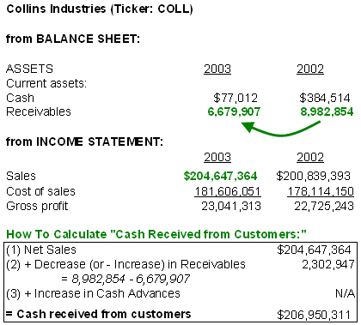
We calculate 'cash received from customers' to compare the growth in cash received to the growth in reported revenues. If the growth in reported revenues jumps far ahead of cash received, we need to ask why. For example, a company may induce revenue growth by offering favorable financing terms - like the ads you often see for consumer electronics that offer "0% financing for 18 months." A new promotion such as this will create booked revenue in the current period, but cash won't be collected until future periods. And of course, some of the customers will default and their cash won't be collected. So the initial revenue growth may or may not be good growth, in which case, we should pay careful attention to the allowance for doubtful accounts.
Allowance for Doubtful Accounts
Of course, many sales are offered with credit terms: the product is sold and an accounts receivable is created. Because the product has been delivered (or service has been rendered) and payment is agreed upon, known and reasonably assured, the seller can book revenue.
However, the company must estimate how much of the receivables will not be collected. For example, it may book $100 in gross receivables but, because the sales were on credit, the company might estimate that $7 will ultimately not be collected. Therefore, a $7 allowance is created and only $93 is booked as revenue. As you can see, a company can report higher revenues by lowering this allowance.
Therefore, it is important to check that sufficient allowances are made. If the company is growing rapidly and funding this growth with greater accounts receivables, then the allowance for doubtful accounts should be growing too.
3. Parse Organic Growth from Other Revenue Sources
The third thing investors can do is scrutinize the sources of revenues. This involves identifying and then parsing different sources of growth. The goal is to identify the sources of temporary growth and separate them from organic, sustainable growth.
Let's consider the two dimensions of revenue sources. The first dimension is cash versus accrual: we call this "cash" versus "maybe cash" (represented on the left side of the box below). "Maybe cash" refers to any booked revenue that is not collected as cash in the current period. The second dimension is sustainable versus temporary revenue (represented on the top row of the box below):
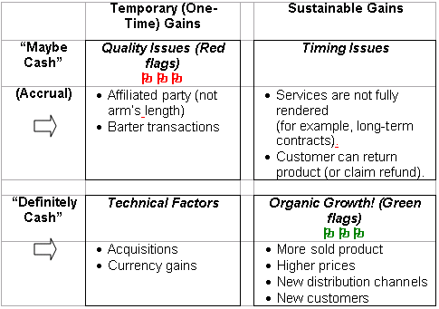
To illustrate the parsing of revenues, we will use the latest annual report from Office Depot (ticker: ODP), a global retail supplier of office products and services. For fiscal 2003, reported sales of $12.358 billion represented an 8.8% increase over the prior year.
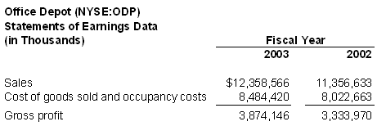
First, we will parse the accrual (the "maybe cash") from the cash. We can do this by looking at the receivables. You will see that, from 2002 to 2003, receivables jumped from $777.632 million to $1.112 billion, and the allowance for doubtful accounts increased from $29.149 million in 2002 to $34.173 million in 2003.
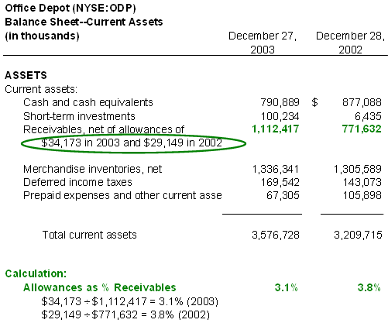
Office Depot's receivables jumped more than its allowance. If we divide the allowance into the receivables (see bottom of exhibit above), you see that the allowance (as a percentage of receivables) decreased from 3.8% to 3.1%. Perhaps this is reasonable, but the decrease helped to increase the booked revenues. Furthermore, we can perform the calculation reviewed above (in #2) to determine the cash received from customers:
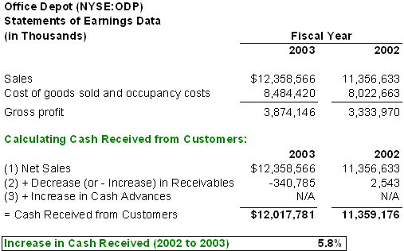
Cash received did not increase as much as reported sales. This is not a bad thing by itself. It just means that we should take a closer look to determine whether we have a quality issue (upper left-hand quadrant of the box above) or a timing issue (upper right-hand quadrant of the box). A quality issue is a "red flag" and refers to the upper left-hand quadrant: temporary accruals. We want to look for any one-time revenue gains that are not cash.
When we read Office Depot's footnotes, we will not find any glaring red flags, although we will see that same store sales (sales at stores open for at least a year) actually decreased in the United States. The difference between cash and accrual appears to be largely due to timing. Office Depot did appear to factor some of its receivables, that is, sell receivables to a third party in exchange for cash, but factoring by itself is not a red flag. In Office Depot's case, the company converted receivables to cash and transferred some (or most) of the credit risk to a third party. Factoring affects cash flows (and we need to be careful with it to the extent that it boosts cash from operations) but, in terms of revenue, factoring should raise a red flag only when (i) the company retains the entire risk of collections, and/or (ii) the company factors with an affiliated party that is not at arm's length.
Cash-Based but Temporary Revenue
When it comes to analyzing the sources of sustainable revenues, it helps to parse the "technical" factors (lower left-hand quadrant). These are often strangely neglected by investors.
The first technical factor is acquisitions. Take a look at this excerpt from a footnote in Office Depot's annual report:
…impacting sales in our International Division during 2003 was our acquisition of Guilbert in June which contributed additional sales of $808.8 million. (Item 7)
Therefore, almost all of Office Depot's $1 billion in sales growth can be attributed to an acquisition. Acquisitions are not bad in and of themselves, but they are not organic growth. Here are some key follow-up questions you should ask about an acquisition: How much is the acquired company growing? How will it contribute to the parent company's growth going forward? What was the purchase price? In Office Depot's case, this acquisition should alert us to the fact that the core business (before acquisition) is flat or worse.
The second technical factor is revenue gains due to currency translation. Here is another footnote from Office Depot:
As noted above, sales in local currencies have substantially increased in recent years. For U.S. reporting, these sales are translated into U.S. dollars at average exchange rates experienced during the year. International Division sales were positively impacted by foreign exchange rates in 2003 by $253.2 million and $67.0 million in 2002 (International Division).
Here we see one of the benefits of a weaker U.S. dollar: it boosts the international sales numbers of U.S. companies! In Office Depot's case, international sales were boosted by $253 million because the dollar weakened over the year. Why? A weaker dollar means more dollars are required to buy a foreign currency, but conversely, a foreign currency is translated into more dollars. So, even though a product may maintain its price in foreign currency terms, it will translate into a greater number of dollars as the dollar weakens.
We call this a technical factor because it is a double-edged sword: if the U.S. dollar strengthens, it will hurt international sales. Unless you are a currency expert and mean to bet on the direction of the dollar, you probably want to treat this as a random variable. The follow-up question to the currency factor is this: Does the company hedge its foreign currency? (Office Depot generally does not, so it is exposed to currency risk.)
Summary
Revenue recognition is a hot topic and the subject of much post-mortem analysis in the wake of multiple high-profile restatements. We don't think you can directly guard against fraud; that is a job for a company's auditor and the audit committee of the board of directors. But you can do the following:
• Determine the degree of accounting risk posed by the company's business model.
• Compare growth in reported revenues to cash received from customers.
• Parse organic growth from the other sources and be skeptical of any one-time revenue gains not tied directly to cash (quality of revenues). Scrutinize any material gains due to acquisitions. And finally, omit currency gains.

Reference: http://www.investopedia.com/university/financialstatements/financialstatements5.asp Access on: May 15th 2013

Working capital: A recurring theme in this series is the importance of investors shaping their analytical focus according to companies' business models. Especially when time is limited, it's smart to tailor your emphasis so it's in line with the economic drivers that preoccupy the company's industry. It's tough to get ahead of the "investing pack" if you are reacting to generic financial results - such as earnings per share (EPS) or revenue growth - after they've already been reported. For any given business, there are usually some key economic drivers, or leading indicators, that capture and reflect operational performance and eventually translate into lagging indicators such as EPS. For certain businesses, trends in the working capital accounts can be among these key leading indicators of financial performance.
Where is Working Capital Analysis Most Critical?
On the one hand, working capital is always significant. This is especially true from the lender's or creditor's perspective, where the main concern is defensiveness: can the company meet its short-term obligations, such as paying vendor bills?
But from the perspective of equity valuation and the company's growth prospects, working capital is more critical to some businesses than to others. At the risk of oversimplifying, we could say that the models of these businesses are asset or capital intensive rather than service or people intensive. Examples of service intensive companies include H&R Block, which provides personal tax services, and Manpower, which provides employment services. In asset intensive sectors, firms such as telecom and pharmaceutical companies invest heavily in fixed assets for the long term, whereas others invest capital primarily to build and/or buy inventory. It is the latter type of business - the type that is capital intensive with a focus on inventory rather than fixed assets - that deserves the greatest attention when it comes to working capital analysis. These businesses tend to involve retail, consumer goods and technology hardware, especially if they are low-cost producers or distributors.
Working capital is the difference between current assets and current liabilities:
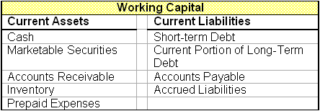
Inventory
Inventory balances are significant because inventory cost accounting impacts reported gross profit margins. (For an explanation of how this happens, see Inventory Valuation For Investors: FIFO and LIFO.) Investors tend to monitor gross profit margins, which are often considered a measure of the value provided to consumers and/or the company's pricing power in the industry. However, we should be alert to how much gross profit margins depend on the inventory costing method.
Below we compare three accounts used by three prominent retailers: net sales, cost of goods sold (COGS) and the LIFO reserve.
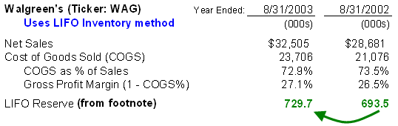
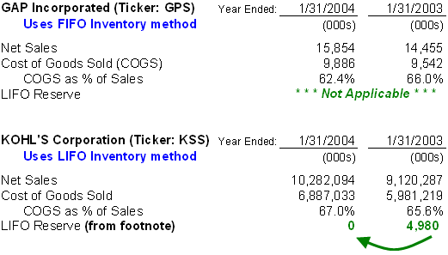
Walgreen's represents our normal case and arguably shows the best practice in this regard: the company uses LIFO inventory costing, and its LIFO reserve increases year over year. In a period of rising prices, LIFO will assign higher prices to the consumed inventory (cost of goods sold) and is therefore more conservative. Just as COGS on the income statement tends to be higher under LIFO than under FIFO, the inventory account on the balance sheet tends to be understated. For this reason, companies using LIFO must disclose (usually in a footnote) a LIFO reserve, which when added to the inventory balance as reported, gives the FIFO-equivalent inventory balance.
Because GAP Incorporated uses FIFO inventory costing, there is no need for a "LIFO reserve." However, GAP's and Walgreen's gross profit margins are not commensurable. In other words, comparing FIFO to LIFO is not like comparing apples to apples. GAP will get a slight upward bump to its gross profit margin because its inventory method will tend to undercount the cost of goods. There is no automatic solution for this. Rather, we can revise GAP's COGS (in dollar terms) if we make an assumption about the inflation rate during the year. Specifically, if we assume that the inflation rate for the inventory was R% during the year, and if "Inventory Beginning" in the equation below equals the inventory balance under FIFO, we can re-estimate COGS under LIFO with the following equation:
Kohl's Corporation uses LIFO, but its LIFO reserve declined year over year - from $4.98 million to zero. This is known as LIFO liquidation or liquidation of LIFO layers, and indicates that during the fiscal year, Kohl's sold or liquidated inventory that was held at the beginning of the year. When prices are rising, we know that inventory held at the beginning of the year carries a lower cost (because it was purchased in prior years). Cost of goods sold is therefore reduced, sometimes significantly. Generally, in the case of a sharply declining LIFO reserve, we can assume that reported profit margins are upwardly biased to the point of distortion.
Cash Conversion Cycle
The cash conversion cycle is a measure of working capital efficiency, often giving valuable clues about the underlying health of a business. The cycle measures the average number of days that working capital is invested in the operating cycle. It starts by adding days inventory outstanding (DIO) to days sales outstanding (DSO). This is because a company "invests" its cash to acquire/build inventory, but does not collect cash until the inventory is sold and the accounts receivable are finally collected.
Receivables are essentially loans extended to customers that consume working capital; therefore, greater levels of DIO and DSO consume more working capital. However, days payable outstanding (DPO), which essentially represent loans from vendors to the company, are subtracted to help offset working capital needs. In summary, the cash conversion cycle is measured in days and equals DIO + DSO – DPO:
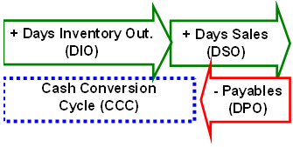
Here we extracted two lines from Kohl's (a retail department store) most recent income statement and a few lines from their working capital accounts.
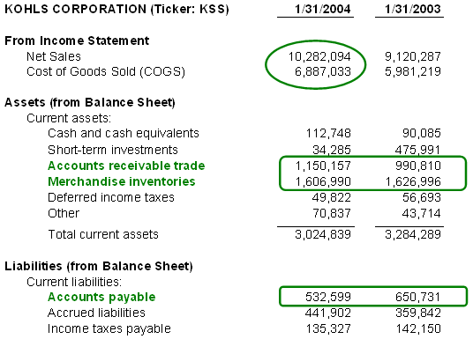
Circled in green are the accounts needed to calculate the cash conversion cycle. From the income statement, you need net sales and COGS. From the balance sheet, you need receivables, inventories and payables. Below, we show the two-step calculation. First, we calculate the three turnover ratios: receivables turnover (sales/average receivables), inventory turnover (COGS/average inventory) and payables turnover (purchases/average payables). The turnover ratios divide into an average balance because the numerators (such as sales in the receivables turnover) are flow measures over the entire year.
Also, for payables turnover, some use COGS/average payables. That's okay, but it's slightly more accurate to divide average payables into purchases, which equals COGS plus the increase in inventory over the year (inventory at end of year minus inventory at beginning of the year). This is better because payables finance all of the operating dollars spent during the period (that is, they are credit extended to the company). And operating dollars, in addition to COGS, may be spent to increase inventory levels.
The turnover ratios do not mean much in isolation; they are used to compare one company to another. But if you divide the turnover ratios into 365 (for example, 365/receivables turnover), you get the "days outstanding" numbers. Below, for example, a receivable turnover of 9.6 becomes 38 days sales outstanding (DSO). This number has more meaning; it means that, on average, Kohl's collects its receivables in 38 days.
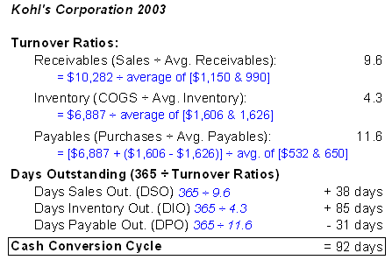
Here is a graphic summary of Kohl's cash conversion cycle for 2003. On average, working capital spent 92 days in Kohl's operating cycle:
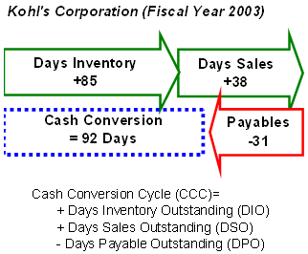
Let's contrast Kohl's with Limited Brands. Below we perform the same calculations in order to determine the cash conversion cycle for Limited Brands:
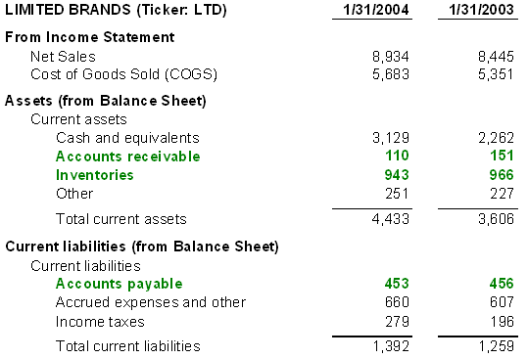
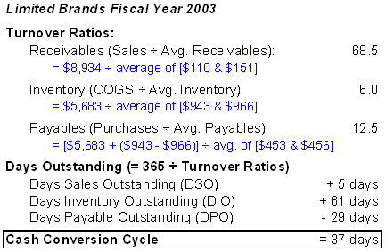
While Kohl's cycle is 92 days, Limited Brand's cycle is only 37. Why does this matter? Because working capital must be financed somehow, with either debt or equity, and both companies use debt. Kohl's cost of sales (COGS) is about $6.887 billion per year, or almost $18.9 million per day ($6.887 billion/365 days). Because Kohl's cycle is 92 days, it must finance--that is, fund its working capital needs--to the tune of about $1.7+ billion per year ($18.9 million x 92 days). If interest on its debt is 5%, then the cost of this financing is about $86.8 million ($1.7 billion x 5%) per year. However, if, hypothetically, Kohl's were able to reduce its cash conversion cycle to 37 days--the length of Limited Brands' cycle--its cost of financing would drop to about $35 million ($18.9 million per day x 37 days x 5%) per year. In this way, a reduction in the cash conversion cycle drops directly to the bottom line.
But even better, the year over year trend in the cash conversion cycle often serves as a sign of business health or deterioration. Declining DSO means customers are paying sooner; conversely, increasing DSO could mean the company is using credit to push product. A declining DIO signifies that inventory is moving out rather than "piling up." Finally, some analysts believe that an increasing DPO is a signal of increasing economic leverage in the marketplace. The textbook examples here are Walmart and Dell: these companies can basically dictate the terms of their relationships to their vendors and, in the process, extend their days payable (DPO).
Looking "Under the Hood" for Other Items
Most of the other working capital accounts are straightforward, especially the current liabilities side of the balance sheet. But you do want to be on the alert for the following:
- Off-balance-sheet financing
- Derivatives
For examples of these two items, consider the current assets section of Delta Airlines' fiscal year 2003 balance sheet:
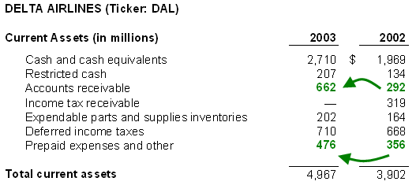
Notice that Delta's receivables more than doubled from 2002 to 2003. Is this a dangerous sign of collections problems? Let's take a look at the footnote:
We were party to an agreement, as amended, under which we sold a defined pool of our accounts receivable, on a revolving basis, through a special-purpose, wholly owned subsidiary, which then sold an undivided interest in the receivables to a third party.... This agreement terminated on its scheduled expiration date of March 31, 2003. As a result, on April 2, 2003, we paid $250 million, which represented the total amount owed to the third party by the subsidiary, and subsequently collected the related receivables. (Note 8, Delta 10-K FY 2003)
Here's the translation: during 2002, most of Delta's receivables were factored in an off-balance sheet transaction. By factored, we mean Delta sold some of its accounts receivables to another company (via a subsidiary) in exchange for cash. In brief, Delta gets paid quickly rather than having to wait for customers to pay. However, the seller (Delta in this case) typically retains some or all of the credit risk - the risk that customers will not pay. For example, they may collateralize the receivables.
We see that during 2003, the factored receivables were put back onto the balance sheet. In economic terms, they never really left but sort of disappeared in 2002. So the 2003 number is generally okay, but there was not a dramatic jump. More importantly, if we were to analyze year 2002, we'd have to be sure to manually "add-back" the off-balance sheet receivables, which would otherwise look artificially favorable for that year.
We also highlighted Delta's increase in "prepaid expenses and other" because this innocent-looking account contains the fair value of Delta's fuel hedge derivatives. Here's what the footnote says:
Prepaid expenses and other current assets increased by 34%, or $120 million, primarily due to an increase in prepaid aircraft fuel as well as an increase in the fair value of our fuel hedge derivative contracts.... Approximately 65%, 56% and 58% of our aircraft fuel requirements were hedged during 2003, 2002 and 2001, respectively. In February 2004, we settled all of our fuel hedge contracts prior to their scheduled settlement dates… and none of our projected aircraft fuel requirements for 2005 or thereafter.
The rules concerning derivatives are complex, but the idea is this: it is entirely likely that working capital accounts contain embedded derivative instruments. In fact, the basic rule is that, if a derivative is a hedge whose purpose is to mitigate risk (as opposed to a hedge whose purpose is to speculate), then the value of the hedge will impact the carrying value of the hedged asset. For example, if fuel oil is an inventory item for Delta, then derivatives contracts meant to lock-in future fuel oil costs will directly impact the inventory balance. Most derivatives, in fact, are not used to speculate but rather to mitigate risks that the company cannot control.
Delta's footnote above has good news and bad news. The good news is that as fuel prices rose, the company made some money on its fuel hedges, which in turn offset the increase in fuel prices - the whole point of their design! But this is overshadowed by news which is entirely bad: Delta settled "all of [their] fuel hedge contracts" and has no hedges in place for 2005 and thereafter! Delta is thus exposed in the case of high fuel prices, which is a serious risk factor for the stock.
Summary
Traditional analysis of working capital is defensive; it asks, "Can the company meet its short-term cash obligations?" But working capital accounts also tell you about the operational efficiency of the company. The length of the cash conversion cycle (DSO+DIO-DPO) tells you how much working capital is tied up in ongoing operations. And trends in each of the days-outstanding numbers may foretell improvements or declines in the health of the business.
Investors should check the inventory costing method, and LIFO is generally preferred to FIFO. However, if the LIFO reserve drops precipitously year over year, then the implied inventory liquidation distorts COGS and probably renders the reported profit margin unusable.
Reference: http://www.investopedia.com/university/financialstatements/financialstatements6.asp Access on: May 15th 2013

Long-lived assets: In the preceding section, we examined working capital, which refers to the current assets and liabilities of a company. In this section, we take a closer look at the long-lived assets (a.k.a. non-current assets) carried on the balance sheet. Long-lived assets are those that provide the company with a future economic benefit beyond the current year or operating period. It may be helpful to remember that most (but not all) long-lived assets start as some sort of purchase by the company.
In fact, whenever a company purchases an asset, it will either expense or capitalize the purchase. Consider a simple example of a company that generates $150 in sales and, in the same year, spends $100 on research and development (R&D). In scenario A below, the entire $100 is expensed and, as a result, the profit is simply $50 ($100 – $50). In scenario B, the company capitalizes the $100, which means a long-lived asset is created on the balance sheet and the cost is allocated (charged) as an expense over future periods. If we assume the asset has a five-year life, only one-fifth of the investment is allocated in the first year. The other $80 remains on the balance sheet, to be allocated as an expense over the subsequent four years. Therefore, the profits are higher under scenario B, although the cash flows in the two scenarios are exactly the same:
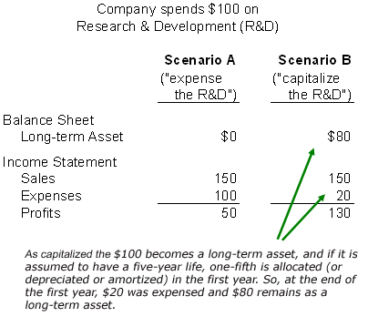
There are various technical terms for the allocation of capitalized assets, but each refers to the pattern in which the assets' prices are allocated to future period expenses: depreciation is the allocation of plant, property and equipment; amortization is the allocation of goodwill; depletion is the allocation of natural resource assets, such as oil wells.
The typical long-lived area of the balance sheet includes the following accounts:
Long-lived asset account: | Usually created because the company purchased: | Allocated to income statement expense (or income) via:
Property, plant & equipment | tangible property | depreciation or impairment (i.e. abrupt loss in value)
Investments | the securities of another company | gain/Loss or impairment
Goodwill | another company, but paid more than fair value (The excess over fair value is goodwill) | amortization or impairment
Depreciation
Depreciation is tricky because it is the allocation of a prior capital expenditure to an annual expense. Reported profits are directly impacted by the depreciation method. And because depreciation is a non-cash expense charge, some analysts prefer cash flow measures or EBITDA, which is a measure of earnings before the subtraction of depreciation. However, depreciation typically cannot be ignored because it serves a valuable purpose: it sets aside an annual amount (a sinking fund, if you will) for the maintenance and replacement of fixed assets.
Because depreciation is an accounting convention, you sometimes see an alternative label: "economic depreciation." This is an adjusted depreciation that represents the "true" amount that a company needs to allocate annually in order to maintain and replace its fixed asset base. In theory, economic depreciation corrects for errors in both directions. Consider the depreciation of real estate, which is usually an over-charge, reducing the real estate's book value, which is calculated by the original investment minus accumulated depreciation, to something far below its fair market value. On the other hand, consider a key piece of equipment that is subject to rapid inflation. Its eventual replacement will cost more than the original, in which case depreciation actually under-charges the expense. If depreciation expense is large relative to other expenses, it often helps to ask whether the charge approximates the replacement value of the assets. Determining this can be difficult, but sometimes the footnotes in a company's financial documents give explicit clues about future expenditures.
It is also helpful to look at the underlying trend in the fixed asset base. This will tell you whether the company is increasing or decreasing its investment in its fixed asset base. An interesting side effect of decreasing investments in the fixed asset is that it can temporarily boost reported profits. Consider the non-current portion of Motorola's balance sheet:
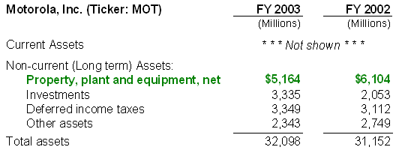
You can see that the book value of Motorola's plant, property and equipment (PP&E) fell roughly a billion dollars to $5.164 billion in 2003. We can understand this better by examining two footnotes, which are collected below:
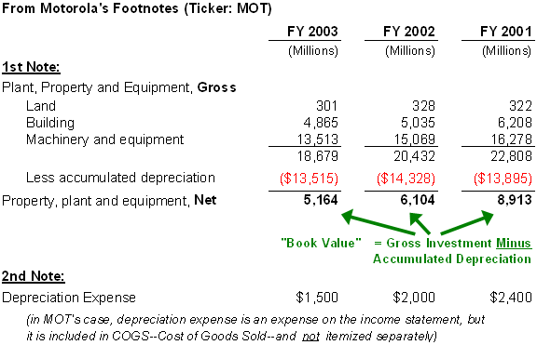
The book value is the gross investment (that is, the original or historical purchase price) minus the accumulated depreciation expense. Book value is also called net value, meaning net of depreciation. In Motorola's case, the gross asset value is dropping (which indicates asset dispositions) and so is the book value. Motorola has disposed of assets without a commensurate investment in new assets. Put another way, Motorola's asset base is aging.
Notice the effect on depreciation expense: it drops significantly, from $2 billion to $1.5 billion in 2003. In Motorola's case, depreciation is buried in cost of goods sold (COGS), but the temporary impact is a direct boost in pre-tax profits of half a billion dollars. To summarize, an aging asset base - the result of the company disposing of some old assets but not buying new ones - can temporarily boost profits. When assets are aged to inflate reported profits, it is sometimes called "harvesting the assets."
We can directly estimate the age of the fixed asset base with two measures: average age in percentage terms and average age in years. Average age in percentage equals accumulated depreciation divided by the gross investment. It represents the proportion of the assets that have been depreciated: the closer to 100%, the older the asset base. Average age in years equals accumulated depreciation divided by the annual depreciation expense. It is a rough estimate of the age of the in-place asset base. Below, we calculated each for Motorola. As you can see, these measures show that the asset base is aging.
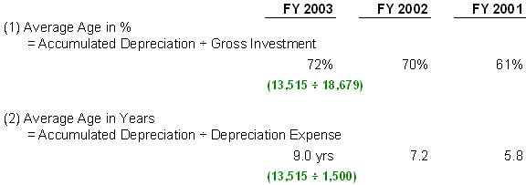
Investments
There are various methods to account for corporate investments, and often management has some discretion in selecting a method. When one company (a parent company) controls more than 50% of the shares of another company (a subsidiary), the subsidiary's accounts are consolidated into the parent's. When the control is less than 50%, there are three basic methods for carrying the value of an investment: these are the cost, market and equity methods. We show each method below. But first, keep in mind that there are three sorts of investment returns:
The investment can appreciate (or depreciate) in market value: we call these holding gains or losses.
- The investment can generate earnings that are not currently distributed to the parent and are instead retained. We call this investment income.
- The investment can distribute some of its income as cash dividends to the parent.
The table below explains the three methods of accounting for corporate investments that are less than 50% owned by the parent:
Method | Value of Investment on the Balance Sheet | Cash Dividends and Investment Income | When Used
Cost | The investment is carried at its historical cost; holding gains/losses are recognized only when the asset is sold. | Only actual (cash) dividends are recognized by the parent. Income is not recognized | The "ready market price" is available or the company intends to hold the investment until sale.
Market | The market value of the asset is updated each period, which creates holding period gains and losses. | Cash dividends are recognized; income may or may not be recognized. | The investment is marketable (has a readily available price) and is either used for trading purposes and is "available for sale" by the trading company.
Equity Method | The investment is carried at its historical cost; holding gains/losses are recognized only when the asset is sold. | The parent\'s share of income - including any cash dividends received - is recognized. | The parent company has a "significant influence" over the investment. This generally applies when the parent owns 20-50% of the investment.
When an investment pays cash dividends, the rules are straightforward: they will be recognized on the parent company's income statement. But the rules are not straightforward for undistributed earnings and gains/losses in the investment's holding value. In both cases, the parent may or may not recognize the earnings/gains/losses.
We have at least three goals when examining the investment accounts. First, we want to see if the accounting treatment has hidden some underlying economic gain or loss. For example, if a company uses the cost method on a superior investment that doesn't pay dividends, the investment gains will eventually pay off in a future period. Our second goal is to ask whether investment gains/losses are recurring. Because they are usually not operating assets of the business, we may want to consider them separately from a valuation of the business. The third goal is to gain valuable clues about the company's business strategy by looking at its investments. More often than not, such investments are not solely motivated by financial returns. They are often strategic investments made in current/future business partners. Interesting examples include investments essentially made to outsource research and development or to tap into different markets.
Let's consider a specific example with the recent long-lived accounts for Texas Instruments:
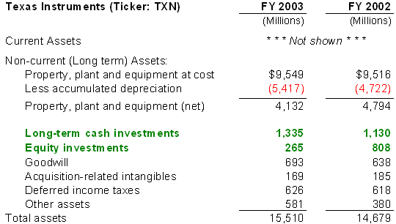
What immediately stands out is that equity investments dropped from $800 million to $265 million in 2003. This should encourage us to examine the footnotes to understand why.
The footnotes in the same annual report include the following:
During the third and fourth quarters of 2003, TI sold its remaining 57 million shares of Micron common stock, which were received in connection with TI's sale of its memory business unit to Micron in 1998. TI recognized pretax gains of $203 million from these sales, which were recorded in other income (expense) net….The combined effect of the after-tax gains and the tax benefit was an increase of $355 million to TI's 2003 net income.
We learn two things from this footnote: 1) TI sold its significant stake in Micron, and 2) that sale created a one-time (nonrecurring) boost in current profits of $355 million.
Goodwill
Goodwill is created when one company (the buyer) purchases another company (the target). At the time of purchase, all of the assets and liabilities of the target company are re-appraised to their estimated fair value. This includes even intangible assets that were not formerly carried on the target's balance sheet, such as trademarks, licenses, in-process research & development, and maybe even key relationships. Basically, accountants try to estimate the value of the entire target company, including both tangible and intangible assets. If the buyer happens to pay more than this amount, every extra dollar falls into goodwill. Goodwill is a catch-all account, because there is nowhere else to put it. From the accountant's perspective, it is the amount the buyer "overpays" for the target.
To illustrate, we show a target company below that carries $100 of assets when it is purchased. The assets are marked-to-market (that is, appraised to their fair market value) and they include $40 in intangibles. Further, the target has $20 in liabilities, so the equity is worth $80 ($100 – $20). But the buyer pays $110, which results in a purchase premium of $30. Since we do not know where to assign this excess, a goodwill account of $30 is created. The bottom exhibit shows the target company's accounts, but they will be consolidated into the buyer's accounts so that the buyer carries the goodwill.
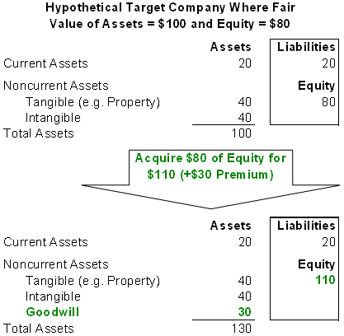
At one time, goodwill was amortized like depreciation. But as of 2002, goodwill amortization is no longer permitted. Now, companies must perform an annual test of their goodwill. If the test reveals that the acquisition's value has decreased, then the company must impair, or write-down, the value of the goodwill. This will create an expense, which is often buried in a one-time restructuring cost, and an equivalent decrease in the goodwill account.
The idea behind this change was the assumption that as an unidentified intangible, goodwill does not necessarily depreciate automatically like plants or machinery. This is arguably an improvement in accounting methods because we can watch for goodwill impairments, which are sometimes significant red flags. Because the value of the acquisition is typically based on a discounted cash flow analysis, the company is basically telling you "we took another look at the projections for the acquired business, and they are not as good as we thought last year."
Consider Novell's latest balance sheet:
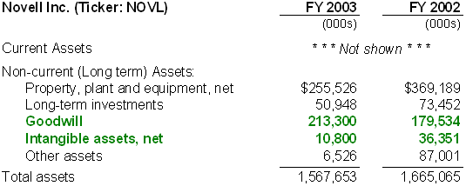
We see that intangible assets decreased from $36.351 million to $10.8 million. Because purchases and dispositions impact the accounts, it is not enough to check increases or decreases. For example, Novell's goodwill increased, but that could be due to a purchase. Similarly, it is possible that the decrease in intangible assets could be the result of a disposition, but this is unlikely as it is difficult to sell an intangible by itself.
A careful look at the footnote explains that most of this intangible asset decline was due to impairment. That is, a previously acquired technology has not generated the revenues that were originally expected:
During the third quarter of fiscal 2003, we determined that impairment indicators existed related to the developed technology and trade names we acquired from SilverStream as a result of unexpected revenue declines and the evident failure to achieve revenue growth targets for the exteNd products. Based on an independent valuation of these assets, we recorded a $23.6 million charge to cost of revenue to write down these assets to estimated fair value, which was determined by the net present value of future estimated revenue streams attributed to these assets.
Summary
You have to be careful when you examine the long-lived assets. It is hard to make isolated judgments about the quality of investments solely by looking at measures such as R&D as a percentage or capital expenditures as a percentage of sales. Even useful ratios such as ROE and ROA are highly dependent on the particular accounting methods employed. For example, both of these ratios count assets at book value, so they depend on the depreciation method.
You can, however, look for trends and clues such as the following:
- The method of depreciation and the pattern of investment - Is the company maintaining investment(s)? If investments are declining and assets are aging, are profits distorted?
- The specific nature and performance of investments - Have investment sales created one-time gains?
- Goodwill impairments - Has goodwill been impaired, and what is the business implication going forward?

Reference: http://www.investopedia.com/university/financialstatements/financialstatements7.asp Access on: May 15th 2013

Long-term liabilities: Long-term liabilities are company obligations that extend beyond the current year, or alternately, beyond the current operating cycle. Most commonly, these include long-term debt such as company-issued bonds. Here we look at how debt compares to equity as a part of a company's capital structure, and how to examine the way in which a company uses debt.
The following long-term liabilities are typically found on the balance sheet:
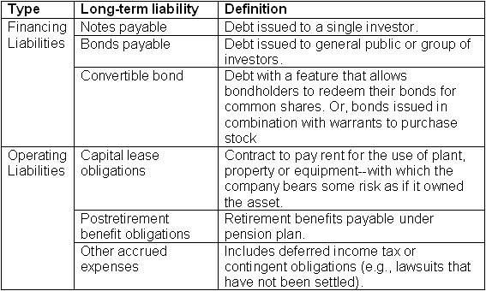
You can see that we describe long-term liabilities as either operating or financing. Operating liabilities are obligations created in the course of ordinary business operations, but they are not created by the company raising cash from investors. Financing liabilities are debt instruments that are the result of the company raising cash. In other words, the company issued debt - often in a prior period - in exchange for cash and must repay the principal plus interest.
Operating and financing liabilities are similar in that they both will require future cash outlays by the company. It is useful to keep them separate in your mind, however, because financing liabilities are triggered by a company's deliberate funding decisions and, therefore, will often offer clues about a company's future prospects.
Debt is Cheaper than Equity
Capital structure refers to the relative proportions of a company's different funding sources, which include debt, equity and hybrid instruments such as convertible bonds (discussed below). A simple measure of capital structure is the ratio of long-term debt to total capital.
Because the cost of equity is not explicitly displayed on the income statement, whereas the cost of debt (interest expense) is itemized, it is easy to forget that debt is a cheaper source of funding for the company than equity. Debt is cheaper for two reasons. First, because debtors have a prior claim if the company goes bankrupt, debt is safer than equity and therefore warrants investors a lower return; for the company, this translates into an interest rate that is lower than the expected total shareholder return (TSR) on equity. Second, interest paid is tax deductible, and a lower tax bill effectively creates cash for the company.
To illustrate this idea, let's consider a company that generates $200 of earnings before interest and taxes (EBIT). If the company carries no debt, owes tax at a rate of 50% and has issued 100 common shares, the company will produce earnings per share (EPS) of $1.00 (see left-hand column below).
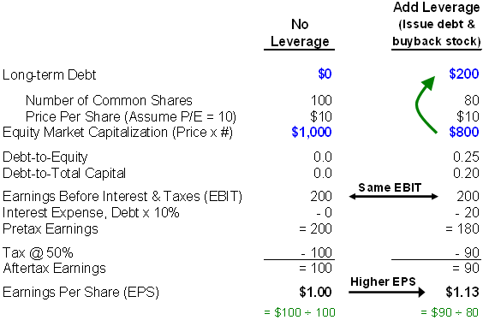
Say on the right-hand side we perform a simple debt-for-equity swap. In other words, say we introduce modest leverage into the capital structure, increasing the debt-to-total capital ratio from 0 to 0.2. In order to do this, we must have the company issue (borrow) $200 of debt and use the cash to repurchase 20 shares ($200/$10 per share = 20 shares). What changes for shareholders? The number of shares drops to 80 and now the company must pay interest annually ($20 per year if 10% is charged on the borrowed $200). Notice that after-tax earnings decrease, but so does the number of shares. Our debt-for-equity swap actually causes EPS to increase!
What Is the Optimal Capital Structure?
The example above shows why some debt is often better than no debt. In technical terms, it lowers the weighted average cost of capital. Of course, at some point, additional debt becomes too risky. The optimal capital structure, the ideal ratio of long-term debt to total capital, is hard to estimate. It depends on at least two factors, but keep in mind that the following are general principles:
- First, optimal capital structure varies by industry, mainly because some industries are more asset-intensive than others. In very general terms, the greater the investment in fixed assets (plant, property & equipment), the greater the average use of debt. This is because banks prefer to make loans against fixed assets rather than intangibles. Industries that require a great deal of plant investment, such as telecommunications, generally utilize more long-term debt.
- Second, capital structure tends to track with the company's growth cycle. Rapidly growing startups and early stage companies, for instance, often favor equity over debt because their shareholders will forgo dividend payments in favor of future price returns because these companies are growth stocks. High-growth companies do not need to give these shareholders cash today, whereas lenders would expect semi-annual or quarterly interest payments.
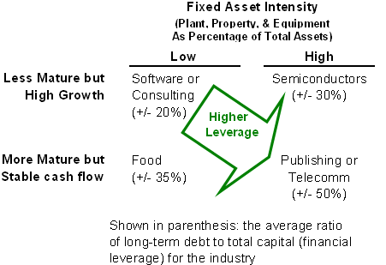
Examining Long-Term Liability
Below, we look at some important areas investors should focus on when analyzing a company's long-term liability accounts.
Ask Why the Company Issued New Debt
When a company issues new long-term debt, it's important for investors to understand the reason. Companies should give explanations of new debt's specific purpose rather than vague boilerplate such as "it will be used to fund general business needs." The most common purposes of new debt include the following:
- To Fund Growth - The cash raised by the debt issuance is used for specific investment(s). This is normally a good sign.
- To Refinance "Old" Debt - Old debt is retired and new debt is issued, presumably at a lower interest rate. This is also a good sign, but it often changes the company's interest rate exposure.
- To Change the Capital Structure - Cash raised by the debt issuance is used to repurchase stock, issue a dividend,or buyout a big equity investor. Depending on the specifics, this may be a positive indicator.
- To Fund Operating Needs - Debt is issued to pay operating expenses because operating cash flow is negative. Depending on certain factors, this motive may be a red flag. Below, we look at how you can determine whether a company is issuing new debt to fund operating needs.
Be Careful of Debt that Funds Operating Needs
Unless the company is in the early growth stage, new debt that funds investment is preferable to debt that funds operating needs. To understand this thoroughly, recall from the cash flow installment that changes in operating accounts (that is, current assets and current liabilities) either provide or consume cash. Increases in current assets - except for cash - are "uses of cash". Increases in current liabilities are "sources of cash." Consider an abridged version of RealNetworks' balance sheet for the year ending Dec 31, 2003:
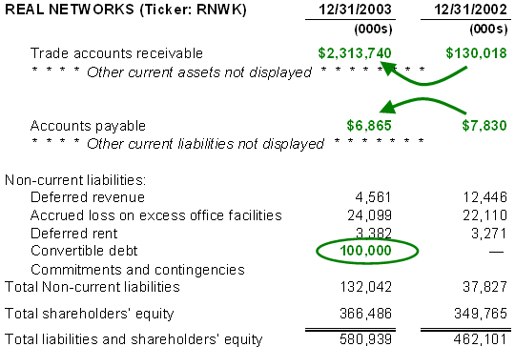
From Dec. 2002 to Dec. 2003, accounts receivable (a current asset) increased dramatically and accounts payable (a current liability) decreased. Both occurrences are uses of cash. In other words, RealNetworks consumed working capital in 2003. At the same time, the company issued a $100 million convertible bond. The company's consumption of operating cash and its issue of new debt to fund that need is not a good sign. Using debt to fund operating cash may be okay in the short run but because this is an action undertaken as a result of negative operating cash flow, it cannot be sustained forever.
Examine Convertible Debt
You should take a look at the conversion features attached to convertible bonds (convertibles), which the company will detail in a footnote to its financial statements. Companies issue convertibles in order to pay a lower interest rate; investors purchase convertibles because they receive an option to participate in upside stock gains.
Usually, convertibles are perfectly sensible instruments, but the conversion feature (or attached warrants) introduces potential dilution for shareholders. If convertibles are a large part of the debt, be sure to estimate the number of common shares that could be issued on conversion. Be alert for convertibles that have the potential to trigger the issuance of a massive number of common shares (as a percentage of the common outstanding), and thereby could excessively dilute existing shareholders.
An extreme example of this is the so-called death spiral PIPE, a dangerous flavor of the private investment, public equity (PIPE) instrument. Companies in distress issue PIPES, which are usually convertible bonds with a generous number of warrants attached. (For more information, see What Are Warrants?) If company performance deteriorates, the warrants are exercised and the PIPE holders end up with so many new shares that they effectively own the company. Existing shareholders get hit with a double-whammy of bad performance and dilution; a PIPE has preferred claims over common shareholders. Therefore, it's advisable not to invest in the common stock of a company with PIPE holders unless you have carefully examined the company and the PIPE.
Look at the Covenants
Covenants are provisions that banks attach to long-term debt that trigger technical default when violated by the borrowing company. Such a default will lower the credit rating, increase the interest (cost of borrowing) and often send the stock lower. Bond covenants include but are not limited to the following:
- Limits on further issuance of new debt.
- Limits, restrictions or conditions on new capital investments or acquisitions.
- Limits on payment of dividends. For example, it is common for a bond covenant to require that no dividends are paid.
- Maintenance of certain ratios. For example, the most common bond covenant is probably a requirement that the company maintain a minimum 'fixed charge coverage ratio'. This ratio is some measure of operating (or free) cash flow divided by the recurring interest charges
Assess Interest Rate Exposure
Two things complicate the attempt to estimate a company's interest rate exposure. One, companies are increasingly using hedge instruments, which are difficult to analyze.
Second, many companies are operationally sensitive to interest rates. In other words, their operating profits may be indirectly sensitive to interest rate changes. Obvious sectors here include housing and banks. But consider an oil/energy company that carries a lot of variable-rate debt. Financially, this kind of company is exposed to higher interest rates. But at the same time, the company may tend to outperform in higher-rate environments by benefiting from the inflation and economic strength that tends to accompany higher rates. In this case, the variable-rate exposure is effectively hedged by the operational exposure. Unless interest rate exposure is deliberately sought, such natural hedges are beneficial because they reduce risk.
Despite these complications, it helps to know how to get a rough idea of a company's interest rate exposure. Consider a footnote from the 2003 annual report of Mandalay Resort Group, a casino operator in Las Vegas, Nevada:
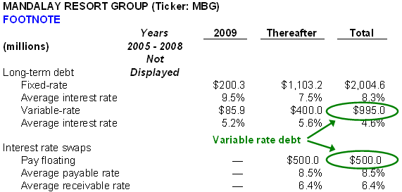
Fixed-rate debt is typically presented separately from variable-rate debt. In the prior year (2002), less than 20% of the company's long-term debt was held in variable-rate bonds. In the current year, Mandalay carried almost $1.5 billion of variable-rate debt ($995 million of variable-rate long-term debt and $500 million of a pay floating interest rate swap) out of $3.5 billion in total, leaving $2 billion in fixed-rate debt.
Don't be confused by the interest rate swap: it simply means that the company has a fixed-rate bond and "swaps" it for a variable-rate bond with a third party by means of an agreement. The term 'pay floating' means the company ends up paying a variable rate; a 'pay fixed interest rate' swap is one in which the company trades a variable-rate bond for a fixed-rate bond.
Therefore, the proportion of Mandalay's debt that was exposed to interest rate hikes in 2003 increased from 18% to more than 40%.
Operating Versus Capital Lease
It is important to be aware of operating lease agreements because economically they are long-term liabilities. Whereas capital leases create liabilities on the balance sheet, operating leases are a type of off-balance sheet financing. Many companies tweak their lease terms precisely to make these terms meet the definition of an operating lease so that leases can be kept off the balance sheet, improving certain ratios like long term debt-to-total capital.
Most analysts consider operating leases as debt, and manually add operating leases back onto the balance sheet. Pier 1 Imports is an operator of retail furniture stores. Here is the long-term liability section of its balance sheet:
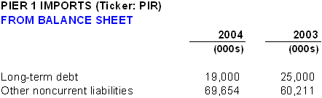
Long-term debt is a very tiny 2% of total assets ($19 million out of $1 billion). However, as described by a footnote, most of the company's stores utilize operating leases rather than capital leases:
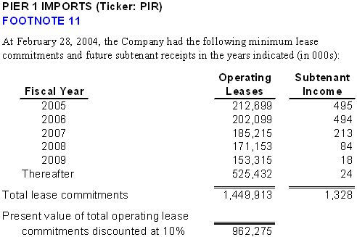
The present value of the combined lease commitments is almost $1 billion. If these operating leases are recognized as obligations and are manually put back onto the balance sheet, both an asset and a liability of $1 billion would be created, and the effective long term debt-to-total capital ratio would go from 2% to about 50% ($1 billion in capitalized leases divided by $2 billion).
Summary
It has become more difficult to analyze long-term liabilities because innovative financing instruments are blurring the line between debt and equity. Some companies employ such complicated capital structures that investors must simply add "lack of transparency" to the list of its risk factors. Here is a summary of what to keep in mind:
- Debt is not bad. Some companies with no debt are actually running a sub-optimal capital structure.
- If a company raises a significant issue of new debt, the company should specifically explain the purpose. Be skeptical of boilerplate explanations; if the bond issuance is going to cover operating cash shortfalls, you have a red flag.
- If debt is a large portion of the capital structure, take the time to look at conversion features and bond covenants.
- Try to get a rough gauge of the company's exposure to interest rate changes.
- Consider treating operating leases as balance sheet liabilities.
Reference: http://www.investopedia.com/university/financialstatements/financialstatements8.asp Access on: May 16th 2013

Pension plans: Following from the preceding section focusing on long-term liabilities, this section focuses on a special long-term liability, the pension fund. For many companies, this is a very large liability and, for the most part, it is not captured on the balance sheet. We could say that pensions are a type of off-balance-sheet financing. Pension fund accounting is complicated and the footnotes are often torturous in length, but the good news is that you need to understand only a few basics in order to know the most important questions to ask about a company with a large pension fund.
There are various sorts of pension plans, but here we review only a certain type: the defined benefit pension plan. With a defined benefit plan, an employee knows the terms of the benefit that he or she will receive upon retirement. The company is responsible for investing in a fund in order to meet its obligations to the employee, so the company bears the investment risk. On the other hand, in a defined contribution plan, a 401(k), for example, the company probably makes contributions or matching contributions, but does not promise the future benefit to the employee. As such, the employee bears the investment risk.
Among defined benefit plans, the most popular type bears a promise to pay retirees based on two factors: 1) the length of their service and 2) their salary history at the time of retirement. This is called a career average or final pay pension plan. Such a plan might pay retirees, say, 1.5% of their "final pay," their average pay during the last five years of employment, for each year of service for a maximum number of years. Under this plan, an employee with 20 years of service would receive a retirement benefit equal to 30% (20 years x 1.5%) of their final average pay. But formulas and provisions vary widely; for example, some will reduce or offset the benefit by the amount of social security the retiree receives.
Funded Status = Plan Assets - Projected Benefit Obligation (PBO)
A pension plan has two primary elements:
- The future liabilities, or benefit obligations, created by employee service.
- The pension fund, or plan assets,that are used to pay for retiree benefits.
At this primary level, a pension plan is simple. The company, called the plan sponsor in this context, contributes to its pension fund, which is invested into bonds, equities and other asset classes in order to meet its long-term obligations. Retirees are then eventually paid their benefits from the fund.
Three things make pension fund accounting complicated. First, the benefit obligation is a series of payments that must be made to retirees far into the future. Actuaries do their best to make estimates about the retiree population, salary increases and other factors in order to discount the future stream of estimated payments into a single present value. This first complication is unavoidable.
Second, the application of accrual accounting means that actual cash flows are not counted each year. Rather, the computation of the annual pension expense is based on rules that attempt to capture changing assumptions about the future.
Third, the rules require companies to smooth the year-to-year fluctuations in investment returns and actuarial assumptions so that pension fund accounts are not dramatically over- (or under-) stated when their investments produce a single year of above- (or below-) average performance. Although well-intentioned, smoothing makes it even harder for us to see the true economic position of a pension fund at any given point in time.
Let's take a closer look at the two basic elements of a pension fund:
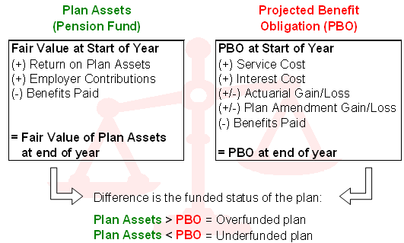
On the left, we show the fair value of the plan assets. This is the investment fund. During the year, wise investments will hopefully increase the size of the fund. This is the return on plan assets. Also, employer contributions, cash the company simply gives from its own bank account, will increase the fund. Finally, benefits paid (or disbursements) to current retirees will reduce the plan assets.
On the right, we show the basic calculation of the projected benefit obligation (PBO), which is an estimate of the future stream of benefit obligations discounted to the present value into a single number. For clarity's sake, we omitted a few items.
In the annual report, you will see two other measures of estimated future obligations: the vested benefit obligation (VBO) and the accumulated benefit obligation (ABO). You do not need either of these for the purposes we discuss here, but ABO is less than PBO because it assumes that salaries will not rise into the future, while PBO assumes salary increases. VBO is less than ABO because it counts only service already performed, but PBO counts the future service (minus turnover assumptions). PBO is the number that matters because it's the best guess as to the present value of the discounted liabilities assuming the employees keep working and salaries keep rising.
By subtracting the PBO from the fair value of the plan assets, you get the funded status of the plan. This is an important number that will be buried somewhere in the footnotes, but it must be disclosed.
Breaking Down the Funded Status of the Plan
Let's look at an actual example. We will use data from the annual report 10-K for PepsiCo (ticker: PEP) for the year ended Dec 31, 2003. Although its pension plan happened to be under-funded at that time, it can be considered relatively healthy, especially compared to other companies. We picked PepsiCo because the company's plan is well-disclosed and its 10-K contains helpful commentary.
Below is the part of the footnote that calculates the fair value of the plan assets. You can see that the pension fund produced an actual return of 7.9% in the year 2003 ($281 / $3,537). Other than the investment returns, the largest changes are due to employer contributions and benefit payouts:
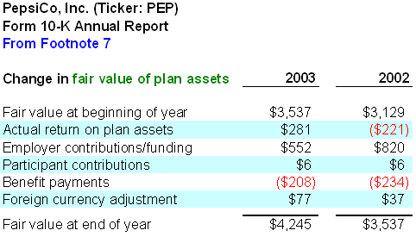
Now take a look at the calculation of the PBO (see below). Whereas the fair value of plan assets (how much the fund was worth) is a somewhat objective measure, the PBO requires several assumptions which make it more subjective:
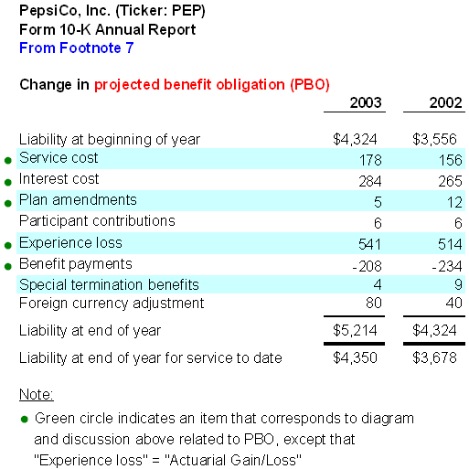
You can see that PepsiCo started 2003 with an estimated liability of $4,324, but the liability is increased by service and interest cost. Service cost is the additional liability created because another year has elapsed, for which all current employees get another year's credit for their service. Interest cost is the additional liability created because these employees are one year nearer to their benefit payouts.
The reason for and effect of the additional interest cost is easier to understand with an example. Let's assume that today is 2005 and the company owes $100 in five years, the year 2010. If the discount rate is 10%, then the present value of this obligation is $62 ($100 ÷ 1.1^5 = $62). (For a review of this calculation, see Understanding the Time Value of Money.) Now let one year elapse. At the start of 2006 the funds now have four years instead of five years to earn interest before 2010, the present value of the obligation as of 2006 increases to $68.3 ($100 ÷ 1.1^4 = $68.3). You can see how interest cost depends on the discount rate assumption.
Now, let's continue with PepsiCo's footnote above. Plan amendments refer to changes to the pension plan and they could have a positive or negative impact on cost. Experience loss is more commonly labeled actuarial loss/gain, and it too can be positive or negative. It refers to additional costs created because the changes in actuarial estimates changes made during the year. For example, we don't know the cause in PepsiCo's case, but perhaps it increased its estimate of the average rate of future salary increases or the average age of retirement. Either of these changes would increase the PBO and the additional cost would show up as an actuarial loss.
We see that PepsiCo's liability at the end of the year 2003 was $5,214. That is the PBO. We also see a lesser amount "for service to date." That is the VBO and we can ignore it.
The fair value of the plan assets ($4,245) subtracted by the PBO ($5,214) results in the funded status at the end of 2003 of -$969 million. The bottom line: PespiCo's pension plan at that time was under-funded by almost one billion dollars.
Pension Plans and the Balance Sheet
Now remember we said that pension plans are off-balance-sheet financing, and in PepsiCo's case, the $4.245 billion in assets and $5.214 billion in liabilities are not recognized on the balance sheet. Therefore, typical debt ratios like long-term debt to equity probably do not count the pension liability of $5+ billion. But it's even worse than that. You might think the net deficit of -$969 million would be carried as a liability, but it is not. Again, from the footnotes:
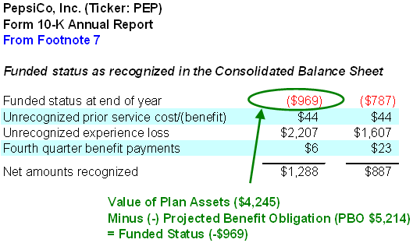
Due to the smoothing rules of pension plan accounting, PepsiCo carried $1,288 in pension plan assets on the balance sheet, at the end of 2003. You can see how the two "unrecognized" lines on the footnote above boost the negative into a positive: the losses for the current year, and prior years, for that matter, are not recognized in full; they are amortized or deferred into the future. Although the current position is negative almost one billion, smoothing captures only part of the loss in the current year--it's not hard to see why smoothing is controversial.
Cash Contributed to the Pension Is Not Pension Cost
Now we have enough understanding to take a look at why cash contributed to the pension plan bears little, if any, resemblance to the pension expense (also known as "pension cost") that is reported on the income statement and reduces reported earnings. We can find actual cash contributed in the statement of cash flows:
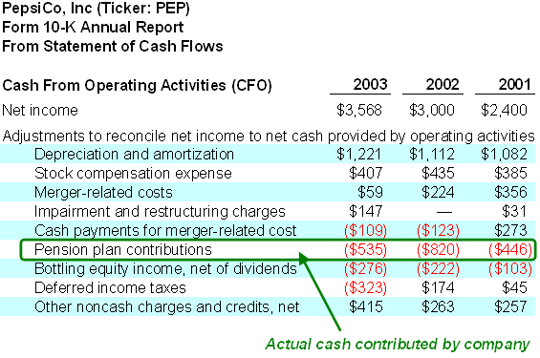
Now compare these cash contributions to the pension expense. In each of the three years reported, cash spent was significantly higher than pension expense:
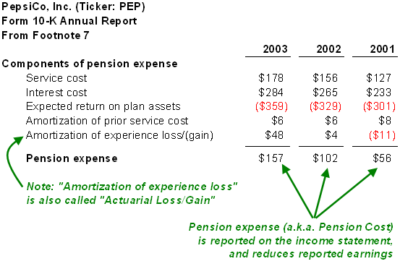
The first two components of pension expense - service and interest cost - are identical to those found in the calculation of PBO. The next component is "expected return on plan assets." Recall that the "fair value of plan assets" includes actual return on plan assets. Expected return on plan assets is similar, except the company gets to substitute an estimate of the future return on plan assets. It is important to keep in mind that this estimate is an assumption the company can tweak to change the pension expense. Finally, the two "amortization" items are again due to the effects of smoothing. Some people have gone so far as to say the pension expense is a bogus number due to the assumptions and smoothing.
Critical Questions
We have just scratched the surface of pension plan accounting, but we have reviewed enough to identify the four or five critical questions you need to ask when evaluating a company's pension fund.
We have two primary concerns in regard to analysis of the pension fund:
- What is the economic status of the liability? A dramatically under-funded plan will require increased cash contributions in the future and foreshadows future increases in income statement expenses.
- How aggressive/conservative is the pension expense? An aggressive accounting policy is a red flag because it will usually have to be unraveled by the company in future periods. Conservative policies contribute to earnings that are higher in quality.
Take a look at key assumptions disclosed by PepsiCo:
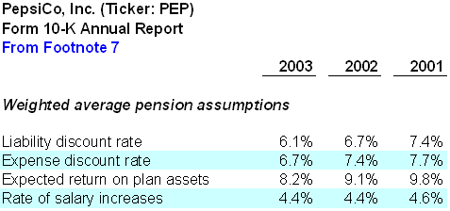
In regard to our first concern - the economic status of the liability - we want to look at the funded status that equals the fair value of plan assets minus the PBO. The two key assumptions that impact the PBO are the discount rate and projected rate of salary increases. A company can decrease its PBO (and therefore, increase its funded status) by either increasing the discount rate or lowering the projected rate of salary increases. You can see that PepsiCo's rate of salary increase is fairly stable at 4.4% but the discount rate dropped to 6.1%. This steady drop in the discount rate contributes significantly to the increased PBO and the resultant under-funded status.
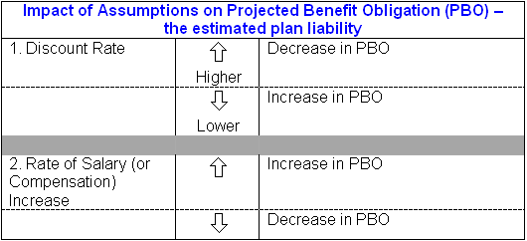
In regard to our second concern - the quality of the pension expense - there are three key assumptions:
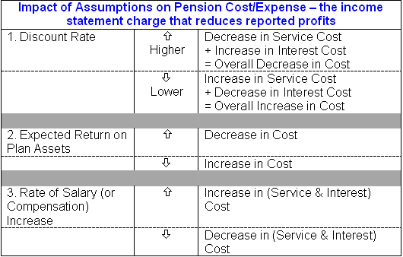
The discount rate is a little bit mixed because it has opposite effects on the service and interest cost, but in most cases, it behaves as before: a lower discount rate implies an increase in pension expense. Regarding expected return on plan assets, notice that PepsiCo's assumption here has steadily decreased over the two years to finish at 8.2%. Soft equity markets are a double-whammy for pension funds; they not only lower the discount rate (which increases the PBO) but they lower the expected return on the plan assets!
So we can now summarize the effect of accounting practices:
- Aggressive (dubious) accounting includes one or more of the following: a high discount rate, an expected return on plan assets that is overly optimistic by being quite higher than the discount rate and a low rate of salary increase.
- Conservative (good) accounting includes all of the following: low discount rate, an expected return on plan assets that is near the discount rate and a high rate of salary increase
Finally, companies are now required to disclose how the pension plan is invested. For example, PepsiCo's footnote explains the target asset allocation of its pension (60% stock and 40% bonds) and then breaks down its actual allocation. Furthermore, you can check to see how much of the pension fund is invested in the company stock.
You should definitely look at these allocations if you have a view about the equity or bond markets. There has been much academic discussion about companies' allocation mismatching. The argument goes that they are funding liabilities with too much equity when liabilities should be funded with bonds. Of course, companies fund with equities to boost their actual and expected returns.
Conclusion
For evaluating stocks that have a pension plan, you can do the following:
1. Locate the funded status, or the fair value of plan assets minus projected benefit obligation.
2. Check the trend and level of the following key assumptions:
- Discount rate: make sure it is conservative (low) enough. If it's going up, ask why.
- Expected return on plan assets: is it conservative (low) enough? If it\'s significantly higher than the discount rate, be skeptical of the pension expense.
- Rate of salary increase: is it high enough?
3. Check the target and actual allocation of the pension plan. Is the company making sufficient use of bonds to fund the pension liability and, conversely, are they overly exposed to equities?

Reference: http://www.investopedia.com/university/financialstatements/financialstatements9.asp Access on: May 16th 2013

SUMMARY - ANALITICAL AND LOGICAL REASONING – SAMPLE QUESTIONS

The following text provides you information for questions 1-3:
Seven lamps are featured in a furniture store's display window. Each lamp is either ceramic or wooden and is paired with either a brown, white or grey shade. The display includes at least two lamps in each of three styles: traditional, modern and retro.
.At least four of the lamps are ceramic.
.If a lamp has a white shade, the lamp is ceramic.
.No wooden lamp is paired with a brown shade.

1.Which of the following is a complete and accurate list of shade colors that might be paired with a wooden lamp?
(A) white only
(B) grey only
(C) brown and grey only
(D) white and grey only
(E) white, brown, and grey

The correct response is (B). Given that a wooden lamp cannot be paired with a brown shade, a wooden lamp must have either a white or grey shade. But given also that a white shade can be paired only with a ceramic lamp, wooden lamps can have only grey shades.

Reference: http://www.west.net/~stewart/lsat/practice-questions-analytical-reasoning-1.htm, Access on: May 17th 2013

2.If every modern-style lamp in the display window is wooden, which of the following must appear in the window?
(A) a retro-style lamp with a grey shade
(B) a modern-style lamp with a brown shade
(C) a traditional-style lamp with a white shade
(D) a retro-style ceramic lamp
(E) a traditional-style wooden lamp Answer and Analysis

The correct response is (D). At least two of the seven lamps are modern in style. (The premise provides that each style is represented at least twice.) Accordingly, if every modern-style lamp in the window is wooden, then at least two of the seven lamps must be wooden. Given that at least four of the lamps are ceramic, you can conclude that at least one of those four ceramic lamps must be retro in style.

Reference: http://www.west.net/~stewart/lsat/practice-questions-analytical-reasoning-2.htm, Access on: May 17th 2013

3.If two and only two ceramic lamps are paired with shades of the same color, which of the following must be true?

(A) One of the seven lamps has a brown shade.
(B) Two of the seven lamps have white shades.
(C) Three of the seven lamps are wooden.
(D) Four of the seven lamps have grey shades.
(E) Five of the seven lamps are ceramic.

The correct response is (C). We know that at least four of the seven lamps are ceramic. Assuming that two and only two such lamps have shades of the same color, the total number of ceramic lamps is limited to four (only three shade colors are available). Under this assumption, then, exactly three of the seven lamps would be wooden.
Reference: http://www.west.net/~stewart/lsat/practice-questions-analytical-reasoning-3.htm, Access on: May 17th 2013
4. Many environmentalists rank global warming as the most serious current threat to the world's environment, citing evidence that over the past 30 years, the global temperature has risen an average of 2 degrees. However, the average global temperature this year is equal to the average global temperature of last year. Global warming, therefore, is not as serious a problem as these environmentalists claim.
The argument is most vulnerable to the criticism that it
(A) Argues that because a threat is present, that threat must be more serious than any other possible threat.
(B) Concludes that because there is lack of evidence for a problem, that problem does not exist.
(C) Attempts to refute a conclusion about a general trend by appealing to a single counterexample, even though such a counterexample may be consistent with the general trend.
(D) Relies on the ambiguous use of a key term.
(E) Presupposes what is seeks to establish.
The correct response is C. The argument concludes that global warming is not as serious as environmentalists claim, because this year the global temperature did not rise. However, the environmentalists' argument is that on average the temperature has risen 2 degrees over the past 30 years. When dealing with averages, it is completely possible to have a year when the temperature stays the same or even drops, while the overall average temperature over 30 years rises. A general average cannot be refuted with a single counterexample.
Choice A is incorrect because the argument does not conclude that global warming is more serious than any other threat. Nor does the argument conclude that global warming does not exist, as stated in choice C. Choice D is incorrect because at no point in the argument is a key term used ambiguously to mean two different things, and choice E is incorrect because the argument's evidence about the difference in temperature between the this year and last year is a fact and does not rely upon the truth of its conclusion.
5. Independent tests have confirmed that, on average, the antilock brakes found on Griffon min-vans outperform those of any other mini-van. Thus, any consumer who is purchasing a mini-van based solely on the criteria of safety should purchase a Griffon mini-van.
Which one of the following statements, if true, most weakens the argument?
(A) Mini-vans are less safe than some other types of automobiles.
(B) Most consumers purchase cars based on multiple criteria in addition to safety.
(C) During the test, the brakes on some Phoenix mini-vans outperformed those on some Griffon mini-vans.
(D) The brakes on Griffon mini-vans are simple to use and maintain.
(E) The Phoenix mini-vans achieved a better frontal crash-test rating than the Griffon mini-vans.
The correct response is E. The argument makes a conclusion about overall safety by considering only brakes. However, there are other possible factors one might consider when trying to buy a safe car, and choice E mentions one such factor, which weakens the conclusion that Griffon mini-vans are the best choice for safety. Choice A is incorrect because the conclusion specifically references "any consumer who is purchasing a mini-van...," so whether other types of automobiles are safer will have no impact on the conclusion. Likewise, choice B is incorrect because the conclusion references "any consumer who is purchasing… based solely on the criteria of safety..." so whether some consumers buy cars for other reasons is irrelevant to the conclusion of the argument. Choice D would strengthen the argument.
6. Any person who uses words ambiguously cannot become a journalist, since journalistic reporting cannot invite artistic interpretation.
Which of the following, if assumed, would allow the conclusion above to be properly drawn?
(A) No person who invites artistic interpretation can use words ambiguously.
(B) Any person who uses words ambiguously will invite artistic interpretation in their reporting.
(C) Any journalist who invites artistic interpretation will sometimes use words ambiguously.
(D) Either a journalist uses words ambiguously or that journalist invites artistic interpretation.
(E) No journalist who invites artistic interpretation can become a great journalist.
The correct response is B. The argument tells us that a rule for journalistic reporting cannot invite artistic interpretation. If choice B is true, and using words ambiguously invites artistic interpretation, then it would also have to be true that journalists cannot use words ambiguously, since they cannot invite artistic interpretation.
Choice A is the opposite of the assumption in the argument: the argument assumes that ambiguous words and artistic interpretation are linked, whereas choice A says that they are not linked. Choice C is backwards: the argument assumes that using words ambiguously leads to artistic interpretation, not that artistic interpretation leads to ambiguous words. Also, it is worth noting that the second half of this answer choice says that journalists sometimes use words ambiguously, which contradicts the conclusion and thus cannot be an assumption. Choice D states that any journalist either uses words ambiguously, or invites artistic interpretation; however, the argument indicates that journalists do not do either. Choice E is incorrect because it discusses what is necessary in order to become a great journalist.
7. Home alarm systems are commonly regarded by insurance companies as improving the safety of the home. However, statistics show that the break-in rate for homes equipped with such alarms is slightly higher than the break-in rate for houses without such alarms.
Which of the following statements, if true, would most help to reconcile the insurance companies' belief with the statistics cited?
(A) Home alarm systems are generally installed only in those homes that are in theft-prone areas.
(B) Because home alarm systems generate many false alarms, authorities are slow to respond to such alarms.
(C) Without signs announcing the presence of a home alarm system, the system does little to deter theft.
(D) Home alarm systems offer little protection against practiced thieves.
(E) Many home owners state that they feel safer after purchasing a home alarm system.
The correct response is A. Choice A explains why home alarm systems would make homes safer, even though homes with such alarms are broken into more often than homes without such alarms. Choices B, C, and D all explain why the alarms might not be effective, but fail to explain why the break-in rate for such houses would be higher than the break-in rate for houses without such alarms. Choice E is incorrect because the home owners' feelings would not explain the burglary rates.
8. Some people interpret the phrase "survival of the fittest" as "survival of the strongest." However, inasmuch as "strong" is interpreted as "physical size and prowess", this is incorrect. Although strength and size provide a survival advantage within a species in such tasks as breeding, fighting for food, and running from predators, a species will survive only if its overall resource requirement for maintaining its strength does not outweigh the resources available, as is often the case during a famine or other ecological disaster.
Based on the passage above, which of the following statements must be true?
(A) If a species' resource requirement for maintaining its strength outweighs the resources available, that species will not survive.
(B) Strength does not provide a survival advantage for hunting food.
(C) The phrase "survival of the fittest" should not be used by the scientific community.
(D) The species with the least strength is the most likely to survive in a famine.
(E) If a species does not survive an ecological disaster, it is because that species' resource requirement for maintaining its strength outweighed the resources available.

The correct response is A. The passage states that "a species in general will survive only if its overall resource requirement to maintain its strength does not outweigh the resources available..." Thus, if the resource requirement outweighs the resources, the species will not survive. Choice B is incorrect because, although the passage lists three advantages for strength (breeding, fighting for food, and running from predators), nothing in the passage indicates that these are the only advantages. Strength may provide a survival advantage for hunting. Choice B is incorrect because nothing indicates that the phrase should be discarded, only that it is incorrect when interpreted in a certain way. Choice D is incorrect because, although strength can be a disadvantage in some way according to the passage, nothing supports the inference that the species with the least strength is the most likely to survive. The weakest species might not die because of its strength, but it still might get eaten by its slightly less weak competitors. By this same logic, Choice E is also incorrect; a species might die for many reasons during an ecological disaster. A lack of resources is one possible reason, but not the only reason.

Reference: http://www.admissionsconsultants.com/lsat/logical_reasoning_questions.asp Access on: May 17th 2013

SUMMARY – MATHS – SAMPLE QUESTIONS

1. The ratio between x and y is 7/9; x and y are increased by 4, what is the ratio between the new values of x and y?
A) 7/9
B) 14/9
C) 7/18
D) 11/13
E) It Cannot Be Determined

Quantitative reasoning:
1.Translate the given information into algebraic equations that can be easily manipulated.
Originally: (x/y) = (7/9)
Note: This DOES NOT mean x and y are 7 and 9 respectively. It only means that "the ratio between x and y is 7/9". Consequently, possible values for x and y are 7 and 9, 14 and 18, 21 and 27, etc.
2.Set up an algebraic equation for the new x and y.
((x + 4) / (y + 4)) = ?
3.In order to see if a pattern emerges, try plugging in numbers and using a chart: x y x + 4 y + 4 (x/y) = (7/9) (x + 4)/(y + 4) = ?
7 9 11 13 7/9 = .777 11/13 = .84
14 18 18 22 14/18 = .777 18/22 = .81
21 27 25 31 21/27 = .777 25/31 = .806
4.As the above chart indicates, there is no consistent ratio between x and y, and x+4 and y+4.
Consequently, the answer choice E is correct.

2. 2x + 3y = 16 and y = -6x; -x=?
A) -1
B) 4/5
C) -4/5
D) -5/4
E) 1

Quantitative reasoning:
1.Start by combining the two equations. Since the second equation is already solved for y, plug it into the first equation to yield:
2x + 3y = 16
Since y = -6x
2x+3(-6x)=16
2.Simplify like terms:
2x+3(-6x)=16
2x+(-18x)=16
-16x=16.
3.Divide by -16 to yield x=-1. Be careful though: the question asks for the value of -x, not x.
4.Since x=-1, -x=1. So the correct answer is E.

3. 5n + 2 > 12 and 7n - 5 < 44; n must be between which numbers?
A) 1 and 8
B) 2 and 6
C) 0 and 9
D) 2 and 7
E) 2 and 9

Quantitative reasoning:
1.We have two inequalities and we need to find an upper and a lower bound for the value of n. Start with the first inequality to find one of these bounds:
5n+2>12
5n>10
n>2
2.Subtract 2 from both sides to yield: 5n>10.
3.Divide by 5 on both sides to yield: n>2. Thus, 2 is one of the limits. This rules out choices A and C.
4.Take the second inequality to find the upper bound:
7n-5<44
7n<49
n<7
5.Add 5 to both sides of the inequality to yield: 7n<49.
6.Divide both sides by 7 to yield the upper bound: n<7.
7.Combining the answers from both inequalities yields that n is between 2 and 7. Thus, choice D is correct.

4. The product of the prime integers between 43 and 50, inclusive, is:
A) 50! – 40!
B) 99,029
C) 2,303
D) 2,021
E) 2,000

Quantitative reasoning:
1.To find the prime numbers between 40 and 50, inclusive, begin by eliminating all even numbers and multiples of 5.
Original List: 43, 44, 45, 46, 47, 48, 49, 50
Possible Primes Remaining: 43, 47, 49

2.Since 7*7 = 49, 49 cannot be a prime number since 7 is a factor.
Possible Primes Remaining: 43, 47

3.Apply the relevant divisibility rules to each number remaining.
43 will not be divisible by 3 since the sum of its digits is 7, which is not divisible by 3
43 will not be divisible by 6 since it is not divisible by 3
43 will not be divisible by 8 since it is not even
43 will not be divisible by 9 since the sum of its digits is 7, which is not divisible by 9
Since 7*6 = 42, you know 43 is not divisible by 7
43 is prime.
47 will not be divisible by 3 since the sum of its digits is 11, which is not divisible by 3
47 will not be divisible by 6 since it is not divisible by 3
47 will not be divisible by 8 since it is not even
47 will not be divisible by 9 since the sum of its digits is 7, which is not divisible by 9
Since 7*7 = 49, you know 47 is not divisible by 7
The only number remaining is 49, which is not prime since 7*7 = 49

4.Having determined the prime numbers, you can multiply them together: 43*47 = 2,021 (D)

5. After running a series of television advertisements, a leading beverage producer saw its sales increase by 25% to $1 million dollars per month. Prior to the advertising campaign, about how many dollars in sales did the company average per day?
A) $1.25 million
B) $800,000
C) $750,000
D) $27,000
E) $10,000

Quantitative reasoning:
1.We are interested in the sales of the old month. We know that the new month had 25% more sales than the old. Since a 25% increase is equal to multiplying a number by 1.25 (=100% + 25% = 1 + .25), we can write the following equation:
1.25(Old month sales) = $1,000,000
Divide both sides by 1.25 to yield $800,000 for the value of sales for the past month.
(Old month sales) = $800,000
2.Be careful that you are not tricked into choosing answer B at this point. The question asks for the amount per day, not per month.
3.To get the amount per day, divide the monthly amount by 30 to yield $26,666 per day (=$800,000/30).
4.The question asks for an approximate value, so answer D, $27,000, is the closest and is correct.

6. Solve for x: 4 - 2x<10
A) x<3
B) x<-5
C) x>-3
D) x>5
E) x<6

Quantitative reasoning:
Isolate x on one side.
4-2x<10
-2x<6 (subtract 4 from both sides)
x>-3 (divide both sides by -2 and flip the inequality). Thus, choice C is correct.

7. What is the range of possible x values given:
2x+8<20
5x>15
A) 2<x<7
B) x>6 and x<0
C) x>10 and x<-2
D) 3<x<6
E) x>3 and x<1

Quantitative reasoning:
1. Solve both equations for x.
2x+8<20
2x<12 (subtract 8 from both sides)
x<6 (divide both sides by 2)

5x>15
x>3 (divide both sides by 5)
2. Rewrite the second inequality so it is in the less than format:
3<x
3.List the two inequalities so the x variable lines up and then combine them.
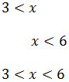
Thus, choice D is correct.

8. What is the range of possible x values given:
x2 + 9 < 34
A) x<6 and x>-6
B) x<5 and x>-5
C) x>5 and x<-5
D) x>6 and x<-6
E) x<3 and x>-3

Quantitative reasoning:
1 Isolate x.
x2 + 9 < 34
x2 < 25 (subtracted 9 from both sides)
2. Remember that due to the even exponent, x could be a negative number.
Take the square root of both sides. In taking the square root, there are two possibilities.
Case (1) is that X is positive:
x2 < 25
x<5
Case (2) is that X is negative:
x2 < 25
Since we are raising both sides by 1/2 and the number x is negative in this case, we must flip the inequality sign:
x>-5
3. Combine the two inequalities:
-5 < x < 5
4. As a check, you could try a few numbers:
x = 4 yields 25, which is less than 34
x = -4 yields 25, which is less than 34
But:
x = 6 yields 45, which is not less than 34
x = -6 yields 45, which is not less than 34
Thus, choice C is correct.

9. During the course of an hour, an employee at Ultimate Packing Solutions wrapped packages weighing 48, 32, 62, 12, 40, and 8 pounds. What was the median weight of the packages that the employee packed?
A) 33.333
B) 34
C) 36
D) 62
E) 33

Quantitative reasoning:
1. The median of a set of numbers is the "middle" number when the set of numbers is ordered sequentially. To find the middle, first order the numbers:
8, 12, 32, 40, 48, 62
2. Since there is an even number of integers in the set, there are two middle numbers: 32 and 40.
3. To find the median, average the two middle numbers:
(32+40)/2 = 36
Thus, answer C is correct.

10. For which of the following values of x is the fraction below an integer:
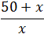
A) 0
B) 4
C) 5
D) 6
E) 7

Quantitative reasoning:
1. Start with the original fraction and simplify:
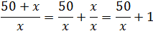
2.Since the question simply asks what value of x will make the equation an integer, the equation can be simplified to 50/x. This is true because, if 50/x is an integer, adding 1 to that value will not change whether it is an integer. Likewise, if 50/x is not an integer, adding 1 to that value will not make it an integer.
3. Simplified version of original question: is 50/x an integer?
4. Use the divisibility rules to quickly evaluate this question:
A: x = 0 --> Not an integer. You cannot divide by 0
B: x = 4 --> Not an integer. You cannot divide 50 by 2 twice, so 50/4 is not an integer.
C: x = 5 --> An integer; 50/5 = 10
At this point, you could stop. However, just to be safe, it does not hurt to keep checking.
D: x = 6 --> Not an integer. You cannot divide 50 by both 2 and 3, so 50/6 is not an integer. (Remember that for a number to be divisible by 3, its digits must sum to a number divisible by 3. The sum of the digits of 50 is 5, which is not divisible by 3).
E: x = 7 --> Not an integer. No quick rule for divisibility by 7. However, since 7*7 is 49, there is no way 50 will be divisible by 7.
Thus, choice C is correct.

Reference: All questions were taken from: http://www.platinumgmat.com/practice_gmat_questions Access on May 18th 2013

